Dear Sir,

Please find attached manuscript of the article *‘***A thermal cycling route for processing nano-grains in AISI 316L stainless steel for improved tensile deformation behaviour’**for consideration of publication in your journal.

The present work significantly improved the mechanical strength of AISI 316L stainless steel by producing nano-sized grains in it. The stable austenitic stainless steel was subjected to cold rolling followed by repetitive thermal cycling to produce ultra-fine/ nano-sized grains. In the present work, the optimum processing parameters including extent of cold deformation, annealing temperature for thermal cycling, soaking period during each thermal cycle, and number of thermal cycles required were determined through a systematic step-by-step procedure. After conducting thermal cycling under the optimum conditions, a significant amount of grain size reduction was achieved in the steel. The effect of nano-sized grains on the tensile deformation behaviour of the steel was also analysed. High cold deformation resulted in increased dislocation density and high amount of stored strain energy. The stored strain energy accelerated the re-crystallization kinetics during the thermal cycling process. Every thermal cycle given to the cold rolled specimen resulted in irregular dispersal of stored energy. This irregular dispersal of stored energy favoured recrystallization rather than grain growth and led to refinement of grains to nano-size in the absence of strain induced martensite. The repetitive thermal cycling process promoted grain refinement and resulted in very significant grain size reduction with the resultant average grain size in the range of 800–1200 nm as compared to the initial size of 90–120 µm. The resultant microstructure improved the tensile strength by 106.8 %, from 590 MPa to 1220 MPa.

Hope to hear a positive response from your end.

Thanks and regards,

Sincerely,

Dr. Tarun Nanda

Assistant Professor,

Mechanical Engineering Department,

Thapar University, Patiala, India

**AUTHOR DETAILS**

|  |  |
| --- | --- |
| **AUTHOR 1** | |
| FIRST NAME | **TARUN** |
| LAST NAME | **NANDA** |
| POSTAL ADDRESS | **AP, MED, TU, PATIALA, PUNJAB, 147004, INDIA** |
| EMAIL ADDRESS | **tarunnanda@thapar.edu** |
| WORKING TELEPHONE NUMBER | **91-175-2393106; 91-9463013983** |
|  |  |
| **AUTHOR 2** | |
| FIRST NAME | **B.** |
| LAST NAME | **RAVI KUMAR** |
| POSTAL ADDRESS | **PRINCIPLE SCIENCIST, MST, NML, JAMSHEDPUR, JHARKHAND, INDIA** |
| EMAIL ADDRESS | **ravik_in@yahoo.com** |
| WORKING TELEPHONE NUMBER | **91-657-2345008; 91-9431567243** |
|  |  |
| **AUTHOR 3** | |
| FIRST NAME | **VISHAL** |
| LAST NAME | **SINGH** |
| POSTAL ADDRESS | **AP, MED, INDUS INTERNATIONAL UNIVERSITY, UNA-174301, INDIA** |
| EMAIL ADDRESS | **vishalraizada57@gmail.com** |
| WORKING TELEPHONE NUMBER | **91-9646454851** |

**FIGURES**

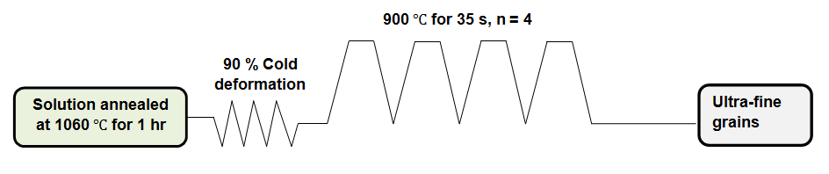

**Figure 1. Graphical representation of the thermal cycling process. n = number of thermal cycles.**

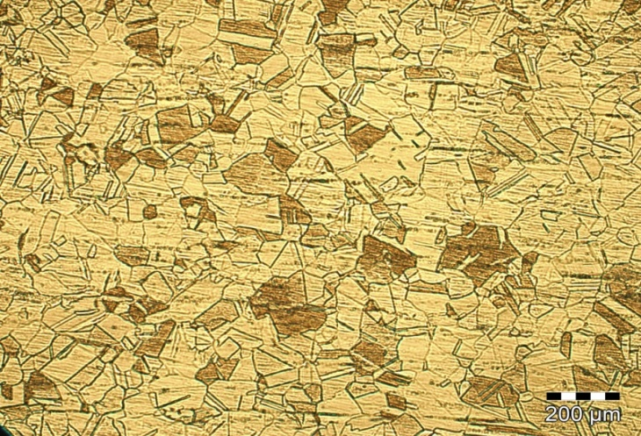

**Annealing Twins**

**Polygonal Grains**

**Figure 2. Optical micrograph of the solution treated 316L austenitic stainless steel**

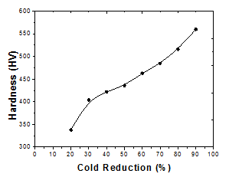

**(a)**

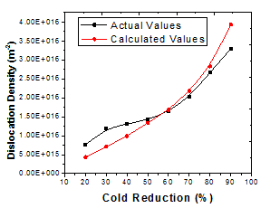

**(b)**

**Figure 3. Effect of cold deformation on (a) hardness, and (b) dislocation density**

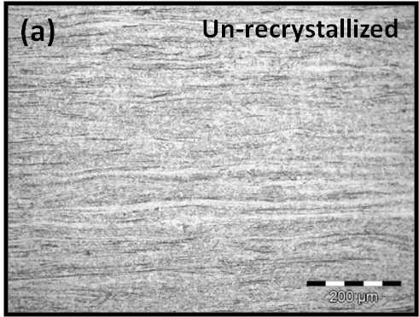 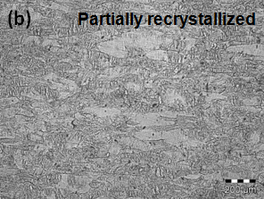

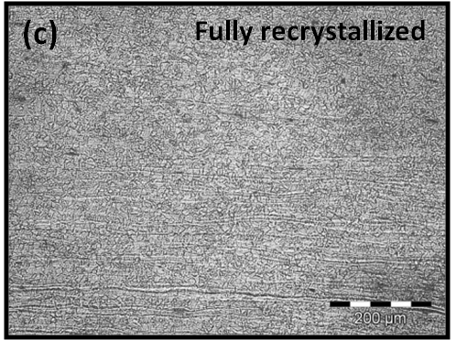

**Figure 4. Optical image of 316L austenitic stainless steel after isothermal annealing at (a) 700 (b) 800 and (c) 900**



**Figure 5. Recrystallization fraction at 900 for different soaking periods**

|  |  |  |
| --- | --- | --- |
| C:\Users\pankaj sharma\Desktop\IMAGES & GRAIN SIZE\for steel only\steel\925-10x.jpg | C:\Users\pankaj sharma\Desktop\IMAGES & GRAIN SIZE\for steel only\90% steel sample\950-10x.jpg | C:\Users\pankaj sharma\Desktop\IMAGES & GRAIN SIZE\for steel only\exp-1-steel\exp-1-10x.jpg |
| a) 875 , 30 s, n = 4 | b) 875 $℃$, 35 s, n = 4 | c) 875 , 40 s, n = 4 |
| C:\Users\pankaj sharma\Desktop\IMAGES & GRAIN SIZE\for steel only\23-05-11-steel\900-50x.jpg | C:\Users\pankaj sharma\Desktop\IMAGES & GRAIN SIZE\for steel only\12-05-11-steel\35-4-100x-2.jpg | C:\Users\pankaj sharma\Desktop\IMAGES & GRAIN SIZE\for steel only\90% steel sample\950-100x.jpg |
| d) 900 , 30 s, n = 4 | e) 900 $℃$, 35 s, n = 4 | f) 900 , 40 s, n = 4 |
| C:\Users\pankaj sharma\Desktop\IMAGES & GRAIN SIZE\for steel only\23-05-11-steel\925-50x.jpg | C:\Users\pankaj sharma\Desktop\IMAGES & GRAIN SIZE\for steel only\12-05-11-steel\35-4-50x-2.jpg | C:\Users\pankaj sharma\Desktop\IMAGES & GRAIN SIZE\for steel only\90% steel sample\950-50x.jpg |
| g) 925 , 30 s, n = 4 | h) 925 $℃$, 35 s, n = 4 | i) 925 $℃$, 40 s, n = 4 |

**Figure 6. Microstructure of 316L austenitic stainless steel thermal cycled at different conditions**

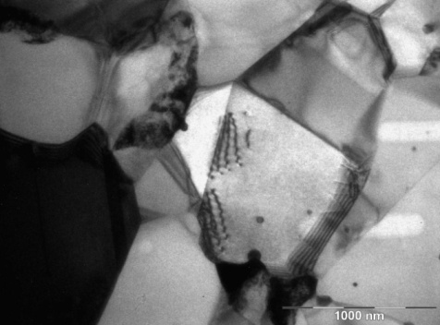

**Figure 7. TEM images of AISI 316L stainless steel after thermal cycling under the optimum conditions**



**Figure 8. Tensile curves of solution annealed and thermal cycled specimen of AISI 316L stainless steel**

**Table File**

**Table 1. Chemistry of the starting AISI 316L steel**

|  |  |  |  |  |  |  |  |  |
| --- | --- | --- | --- | --- | --- | --- | --- | --- |
| **Element** | **C** | **Si** | **Mn** | **P** | **Cr** | **Ni** | **Mo** | **Fe** |
| **% wt.** | 0.025 | 0.30 | 1.20 | 0.030 | 16.90 | 10.60 | 2.06 | **Balance** |

**Figures Captions**

**Figure 1. Graphical representation of the thermal cycling process. n = number of thermal cycles**

**Figure 2. Optical micrograph of the solution treated 316L austenitic stainless steel**

**Figure 3. Effect of cold deformation on (a) hardness, and (b) dislocation density**

**Figure 4. Optical image of 316L austenitic stainless steel after isothermal annealing at (a) 700 $℃$ (b) 800 $℃$ and (c) 900 $℃$**

**Figure 5. Recrystallization fraction at 900 $℃$ for different soaking periods**

**Figure 6. Microstructure of 316L austenitic stainless steel thermal cycled at different conditions**

**Figure 7. TEM images of AISI 316L stainless steel after thermal cycling under the optimum conditions**

**Figure 8. Tensile curves of solution annealed and thermal cycled specimen of AISI 316L stainless steel**

**Table Captions**

**Table 1. Chemistry of the starting AISI 316L steel**

**REFERENCES**

1. [Li](http://www.tandfonline.com/author/Li%2C+Yang),Y.; [Hu](http://www.tandfonline.com/author/Hu%2C+Shengsun), S.; [Shen](http://www.tandfonline.com/author/Shen%2C+Junqi), J. & Hu, B. [Dissimilar welding of H62 brass-316L stainless steel using continuous-wave Nd:YAG laser](http://www.tandfonline.com/doi/full/10.1080/10426914.2013.822981#abstract). *Mater. Manuf. Process,* 2014, **29**(8), 916–921.
2. Eskandari, M.; Najafizadeh, A. & Kermanpur, A. Effect of strain-induced martensite on the formation of nanocrystalline 316L stainless steel after cold rolling and annealing. *Mat. Sci. Eng. A,* 2009, **519**, 46–50.
3. Rao, G.A.; Sankaranarayana, M. & Balasubramaniam, S. Hot isostatic pressing technology for defence and space applications. *Def. Sci. J.*, 2012, **62**(1), 73–80.
4. [Tathgir](http://www.tandfonline.com/author/Tathgir%2C+Surinder), S. & [Bhattacharya](http://www.tandfonline.com/author/Bhattacharya%2C+Anirban), A. [Activated-TIG welding of different steels: influence of various flux and shielding gas](http://www.tandfonline.com/doi/full/10.1080/10426914.2015.1037914#abstract). *Mater. Manuf. Process,* 2016, **31**(3), 335–342.
5. [Kumar](http://www.tandfonline.com/author/Kumar%2C+K+V+Satheesh), K.V.S.; [Gejendhiran](http://www.tandfonline.com/author/Gejendhiran%2C+S), S. & [Prasath](http://www.tandfonline.com/author/Prasath%2C+M), M. [Comparative investigation of mechanical properties in GMAW/GTAW for various shielding gas compositions](http://www.tandfonline.com/doi/full/10.1080/10426914.2014.901527#abstract). *Mater. Manuf. Process,* 2014, **29**(8), 996–1003.
6. Sugur, V.S. & Manwani, G.L. Problems in storage and handling of red fuming nitric acid.*Def. Sci. J.*, 1983, **33**(4), 331–337**.**

# [Karimzadeh](http://www.tandfonline.com/author/Karimzadeh%2C+A), A. & [Rouhaghdam](http://www.tandfonline.com/author/Rouhaghdam%2C+A+Sabour), A.S. [Effect of nickel pre-plated on microstructure and oxidation behavior of aluminized AISI 316 stainless steel](http://www.tandfonline.com/doi/full/10.1080/10426914.2015.1019091#abstract). *Mater. Manuf. Process,* 2016, 31(1), 87–94.

# [Ganesh](http://www.tandfonline.com/author/Ganesh%2C+K+C), K.C.; [Vasudevan](http://www.tandfonline.com/author/Vasudevan%2C+M), M.; Balasubramanian, [K.R.;](http://www.tandfonline.com/author/Balasubramanian%2C+K+R) [Chandrasekhar](http://www.tandfonline.com/author/Chandrasekhar%2C+N), N. & [Vasantharaja](http://www.tandfonline.com/author/Vasantharaja%2C+P), P. Thermo-mechanical analysis of TIG welding of AISI 316LN stainless steel. *Mater. Manuf. Process,* 2014, 29(8), 903–909.

1. [Mishnev](http://www.sciencedirect.com/science/article/pii/S0921509315000921), R.; [Shakhova](http://www.sciencedirect.com/science/article/pii/S0921509315000921), I.; [Belyakov](http://www.sciencedirect.com/science/article/pii/S0921509315000921), A. & [Kaibyshev](http://www.sciencedirect.com/science/article/pii/S0921509315000921), R. Deformation microstructures, strengthening mechanisms, and electrical conductivity in a Cu–Cr–Zr alloy. [*Mat. Sci. Eng. A*](http://www.sciencedirect.com/science/journal/09215093), 2015, **629**, 29–40.
2. Rao, K.S. & N, Hossein. Brittle failure in heterogeneous crystalline rocks. *Def. Sci. J.*, 2008, **58**(2), 285–294.
3. Ucok, I.; Ando, T. & Grant, N.J. Property enhancement in type 316L stainless steel by spray forming. *Mat. Sci. Eng. A*, 1991, **133**, 284–287.
4. Chen, S.; Shibata, A.; Gao, S. & Tsuji, N. Formation of fully annealed nanocrystalline austenite in Fe–Ni–C alloy. *Mater. T. JIM.,* 2014, **55**(1), 223– 226.
5. Salishchev, G.A.; Zaripova, R.G. & Zakirova, A.A. Structure and properties of stainless steels subjected to severe plastic deformation. *Metal Sci. Heat Treat.,* 2006*,* **48** (1–2), 70–75.
6. [Ye](http://www.tandfonline.com/author/Ye%2C+K+L), K.L.; Luo,  [H.Y. &](http://www.tandfonline.com/author/Luo%2C+H+Y) Ly, [J.L.](http://www.tandfonline.com/author/Lv%2C+J+L) Producing nanostructured 304 stainless steel by rolling at cryogenic temperature. *Mater. Manuf. Process*,2014, **29**(6), 754–758.

# [Sun](http://www.tandfonline.com/author/Sun%2C+S+L), S.L.; [Huang](http://www.tandfonline.com/author/Huang%2C+Q+X), Q.X. & [He](http://www.tandfonline.com/author/He%2C+W+W), W.W. New optimum extrusion parameters of 9% Cr ferritic steel tubes. *Mater. Manuf. Process,* 2016, 31(6), 751–757.

1. Kumar, B.R.; Das, S.K.; Mahato, B. & Ghosh, R.N. Role of strain-induced martensite on microstructural evolution during annealing of metastable austenitic stainless steel. *J. Mater. Sci.,* 2009,**45**, 911–918.
2. Misra, R.D.K.; Nayak, S.; Mali, S.A.; Shah, J.S.; Somani, M.C. & Karjalainen, L.P. Microstructure and deformation behaviour of phase-reversion-induced nanograined/ultrafine-grained austenitic stainless steel. *Metall. Mater. Trans. A*,2009,**40**, 2498–2509.
3. Mythili, R.; Saroja, S. & Vijayalakshmi, M. Study of strain induced martensite formation in a Ti modified 316 stainless steel bellow by transmission electron microscopy. *T. Indian I. Metals*,2009, **62**(6), 573–579.
4. Kumar, B.R.; Das, S.K.; Sharma, S. & Sahu, J.K. Effect of thermal cycles on heavily cold deformed AISI 304L austenitic stainless steel. *Mat. Sci. Eng. A,* 2010, **527**, 875–882.

# [Li](http://www.tandfonline.com/author/Li%2C+Yongfeng), Y.; [Bu](http://www.tandfonline.com/author/Bu%2C+Fuming),F.; [Kan](http://www.tandfonline.com/author/Kan%2C+Wenbin), W. & [Pan](http://www.tandfonline.com/author/Pan%2C+Hongliang), H. Deformation-induced martensitic transformation behavior in cold-rolled AISI304 stainless steels. *Mater. Manuf. Process,* 2013, 28(3), 256–259.

1. Kumar, B.R.; Mahato, B.; Sharma, S. & Sahu, J.K. Effect of cyclic thermal process on ultrafine grain formation in AISI 304L austenitic stainless steel. *Metall. Mater. Trans. A,* 2009, **40**, 3226–3234.
2. Matlock, D.K. & Speer, J.G. Processing opportunities for new advanced high-strength sheet steels. *Mater. Manuf. Process*,2010, **25**(1–3), 7–13.
3. Kumar, B.R. & Gujral, A. Plastic deformation modes in mono- and bimodal-type ultrafine-grained austenitic stainless steel. [*Metall. Micro. Analysis*](http://link.springer.com/journal/13632)*,* 2014, **3**(5), 397–407.
4. Szpunar, J.A.; Narayanan, R. & Li, H. Computer model of recrystallization texture in aluminium alloys. *Mater. Manuf. Process*,2007, **22**(7–8), 928–933.
5. Chia, K.H.; Jung, K. & Conrad, H. Dislocation density model for the effect of grain size on the flow stress of a Ti–15.2 at % Mo alloy at 4.2–650K. *Mat. Sci. Eng. A,* 2005, **409**, 32–38.
6. Raghavan, V. Materials science and engineering. PHI Learning Private Limited, India, 2004. 285 p.
7. Roucoules, C.; Pietrzyk, M. & Hodgson, P.D. Analysis of work hardening and recrystallization during the hot working of steel using a statistically based internal variable model. *Mat. Sci. Eng. A,* 2003, **339**, 1–9.
8. Samuel, K.G. & Rodriguez, P. On power-law type relationships and the ludwigson explanation for the stress-strain behaviour of AISI 316 stainless steel. *J.Mater. Sci.,* 2005, **40**, 5727–5731.
9. Samuel, E.I. & Choudhary, B.K. Universal scaling of work hardening parameters in type 316L (N) stainless steel. *Mat. Sci. Eng. A*,2010, **527**, 7457–7460.
10. [Nakashima](http://www.scientific.net/author/Koichi_Nakashima), K.; [Suzuki](http://www.scientific.net/author/M_Suzuki_1), M.; [Futamura](http://www.scientific.net/author/Y_Futamura), Y.; [Tsuchiyama](http://www.scientific.net/author/Toshihiro_Tsuchiyama), T. & [Takaki](http://www.scientific.net/author/Setsuo_Takaki), S. Limit of dislocation density and dislocation strengthening in iron. [*Mater. Sci. Forum*](http://www.scientific.net/MSF), 2006, **503–504**, 627*–*632.
11. Dischino, A.; Kenny, J.M.; Salvatori, I. & Abbruzzese, G. Modelling primary recrystallization and grain growth in a low nickel austenitic stainless steel. *J. Mater. Sci.,* 2001, **36**, 593– 601.
12. Kolmogorov, A.N. On the statistical theory of crystallization of metals (translated title). *Izv. Akad. Nauk. SSSR, 1937*, **1**, 355–359.
13. Avrami, M. Kinetics of phase change I. General theory. *J. Chem. Phys.,* 1939, **7**(12), 1103–1109.
14. Johnson, W.A. & Mehl, R.F. Reaction kinetics in processes of nucleation and growth*. AIMMPE*,1939, **135**(8), 416–442.
15. Avrami, M. Kinetics of phase change II. Transformation-time relations for random distribution of nuclei. *J. Chem. Phys.,* 1940, **8**(2), 212–224.
16. Avrami, M. Kinetics of phase change III. Granulation, phase change, and microstructure. *J. Chem. Phys.,* 1941, **9**(2), 177–184.
17. Gao, M.; Reid, C.N.; Jahedi, M. & Li, Y. Estimating equilibration times and heating/cooling rates in heat treatment of workpieces with arbitrary geometry. *J. Mater. Eng. Perform*., 2000, **9**(1), 62–71.