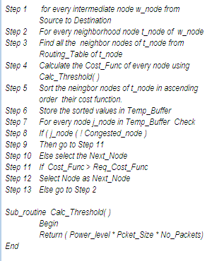
Fig.1 Algoritm for node selection

Fig.2 Functional Block diagram of Cross layer interaction

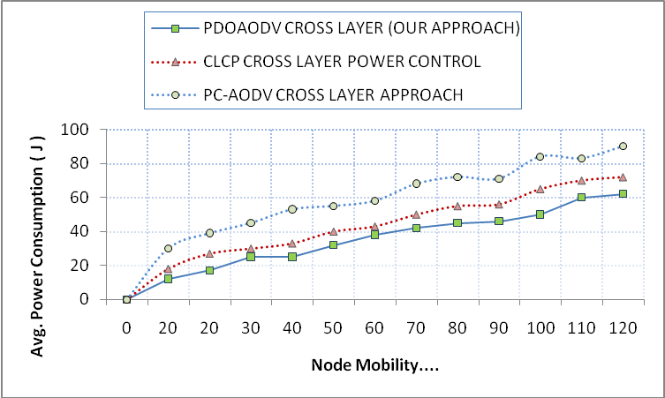
Fig 3. Comparison of Power Consumption

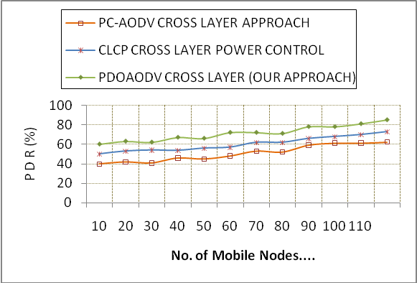
Fig 4. Comparison of PDR
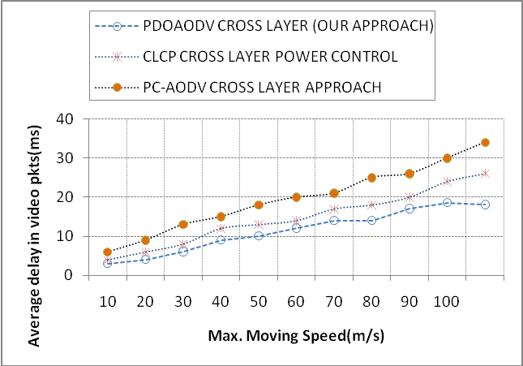
Fig.5 Average Delay Comparison for video packets

