Mr Ajit Dhanawade

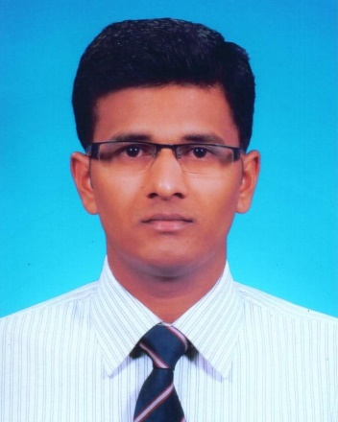

Email ID- dhanawadeajitd@gmail.com

Educational qualification

Sr. No. | Degree | Division/Grade | Year of completion | College/University
1 | BE (Production Engineering) | 73.27% First class with distinction | 2009 | D. Y. Patil college of engineering & Technology, Kolhapur, Maharashtra
2 | ME(Mechanical-Production Engineering) | 71.71% First class with distinction | 2012 | KIT’s college of engineering, Kolhapur, Maharashtra
3 | PhD (Mechanical Engineering) | --- | Pursuing | S V National Institute of Technology, Surat, Gujrat
Current position: Research Scholar, Department of Mechanical Engineering, S V National Institute of Technology, Surat
Area of Research work
- Non-traditional machining of composite materials

Dr. Shailendra Kumar

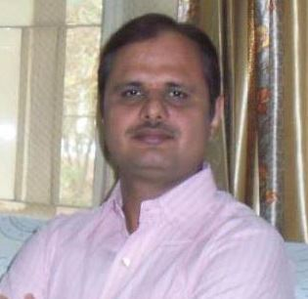

Email ID- skbudhwar@med.svnit.ac.in , skbudhwar2003@yahoo.co.in
Educational qualification

Sr. No. | Degree | Division/Grade | Year of completion | College/University
1 | B.Sc. Engineering (Production Engineering) | 79% First class with distinction | 1999 | Regional Institute of Technology, Jamshedpur (Presently NIT Jamshedpur)
2 | PhD (Mechanical Engineering) | --- | March 2007 | Maharshi Dayanand University, Rohtak, Haryana, India

Teaching Experience

Organization | Post held | Duration | Responsibilities
SV NIT Surat | Associate Professor | 16-8-2007 | Teaching of UG & PG subjects,
 | (Present Post) | onwards | Research & Administrative work
Hindu College of | Assistant Professor | 15-5-2007 | Teaching of UG subjects
Engineering, Sonepat | & Head | to | Research &Administrative work
(Haryana)
 |  | 14-8-2007
Hindu College of | Lecturer | 9-11-1999 | Teaching of UG subjects
Engineering, Sonepat |  | to
(Haryana) |  | 14-5-2007

Research Publications:
- International Journals: 27
- National Journals: 08
- International Conferences: 45
- National Conferences: 30

Area of Research Interests:
- AI Applications in Sheet Metal Forming
- Press Tool Design • Manufacturing Processes
- Automation in Manufacturing
- Flexible Manufacturing Systems
- Computer Aided Process Planning (CAPP)
- CAD/CAM/CIM

Research Projects:

Funding Agency | Title of Project | Grants | Duration | PI/Co-PI | Status
 |  | Sanctioned
DST, New Delhi | Development of an | 3,60000/- | 2008-2011 | PI | completed
(Under Fast Track | intelligent system
Scheme for Young | for selection of
Scientist) | materials for press
 | tool components
MHRD, New Delhi | National Mission | 91,00000/- | 2013-2015 | Institute | Ongoing
(Project is headed | Project on | (total 13 |  | Coordinator
by IIT Kharagpur) | “Developing | courses, each |  | (Also
 | suitable pedagogical | course budget |  | developing
 | methods for various | – Rs. 7 Lakh) |  | one course
 | classes, intellectual |  |  | as PI)
 | calibers and
 | research in e-
 | learning”
Science & | Automation of | 24,10000/- | 2014-2017 | PI | Ongoing
Engineering | design of compound
Research | dies for sheet metal
Board(SERB), | industries
New Delhi
Naval Research | Investigation on the | 18,12000/- | 2014-2017 | PI | Ongoing
Board, Directorate | influence of
of Naval R&D | Machining
(DNRD), New | Parameters
Delhi | in the Machining of
 | Carbon epoxy
 | composite with
 | AWJM to
 | improve surface
 | finish and minimize
 | defects

Books:
Book Chapter: AI Applications to Metal Stamping Die Design, In: Artificial Intelligence: Approaches, Tools and Applications (ISBN 978-1-61324-019-9), Nova Science Publishers, New York, 2011, pp. 71-95.
Book Edited: Proceedings of five National Conferences
Books Reviewed: 04 (Publisher - Tata-McGraw Hills, New Delhi)

Ph.D. Guidance: 03 (awarded), 05 (ongoing)

Mr. R V Kalmekar

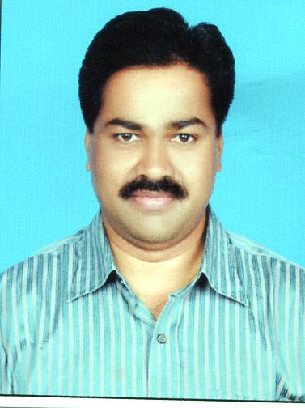

Email ID:- rajkalmekar@yahoo.co.in

Address:- Naval Materials Research Laboratory, Ministry of Defence (DRDO), Ambernath-E, Dist-Thane, Maharashtra PIN-421503
Educational qualification
Sr. No. | Degree | Division/Grade | Year of completion | College/University
1 | B.E. (Mechanical Engineering) | 70% First Class | 1994 | Government College of Engineering, Amravati. Saint Gadge Baba University, Amravati, Maharashtra, India
2 | M. Tech (Material Science & Engineering) | 9.26 CGPA | 2012 | IIT, Kharagpur, West Bengal, India

Area of Research Interests:
- CAD & FEM Analysis
- Friction Stir Welding & Processing Technology
- Residual Stress Investigation and related Fatigue Life Assessment of welded joints
- Contour Method of Residual Stress Measurement
- Welding technology and testing of welded joints
Working Experience:

Organization | Post held | Duration | Responsibilities
Naval Materials Research Laboratory (NMRL), DRDO Ambernath, Dist- Thane MS, India | Scientist-E | 05-Apr-2013 to Till date | - Research and Development of Welding Technology for Naval Structures.  - Testing and Certification of Welded Joints.
Naval Engineering College, INS Shivaji, Lonavala, MS, India | Scientist-D | 26-Dec-2008 to 04-Apr-2013 | - Vice Principal  - Teaching UG Naval Officers and Cadets Mechanical Engineering & Materials Science Subject
Instruments Research & Development Establishment (IRDE), DRDO, Dehradun, Uttaranchal, India | Scientist- B to  Scientist- D | 09-Jun-1997 to 25-Dec-2008 | - Research & Development of Opto-Mechanical Systems for Defence Applications.  - CAD & FEM Analysis
Government Polytechnic College, Board of Technical Education, Khamgaon & Gadchiroli, Maharashtra, India | Lecturer in Mechanical Engineering | 05-Nov-1995 to 30-May-1997 | - Teaching Diploma in Engineering Students

