Narrow band interference elimination based on compressed sensing in UWB energy detector

List of tables
TABLE 1 Comparison of direct compressed and reconstruction based UWB energy detector [10]

Features | Direct compressed energy detector | Reconstruction based energy detector
Type of samples | Compressed samples | Reconstructed samples
Timing information | Cannot be relaxed | Can be relaxed
Measurement process | Identical | Independent
Theoretical BEP | Requires orthogonal measurement matrix | Requires random measurement matrix

TABLE 2 comparisons of NBI mitigation methods

Features | [15] | [11]
Pulsing rate | independent | Low
Timing issue | Robust | Requires perfect timing
Discrete cosine transform (DCT) | Do not require | Requires
Domain of CS ensembles | Fourier | Time

List of figures
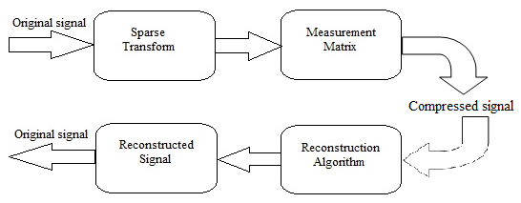
Fig. 1 Process of compressed sensing theory

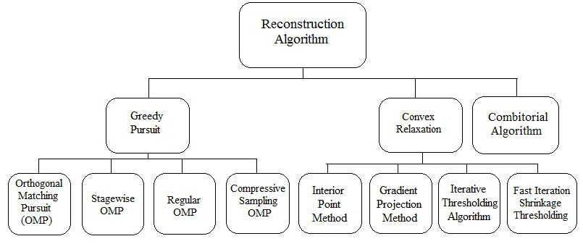
Fig. 2 Classifications of reconstruction algorithms in CS theory.

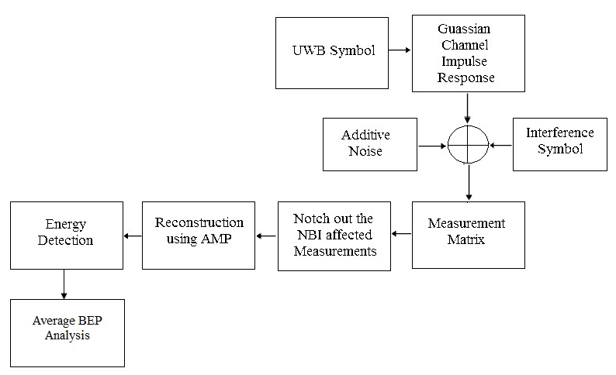
Fig.3 Block diagram of NBI robust UWB energy detector.

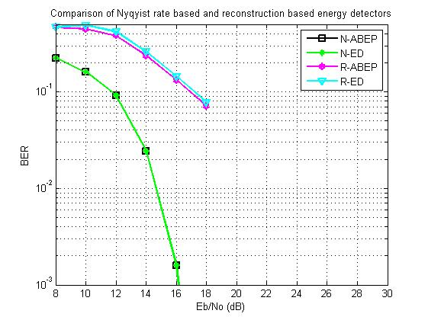
Fig.4 Comparison of Nyquist Rate and reconstruction based energy detectors w.r.t. Eb/No.
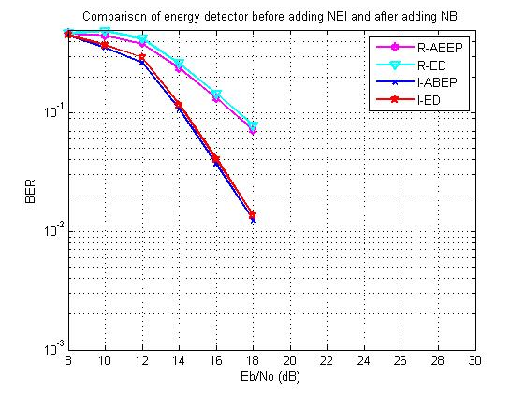
Fig.5 Effect of NBI on reconstruction based energy detector w.r.t. Eb/No.
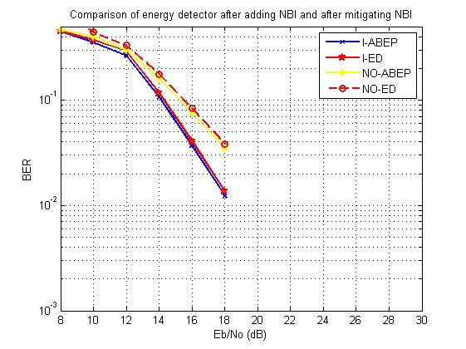
Fig. 6 Comparison of detectors in the presence of NBI and after mitigating NBI w.r.t. Eb/No
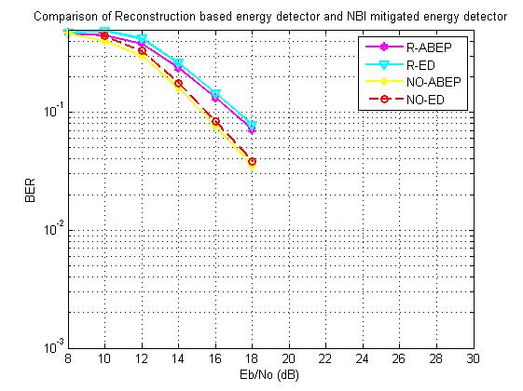
Fig. 7 Comparison of detectors in the abcence of NBI and after notching out NBI w.r.t. Eb/No.

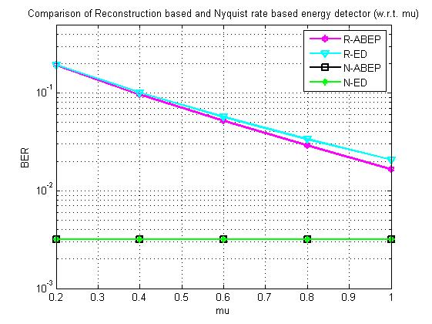
Fig.8 Comparison of Nyquist rate energy detector and compressed sampling based energy detector w.r.t. mu.
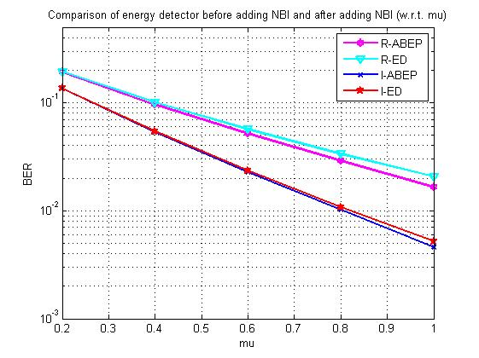
Fig.9 Comparison of energy detector in the absence of and in the presence of NBI w.r.t. mu

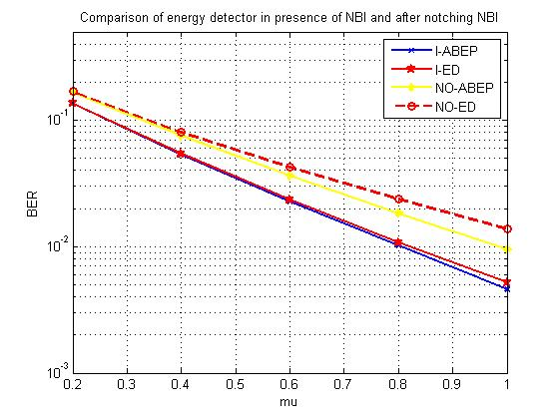
Fig.10 Comparison of energy detector in the presence of NBI and after mitigating NBI.
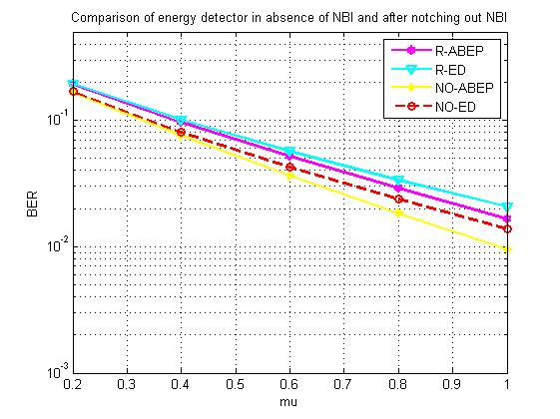
Fig.11 Comparison of energy detector in the absence of NBI and after mitigating NBI w.r.t mu.

