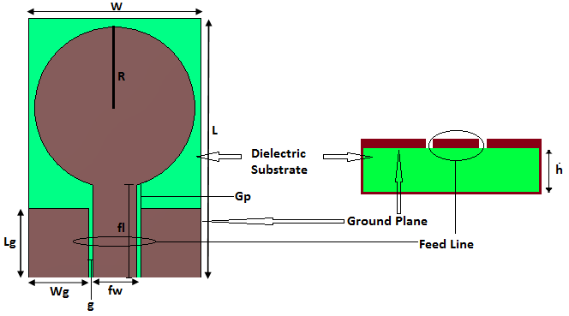
Fig.1. (a) Conventional CPW fed circular patch antenna

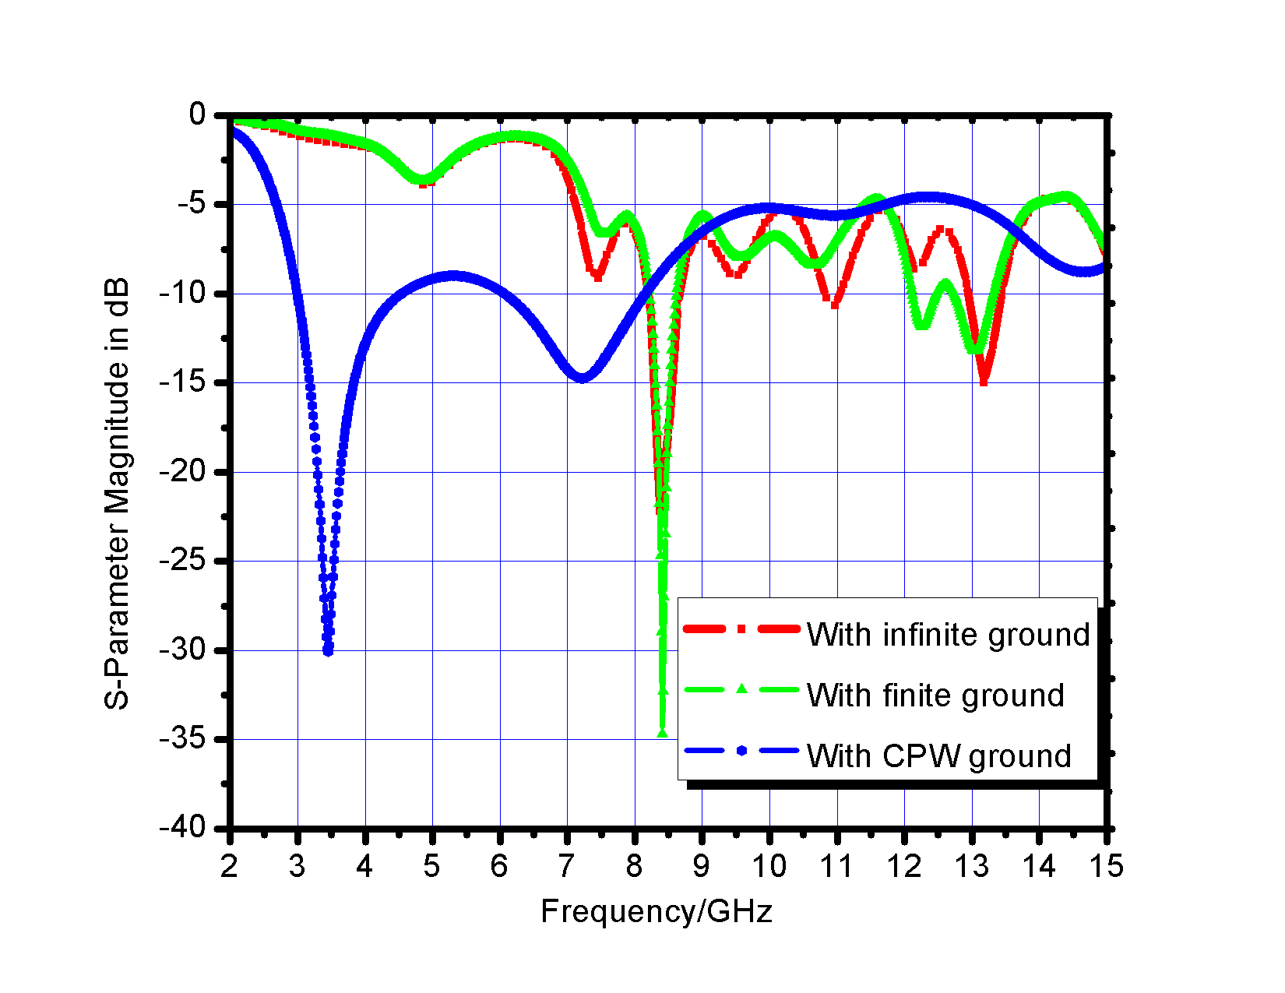 |  |  | 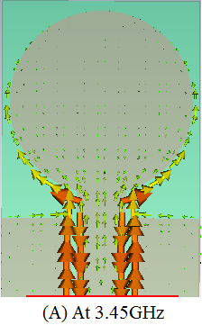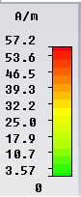
Fig. 1.(b) Variation of reflection coefficient of considered antennas with frequency |  |  | Fig.1. (c) Current distribution
 | 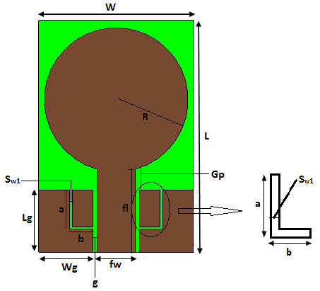 | 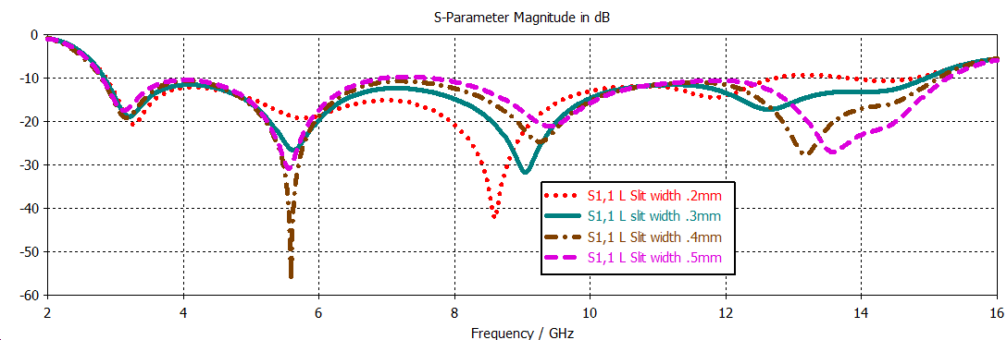
 | (a) | (b)
 | Fig.2. (a) CPW fed circular patch antenna L shaped slits in ground | Fig.2. (b) Reflection coefficient variation for different slit thicknesses
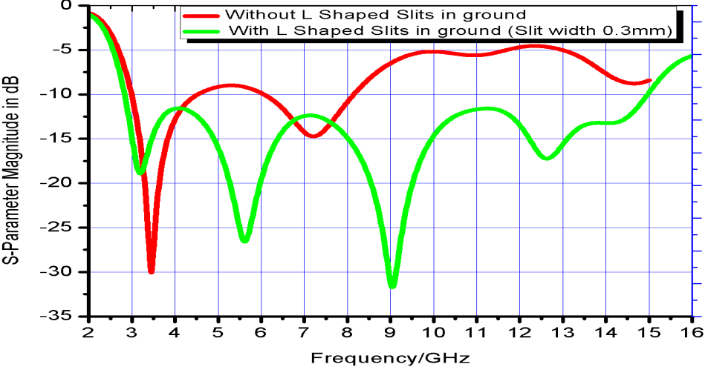

Fig.2. (c) Reflection coefficient of patch antenna with & without L shaped slits in ground
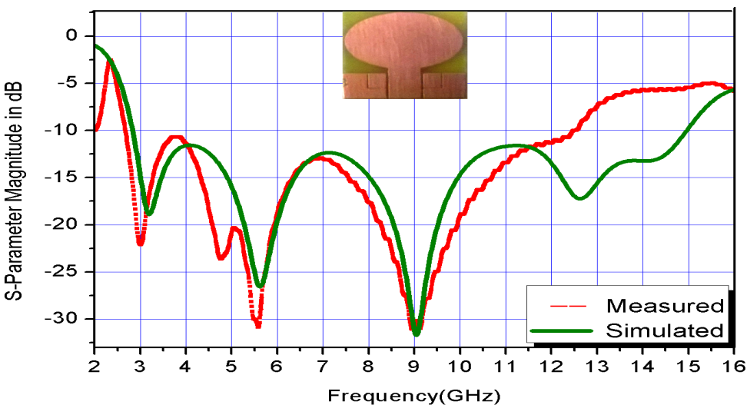
Fig. 3. Reflection coefficient of CPW fed circular patch antenna L shaped slits in ground
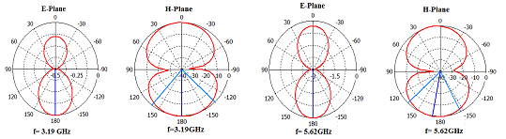
Fig.4. Two dimensional patterns of considered antenna at frequencies 3.19GHz and 5.62GHz
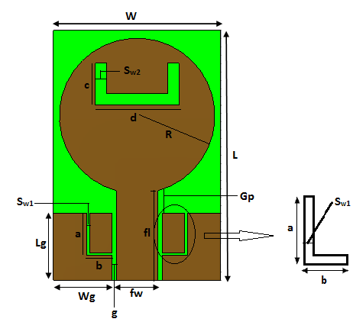 | 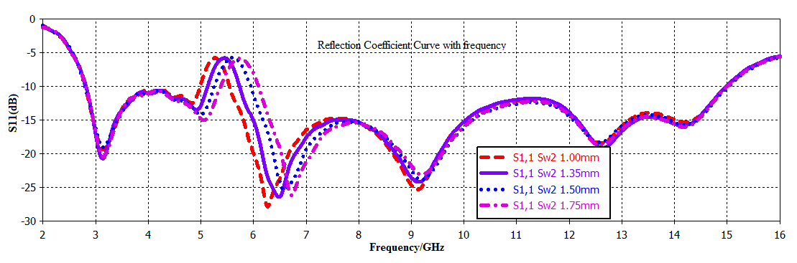
Fig.5. (a) CPW fed circular patch antenna L shaped slits in ground | Fig.5. (c) Reflection coefficient variation for different slit thicknesses
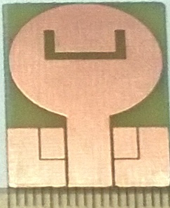 | 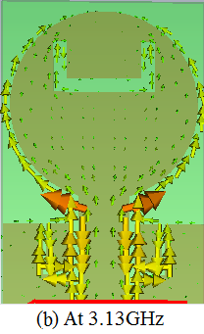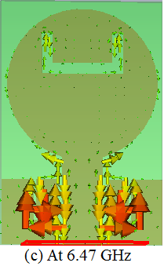
Fig.5. (b) CPW fed prototype of circular patch antenna L shaped slits in ground | Fig.5. (d) Current distribution
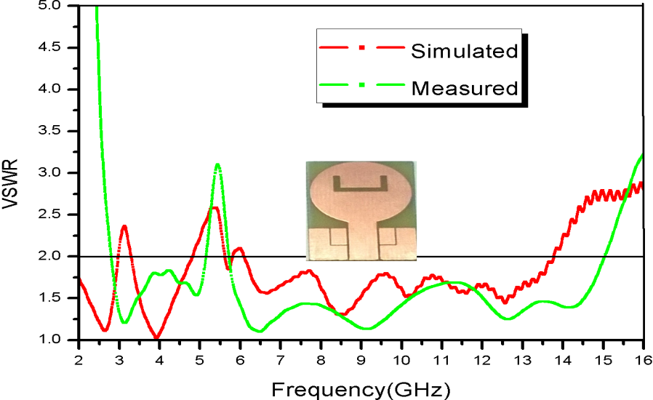
Fig. 6. Reflection coefficient of CPW fed modified circular patch antenna
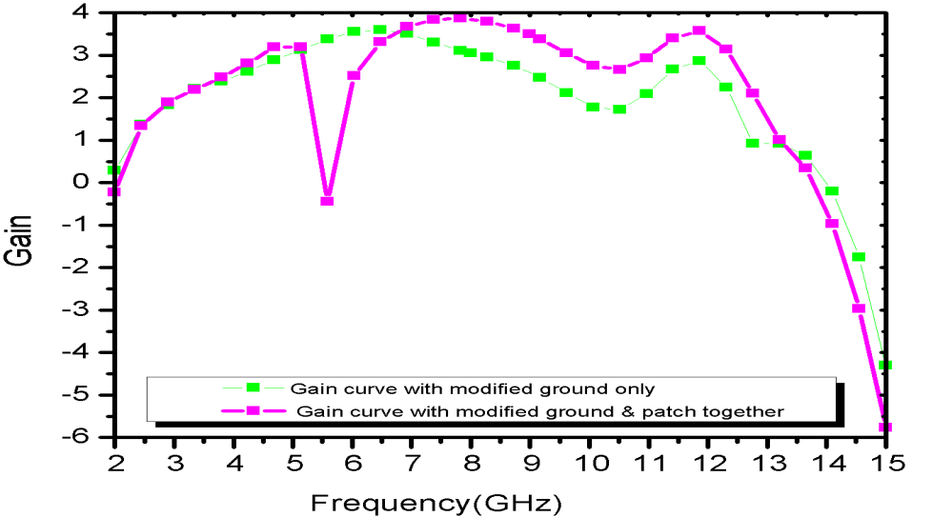
Fig. 7. Simulated gain variations of two considered antennas as a function of frequency

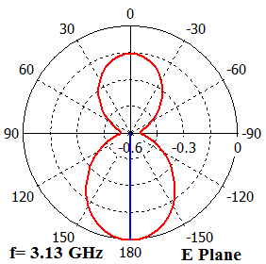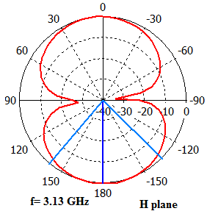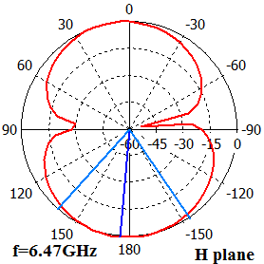

Fig.8. Two dimensional patterns of considered antenna at frequencies 3.13GHz and 6.47GHz

