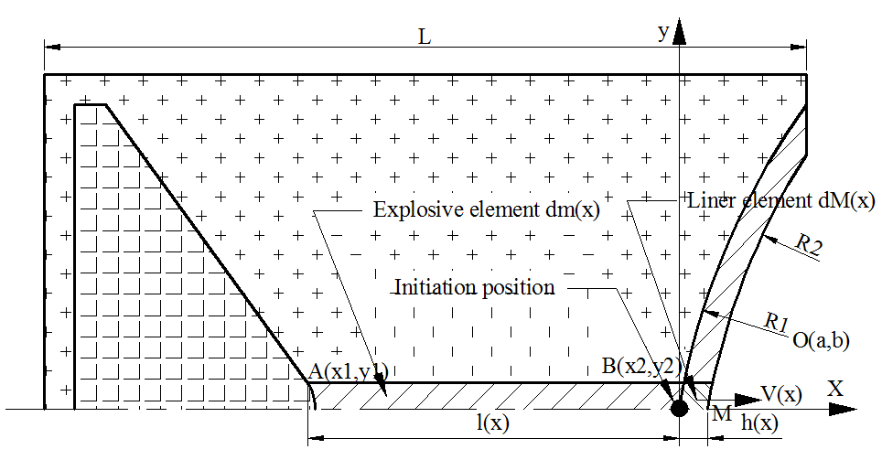
Fig.1 One dimensional motion of liner element when it formed at initiation top point of liner
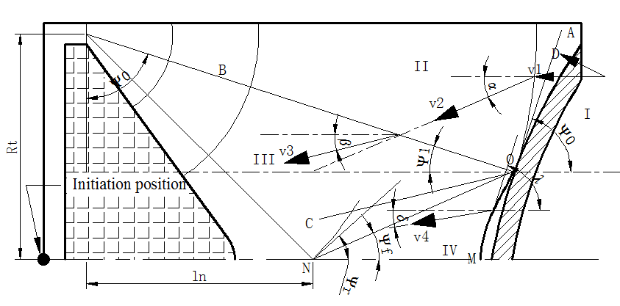
Fig.2 The detonation wave propagation and reflection when it formed at initiation top point of charge
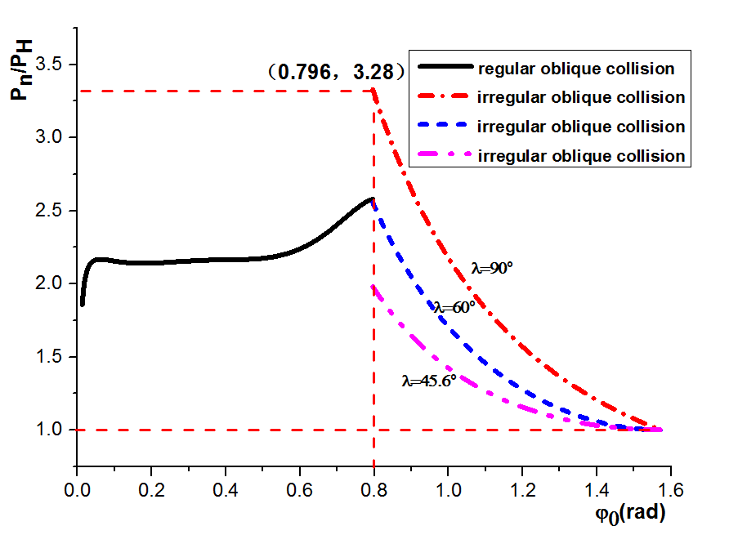
Fig.3 Pressure of denotation waves versus incidence angle
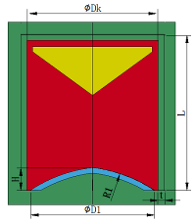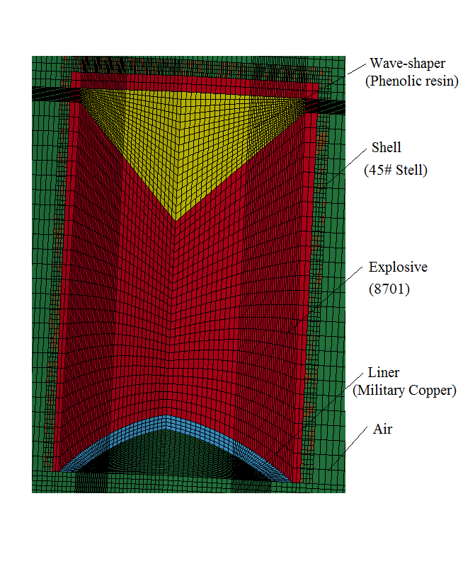
Fig. 4 Simulation model of a subcaliber charge structure and wave shaper
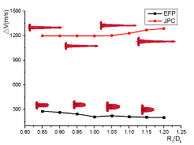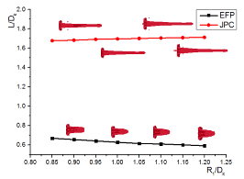
Fig. 5 Forms of dual-mode penetrators and curves showing the effect of the curvature radius on formation parameters
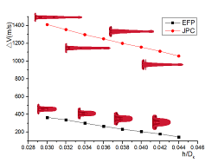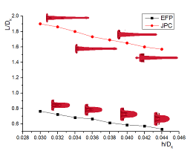
Fig. 6 Forms of dual-mode penetrators and curves showing the effect of the liner shell thickness on formation parameters
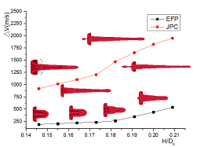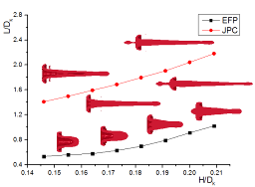
Fig. 7 Forms of dual-mode penetrators and curves showing the effect of the liner top height on formation parameters
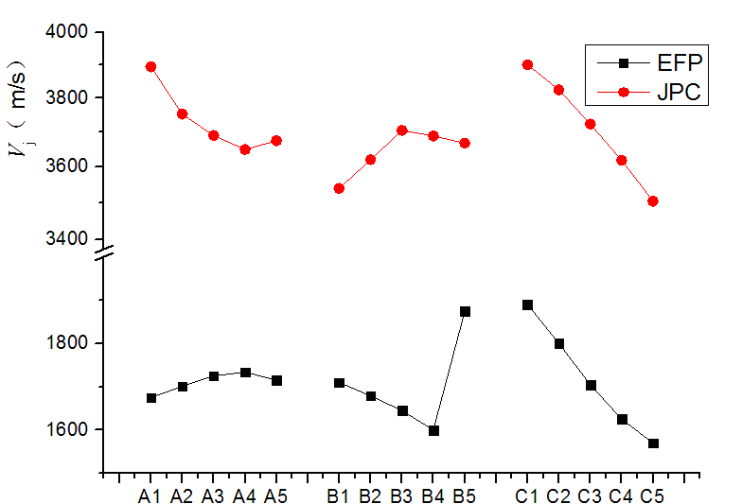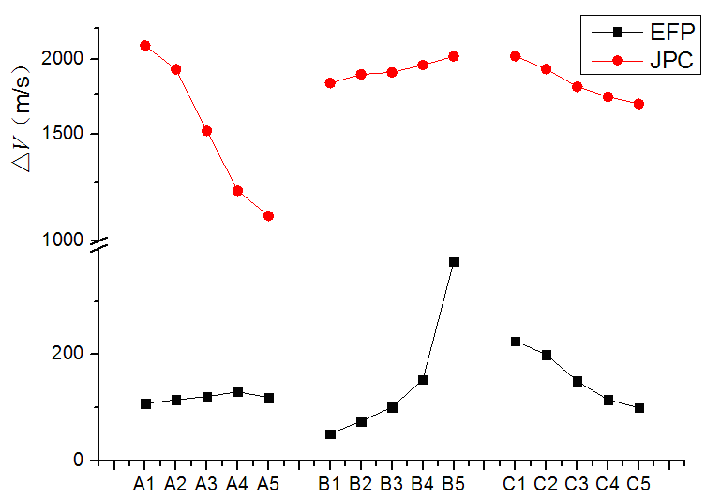
Fig.8 The change curve of formation paramaters of penetrators with factors
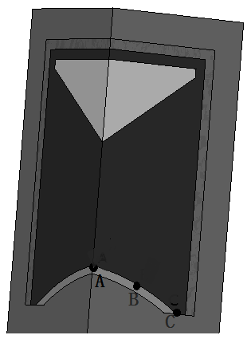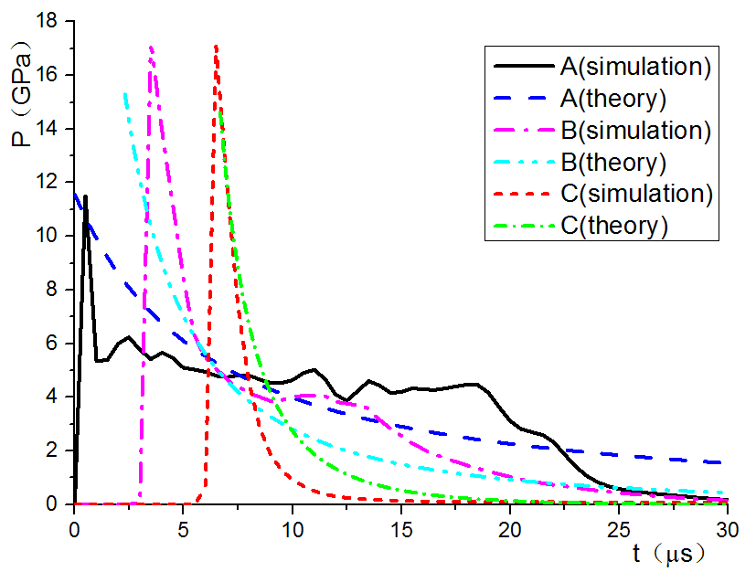
Fig. 9 Pressure at different points according to analytical and numerical analyses with liner top initiation
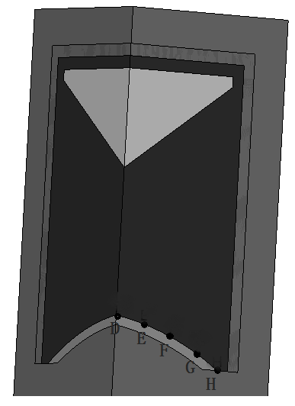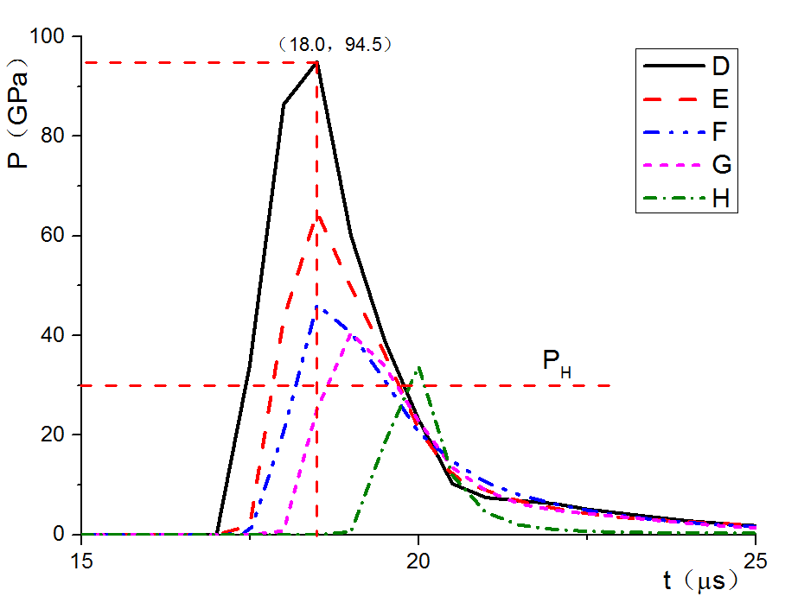
Fig. 10 Pressure at different points according to analytical and numerical analyses with liner top initiation
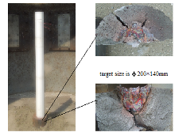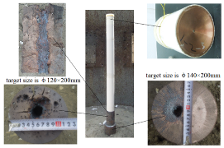
(a) Penetration effect of the EFP (b) Penetration effect of the JPC
Fig. 11 Experiments on the penetration of a steel target by dual-mode penetrators with burst height of 13D_{k}

