Contributors
Mr. Manjeet Singh postgraduated in Computer Aided Design and Manufacturing Engineering from Thapar University, Patiala, Punjab. Currently he is pursuing his doctoral degree from Thapar University, Patiala, Punjab. His research work involves development of new polymer composite materials for high strength joints.

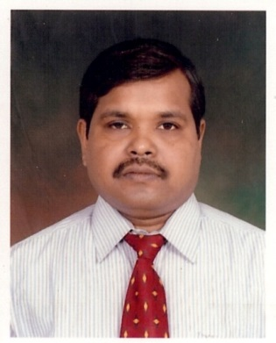
Dr. H. Bhunia is working as Associate Professor in Chemical Engineering Department at Thapar University, Patiala, Punjab. His speciliazation is polymer nano composites. He has nearly 30 reasearch papers in variuos reputed journals. He has published 3 books. Currently he is working in the area of development of polymer nano composites materials.

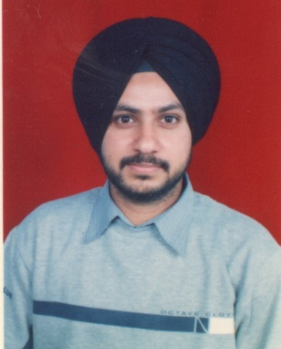
Dr. J. S. Saini is working as Assistant Professor in Mechanical Engineering Department at Thapar University, Patiala, Punjab. His specialization is Design and Analysis. He has nearly 20 research papers in various journals and conferences. Currently he is working in the area of polymer nano composites and their analysis.

