- HEART RATE: Age (22-35)
The age group of people between 22-35 has been identified and the six emotions, anger, tension, happy, relaxed, fear and excitement with the normal heart rate of the soldiers, these are all listed in second column of table 2 and table 3 for male and female soldiers respectively. Happy emotion is expressed with a heart rate of 68 and the relaxed emotion is expressed with a heart rate of 72 beats. The tension lies just below the excitement. The fear is expressed by a heart rate of 75 beats and anger is expressed by 74 whereas excitement is expressed by 66 beats. These are all shown in Figure 2.
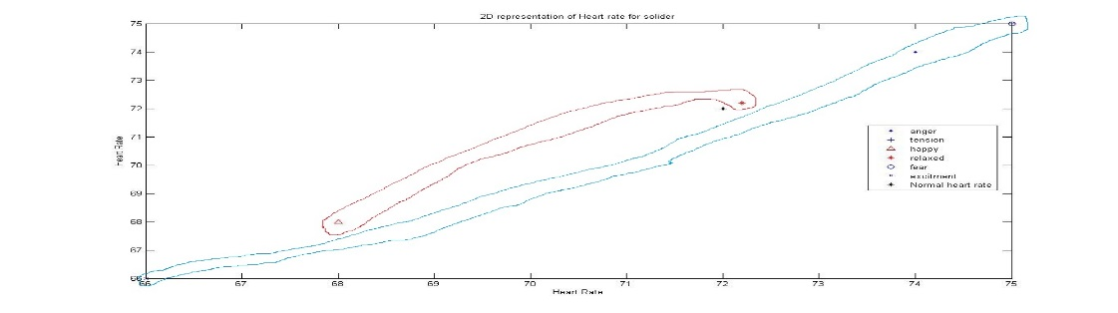
Fig 2. Variation of Heart Rate with emotion Age (22-35)
Age (36-45)
The age group of people between 36-45 has been identified and the six emotions, anger, tension, happy, relaxed, fear and excitement with the normal heart rate of the soldiers, these are all listed in third column of table 2 and table 3 for male and female soldiers respectively. Happy emotion is expressed with a heart rate of 70 and the relaxed emotion is expressed with a heart rate of 72 beats. The tension lies just below the excitement as 71. The fear is expressed by a heart rate of 75 beats and anger is expressed by 74 whereas excitement is expressed by 66 beats. These are all shown in Figure 3.
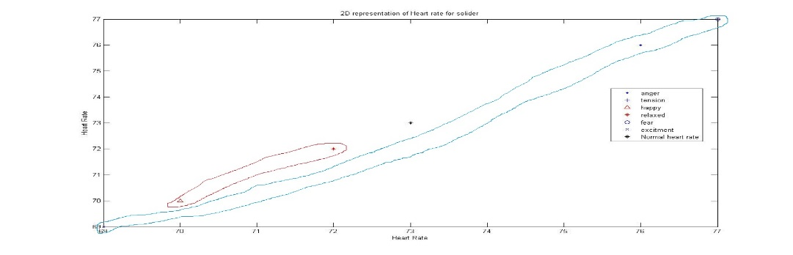
Fig 3. Variation of Heart Rate with emotion Age (36-45)

Age (46-55): The age group of people between 46-55 has been identified and the six emotions, anger, tension, happy, relaxed, fear and excitement with the normal heart rate of the soldiers, these are all listed in fourth column of table 2 and table 3 for male and female soldiers respectively. Happy emotion is expressed with a heart rate of 72 and the relaxed emotion is expressed with a heart rate of 74 beats. The tension lies just below the excitement as 73. The fear is expressed by a heart rate which is above 79 beats and anger is expressed by 77 whereas excitement is expressed by 79 beats. These are all shown in Figure 4.
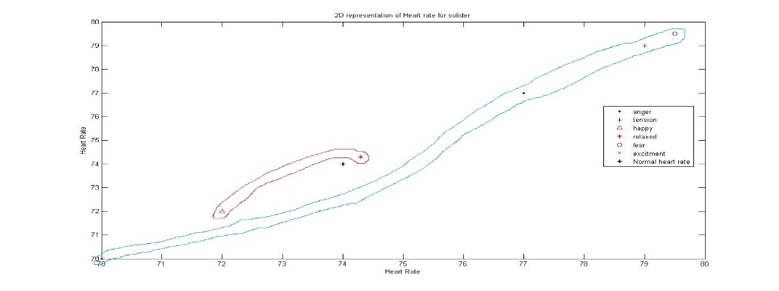
Fig 4. Variation of Heart Rate with emotion Age (46-55)
Age (56-60) : The age group of people between 56-60 has been identified and the six emotions, anger, tension, happy, relaxed, fear and excitement with the normal heart rate of the soldiers these are all listed in fifth column of table 2 and table 3 for male and female soldiers respectively. Happy emotion is expressed with a heart rate of 73 and the relaxed emotion is expressed with a heart rate of 74 beats. Tension lies between 73 and 74. The fear is expressed by a heart rate which is above 82 beats and anger is expressed by 81 whereas excitement is expressed by 80 beats. These are all shown in Figure 5.
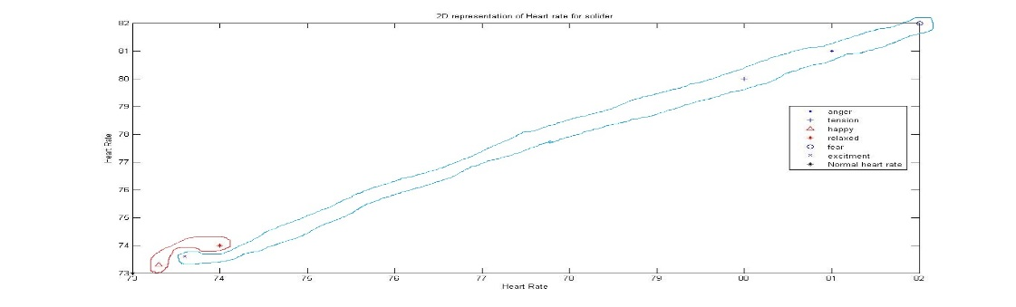
Fig 5. Variation of Heart Rate with emotion Age (56-60)

Table 2. Present the observed values of Heart Rate for Male
Soldier parameter analysis (MALE)
Heart Rate (bpm)
Age: | 22-35 | 36–45 | 46–55 | 56–60
Normal | 71-74 | 71-75 | 72-76 | 72-75
Anger | 73-76 | 75-77 | 75-80 | 78-84
Tension | 74-77 | 75-79 | 75-82 | 76-86
Happy | 66-70 | 67-72 | 69-73 | 70-76
Relaxed | 71-74 | 71-75 | 72-76 | 72-75
Fear | 74-77 | 75-79 | 76-82 | 79-86
Excited | 65-68 | 67-71 | 67-74 | 69-76

Table 3. Present the observed values of Heart Rate for Female
Soldier parameter analysis (FEMALE)
Heart Rate (bpm)
Age: | 22-35 | 36–45 | 46–55 | 56–60
Normal | 73-76 | 74-78 | 74-77 | 74-77
Anger | 73-78 | 75-80 | 78-84 | 79-86
Tension | 74-78 | 75-81 | 77-82 | 78-88
Happy | 68-72 | 70-75 | 73-77 | 75-78
Relaxed | 69-72 | 70-74 | 70-76 | 74-78
Fear | 73-78 | 75-80 | 77-84 | 80-88
Excited | 66-70 | 68-72 | 70-76 | 74-80
Diagrams of various state of soldiers grouped under 4 age groups to show the emotion with respect to the physiological parameters are exhibited using SVM.
- SKIN CONDUCTANCE
Age (22-35): The age group of people between 22-35 has been identified and the six emotions anger, tension, happy, relaxed, fear and excitement with the normal heart rate of the soldiers these are all listed in second column of table 4 and table 5 for male and female soldiers respectively. Happy emotion is expressed with a skin conductance rate of 3 and the relaxed emotion is expressed with a skin conductance rate of 2. Tension lies between 0.5 and 1. Fear is expressed by a skin conductance rate of 4 and excitement is between 4 and 4.5 and anger is expressed by a skin conductance rate less than 0.5 whereas normal skin conductance is between 0.5 and 1. These are all shown in Figure 6.
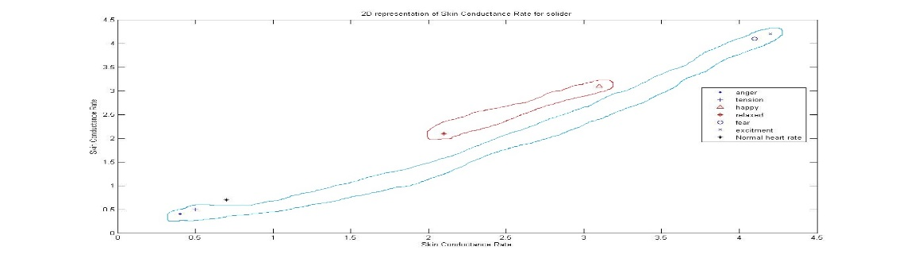
Fig 6. Variation of Skin Conductance with emotion Age (22-35)
Age (36-45): The age group of people between 36-45 has been identified and the six emotions anger, tension, happy, relaxed, fear and excitement with the normal heart rate of the soldiers, these are all listed in third column of table 4 and table 5 for male and female soldiers respectively. Happy emotion is expressed with a skin conductance rate of 3.5 and the relaxed emotion is expressed with a skin conductance rate of 2.5. Tension lies below 1. Fear is expressed by a skin conductance rate of 4.5 and excitement is expressed nearly at the value of 5 and anger is expressed by a skin conductance rate between 1 and1.5 whereas normal skin conductance is between 1.5 and 2. These are all shown in Figure 7.
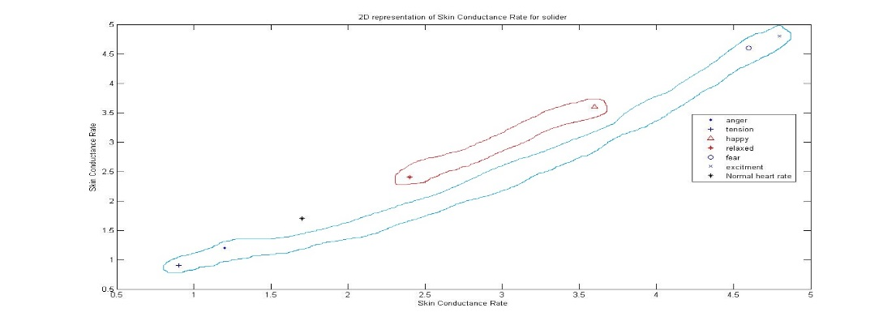
Fig 7. Variation of Skin Conductance with emotion Age (36-45)
Age (46-55): The six emotions anger, tension, happy, relaxed, fear and excitement with the normal heart rate of the soldiers is observed in the age group of 46-55, these are all listed in fourth column of table 4 and table 5 for male and female soldiers respectively. Happy emotion is expressed with a skin conductance rate between 4 and 4.5 and the relaxed emotion is expressed with a skin conductance rate of 3.Tension lies below 1.5. Fear is expressed by a skin conductance rate of 5.2 and excitement is expressed nearly at the value of 5.5 and anger is expressed by a skin conductance rate between 1.5 and 2 whereas normal skin conductance is between 2 and 2.5. These are all shown in Figure 8.
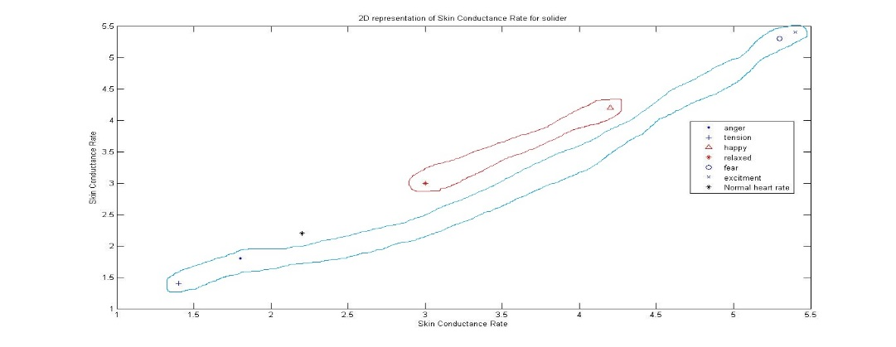
Fig 8. Variation of Skin Conductance with emotion Age (46-55)
Age (56-60): The age group of people between 56-60 has been identified and the six emotions anger, tension, happy, relaxed, fear and excitement with the normal heart rate of the soldiers, these are all listed in fifth column of table 4 and table 5 for male and female soldiers respectively. Happy emotion is expressed with a skin conductance rate between 4.5 and 5 the relaxed emotion is expressed with a skin conductance rate of 3.5. Tension lies below 2. Fear is expressed by a skin conductance rate of 5.5 and excitement is expressed nearly at the value of 5 and anger is expressed by a skin conductance rate between 2 and2.5 whereas normal skin conductance is between 3.5 and 4. These are all shown in Figure 9.
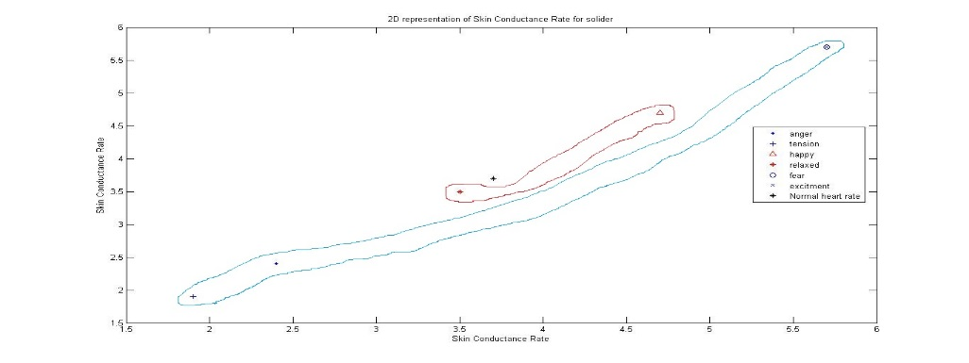
Fig 9. Variation of Skin Conductance with emotion Age (56-60)
Table 4. Present the observed values of Skin conductance for Male
Soldier parameter analysis (MALE)
Skin conductance (μSiemen)
Age: | 22-35 | 36–45 | 46–55 | 56–60
Normal | .02-1 | .5-5.5 | 1.6-3 | 2.5-5
Anger | .02-.5 | .3-1.5 | 1.2-2.4 | 1.8-3
Tension | .01-.8 | .6-1.2 | 1-1.8 | 1.5-2.2
Happy | 2.8-3.4 | 3.4-3.9 | 3.9-4.4 | 4.3-5.2
Relaxed | 1.8-2.4 | 2-2.8 | 2.6-3.4 | 3-4
Fear | 3.8-4.4 | 4.4-5 | 5-5.6 | 5.4-6
Excited | 4-4.7 | 4.6-5.2 | 5.2-5.7 | 5.6-6.2
Table 5. Present the observed values of Skin conductance for Female
Soldier parameter analysis (FEMALE)
Skin conductance (μSiemen)
Age: | 22-35 | 36–45 | 46–55 | 56–60
Normal | .02-1 | .5-5.5 | 1.6-3 | 2.5-5
Anger | .02-.5 | .3-1.5 | 1.2-2.4 | 1.8-3
Tension | .01-.8 | .6-1.2 | 1-1.8 | 1.5-2
Happy | 2.8-3.4 | 3.4-3.9 | 3.9-4.4 | 4.3-5
Relaxed | 1.8-2.4 | 2-2.8 | 2.6-3.4 | 3-4
Fear | 3.8-4.4 | 4.3-5.1 | 5-5.6 | 5.4-6
Excited | 4-4.7 | 4.6-5.2 | 5.2-5.7 | 5.6-6.2

- RESPIRATION RATE: Age (22-35)
The age group of people between 22-35 has been identified and the six emotions anger, tension, happy, relaxed, fear and excitement with the normal respiration rate of the soldiers, these are all listed in second column of table 6 and table 7 for male and female soldiers respectively. Happy emotion is expressed with a respiration rate between 10 and 12 the relaxed emotion is expressed with a respiration rate of 10. Tension lies below 8. Fear is expressed by a respiration rate of 17 and excitement is expressed nearly at the value of 8 and anger is expressed by respiration rate of 18 whereas normal respiration rate is 12, shown in Figure 10.
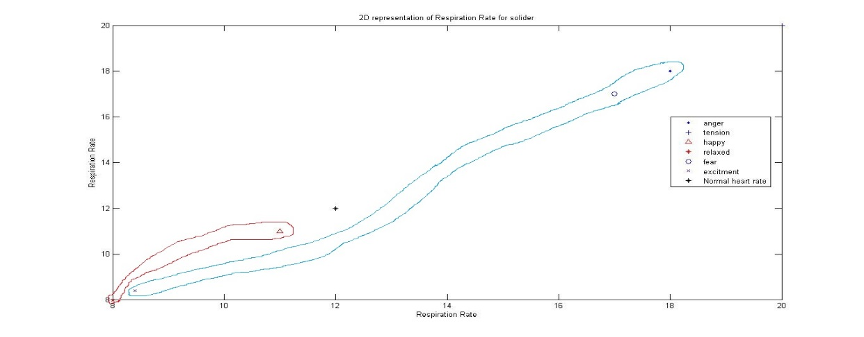
Fig 10. Variation of Respiration rate with emotion Age (22-35)
Age (36-45): The age group of people between 36-35 has been identified and the six emotions, anger, tension, happy, relaxed, fear and excitement with the normal respiration rate of the soldiers, these are all listed in third column of table 6 and table 7 for male and female soldiers respectively. Happy emotion is expressed with a respiration rate of 12 the relaxed emotion is expressed with a respiration rate of 9. The tension lies with a respiration rate of 21. The fear is expressed by a respiration rate of 19 and the excitement is expressed nearly at the value of 9 and anger is expressed by a respiration rate of 20 whereas the normal respiration rate is 14, shown in Figure 11.
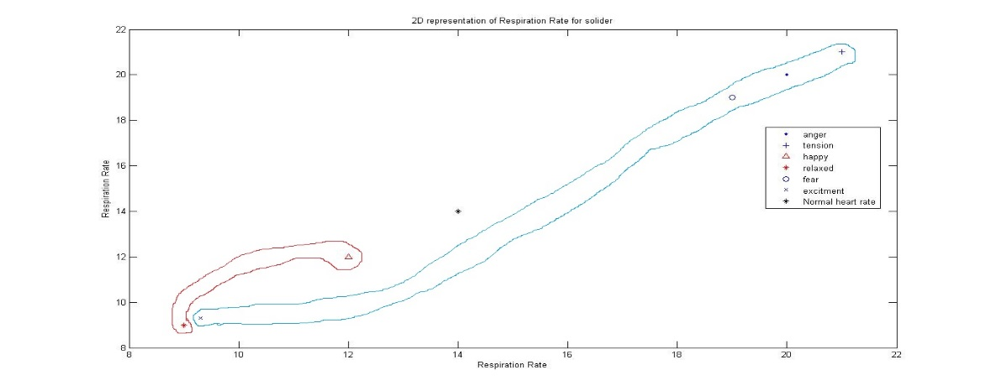
Fig 11. Variation of Respiration rate with emotion Age (36-45)
Age (46-55): The age group of people between 46-55 has been identified and the six emotions, anger, tension, happy, relaxed, fear and excitement with the normal respiration rate of the soldiers, these are all listed in fourth column of table 6 and table 7 for male and female soldiers respectively. Happy emotion is expressed with a respiration rate of 14 the relaxed emotion is expressed with a respiration rate of 9. The tension lies with a respiration rate of 23. The fear is expressed by a respiration rate of 20 and the excitement is expressed nearly at the value of 10 and anger is expressed by a respiration rate of 22 whereas the normal respiration rate is 17, shown in Figure 12.
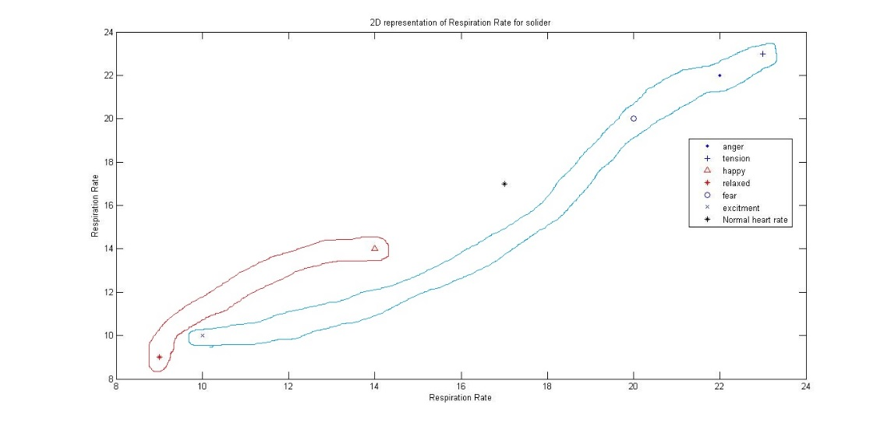
Fig 12. Variation of Respiration rate with emotion Age (46-55)
Age (56-60): The age group of people between 56-60 has been identified and the six emotions, anger, tension, happy, relaxed, fear and excitement with the normal respiration rate of the soldiers, these are all listed in fifth column of table 6 and table 7 for male and female soldiers respectively. Happy emotion is expressed with a respiration rate of 16 the relaxed emotion is expressed with a respiration rate of 9. The tension lies with a respiration rate of 24. The fear is expressed by a respiration rate of 20 and the excitement is expressed nearly at the value of 11 and anger is expressed by a respiration rate of 23.9 whereas the normal respiration rate is 18, shown in figure 13.
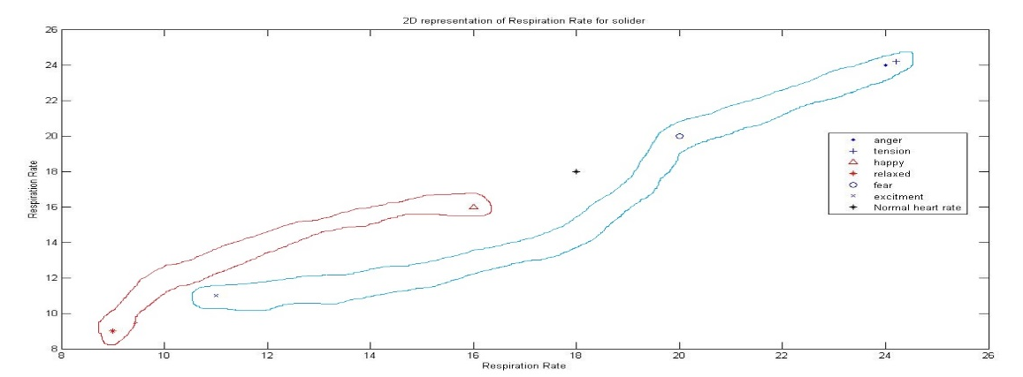
Fig 13. Variation of Respiration rate with emotion Age (56-60)
Table 6.Present the observed values of Respiration Rate for Male
Soldier parameter analysis (MALE)
Respiration Rate (Bpm)
Age: | 22-35 | 36–45 | 46–55 | 56–60
Normal | 11-14 | 13-16 | 15-18 | 16-20
Anger | 17-20 | 19-22 | 20-25 | 22-26
Tension | 19-21 | 20-23 | 22-25 | 22-26
Happy | 9-12 | 11-13 | 12-15 | 14-18
Relaxed | 7-10 | 8-10 | 8-10 | 8-11
Fear | 16-19 | 18-20 | 19-21 | 19-22
Excited | 7-9 | 8-10 | 8-12 | 9-13
Table 7.Present the observed values of Respiration Rate for Female
Soldier parameter analysis (FEMALE)
Respiration Rate (Bpm)
Age: | 22-35 | 36–45 | 46–55 | 56–60
Normal | 11-14 | 13-16 | 15-18 | 16-20
Anger | 17-20 | 19-22 | 20-25 | 22-26
Tension | 19-21 | 20-23 | 22-25 | 22-26
Happy | 9-12 | 11-13 | 12-15 | 14-18
Relaxed | 7-10 | 8-10 | 8-10 | 8-11
Fear | 16-19 | 18-20 | 19-21 | 19-22
Excited | 7-9 | 8-10 | 8-12 | 9-13
D.BLOOD PRESSURE
Age (22-35):The age group of people between 22-35 has been identified and the six emotions anger, tension, happy, relaxed, fear and excitement with the normal blood pressure rate of the soldiers, these are all listed in second column of table 8 and table 9 for male and female soldiers respectively. Happy emotion is expressed with a blood pressure range between 110-113/75-79 the relaxed emotion is expressed with a blood pressure rate of 110-114/75-79. Tension goes upper with122-128/60-67. Fear is expressed by a blood pressure range of 110-114/75-79 and excitement is expressed nearly at the range of 110-117/60-67 and anger is expressed nearly equal to normal 0range of 120-123/69-73 whereas normal blood pressure range is 120-122/79-81.
Age (36-45):The age group of people between 36-35 has been identified and the six emotions, anger, tension, happy, relaxed, fear and excitement with the normal blood pressure range of the soldiers, these are all listed in third column0 of table 8 and table 9 for male and female soldiers respectively. Happy emotion is expressed with a blood pressure range 0000of 111-117/79-83 the relaxed emotion is expressed with a blood pressure range of 115-119/77-83. The tension lies with a blood pressure range of 127-133/65-73. The fear is expressed by a blood pressure range of 129-137/75-81 and the excitement is expressed nearly at the value of fear as 117-121/65-71 and anger is expressed by a blood pressure range of 122-126/70-75 whereas the normal blood pressure range is 122-125/81-83.
Age (46-55):The age group of people between 46-55 has been identified and the six emotions, anger, tension, happy, relaxed, fear and excitement with the normal blood pressure range of the soldiers, these are all listed in fourth column of table 8 and table 9 for male and female soldiers respectively. Happy emotion is expressed with a blood pressure range of 114-119/83-88 the relaxed emotion is expressed with a pressure range of 117-121/80-87. The tension lies with a blood pressure range of 130-136/69-77. The fear is expressed by a blood pressure range of 133-141/77-83 and the excitement is expressed nearly at the value of 121-126/69-75 and anger is expressed by a pressure range of 124-127/72-77 near equivalent to the normal respiration rate which is, 125-130/83-86.
Age (56-60):The age group of people between 56-60 has been identified and the six emotions, anger, tension, happy, relaxed, fear and excitement with the normal blood pressure range of the soldiers, these are all listed in fifth column of table 8 and table 9 for male and female soldiers respectively. Happy emotion is expressed with a blood pressure range of 115-120/85-91 the relaxed emotion is expressed with a respiration rate of 120-125/83-90. The tension lies with a blood pressure range of 133-141/73-80. The fear is expressed by a pressure range of 140-147/81-85 and the excitement is expressed nearly at the value of 11 and anger is expressed by a blood pressure range of 140-147/81-85 whereas the normal blood pressure lies as 131-134/86-87.
Table 8. Observed values of blood pressure for male
Soldier parameter analysis (MALE)
Blood pressure (mmHg)
Age: | 22-35 | 36–45 | 46–55 | 56–60
Normal | 120-122/79-81 | 122-125/81-83 | 125-130/83-86 | 131-134/86-87
Anger | 120-123/69-73 | 122-126/70-75 | 124-127/72-77 | 127-131/75-82
Tension | 122-128/60-67 | 127-133/65-73 | 130-136/69-77 | 133-141/73-80
Happy | 110-113/75-79 | 111-117/79-83 | 114-119/83-88 | 115-120/85-91
Relaxed | 110-114/75-79 | 115-119/77-83 | 117-121/80-87 | 120-125/83-90
Fear | 120-131/70-77 | 129-137/75-81 | 133-141/77-83 | 140-147/81-85
Excited | 110-117/60-67 | 117-121/65-71 | 121-126/69-75 | 140-147/81-85
Table 9.Observed values of blood pressure for female
Soldier parameter analysis (FEMALE)
Blood pressure (mmHg)
Age: | 22 - 35 | 36–45 | 46–55 | 56–60
Normal | 120-122/79-81 | 122-125/81-83 | 125-130/83-86 | 131-134/86-87
Anger | 120-123/69-73 | 122-126/70-75 | 124-127/72-77 | 127-131/75-82
Tension | 122-128/60-67 | 127-133/65-73 | 130-136/69-77 | 133-141/73-80
Happy | 110-113/75-79 | 111-117/79-83 | 114-119/83-88 | 115-120/85-91
Relaxed | 110-114/75-79 | 115-119/77-83 | 117-121/80-87 | 120-125/83-90
Fear | 120-131/70-77 | 129-137/75-81 | 133-141/77-83 | 140-147/81-85
Excited | 110-117/60-67 | 117-121/65-71 | 121-126/69-75 | 140-147/81-85
E. TEMPERATURE: Six emotions, anger, tension, happy, relaxed, fear and excitement with the normal temperature of the soldiers. Happy emotion is expressed with a temperature of 98.5 and 99 the relaxed emotion is expressed with a temperature of 98.5. The tension lies with a temperature of nearly 99. The fear is expressed by a temperature of 98.5 and the excitement is expressed nearly at the value of 98 and anger is expressed by a temperature of 98.5 whereas normal temperature is 98.6, shown in Figure 14.
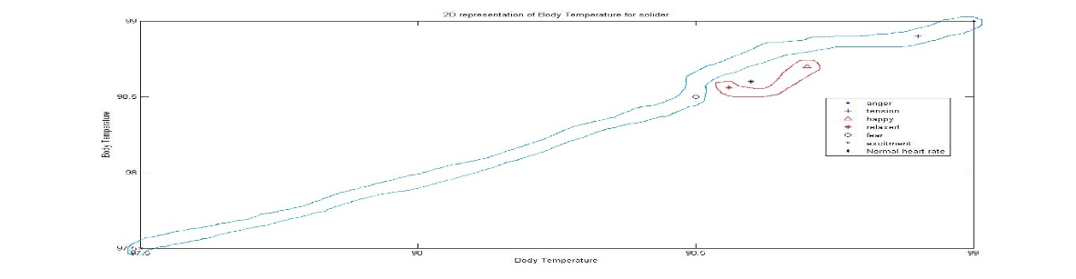
Fig 14. Variation of Temperature with emotion Age (22-35)
Table 10. Present the observed values of Temperature for male
Soldier parameter analysis (MALE)
Temperature (⁰F)
Age: | 22-35 | 36–45 | 46–55 | 56–60
Normal | 98.6 | 98.6 | 98.6 | 98.6
Anger | 98.6-99.4 | 98.6-99.4 | 98.6-99.4 | 98.6-99.4
Tension | 98-99.8 | 98-99.8 | 98-99.8 | 98-99.8
Happy | 98.4-99 | 98.4-99 | 98.4-99 | 98.4-99
Relaxed | 98.6 | 98.6 | 98.6 | 98.6
Fear | 98-99 | 98-99 | 98-99 | 98-99
Excited | 97-98 | 97-98 | 97-98 | 97-98
Table 11.Present the observed values of Temperature for female
Soldier parameter analysis (FEMALE)
Temperature (⁰F)
Age: | 22-35 | 36–45 | 46–55 | 56–60
Normal | 98.6 | 98.6 | 98.6 | 98.6
Anger | 98.6-99.4 | 98.6-99.4 | 98.6-99.4 | 98.6-99.4
Tension | 98-99.8 | 98-99.8 | 98-99.8 | 98-99.8
Happy | 98.4-99 | 98.4-99 | 98.4-99 | 98.4-99
Relaxed | 98.6 | 98.6 | 98.6 | 98.6
Fear | 98-99 | 98-99 | 98-99 | 98-99
Excited | 97-98 | 97-98 | 97-98 | 97-98

