FIGURES AND TABLES

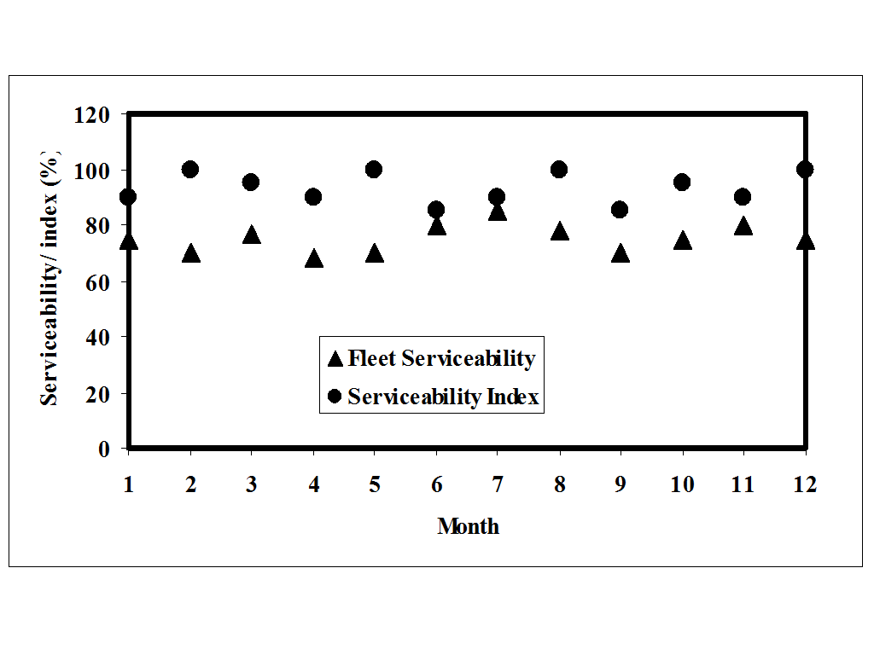

Figure 1: Variation of Fleet Serviceability and Serviceability Index

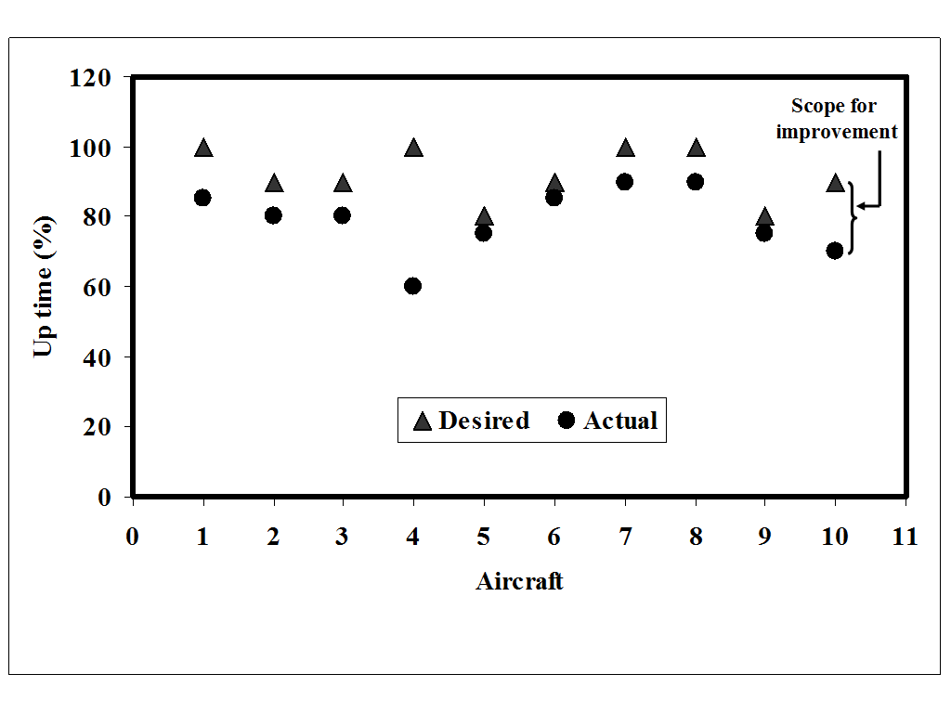

Figure 2: Variation of Desired and Actual Up time

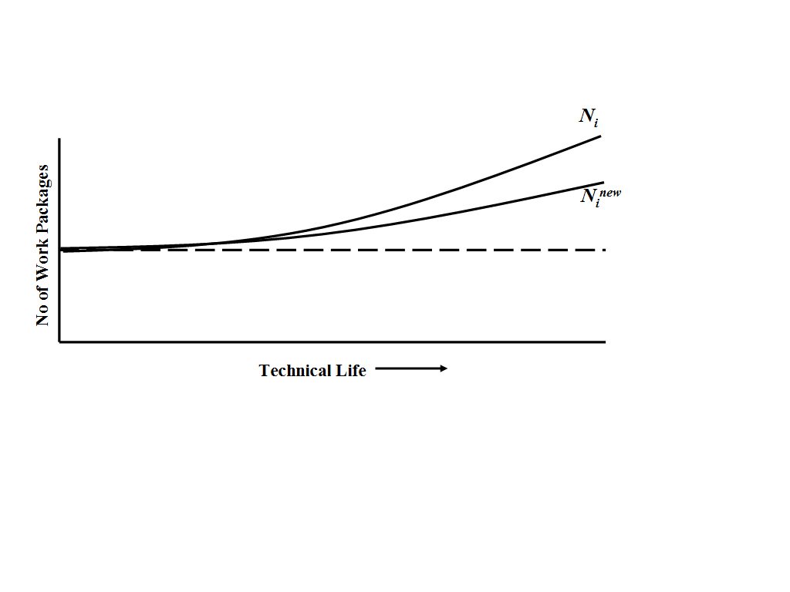

Figure 3. Variation of N_{i} and N_{i}^{new} with technical life

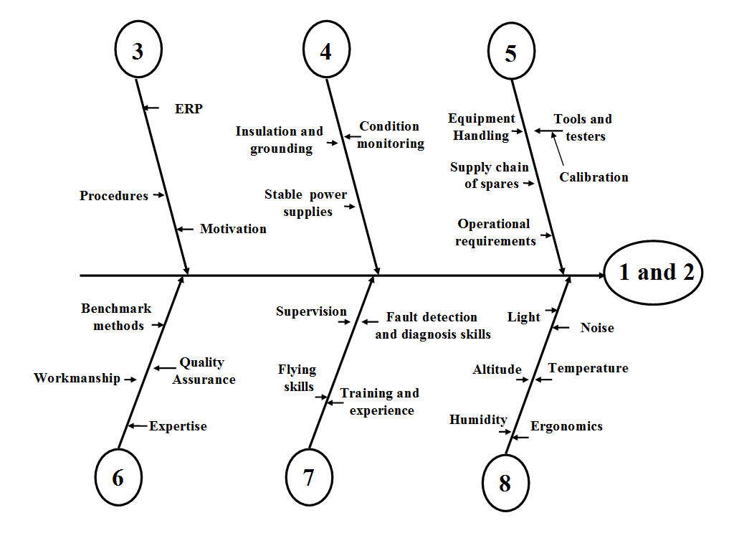

Figure 4. MPI ‘fish-bone’ diagram

Table 1: Validation remarks and system requirement

S No | Index |  | Remarks on data and results | Systems required  to be in place
1 | Serviceability index | I_{s} | Deterministic | Maintenance Control Centre (MCC) for critically monitoring each aircraft availability, utilization and stagger
2 | Equipment uptime | T_{up} | $t_{\text{up}}^{d}$is determined by normalized statistical data
3 | Time index | T_{i} | t^{d}_{i} is determined by normalized statistical data
4 | Index for breakdowns caused by poor preventive maintenance | I_{bd} | $t_{\text{bd}}^{p}$ can be considered during FMECA | Quality Assurance, FMECA and data analysis
5 | Work accomplishment index | W_{i} | Deterministic | Quality Assurance, FMECA and data analysis
6 | As good as new index | C_{new} | Deterministic | Quality Assurance, FMECA and data analysis
7 | Efficiency of fault diagnosis | η_{fd} | Non deterministic | Statistical and ERP data analysis
8 | Environmental condition index | I_{ec} | Deterministic | Environment condition monitoring

