
Daniel-Ioan Curiac received the M.S. degree in automation and computer engineering in 1990 and the Ph.D. degree in control system engineering in 1996, from the "Politehnica" University of Timisoara, Romania. Since 1990, he has been with the Automation and Applied Informatics Department at Politehnica University of Timisoara, where he is currently a professor and a doctoral supervisor in computer engineering. His scientific researches, evidenced by numerous journal and conference publications, cover a wide variety of scientific domains including intelligent control systems, applied artificial intelligence, chaotic systems and their applications to autonomous robots path planning, and unconventional methods for data security.

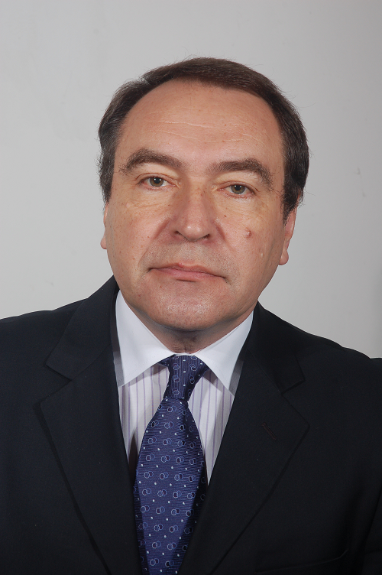
Constantin Volosencu received the licence degree in electrical engineering, specialty of automation and computer in 1981 and the Ph. D. degree in control system engineering in 2000, from the "Politehnica" University of Timisoara, Romania. Since 1990, he has been with the Automation and Applied Informatics Department at Politehnica University of Timisoara, where he is currently a professor and a doctoral supervisor in computer engineering. He is author of over 10 books, over 150 scientific papers, 27 patents, grant manager and plenary speaker at international conferences. Its research interest is in domains of: control systems, fuzzy logic, neural networks, control of electrical drives, distributed parameter systems, sensor networks.

