Self-affine Fractal Modeling of Aircraft Echoes from Low-resolution Radars

Li Qiusheng^{1*}, Pei Jihong² and Liu Xiaoyan
¹ School of Physics and Electronic Information, Gannan Normal University, Ganzhou-341000, China

² Intelligent Information Institute, Shenzhen University, Shenzhen-518060, China
*E-mail: bjliqiusheng@163.com
Abstract
As a kind of complex targets, the nonrigid vibration of an aircraft as well as its attitude change and the rotation of its rotating parts will induce complex nonlinear modulation on its echo from low-resolution radars. If one performs the fractal analysis of measures on an aircraft echo, it may offer a fine description of the dynamic characteristics which induce the echo structure. On basis of introducing self-affine fractal theory, the paper models real recorded aircraft echo data from a low-resolution radar using the self affine fractal representation, and investigates the application of echo self-affine fractal characteristics in aircraft target classification. The analysis results show that aircraft echoes from low-resolution radars can be modeled by using the self-affine fractal method, and the self-affine fractal features can be effectively applied to target classification and recognition.
Keywords: Low-resolution radar, self-affine fractal, echo modeling, target recognition

Introduction
Aircraft is a kind of nonrigid targets with complex shapes. The nonrigid vibration or attitude change of aircraft relative to the observation radar will induce complicated nonlinear modulations on the echo amplitude and its phase¹. In addition, the jet engine modulation (JEM) induced by the rotation of the aircraft rotating parts, such as the rotor, empennage, propeller, turbine fan, etc., is also a typical nonlinear modulation, which embodies in the echo characteristics, such as amplitude, phase, frequency, and polarization¹⁻³. These kinds of nonlinear modulations reflect the complicated micro-motion modulation effects of various parts of aircraft and contain target attribute information, such as the geometric structure, material composition, etc.⁴⁻⁵. Different types of aircraft targets generally have different structure and rotating parts, and often have different nonrigid vibration and JEM characteristics. So if these nonlinear modulation signatures which reflect the physical characteristics of an aircraft target can be extracted effectively, then one may apply them to target classification and recognition directly⁶⁻⁷.
So far, some scholars have proposed several theoretical models for aircraft echoes from low-resolution radars⁸⁻¹². However, due to the complexity of the nonlinear modulation induced by the nonrigid vibration or attitude change, most models have paid more attention to the modeling of the JEM echo section, and simplified the modeling of the airframe echo section; so in some cases they are unsatisfactory in analyzing the nonlinear modulation characteristics of aircraft echoes from low-resolution radars. In recent years, some fractal geometry methods, such as mono-fractal, fuzzy fractal, multifractal, etc., have been introduced into the characteristic analysis of aircraft echoes from low-resolution radars^{6-7, 13-15}. However, it has not been reported that self-affine fractal theory has been applied to the modeling of real-recorded aircraft echo data from low-resolution radars so far. Therefore, the paper plans to take self-affine fractal theory as the tool to model aircraft echoes from low-resolution radars. On basis of introducing self-affine fractal theory, the text models aircraft echoes from low-resolution radars by using the self-affine fractal representation method¹⁶, analyzes their self-affine fractal characteristics, and investigates the application of echo multifractal signatures in aircraft target classification.

The theoretical basis of self-affine fractal and its representation

2.1 The theoretical basis of self-affine fractal
Iterated Function System¹⁷ (IFS) theory is a powerful mathematical tool for the research of self-affine fractal, which is built on the basis of the compression mapping. Firstly, the definitions related to compression mapping are given as follows¹⁸.
Definition 1: Let be a metric space and be a mapping of. If there exists a positive constant, forming,, then is called a compression mapping, and c is its compression factor.
Definition 2: A hyperbolic IFS is composed of a complete metric space and a set of compression mapping with its compression factor ( ). The system can be expressed as , and its compression factor .
If a time series is known, then one can construct an IFS and make its attractor approximate a specified sequence to model the series. Research on the attractor is usually carried out in the Hausdorff metric space. One can map the series to the corresponding local through each of the self-affine transform of the IFS and piece these local fragments together, and then the error of the new series with the original series describes the degree of similarity between the attractor generated by the IFS and the original series. The smaller is the error, the higher is the degree of similarity between the two. For the error with the original series, the following collage theorem gives a metric method.
Collage theorem¹⁹: Let be a complete metric space, and the elements of the space consist of all non empty set of on X. If given L∈ and, one can select an IFS with its compression factor c (), making
                                                                      
then one can get, where A denotes the attractor of the IFS and is Hausdorff distance.

2.2 Representation of self-affine fractal
In the last section we described the theoretical basis of self-affine fractal for modeling a time series, below we further discuss the realization of self-affine fractal²⁰. Consider a linear affine mapping of point in the plane, defined as
, (2)
where a, c, d, e and f are the mapping parameters, t is the time, and x is the amplitude of the signal. The mapping in Equation (2) is called shear transformation; this is because it has different scaling in the horizontal and vertical direction. The parameter d is called the compression factor of the mapping, and. If the signal defined in the interval is self-affine and the corresponding endpoint values are and, then for the subinterval, there exists a linear mapping which maps the signal in to the signal fragment in [t_{p}, t_{q}]. In particular, andare mapped as x_{p} = x(t_{p}) and x_{q} = x(t_{q}), so
. (3)
According to equation (3), a, c, e and f can be calculated by the compression factor d and the corresponding boundary values, which can be expressed as
, (4)
, (5)
, (6)
. (7)
Assume that t₀ ≤ t_{p} ≤ t_{q} ≤ t_{f}, then the compression factor d can be obtained by the analytic technique given by Literature [20]. Obviously, the affine mapping is completely determined by the compression factor d and the subinterval boundary condition. In practice, the signal is often a discrete time series. When compresses the whole series to a series subset according to the proportion, the number of sampling points will not be consistent before and after mapping. If assuming that the discrete series is and is the subinterval of, i.e., , where p, q and N are all positive integers, then is an approximate affine mapping, viz.
(8)
with p ≤ m ≤ q. Here, the symbol denotes the image of x_{n} in the m position. Attention is required, here m is not necessarily an integer. The optimal compression factor d for the mapping should make the mean square error (MSE) between the mapping value and the measured value smallest, and the error function²¹ is
. (9)
Obviously, in the subinterval, the mapping points is N, while the measuring point has only q - p + 1. In Equation (9), denotes the average value of all , where $\text{round}(m)=k$ ($\text{round}(⋅)$represents the nearest integer). The method is used to overcome the inconsistency of the sampling points before and after mapping. The minimum variance estimator for the compression factor d is²⁰
, (10)
with
, (11)
and
. (12)

Self-affine fractal modeling of aircraft echoes

3.1 Self-affine modeling of a signal
Consider a discrete time series, which can be divided into M overlapping subintervals with δ and φ as their sizes, there into, δ denotes the number of points in the subinterval, and φ denotes the overlapping points of two adjacent subintervals. Due to self-similarity, each subinterval is the replication of the whole series by shrinking proportionally and rotating corresponding to the compression factor. Segmenting data according to this method, we can get M contraction factors . The evolution process of the contraction factor can be modeled as a P-th order AR process²¹, i.e.
, (13)
where is the noise term and are AR model coefficients. P can be selected by Akaike’s Information Criterion (AIC) ²². Then the (M+1)-th contraction factor can be estimated as
. (14)
As can be known from Equations (4) ~ (7), the mapping is completely determined by the two boundary values and the contraction factor. The estimator of d_{M+1} can be obtained by Equation (14). Because the data overlap, the right boundary can be estimated by the minimum mean square error between the estimation value and the actual value of the overlapping part of the (M+1)-th subinterval. And then it can be used to predict the values of.

3.2 Echo modeling results based on self-affine fractal
The echo data used in the text are recorded from a surveillance radar, and they are from two different types of aircraft targets with the one fighter aircraft and the other civil aircraft. There into, the radar operates in the VHF band with its PRF 100 Hz and pulse width 25 μs, and the flight attitude of both types of aircraft targets contains two kinds: towards the radar station and off the radar station. Fig. 1 (a) and (b) show the self-affine fractal modeling results of a group of a normalized echo data from both types of aircraft targets when fly off the radar station. Among them, the echo data points N equals to 1024, the number of points in a subinterval δ equals to 32, and the number of overlapping data points φ equal to δ/2. Fig. 2 presents the relationship curves of the mean square modeling error E_{x} of these two groups of echo data with δ, and the number of overlapping data points φ are also δ/2.
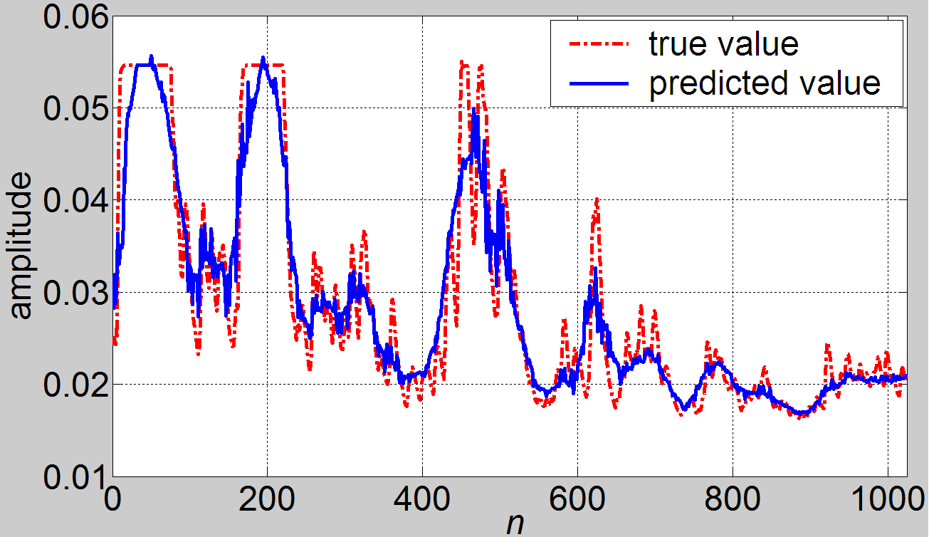
(a) Civil aircraft
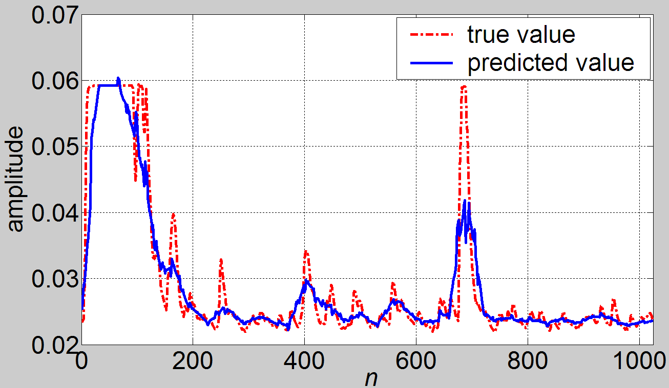
(b) Fighter aircraft
Figure 1. Self-affine fractal modeling of echo data from two types of aircraft targets
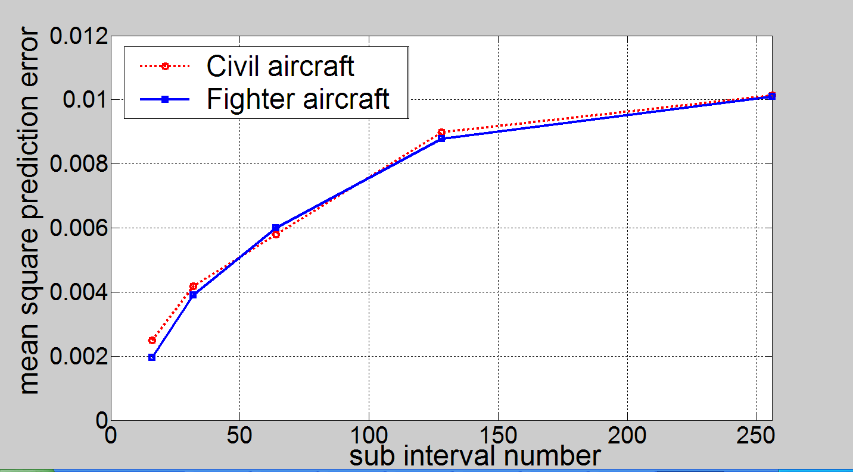
Figure 2. The relationship curves of the mean square modeling error E_{x} with the number of points in a subinterval δ
It can be seen from Fig. 1, the self-affine fractal model can track the change trend of echo data from the two types of aircraft targets effectively, and therefore it can model them effectively. As can be seen from Fig. 2, the mean square modeling errors of echo data from the two types of aircraft targets increase with the increase of δ, but with the further increase of δ, both them grow more and more slowly and gradually stabilize. Comprehensively considering the factors such as computation, 128 is selected as the number of points in a subinterval, i.e., δ = 128, and φ is still taken as δ/2.
Fig. 3 shows the distributing circumstances of the 2-D signatures composed of the mean square modeling error E_{x} and the model order P of the AR process of the contraction factor d of echo data from both types of aircraft targets, with “☆” and “o” denoting the fighter aircraft and the civil aircraft respectively. Among them, the group numbers of echo data from both types of aircraft are all 2560, with the echo group numbers for each flight attitude 1280. It can be seen from the figure, although there are some overlaps between the 2-D signatures of both types of aircraft targets, as a whole, the signatures belonging to different types of aircraft separate from each other distinctly. Therefore, if combining the two characteristic parameters together to identify different types of aircraft targets, it is hopeful to obtain a better performance.
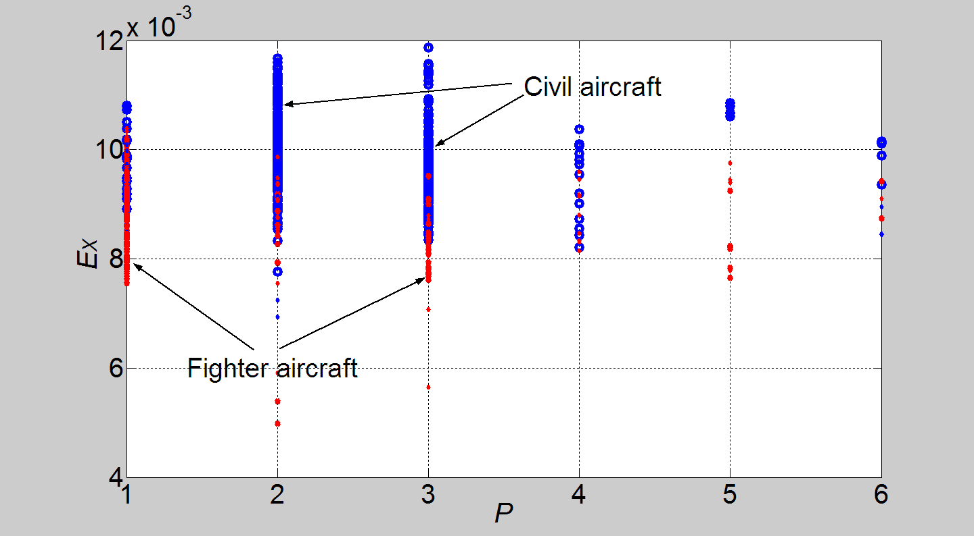
Figure 3. Distributing circumstances of 2-D signatures composed of E_{x} and P of echo data from both types of aircraft

Aircraft target classification based on self-affine fractal signatures
The previous section shows that the self-affine fractal method can model an aircraft echo from low-resolution radar effectively. As pointed out in the introduction, echo data from different types of aircraft targets often have different nonlinear characteristics, and thus they certainly will appear different self-affine fractal signatures. Therefore, it provides a probability for aircraft target classification and recognition with low-resolution radars. Based on the foregoing real recorded aircraft echo data, below the paper will investigate the application of self-affine fractal signatures in aircraft target classification with low-resolution radars.
Due to complexities of the actual target state and the environment, the target attitude, distance, background, etc. often change, which makes the raw target echo data can not be directly used for feature analysis and extraction, and therefore one must do some data preprocessing to reduce the influence of these factors. Here the following two kinds of preprocessing will mainly be done: one is attitude partition, the other is energy normalization. The specific method can be found in Literature 23.
Based on the difference between the distributing circumstances of the 2-D signatures of echo data from both types of aircraft targets shown by Fig. 3, here E_{x} and P are chosen as the characteristic parameters for target classification. Compared to other classifiers, support vector machine (SVM) has stronger generalization abilities and a faster convergence rate²⁴, so in the experiment SVM using the Gaussian kernel function is taken as the classifier, and the kernel function parameters are selected rationally without going beyond the calculation burden.
Tab. 1 shows the classification results of the two types of aircraft targets, and as a contrast, the results using the raw echo data without performing any preprocessing are also presented. Among them, the group numbers of echo data from both types of aircraft targets are the same as those in Fig. 3, and for each type of aircraft targets, the signature data extracted from 512 groups of echo data are chosen as training samples (the group numbers for each of the two flight attitudes useful for classification are 256), with the rest signature data as testing samples. As can be seen from Tab. 1, the average correct classification rate (CCR) is more than 91 percent, and the data preprocessing obtains a classification gain more than two percentage points. Therefore the classification effect is satisfactory. What should be pointed out is that the signature dimension reduction processing has been done in the classification experiment. If the whole signatures such as the AR model parameters of the contraction factor d are made full use of, the average CCR could still have an increase to a certain extent.
Table 1. Classification results
 | Using raw echo data | Using preprocessed echo data
Fighter aircraft | 86.86% | 91.77%
Civil aircraft | 90.89% | 90.48%
Average CCR | 88.77% | 91.11%

Conclusions
Based on the complex nonlinear modulation characteristics induced by the nonrigid vibration and attitude change of aircraft targets along with the JEM effect, the paper models aircraft echoes from low-resolution radars from the viewpoint of self-affine fractal. On basis of introducing self-affine fractal theory, it models the real recorded aircraft echo data from low-resolution radars by using the self-affine fractal representation, and investigates the application of aircraft echo self-affine fractal signatures in target classification with low-resolution radars. The experimental results show that:
- It is an effective method to model aircraft echoes from low-resolution radar using a self-affine fractal model;
- If one performs the self-affine fractal analysis of measures on an aircraft echo, it is hopeful to reveal its internal dynamics evolution mechanism;
- Self-affine fractal characteristic parameters of aircraft echoes can be used as effective signatures for aircraft target classification with low-resolution radars.

Acknowledgements
Firstly, we’d like to thank Professor Huang Jianjun at Shenzhen University for offering the experiment data and many useful discussions about target classification and recognition with radars. Secondly, we wish to thank the National Natural Science Foundation of China (Grant: 61331021, 61271107) and the Research Fund for the Science & Technology of Education Department of Jiangxi province (Grant: GJJ14658). Finally, we also wish to thank the anonymous reviewers for their help in improving this paper.

References
- Huang, P. K.; Yin, H. C. & Xu, X. J.. Radar Target Characteristics. Publishing House of Electronic Industry, Beijing, 2005.
- Nalecz, M., Andrianik, R. R. & Wojtkiewicz A. Micro-Doppler analysis of signal received by FMCW radar. Proceedings of International Radar Symposium, 2003, 231-235.
- Ding, J. J. & Zhang, X. D.. Automatic classification of aircraft based on modulation features. Journal of Tsinghua University (Science & Technology), 2003, 43(7), 887-890.
- Chen, V. C. ; Li, F. Y., Ho, S. S. & et al. Micro-Doppler effect in radar: phenomenon, model, and simulation study. IEEE Trans. AES, 2006, 42(1), 2-21.
- Zhuang, Z. W., Liu, Y. X. & Li X. The achievements of target characteristic with micro-motion. Acta Electronica Sinica, 2007, 35(3), 520-525.
- Li, Q. S., Xie, W. X. & Luo C. Identification of aircraft targets based on multifractal spectrum features. Proceedings of IEEE International Conference on Signal Processing, 2012, 1821-1824.
- Li, Q. S. & Xie, W. X. Target classification with low-resolution surveillance radars based on multifractal features. Progress In Electromagnetics Research B, 2012, 45, 291-308.
- Martin, J., & Mulgrew, B. Analysis of the effects of blade pitch on the radar return signal from rotating aircraft blades. Proceedings of IET International Conference on Radar, 1992, 446-449.
- Bell, M. R. & Grubbs, R. A. JEM modeling and measurement for radar target identification. IEEE Trans. AES, 1993, 29(1), 73-87.
- Pizza, E. Radar signals analysis and modellization in the presence of JEM application in the civilian ATC radars. IEEE AES Magazine, 1999, 14(1), 35-40.
- Ding, J. J., Zhang, X. D. & Lv J. J. Modeling of the modulation signature for aircraft returns in the conventional radar. Systems Engineering and Electronics, 2003, 25(11), 1407- 1410.
- Chen, F.; Liu, H. W.; Du, L.; & et al. Target classification with low-resolution radar based on dispersion situations of eigenvalue spectra. Science China: Information Sciences, 2010, 53, 1446-1460.
- Ni, J.; Zhang, S. Y.; Miao, H. F. & et al. Target classification of low-resolution radar based on fractional Brown feature. Modern Radar, 2011, 33(6), 46-48.
- Li Q. S. & Xie, W. X. Classification of aircraft targets with surveillance radars based on fuzzy fractal features. Progress In Electromagnetics Research M, 2013, 29, 65-77.
- Li Q. S., Xie W. X. Multifractal Modeling of Aircraft Echoes from low-resolution Radars based on Structural Functions [J]. Defence Science Journal, 2013, 63(5): 515-520.
- Guan, J; Liu, N. B. ; Huang, Y. & et al. Fractal Theory for Radar Target Detection as well as its Application. Publishing House of Electronics Industry, Beiijng, 2011.
- Xie, H. P. & Xue, X. Q. The mathematical basis and method of fractal application. Science Press, Beijing, 1997.
- Shi, B.; Wang, X. P. & Gai, M. J. The introduction and application of functional analysis. National Defence Industry Press, Beijing, 2009.
- Packard, N. H.; Crutchfield J. P. & Farmer J. D. Geometry from a time series[J]. Physica Review Letters, 1980, 45(9): 712-716.
- Mazel, D. S. & Hayes, M. H. Using iterated function systems to model discrete sequences [J]. IEEE Transactions on Signal Processing, 1992, 40(7): 1724-1734.
- Zhou, Y. F.; Yip P. C. & Leung H. On the efficient prediction of fractal signals [J]. IEEE Transactions on Signal Processing, 1997, 45(7): 1865-1868.
- Bozdogan, H. Model selection and Akaike's Information Criterion (AIC): The general theory and its analytical extensions [J]. Psychometrika, 1987, 52(3): 345-370.
- Li, Q. S. & Xie W. X. Multifractal Modeling of Aircraft Echoes from low-resolution Radars based on Structural Functions [J]. Defence Science Journal, 2013, 63(5): 515-520.
- Duda, R. O., Hart, P. E. & Stork, D. G. Pattern Classification. 2nd ed. John Wiley and Sons, New York, 2001.

The separate list of figure captions:
Figure 1 Self-affine fractal modeling of echo data from two types of aircraft targets
Figure 2 The relationship curves of the mean square modeling error E_{x} with the number of points in a subinterval δ
Figure 3 Distributing circumstances of 2-D signatures composed of E_{x} and P of echo data from both types of aircraft

Brief biodata:
 Mr. Q. S. Li was born in Ganzhou (Jiangxi), China, on July 6, 1976. He received the bachelor degree in automatic control in 1998 from Tongji University, Shanghai, China, the master degree in signal and information processing in 2004 from Beihang University, Beijing, China, and the Ph. D. degree in signal and information processing in 2013 from Shenzhen University, Shenzhen, China. Now he is with the school of physics and electronic information, Gannan Normal University, Ganzhou, China. His fields of interests include: Intelligent information processing, automatic target recognition and tracking.

