The identification of damages parameters of cantilever based analysis of the features of its own forms of flexural vibrations in the analytical modeling
A.V.Cherpakov¹, A.N.Soloviev^{1,2,3}, V.V.Gricenko², O.U.Goncharov⁴
¹ Southern Federal University, Rostov-on-Don, Russia
² Don State Technical University, Rostov-on-Don, Russia
³ Southern Scientific Center of Russian Academy of Sciences, Rostov-on-Don, Russia
⁴ North Caucasus Federal University, Pyatigorsk, Russia
e-mail: alex837@yandex.ru

Annotation: the article describes the approach to the identification of damages parameters in beam structures based on the analysis of the shape parameter fluctuations. The novelty of the approach lies in the fact that the identification procedure is divided into two stages: Stage 1 is defined by the location of the damage, and the second - the value of the damage. An example of the construction damage parameters depending on its magnitude in a cantilever beam-based analytical modeling.
Keywords: cantilever, the identification of damages, flexural vibration waveform, the location of the damage, the size of the damage, the curvature of the waveform.

1. INTRODUCTION
One of the main tasks of monitoring and evaluation of buildings and structures, as well as their individual components is to define the parameters of damages and stress state.
Solving the problem of identification of damage in rods, beams and more complex structures involving many papers of such scientists as A.P.Bovsunovskii, A.O.Vatulyan, V.V.Matveev, V.A.Postnov, A.D.Dimaragonas, M.I.Friswell, M.F.Dado, Omar A. Shpli and many other researchers. The analysis of these studies is described in reviews [1-9].
In most of these studies investigating problems of parameter identification of damages and their location in the structural elements have been conducted using a variety of analytical and finite element models [10], combined c using artificial neural networks [11-12], as well as the base of field experiments using a strain gauge, optical and vibrodiagnostic techniques [13-14].
In [8, 9], there are several different algorithms for solving the problems based on the influence of damages parameters to change the natural oscillation frequencies, modal characteristics of the waveforms, dynamic calculations on compliance and damping matrices of the damaged structures. The difference between the latter algorithm is in contrast to the expressions for the objective functions and the scheme used for optimization. In some algorithms for solving the problems of identification of damage based on the change in the shape of various oscillation modes used warranty modal criterion (the modal assurance criterion - MAC) [9].
Analysis of different approaches to solving the problems of identification of damages shows that the study of the parameters causes significant damage, including computational difficulties [7]. In this connection, selects the most simple and simultaneously, reliable diagnostic identification tag based on the method of free oscillations of [10], based on an analysis of the frequency characteristics. In this method for the synthesis of natural frequencies and mode shapes of the system given by the eigenfunctions of subsystems can be used for theoretical justification of monitoring structures in parts by measuring its vibrations in the form of a linear combination of the responses of the system to test the impact [15].

2.RESEARCH OBJECTIVES

Modeling of damage identification parameters of the cantilever based on the analysis of the shape parameter of the transverse oscillations.

As an example the identification of damages in the core design based on analytical modeling [10].

3.SIMULATION OBJECT

Simulation object was cantilever rod (length$L$ = 250 mm, height of the cross section of $h=$8 mm, $a=$4 mm thick) with a damage (the cross cut width 1 mm, and the absolute depth of $h_{d}=$4 mm) arranged in spaced apart from the pinch point of the rod distance ${\bar{L}}_{d}$= 0.25 where, ${\bar{L}}_{d}={L_{d}}/L$, $L_{d}$- location of the damage. Next, we introduce the dimensionless coordinate $\bar{x}=x/L$. The relative depth of the damage taken as $\bar{t}={h_{d}}/h$. Rod model had a damage with the following values:

$\bar{t}$ = 0; 0.25; 0.5; 0.75; 0.85. We consider the transverse vibrations of the rod.

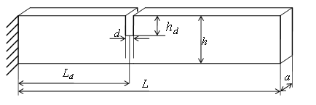
Fig. 1. Scheme of the cantilever with the location of the damage

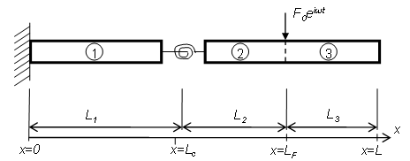
Fig. 2. Model of a cantilever beam with an elastic element

4.Modeling.
In the analytical modeling, consider the differential equation of forced oscillations in the model of the Euler-Bernoulli:
$\frac{∂^{2}}{∂x^{2}}\left[\text{EJ}(x)\frac{∂^{2}u_{i}}{∂x}\right]−m(x)\frac{∂^{2}u_{i}}{∂t^{2}}+F(t)δ(x−L_{F})+p(x,t)=0$, (1)
where $u_{i}\left(x,t\right), i=1, 2, 3$- the displacement of the beam axis of the points where the subscript indicates the number of area of the beam, as shown in Fig. 1; $J\left(x\right)$- modulus of elasticity; $m\left(x\right)$- the moment of inertia; $F(t)δ(x−L_{F})$- linear density; - the force applied at the point $L_{F}$; $p\left(x,t\right)$- distributed load.

Boundary conditions for the composite rod construction are of the form:

$\text{at} x=0:$$u_{1}(0)= u_{1^{′}}(0)=0;$
$\begin{aligned}\text{at} x=L_{c}: u_{1}(L_{c})=u_{2}(L_{c}); \\ u_{1^{″}}(L_{c})=u_{2^{″}}(L_{c}); \\ u_{1^{\text{'''}}}(L_{c})=u_{2^{\text{'''}}}(L_{c}); \\ −\text{EJ}⋅ u_{1^{″}}(L_{c})=K_{t}[u_{1^{′}}(L_{c})−u_{2^{′}}(L_{c})];\end{aligned}$ (2)$\begin{aligned}\text{at} x=L_{F}: u_{2}(L_{F})=u_{3}(L_{F}); \\ u_{2^{'}}(L_{F})=u_{3^{'}}(L_{F}); u_{2^{\text{''}}}(L_{F})=u_{3^{\text{''}}}(L_{F}); \\ u_{2^{\text{'''}}}(L_{F})−u_{3^{\text{'''}}}(L_{F})={F_{0}}/{\text{EJ}} ;\end{aligned}$
$\text{at} x=L:$$u_{3^{″}}(L)= u_{3^{\text{'''}}}(L)=0;$
where $K$ - stiffness of the elastic element.
To determine the relationship between the magnitude of damage to full-bodied FE model and the stiffness of the elastic element analytical model was obtained by the relation [10]:
$\bar{t}=1\text{.}\text{186} − 0\text{.}\text{135} K_{t^{0\text{.}\text{23}}}$. (3)
Counting results by applying the expression (1), the value of flexural rigidity of the elastic element to the analytical model shown in Table 1. To determine the natural modes at different values of stiffness of the elastic element and its location ${\bar{L}}_{с}$= 0.25 based on analytical modeling of the package have been computed natural frequencies (Table 1).
Table 1
Natural frequencies $ω_{i}$ (Hz) of the cantilever at different values of the stiffness $K_{t}$ of the elastic element and its location ${\bar{L}}_{с}$= 0.25
$$K_{t}$$ | Natural frequencies $ω_{i}$ (Hz)
$$K_{t}$$ | $$ω_{1}$$ | $$ω_{2}$$ | $$ω_{3}$$ | $$ω_{4}$$
12684 | 107.8 | 676 | 1892 | 3709
4531 | 105.1 | 675.9 | 1856 | 3633
1173 | 98.1 | 674 | 1772 | 3486
163 | 67,9 | 667 | 1533 | 3216
52 | 44,9 | 664 | 1440 | 3147

Solved the problem of the natural vibrations of the cantilever. Get the shape of the cantilever when different stiffness of the damage. Figure 3 shows the normalized eigenmodes of the rod at different values of the damage
Analysis charts waveforms shows that the damage in the place has a characteristic pronounced "kink" in varying degrees depending on the size of the damage. As the exponential characteristic of a damage in a cantilever beam can be used at an angle $α$ formed by the tangent to the curve shape of the oscillations.
The parameter of the angle $α$ between the tangents at the points of waveform can be calculated using the discrete approach associated with the process of measuring the amplitudes of the oscillations in a finite number of points. Figure. 4 shows a diagram of the location of points on the curve section waveforms:

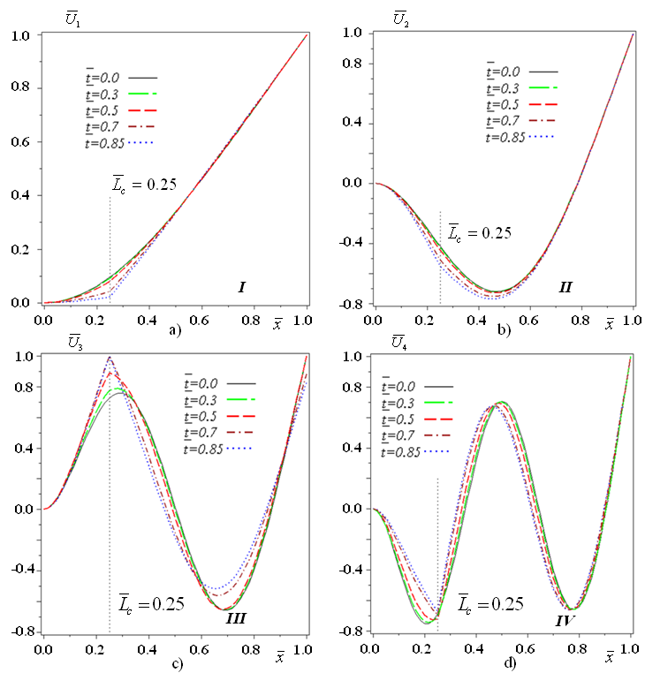
Fig. 3. The normalized values of the transverse displacement of the cantilever with the damage of various size for the first four transverse modes of vibration. Accordingly, the oscillation modes: a) 1; b) 2; c) 3; d) 4
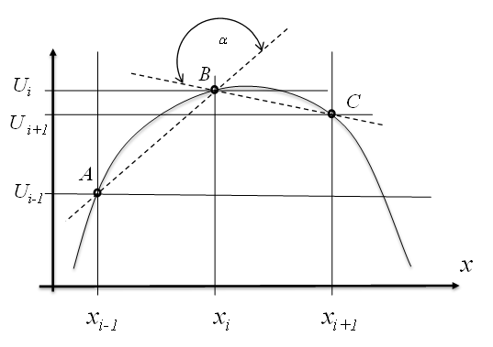
Fig. 4. Arrangement of points in the calculation of the parameter of the angle $α$between the tangent
Figure 4 shows: $U_{i}$ - displacement of natural modes in the $i$-th point of the rod; $х_{i}$- coordinate of the point with the number $i$, $i∈1\text{.}\text{.}N$, $N$- the total number of points.

In the presence of discrete information about the shape of the oscillation in the angle point №$i$of the corresponding vibration mode can be calculated as follows:
$α_{i}=\text{arccos}\left(\frac{(\overline{\text{AB}})(\overline{\text{BC}})}{\left\|\overline{\text{AB}}\right\|\left\|\overline{\text{BC}}\right\|}\right)$, (4)
where $\overline{\text{AB}} ∧ \overline{\text{BC}}$- the vector representation of the two segments, respectively, between the points of the normalized waveform numbers $[i−1 , i]$ and $[i , i+1]$.
The curvature of the waveform can be considered as an additional feature that allows to specify the parameters of the damage.
When using discrete measurements, taking into account the curvature of the small oscillations in the №$i$ point of the rod can be calculated by the following expression:
$U_{i}^{''}=\frac{U_{i−1}−2U_{i}+U_{i+1}}{{Δx}^{2}}$, (5)
where $Δx$- the distance between the points of measurement.
Upon receipt and processing of the data collection necessary for the organization of the oscillation amplitudes of the vectors waveforms at various frequencies. This requires a normalization of the data on the amplitudes to the interval [0,1]. Each point of the waveform amplitude readings normalized to the maximum value of deflection:
${\bar{U}}_{i}=\frac{U_{i}}{\left|U_{\text{max}}\right|}$, (6)
where ${\bar{U}}_{i}$- the normalized magnitude of the displacement in the $i$ point of the rod; $U_{\text{max}}$ - the value of the maximum deviation of points waveforms.
The curvature at the point $i$ when the normalized amplitude of the waveform will be calculated as:
${\bar{U}}_{i}^{\text{\} \} = \{ \{ \{ bar \{U\}\} rSub \{ size 8\{i - 1\} \} - 2 \{ bar \{U\}\} rSub \{ size 8\{i\} \} + \{ bar \{U\}\} rSub \{ size 8\{i+1\} \} \} over \{Δx rSup \{ size 8\{2\} \} \} \} \} \{}}$. (7)
The values of curvature at different points of the expression (5) and the angles between the tangents at various points along the length of the cantilever by the expression (4). The magnitude of the discrete segment $Δx$ assumed $1/{\text{60}}$to be equal to the length of the cantilever. Graphs of curvature at different points of waveforms shown in Fig. 5, the angles between the tangents in the various points of the curve waveform shown in Fig. 6.
Analysis parameters waveforms shows that the injury site has a characteristic pronounced "kink" in varying degrees depending on the size of the damage. In the analysis of the graphs of curvature and angle between the tangents at the location of the damage has outliers "kink ".
To assess the influence on cut depth variation of the amplitude, waveform curvature and the angle in the "kink" zone, were considered the relative values of these parameters from different rigidity values of the elastic element at its location.
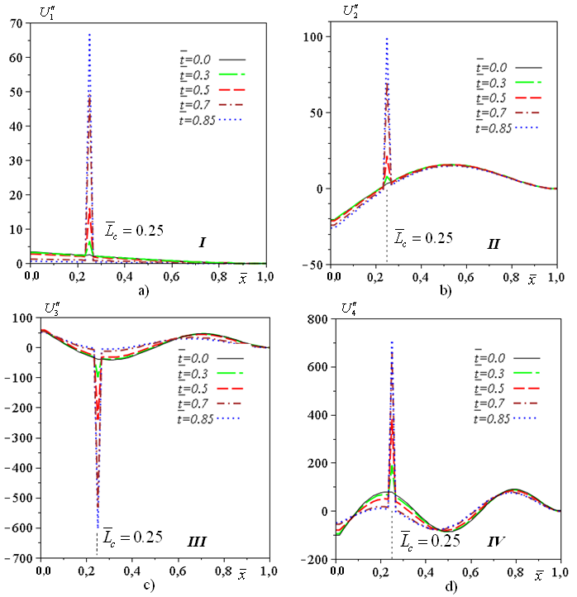
Fig. 5. The curvature of the graph of the first four forms of the transverse oscillations of the cantilever with the damage of various size.
Accordingly, the oscillation modes: a) 1; b) 2; c) 3; d) 4

For this case the location of the elastic element relative magnitude of the changes of the normalized amplitude is calculated as follows:
$Δ{\bar{U}}_{i}=\frac{\left|{\bar{U}}_{i }^{d}−{\bar{U}}_{i}^{0}\right|}{{\bar{U}}_{i}^{0}}\text{100}\text{\%}$, (8)
where ${\bar{U}}_{i }^{d} ∧ {\bar{U}}_{i}^{0}$ - the normalized amplitude of the curve shape oscillations of an elastic rod in the i-th point along the length of the rod when it is damaged and intact, respectively.

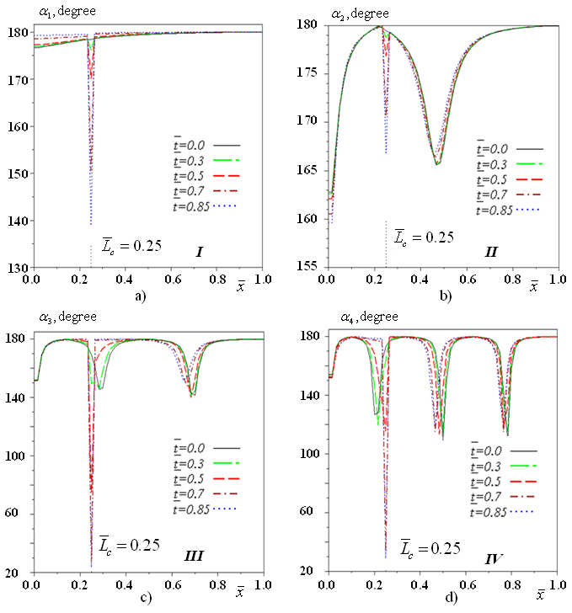
Fig. 6. The angles between the tangents to the waveforms at various points of the cantilever with the damage of various sizes.
Accordingly, the oscillation modes: a) 1; b) 2; c) 3; d) 4

Values of the transverse displacement for various oscillation modes and their relative values at a location of damage are shown in Table 2.
For comparison, the curvature of the waveforms in this cases the location of the elastic element addressed by the following expression:
${\bar{U}}_{i^{″}}=\left|{\bar{U}}_{\text{id} }^{''}\right|$, (9)
where ${\bar{U}}_{\text{id} }^{''}$ - the curvatures waveforms in $i$th point along the length of the rod
The curvatures ${\bar{U}}^{''}$ waveform at a location of the damage are presented in Table 3.

Table 2
The value of the transverse displacements $\bar{U}$ and their relative values$Δ\bar{U}$ at a point to the location of the damage for different oscillation modes, depending on the stiffness of the cantilever
$$K_{t}$$ | $$\bar{t}$$ | 1 mode |  | 2 mode |  | 3 mode |  | 4 mode
$$K_{t}$$ | $$\bar{t}$$ | $$\bar{U}$$ | $Δ\bar{U}$,% | $$\bar{U}$$ | $Δ\bar{U}$,% | $$\bar{U}$$ | $Δ\bar{U}$, % | $$\bar{U}$$ | $Δ\bar{U}$,%
1 | 2 | 3 | 4 | 5 | 6 | 7 | 8 | 9 | 10
12684 | 0 | 0.097 | 0.0 | -0.417 | 0.0 | 0.727 | 0.0 | -0.686 | 0.00
4531 | 0.25 | 0.093 | 4.1 | -0.424 | 1.7 | 0.774 | 6.5 | -0.703 | 2.48
1173 | 0.50 | 0.081 | 16.5 | -0.444 | 6.5 | 0.889 | 22.3 | -0.723 | 5.39
163 | 0.75 | 0.0431 | 55.6 | -0.51 | 22.3 | 1 | 37.6 | -0.695 | 1.31
52 | 0.85 | 0.022 | 77.3 | -0.551 | 32.1 | 1 | 37.6 | -0.67 | 2.33

Table 3
Curvatures $U^{''}$ waveform at a damage location to various modes in dependence on the stiffness $K_{t}$of the cantilever
$$K_{t}$$ | $$\bar{t}$$ | 1 mode | 2 mode | 3 mode | 4 mode
$$K_{t}$$ | $$\bar{t}$$ | $${\bar{U}}^{''}$$ | $${\bar{U}}^{''}$$ | $${\bar{U}}^{''}$$ | $${\bar{U}}^{''}$$
1 | 2 | 3 | 4 | 5 | 6
12684 | 0 | 2.5 | 3.2 | 38.8 | 80.8
4531 | 0.25 | 6.4 | 8.2 | 97.7 | 187
1173 | 0.50 | 15.9 | 21.1 | 237 | 381
163 | 0.75 | 49.3 | 70.3 | 529 | 660
52 | 0.85 | 66.6 | 98.8 | 602 | 713

The relative magnitude of changes in the angle $α$ between the tangent at the point waveform in this case the location of the elastic element is calculated as follows:
${Δα}_{i}=\frac{α_{i }^{d}−α_{i}^{0}}{α_{i}^{0}}\text{100}\text{\%}$ , (8)
где $α_{i }^{d} и α_{i}^{0}$- углы в $i$-й точке формы колебаний стержня при наличии дефекта и в неповрежденном состоянии соответственно.
where $α_{i }^{d} ∧ α_{i}^{0}$- the corners in $i$th point waveforms rod in the presence of the damage and intact, respectively.
Angles "kink" waveforms and their relative quantities for the points to the location of the damage are presented in Table 4.
Table 4
The angles $α$ between the tangent to the graph of the waveforms at the point of location of the damage and their relative values $Δα$ depending on the stiffness $K_{t}$ for different modes of vibrations
$$K_{t}$$ | $$\bar{t}$$ | 1 mode |  | 2 mode |  | 3 mode |  | 4 mode
$$K_{t}$$ | $$\bar{t}$$ | $$α$$ | $Δα$,% | $$α$$ | $Δα$,% | $$α$$ | $Δα$, % | $$α$$ | $Δα$,%
1 | 2 | 3 | 4 | 5 | 6 | 7 | 8 | 9 | 10
12684 | 0 | 178.4 | 0.0 | 179.5 | 0.0 | 169.1 | 0.0 | 173.3 | 0.0
4531 | 0.25 | 176.1 | -1.3 | 178.8 | -0.4 | 149.3 | -11.7 | 163.3 | -5.8
1173 | 0.50 | 170.1 | -4.7 | 176.9 | -1.4 | 74.5 | -55.9 | 115.8 | -33.2
163 | 0.75 | 150.4 | -15.7 | 170.6 | -5.0 | 27.2 | -83.9 | 34.2 | -80.3
52 | 0.85 | 138.7 | -22.3 | 166.7 | -7.1 | 23.3 | -86.2 | 28.6 | -83.5

5. ANALYSIS
Analysis of the graphs of waveforms, angles at points between the tangent and curvature shows that the location of the elastic element ${\bar{L}}_{с}$=0.25 relative variation of displacement compared with intact waveforms model is when the value of damage $\bar{t}$=0.75 for the 1st oscillation modes $Δ\bar{U}$=55.6%, for the 2nd oscillation modes $Δ\bar{U}$=22.3%, for the 3rd oscillation modes $Δ\bar{U}$=37.6%, for the 4th oscillation modes $Δ\bar{U}$=1.31%. For the value of the angle $α$ between the tangent at points along the length of the rod to the schedule of waveforms changes the corresponding coefficients at the same location of the elastic element are: for the 1st oscillation modes $Δα$=15.7%for the 2nd oscillation modes $Δα$=5%, for the 3rd oscillation modes $Δα$=83.9%, for the 4th oscillation modes $Δα$=83.5%. For values of curvature waveforms location ${\bar{L}}_{с}$=0.25 and the size of damage $\bar{t}$=0.75 for different modes of oscillation: for the 1st oscillation modes ${\bar{U}}^{''}$=49.3 , for the 2nd oscillation modes ${\bar{U}}^{''}$=70.3 , for the 3rd oscillation modes ${\bar{U}}^{''}$=529 , 4-th oscillation modes ${\bar{U}}^{''}$=660 .
The dependency analysis of the relative magnitude of the transverse displacement and the magnitude of damage at the point of location for different modes of vibrations shows that this dependence is well manifested in this case the location of the damage for the 1st, 2nd and 3rd modes and less sensitive at the 4th oscillation modes.
Analysis of the relative magnitude of the curvature mode shapes at the point of location of the damage from its size for different modes of oscillation shows that all the graphics are monotonically increasing. This dependence in this case the location of the damage is well shown for the 1st and 2nd modes, 3rd and 4th modes slightly less sensitive to the magnitude of the damage.
Analysis of the dependences of the relative change value of angle "kink" mode shapes between the tangent at the point of location of the damage from its size for different modes of oscillation shows that all the graphics are monotonically decreasing in varying degrees. In this case the location of the damage, this dependence is well manifested in its dimensions $\bar{t}>0\text{.}3$ to the 3rd and 4th modes of oscillation, and is not pronounced for the 1-St and 2-nd.
Analysis of the characteristics of mode shapes of a cantilever with damage shows the following:
- graphics mode shapes have a point "kinks" in the location of the damage. If the location of the damage (elastic element) is localized in the zone of inflection of the curve of the waveform or in its surroundings, the "kinks" curve mode shapes are poorly identified, and thus this fashion will be weakly sensitive to the identification of the location of the damage in design.
- parameters of the angle $α$ at points between the tangent and curvature ${\bar{U}}^{''}$ mode shapes are more sensitive compared with the amplitude $\bar{U}$ of the oscillations to identify the location of the damage.

6.CONCLUSION
1. Studies of the characteristics of the waveforms in the process to identify the parameters of the damages show that the features found in the form of "kinks" and local extrema of the angle $α$ between the tangent and curvature $U^{''}$ on the forms of the different modes of Flexural vibrations, which coincides with the coordinate location of the damage in the cantilever, can serve as one of the diagnostic characteristics identification of the damage and identify its location.
2. The angle $α$ between the tangent and curvature $U^{''}$ mode shapes of the first 4 modes in the point damage location can serve as a diagnostic sign of identification of its size.

ACKNOWLEDGEMENT
The present study was carried out with the partial support of RFBR (grants No 14-38-50933 mol_nr, No 13-08-00516-A, No 14-38-50915 mol_nr)
REFERENCES
- Vatulyan A.O. Inverse problems in the mechanics of a deformable rigid body, M .: Fizmatlit, 2007.- 224 p.
- Farrar C. R., Hemez F. M., Shunk D. D., Stinemates D. W., Nadler B. R. and Czarnecki J. J., A review of structural health monitoring literature: 1996-2001, Los Alamos National Laboratory Report, LA-13976-MS. 2004.
- Dimarogonas A.D. Vibration of cracked structures: a state of the art review. Eng. Fract.Mech. 1996. 55, p.p.831–857. (doi:10.1016/0013-7944(94)00175-8).
- Friswell M.I. Damage identification using inverse methods// Phil. Trans. R. Soc. A (2007) 365, p.p. 393–410. (doi:10.1098/rsta.2006.1930.).
- Mohammad H.F. Dado, Omar A. Shpli. Crack parameter estimation in structures using finite element modeling // Intern. Journ. Solid and Structures. 2003,v.40, p.p. 5389-5406.
- Bovsunovskii, A.P., Bovsunovskii, O.A // Diagnostics of closing cracks in rodlike elements at nonlinear resonances by the method of variation of the asymmetry of driving forces. Strength of Materials Volume 42, Issue 4, July 2010, p.p. 397-405
- Postnov, V.A. Use of Tikhonov's regularization method for solving identification problem for elastic systems. // Mechanics of Solids Volume 45, Issue 1, March. 2010. p.p. 51-56
- Rizos P.F., Aspragathos N. and Dimarogonas A.D. Identification of crack location and magnitude in a cantilever beam from the vibration modes. //Journal of sound and vibration, 1990.v.138, pp.381-388.
- Bamnios Y., Douka E. and Trochidis. Crack identification in beam structures using mechanical impedance// J. of Sound and Vibration. 2002. v. 256(2), p.p. 287-297.
- Analytical and finite element analysis of vibration parameters in terminal damage [Text]// V. A., Akopian, A. V. Cherpakov, A. N. Soloviev and others, Izvestiya vuzov North Caucasus region. Technical science. - 2010. No.5. – p.p.21-28.
- Krasnoshchekov A. A., Sobol B. V., Solov’ev A. N., and Cherpakov A. V. // Identification of Crack Like Defects in Elastic Structural Elements on the Basis of Evolution Algorithms. ISSN 1061_8309, Russian Journal of Nondestructive Testing, 2011, Vol. 47, No. 6, p.p. 412–419.
- Panigrahi, S. K., Chakraverty, S., and Mishra, B. K. Vibrationbased damage detection in a uniform strength beam using genetic algorithm. //Meccanica, 2009. 44(6), p.p.697–710.
- Akopyan, V. Parameter Estimation of Pre-Destruction State of the Steel Frame Construction Using Vibrodiagnostic Methods [Text]/ V. Akopyan, A. Soloviev, A. Cherpakov //Mechanical Vibrations: Types, Testing and Analysis. - N-Y.: Nova Science Publishers, 2010. - Chapter 4. – p.p.147-161.
- V. A. Akopyan, A. N. Solov’ev, A. V. Cherpakov, and S. N. Shevtsov// On a Deformation Sign for Identifying Defects on the Basis of the Analysis of the Forms of the Natural Vibrations of a Cantilever with a Notch // Russian Journal of Nondestructive Testing, 2013, Vol. 49, No. 10, p.p. 579–583.
- V.N. Voronkov. The method of solving eigenvalue problems for complex linear systems // Mechanics of Solids. № 4. 2005. p.p. 178 - 187.

CONTRIBUTORS

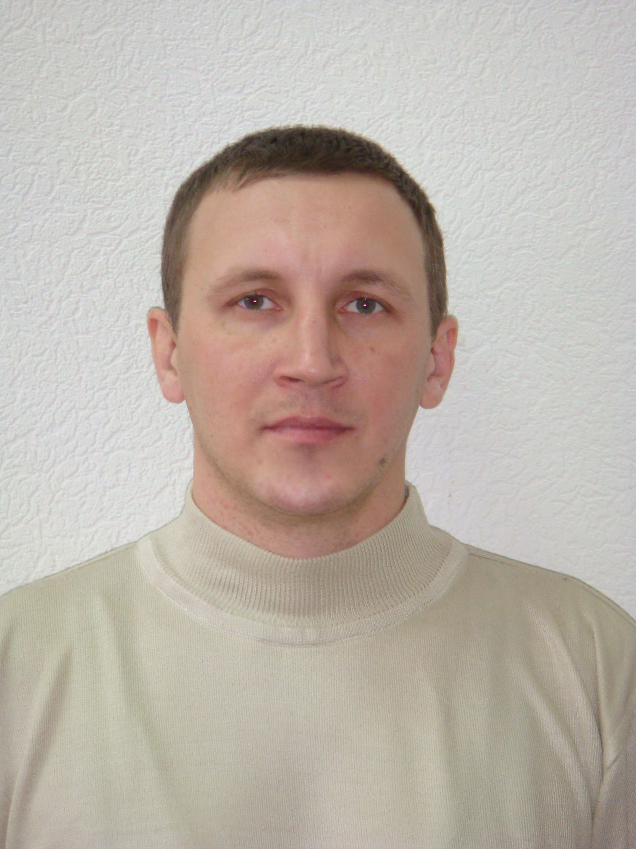 | Cherpakov Alexander Vladimirovich. Ph.D., researcher associate Scientifically Research Institute of Mechanics and Applied Mathematics Southern Federal University, Rostov-on-Don, Rostov region, Russia. alex837@yandex.ru. His areas of interest include modeling, structural dynamics, programming, creation of systems of identification of defects. |  | Soloviev Arkady Nikolaevich, Doctor of Physical and Mathematical Sciences. Don State Technical University, Rostov-on-Don, Rostov region, Russia. Proff. Of Chief. Professor. Southern Federal University, Rostov-on-Don, Russia. Proff. Of Southern Scientific Center of Russian Academy of Sciences, Rostov-on-Don, Russia. His areas of interest include modeling of various physical processes, the dynamics electroelasticity, wave processes in the body.
 | Vadim Gritsenko. graduate student. Don State Technical University. Rostov-on-Don, Rostov region, Russia.His areas of interest include modeling of technical systems. | 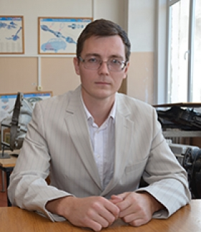 | Oleg Goncharov. Senior Lecturer, Department of vehicles and processes. North Caucasian Federal University of Pyatigorsk, Russia. His areas of interest include modeling of technical systems.

