Brief Biodata
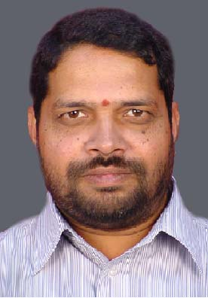 | Mr. S. Krishnamachary presently working as a scientist at Propellant and Polymer Division of Directorate of Propulsion, Defence Research and Development, Hyderabad. He has completed his MSc chemistry from Sri Krishna Devaraya University, Anantapur, Andhra Pradesh. His area of expertise is development of liquid propellants for rockets, liquid fuels for ramjets, and thermal protection systems for rocket applications. His contributions includes development of liquid high density hydrocarbon fuels, Mixed oxides of nitrogen (MON-10) for low freezing applications and silicone based low density ablative material for external thermal protection. He is pursuing for his doctorate from DIAT, Pune.
 | Dr. S.G Kulkarni is working as Visiting Professor at Defence Institute of Advanced Technology, Pune (India). He has vast experience of teaching at post graduate level and guided several M.Tech and PhD theses. He has published a number of research papers in national and international journals of repute and attended seminars / symposia / conferences and presented papers. His areas of interest include High energy materials, Detonics, NBC warfares, Energetic polymers and Nanocomposites. He has delivered a number of invited lectures at various universities, research establishments and ordnance factories in the country.
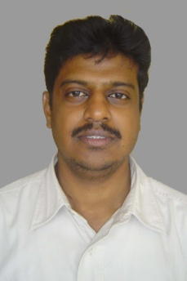 | Dr. S. Krishna Mohan presently working as a scientist at Propellant and Polymer Division of Directorate of Propulsion, Defence Research and Development, Hyderabad. He obtained his PhD in organic chemistry from Indian institute of chemical technology, Hyderabad. He has received prestigious fellowships from Japan science and technology, Japan society of promotion of science and Swiss postdoctoral research. He has filed 02 world patents, 06 Indian patents, published over 40 peer reviewed international journal papers and 01 book. His current research interests include development of polymer matrix composites for air frames, ablative materials for thermal protection systems and liquid propellants for rocket and ramjet applications.
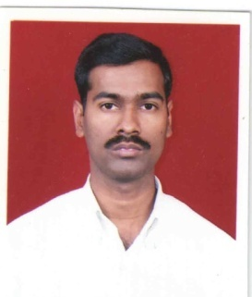 | Dr. D. Jayaraman Completed his M.Sc from School of Chemical Sciences, Pondicherry University. He obtained his Ph.D from Indian Institute of Technology, Bombay. He joined DRDL (DRDO), Hyderabad at Propellants and Polymer Division under Directorate of Propulsion in the year 2005. Presently he is working as Scientist-‘D’. His areas of research include synthesis, characterization and performance evaluation of high density hydrocarbon fuels for SCRAMJET and LFRJ application and materials for thermal protection of rocket motor.
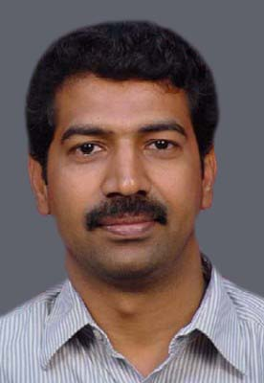 | M. Raghavendra Rao is currently working as scientist ‘F’ and is the head of Liquid Propulsion Division in Defence Research and Development Laboratory, Hyderabad. He has received his BE in Mechanical Engineering from National Institute of Technology Bhopal and ME in Aerospace engineering from Anna University, Chennai. He is the designer and system manager for ‘Reaction control Systems’ (RCS) of all the AGNI missile variants. He has more than 20 years of experience in design and developments of various sub systems for RCS and Velocity Trimming Package (VTP).
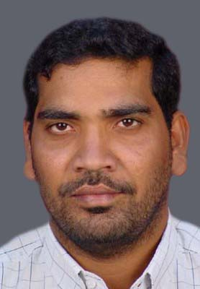 | L. Dev Singh is currently working as scientist ‘D’ in Liquid Propulsion Division of Defence Research and Development Laboratory, Hyderabad. He has received his BE in Mechanical Engineering and ME in Production Engineering from Osmania University, Hyderabad. He has 10 years of experience in production management in BDL and is presently the in-charge of the Liquid rocket engines’ static testing facility in DRDL.
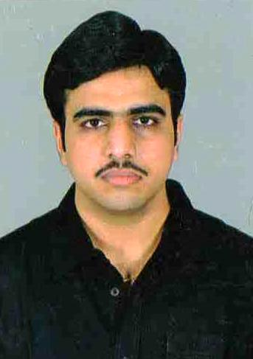 | G. Sai Krishna Prasad is currently working as scientist ‘C’ in Liquid Propulsion Division of Defence Research and Development Laboratory, Hyderabad. He has received his BTECH and MTECH degrees in Aerospace Engineering from Indian Institute of Technology Madras. His research areas are design of liquid propulsion systems & development of pulse detonation engine technology.

