Design and Analysis of Slit-Cut Stacked Equilateral Triangular Microstrip Patch Antenna
Prabal Pratap¹, Dr.R.S.Bhatia², Dr.Binod Kumar³, Mohd.Nazir^{4 ,} Saurabh Pratap⁵
1, 2 Electrical Engg Deptt, National Institute of Technology, Kurukshetra, Haryana, INDIA
3,4 Electronics Engg Deptt, Ambedkar Institute of Technology, Delhi, INDIA
5 Industrial & Systems Engineering, Indian Institute of Technology, Kharagpur, INDIA

Abstract:
In this paper, a novel structure of slit-cut Stacked Equilateral Triangular Microstrip Antenna (ETMA) has been theoretically studied using cavity model and found in agreement with the Stimulated Result calculated by High Frequency Simulator Structure (HFSS). The analysis of stacked ETMA and slit-cut ETMA is done. The theoretical and simulated result of stacked ETMA and slit-cut ETMA are presented and compared. The main concentration is to find the different results i.e. input impedance, VSWR, and Return loss of the Slit cut Stacked ETMA.
Keywords: Microstrip antenna, Bandwidth, Resonant frequency
- INTRODUCTION
Microstrip antennas (MSAs) has vast applications in missiles, secure cryptographic communication system, mobile, satellite communication system to biomedical equipment, because of its conformability, simple in use, low production rate, light weight and ease in manufacture and amalgamation with microwave components. These smart and beneficial qualities have raised the usage of Microstrip antennas (MSAs) and simulated superior work to explore their performance. Microstrip antennas (MSAs) shape may vary; it may be of any geometrical shape [1-3].
For miniaturization of size of patch, an equilateral triangular microstrip patch antenna is preferred. It has similar radiation properties with rectangular patch antenna. For design of periodic arrays, radiating elements are organized in such a way to lessen ominously connection between end-to-end elements of the array, this will help in design of antenna array. In equilateral triangular microstrip patch antenna designs, important is to calculate the resonant frequencies of the microstrip antenna precisely because microstrip patch antennas have narrow bandwidths which can only activate successfully in the locale of the resonant frequency.
In this paper author, discuss the stacked equilateral triangular microstrip patch antenna analysis, slit-cut equilateral triangular microstrip antenna analysis and slit-cut stacked equilateral triangular microstrip antenna analysis. Variation of input impedance vs. frequency is shown. Theoretical and simulated result was shown.
- Theoretical Considerations
- Stacked Equilateral triangular Microstrip Antenna Analysis
Upper Equilateral Triangular patch
Lower Equilateral Triangular Patch
Coaxial Cable
Ground Plane

Fig. 1 (a) Stacked Equilateral triangular microstrip Antenna

The geometry of Stacked ETMA is shown in Fig. 1(a) in which Upper Equilateral triangular patch (UETP) fed by coaxial cable. Lower Equilateral triangular patch (LETP) is analysed as Equilateral triangular patch antenna with superstrate and deserting the effect of upper patch. By changing the effective side of LETP, dielectric layer above radiating patch disrupts the fringing fields. Height of dielectric substrate h₁ and dielectric superstrate h₂ are same i.e. h₁=h₂=0.159cm as shown in figure 1(b).

h₁
Ground Plane
ETMA
Dielectric Substrate
Superstate
h₂

Fig. 1(b) Equilateral triangular patch antenna covered with a dielectric superstrate: a cross-sectional view.
The effective dielectric constant of equivalent substrate is given as
$\begin{aligned}ε_{r_{\text{eff}}}=ε_{r1}p_{1}+ε_{r1}(1−p_{1})^{2}×[ε_{{r2}^{2}}p_{2}p_{3}+ε_{r2} \\ \end{aligned}$ (1)

Where
(2) (3)
(4)
(5)
(6)
(7)
(8)
(9)
By choosing a suitable thickness, the surface waves are concentrated to an assured level, when the relative dielectric constant of superstrate is greater than substrate.
(10)
Currently effective side of LETP is calculated as
(11)
LETP’s input impedance is calculated as
$Z\text{in}1=\frac{1}{\left\{\left(\frac{1}{R1}\right)+({jωC}_{1})+\left(\frac{1}{{jωL}_{1}}\right)\right\}}$ (12)

The resonance resistance R₁ of LETP
$R=\frac{S}{Tωpδk}$ (13)
The inductance $L$can be given as:
$L=\frac{S}{Tωpμ\text{εω}}$ (14)
The conductance $C$can be given as:
$C=\frac{Tωpμε}{S}$ (15)
Where

$T=\left(ω−ω\right)με+δk$ (16)
$S=\left(ωpδk\right)+\left(ωpμε\left(ω−ω\right)\right)$ (17)

The UETP is examined like an uncovered microstrip patch antenna as it is driven element. By the change of diameter in UETP, the resonant frequency of LETP rests unaffected. For two different fringing field cavities, their effective side is different even though when there physical side is same. Therefore, the expectation is of two resonant frequencies. With the thickness as h₂ and dielectric constant as ε_{r2} of single patch antenna, the analysis of upper patch is performed. Reverse current induced at lower patch hence acts as ground plane. Due to its finite size, the current gets reflected from the edges of the lower patch, this shows ground plane is not finite which is considered in calculation.
The input impedance of upper cavity for UETP is calculated as
$Z\text{in}2=\frac{1}{\left\{\left(\frac{1}{R2}\right)+({jωC}_{2})+\left(\frac{1}{{jωL}_{2}}\right)\right\}}$ (18)

In the above expression resistance R₂, capacitance C₂ and inductance L₂ are equivalent components of circuit for Equilateral triangular patch antenna expressed as parallel combination for TM_{mn mode}.
The resonance resistance (R₂) of UETP is expressed by
$R=\frac{S}{Tωpδk}$ (19)
The inductance $L$can be given as:
$L=\frac{S}{Tωpμ\text{εω}}$ (20)
The conductance $C$can be given as:
$C=\frac{Tωpμε}{S}$ (21)
There is no variation of electric field in z direction so total electric field is sum of the electric fields in LETP and UETP [9]. Likewise, LETP is signified as parallel combination of a resistance (R₁), an inductance (L₁) and a capacitance (C₁).
$Z_{\text{in}}=Z_{\text{in}1}+Z_{\text{in}2}$ (22)
- Slit Cut Equilateral triangular Analysis
Suitable slots are embedded in the ETMA, the bandwidth should be enhanced with reduced antenna size. Here embedding a pair of slot of proper dimensions i.e. slit-cut, the first broadside radiations modes of ETMA can be disturbed such that their resonant frequencies are lowered and close to each other to form a wide impedance bandwidth. This also can lower the fundamental resonant frequency by winding the excited patch surface current path in the antenna’s radiating patch.
Coaxial Cable
Ground Plane
Equilateral triangular Patch

Fig. 2 (a) Slit-cut Equilateral triangular microstrip Antenna

_{c}
_{b}

Fig. 2 (a) Top view of Equilateral triangular microstrip Antenna with pair of slits

The dual frequencies of proposed design can be deduced by replacing the slit cut ETMA by two equivalent ETMA patches of perimeter P1 and P2. The slit cut ETMA fed by a coaxial probe is shown in Figure 2(a). The perimeter of P1 is the total perimeter of the ETMA patch with slot and its corresponding resonance frequency would be fr1, the lower resonance frequency of the proposed design. Similarly the perimeter, P2 is the length of slit cut ETMA patch and its resonant frequency would be fr2, the second resonance of the proposed design.

$f_{\text{ri}}=\frac{2c}{P_{e}\sqrt{ε_{r}}}\left(m+\text{mn}+n\right)$ (23)

Where c is a speed of light, $P$is the effective perimeter of modified triangular patch.

$\text{Pe}=P+h\left(ε\right)$ (24)

$i=\begin{aligned}\left\{1,\begin{matrix} & \end{matrix}P=3a−\left(s+s\right)+2\left(s+b+c\right) | \right.\end{aligned}$ (25)

Where $s$ and $s$are slit width and $a,b$and $c$are slit length.

The resonant resistance $R$ can be given as:

$R=\frac{S}{Tωpδk}$ (26)
The inductance $L$can be given as:
$L=\frac{S}{Tωpμ\text{εω}}$ (27)
The conductance $C$can be given as:
$C=\frac{Tωpμε}{S}$ (28)

Where
$T=\left(ω−ω\right)με+δk$ (29)
$S=\left(ωpδk\right)+\left(ωpμε\left(ω−ω\right)\right)$ (30)

Thus the input impedance is given as:
$Z_{\text{in}}=R_{\text{in}}+{\text{jX}}_{\text{in}}$ (31)
$=\frac{1}{\frac{1}{R}+jωC+\frac{1}{jωL}}$ (32)
- Slit Cut Stacked Equilateral triangular Analysis
The regular ETMA is replaced by Slit Cut ETMA in the Lower patch of the Stacked ETMA [10-11]. The Analysis of the stacked structure is based stacking as discussed in section A where the lower patch is taken as slit cut ETMA. The structure is shown in the fig. 3. LETP is analysed as slit cut ETMA patch antenna with superstrate and negligence the effect of upper patch. By change of effective side of LETP, the dielectric layer above radiating patch disturbs the fringing fields. Height of dielectric substrate h₁ and dielectric superstrate h₂ are same i.e. h₁=h₂=0.159cm.
Coaxial Cable
Ground Plane
Lower Equilateral Triangular Patch
Upper Equilateral Triangular patch

Fig. 3 Slit-cut Stacked Equilateral triangular microstrip Antenna
- ANTENNA Design Parameters
The analysis of the ETMA has been designed with the following specifications:
Material used as Substrate | RT Duroid
Relative permittivity of the substrate | ε_{r} = 2.32
Thickness of dielectric substrate | h = 0.159cm
Sides of Equilateral triangular patch | a = 10 cm
Slit width | $s=s=$ 0.2 cm
Slit length | b = c = 2.0cm
- Calculations & RESULTS
The various parameters of the Stacked Equilateral triangular Microstrip Antenna when feed alone at a point are calculated using the above equations. The input impedance & Return Loss is calculated for the same as the function of frequency as shown in the fig. 4(a) & fig. 4(b) respectively. The various parameters of the Slit Cut ETMA when feed alone at a point are calculated using the above equations. The input impedance & Return Loss is calculated for the same as the function of frequency as shown in the fig. 5(a) and fig. 5(b) respectively.
The various parameters of the Stacked Slit Cut ETMA when feed alone at a point are calculated using the above equations. The input impedance of Stacked Slit Cut ETMA calculated as the function of frequency as shown in fig. 6(a). The Return loss is also calculated as the function of frequency as shown in fig. 6(b).
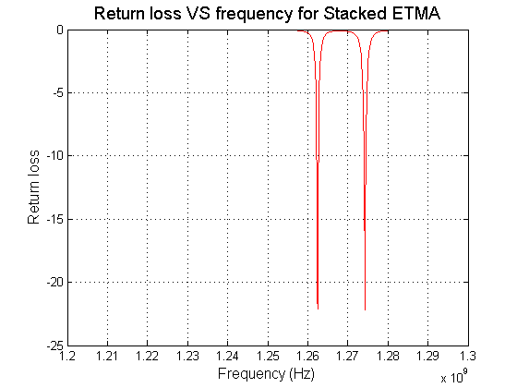
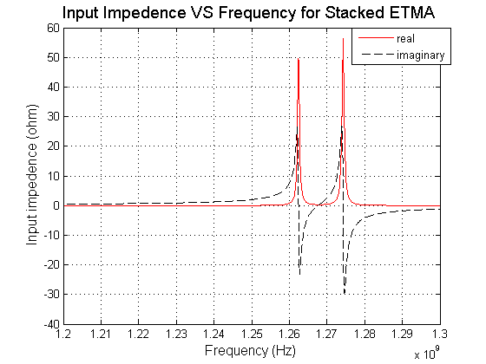

Fig 4(a) Variation of Input Impedance vs. Frequency of Stacked ETMA
Fig 4(b) Variation of Return Loss vs. Frequency of Stacked ETMA
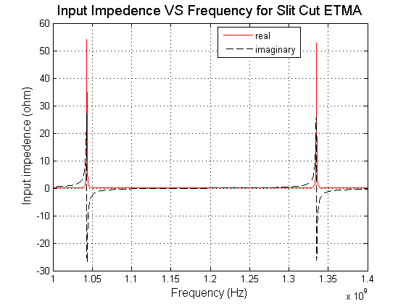
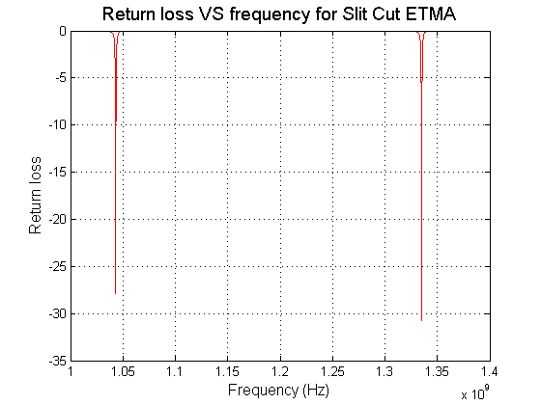

Fig 5(a) Variation of Input Impedance vs. Frequency of Slit Cut ETMA
Fig 5(b) Variation of Return Loss vs. Frequency of Slit Cut ETMA

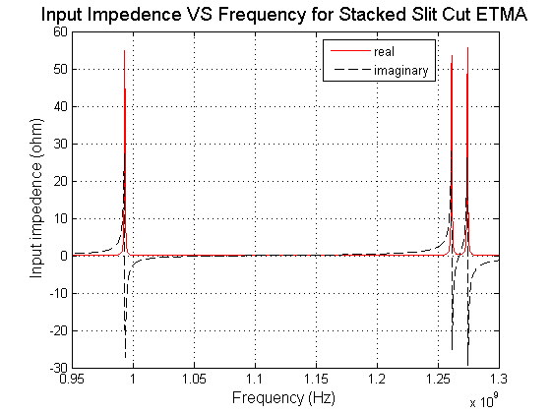
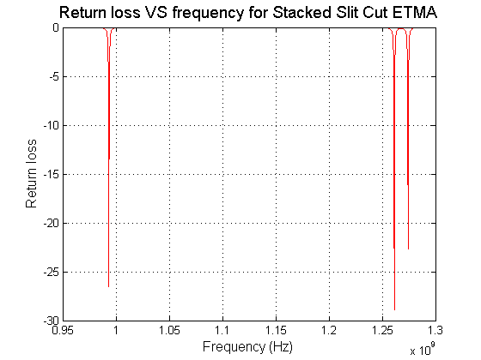

Fig 6(a) Variation of Input Impedance vs. Frequency of Stacked
Slit Cut ETMA
Fig 6(b) Variation of Return Loss vs. Frequency of Stacked
Slit Cut ETMA
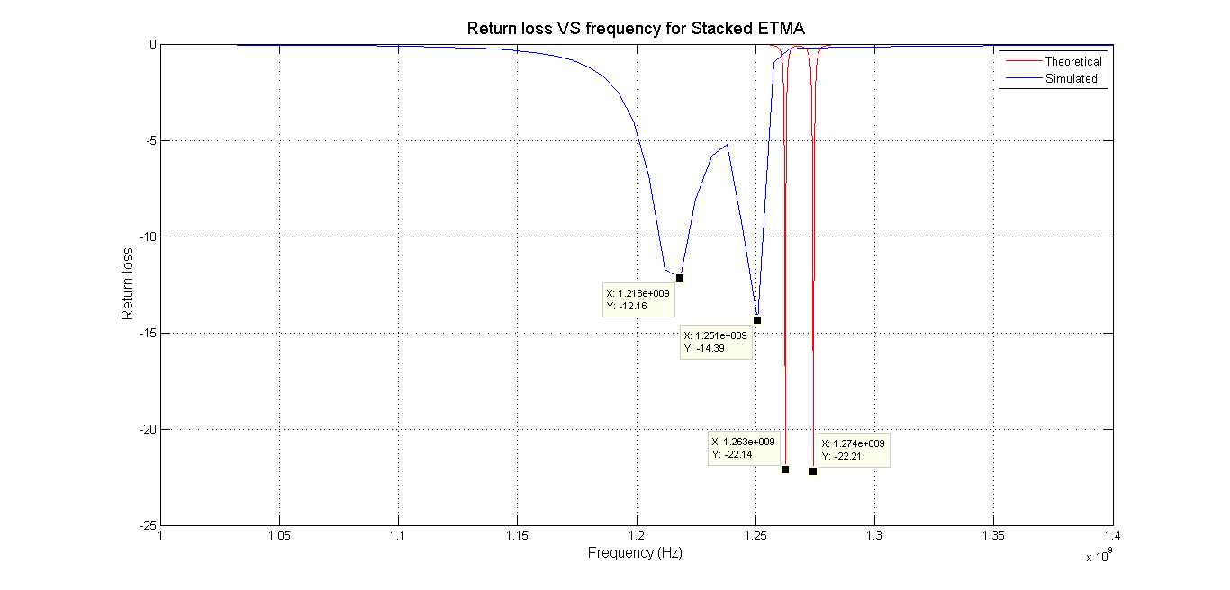

Fig 7 Theoretical & Simulated variation of Return Loss vs. Frequency of Stacked ETMA

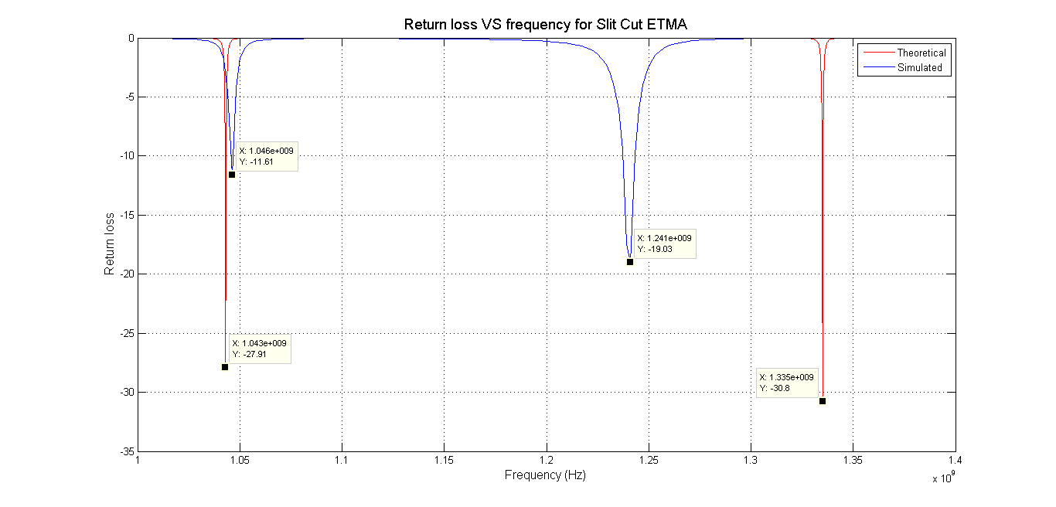

Fig 8 Theoretical & Simulated variation of Return Loss vs. Frequency of Slit-Cut ETMA

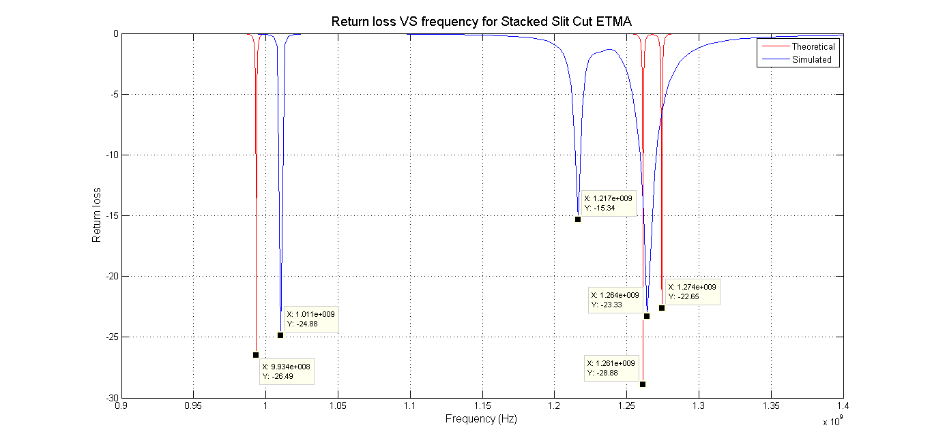

Fig 9 Theoretical & Simulated variation of Return Loss vs. Frequency of Stacked Slit Cut ETMA

Conclusion: It was concluded from our proposed model of antenna that efficiency, gain and bandwidth are far much better which can be further use for commercialization. The major characteristics of our antenna were accurately verified by simulation and practical data. The results shown in this research paper are encouraging and helpful for those researchers who are working in this field. It was shown that proposed Multi band ETMA was simple in design with improved version. The merit of our work that we have given our mathematical design equations for calculating resonant frequencies of proposed design.

References

[1] R. Garg, P. Bhartia, I. Bahl and A. Ittipiboon, “Microstrip Antenna Design Handbook,” Artech House, Norwood, 2001.
[2] Shyh-Tirng Fang and Kin-Lu Wong, “A Dual Frequency Equilateral Triangle Microstrip Antenna with a pair of Narrow Slots”
MOTL, Vol. 23, No.2, October 20 1999.
[3] Amit A. Deshmukh, K. P. Ray “Resonant Length Formulations for Dual Band Slot Cut Equilateral Triangular Microstrip Antennas”
Wireless Engineering and Technology, 2010, 1, 55-63
[4] P. S. Bhatnagar, J.-P. Daniel, K. Mahdjoubi, C. Terret, “Experimental Study on Stacked Triangular Microstrip Antennas”
ELECTRONICS LETTERS 31st July 1986 Vol.22 No. 16.
[5] Dr. Manish Rai, Yogesh Tyagi, Raghvendra Singh, Mohd Shahab, “Some Investigation On Slot-Loaded Equilateral triangular
Microstrip Antenna” Int’l Conf. on Computer & Communication Technology, 2010
[6] J. Helszain and D. S. James, "Planar Triangular Resonators with Magnetic Walls", IEEE Trans. Microwave Theory Tech.,vol.MTT-
26, Feb.1978, pp.95-100.
[7] J. S. Dahele and K. F, Lee, On the resonant frequencies of the triangular patch antenna, IEEE Trans. Antennas Propagat AP-
35, 1987, pp.100-101.
[8] Wolff Edward A, Antenna Analysis, Massachusetts: Artech house, 1988, pp.148-150 and 37-48.
[9] K. Guney, "Input Impedance Of an Equilateral Triangular Microstrip Antenna,"IEEE Trans. pp. 414-417,1994.
[10] Shilpee Patil, Binod K. Kanaujia, “Tunable Stacked Circular Patch Microstrip Antenna” 2011 International Conference on
Computational Intelligence and Communication Systems, DOI 10.1109/CICN.2011.164
[11] Debatosh Guha and Jawad Y. Siddiqui, “Resonant Frequency of Circular Microstrip Antenna Covered With Dielectric Superstrate”
IEEE Transactions On Antennas And Propagation, Vol. 51, No. 7, July 2003

