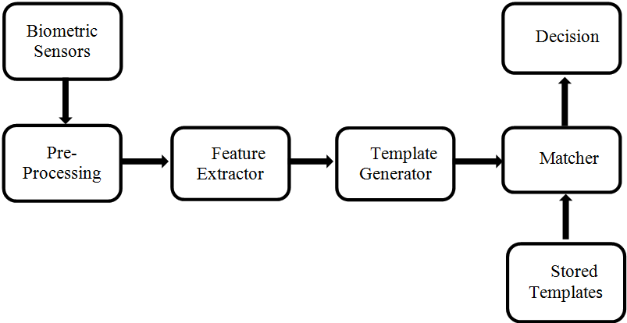
Figure 1. Working of a Biometric system

Figure 2 Averaged Pictures of Categories of Images¹ (Courtesy by Torralba & Oliva, 2003)

Figure 3 Spectral signatures of 14 different image categories¹ (Courtesy by Torralba & Oliva,2003)
.
Figure 4 Some Natural Image Patches² (Courtesy by Hyvarinen et al, 2009)

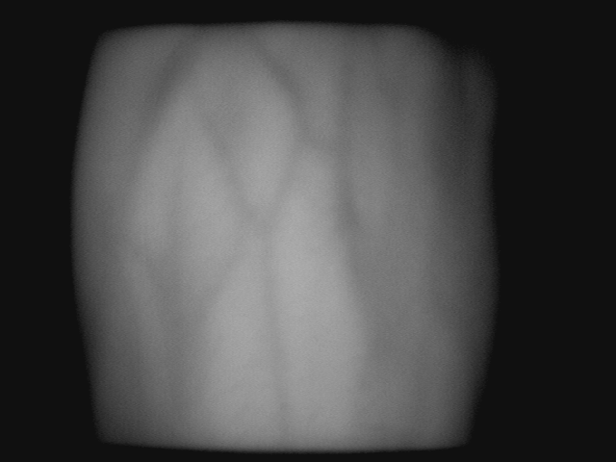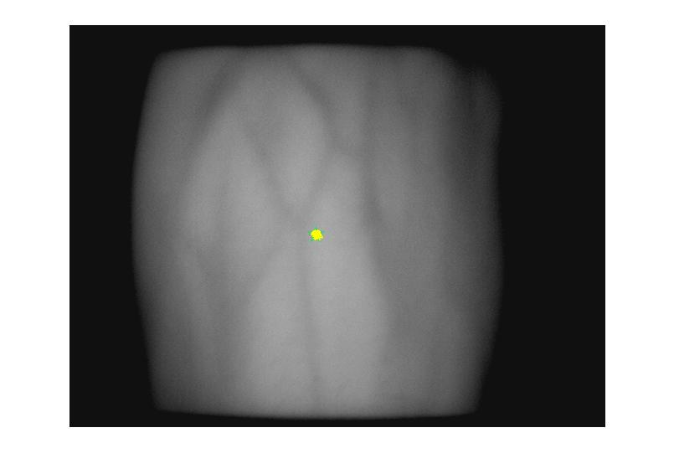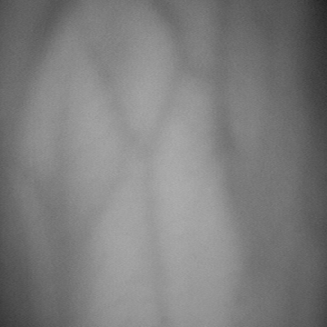
(a)
(b)
(c)
Figure 5. Back of hand vein image Centroid ROI
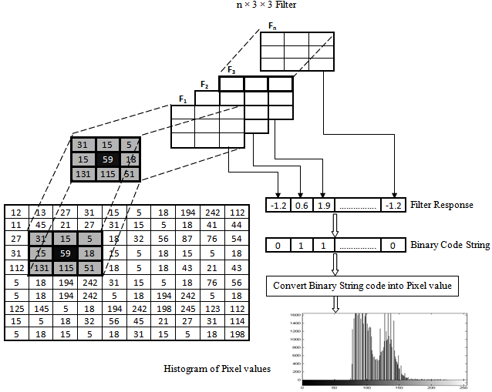
Figure 6 Binary code string calculation using set of filters

Table 1 NCUT Dorsal hand vein data set

Name of the databases | Number of subjects | Number of samples | Total number of images | Size
NCUT hand vein database | 102 | 20/subject  (10 –Left & 10 -Right) | 2040 | 640 × 480

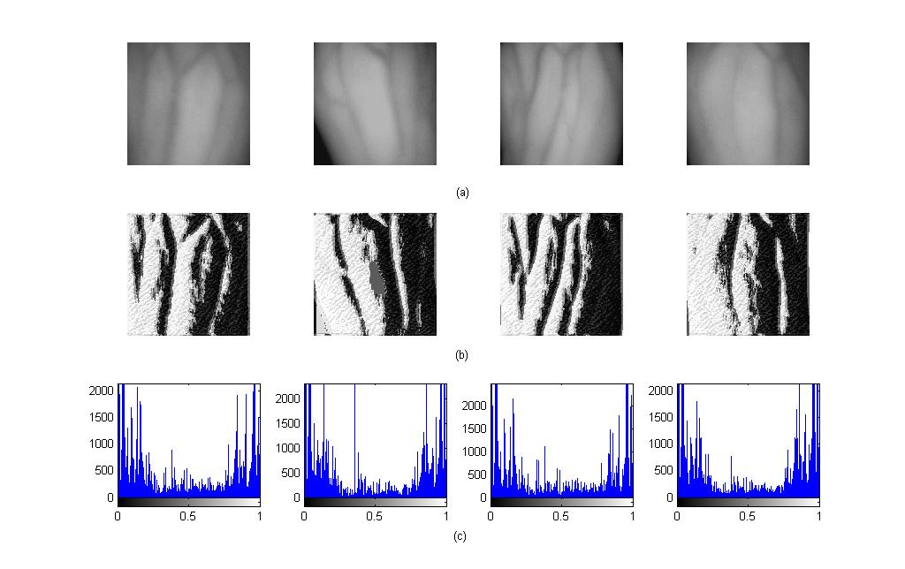
Figure 7 A sample gallery of image and the corresponding natural image statistical descriptor code and histogram

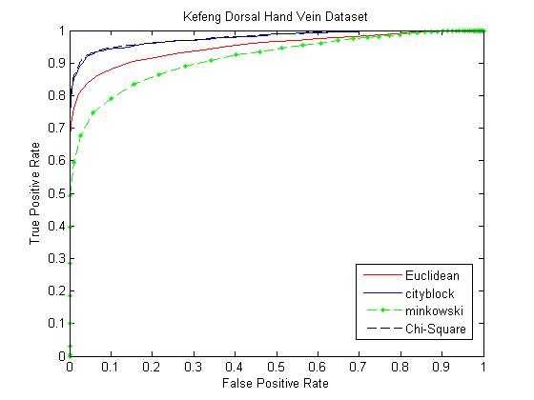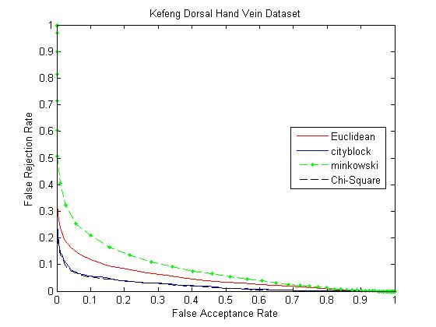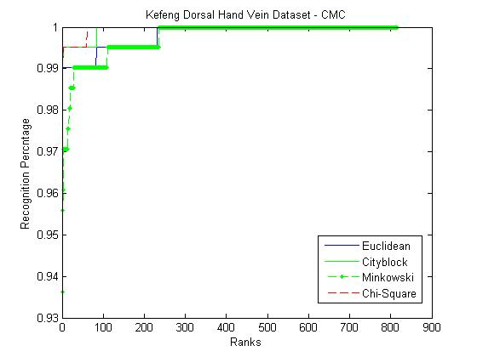
(a) ROC curve
(b) DET curve
(c) CMC curve
Figure 8 ROC, DET and CMC curve for Left hand images
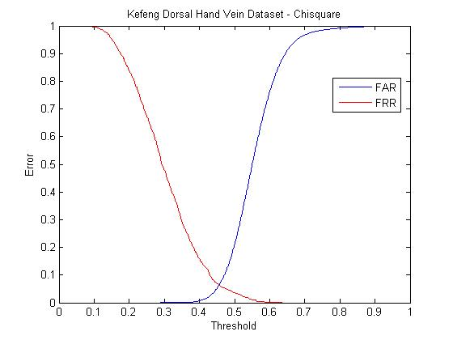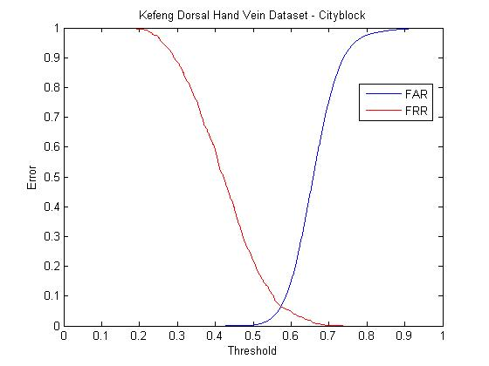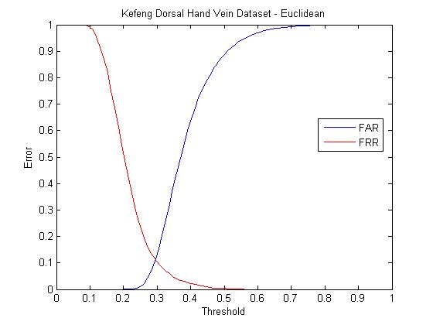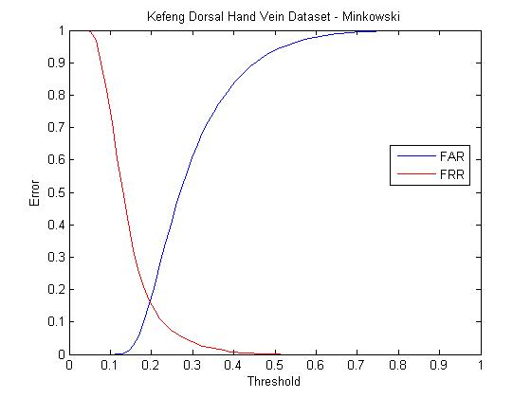Figure 9 EER curve for Left hand Images

Table 2: Equal Error Rate
Distance Measure | Equal Error Rate
Distance Measure | Left | Right
Chi-Square | 0.05 | 0.06
Cityblock | 0.06 | 0.07
Euclidean | 0.15 | 0.12
Minkowski | 0.18 | 0.15

Table 3 Average Recognition rate (%) of using different number of training images

Training  Images/  Subject | Test  Images/  Subject | Chi-Square |  | Cityblock |  | Euclidean |  | Minkowski
Training  Images/  Subject | Test  Images/  Subject | Left Hand | Right Hand | Left Hand | Right Hand | Left Hand | Right Hand | Left Hand | Right Hand
1 | 9 | 86.89 | 88.45 | 86.67 | 88.87 | 67.18 | 78.43 | 51.20 | 66.41
2 | 8 | 94.24 | 93.87 | 93.01 | 93.75 | 83.57 | 87.86 | 70.09 | 78.30
3 | 7 | 96.91 | 96.49 | 96.21 | 96.07 | 88.93 | 91.03 | 76.33 | 83.61
4 | 6 | 98.36 | 98.85 | 98.52 | 98.69 | 92.48 | 94.77 | 83.82 | 88.72
5 | 5 | 98.82 | 99.01 | 98.62 | 99.01 | 94.51 | 96.27 | 87.45 | 90.78
6 | 4 | 99.51 | 99.26 | 99.26 | 99.26 | 97.05 | 98.28 | 90.19 | 94.60
7 | 3 | 99.51 | 99.26 | 99.34 | 99.44 | 98.03 | 99.34 | 93.79 | 95.49
8 | 2 | 99.51 | 99.51 | 99.75 | 99.80 | 99.16 | 99.34 | 97.59 | 98.48
9 | 1 | 99.75 | 99.75 | 99.80 | 99.80 | 99.51 | 99.34 | 98.52 | 98.85

Table 4 Comparison of Average Recognition Rates

Distance Measure | Chi - Square |  | Cityblock |  | Euclidean |  | Minkowski
Distance Measure | Left | Right | Left | Right | Left | Right | Left | Right
Methods | Average Recognition Rate (%)
HOG | 94.70 | 96.27 | 91.82 | 93.82 | 88.92 | 91.86 | 86.96 | 89.50
LBP | 90.68 | 92.25 | 87.35 | 90.88 | 80.39 | 84.71 | 74.80 | 79.71
WLBP | 94.79 | 96.07 | 93.32 | 92.05 | 79.21 | 50.80 | 68.03 | 39.20
LPQ | 99.31 | 99.60 | 99.01 | 99.11 | 95.78 | 96.96 | 92.94 | 94.90
Proposed method | 99.51 | 99.51 | 99.75 | 99.80 | 99.16 | 99.34 | 97.59 | 98.48

Table 5: Performance of Different Methodologies
Reference | Methodology | Imaging | Number of subjects | Samples for each subject | Total images | Performance
Cross and Smith⁴ | Sequential correlation in vein maps | NIR,HDF | 20 | 5 | 100 | FAR=0%  FRR=7.9%
Kim et al.⁵ | DSP processor | NIR imaging | Not mentioned | Not mentioned | 5000 | FAR=0.001% Reliability=99.45%
Tanaga and kubo⁶ | FFT based phase correlation | NIR,HDF | 25 | Not mentioned | Not mentioned | FAR=0.073%  FRR=4%
Fan et al.⁷ | Multi-resolution analysis and combination | Thermal Hand Vein Imaging | 32 | 30 | 960 | FAR=3.5%  FRR=1.5%
Wang and Leedham⁸ | Line Segment Housdorff distance matching | Thermal Hand Vein Imaging | 12 | 9 | 108 | FAR=0%  FRR=0%
Ding et al.⁹ | Distance between feature points | NIR imaging, | 48 | 5 | 240 | FAR=0%  FRR=0.9%
Shahin et al.¹⁰ | fast spatial correlation | NIR imaging | 50 | 10 | 500 | EER=0.25%
Wang et al.¹¹ | A multi-resolution wavelet algorithm | NIR imaging | 82 | 10 | 820 | FAR=0.046%  FRR=5.08%
Wang et al.¹² | Modified Hausdorff distance algorithm | Far-infrared imaging | 47 | 3 | 141 | EER=0%
Ajay Kumar and Prathyusha¹³ | Vein triangulation and knuckle tips | NIR imaging | Not mentioned | Not mentioned | 100 | FAR=1.14%  FRR=1.14%
Wang et al.¹⁴ | SIFT | NIR imaging | 102 | 20 | 2040 | FAR = 0.002%  FRR = 0.93%.
Wang et al.¹⁵ | LBP | NIR imaging | 102 | 20 | 2040 | Recognition rate = 98.13%
Crisan et al.¹⁶ | Thinning algorithm | NIR imaging | 306 | 2 | 612 | FAR=0.012%  FRR=1.03%
Huang et al.¹⁷ | Oriented Gradient Maps | NIR imaging | 102 | 20 | 2040 | Recognition rate = 97.60%
Wang and Liao¹⁸ | LBP with back propagation encoder | NIR imaging | 102 | 20 | 2040 | Recognition rate = 97.60%
Wang et al.¹⁹ | Coded and weighted LBP | NIR imaging | 102 | 20 | 2040 | Recognition rate = 98.63%
Premalatha et al²⁰ | Local Gabor Phase Quantization with Whitening Transformation | NIR imaging | 102 | 20 | 2040 | Recognition rate = 99.71%
Anantha kumar and Premalatha²¹ | local Gaussian quadrature filter pair phase quantisation | NIR imaging | 102 | 20 | 2040 | Recognition rate = 99.70%
This paper | Natural image statistical Descriptor | NIR imaging | 102 | 20 | 2040 | Recognition rate = 99.80%

