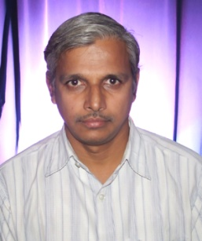
Prof. C. Raghavendra Rao, Completed his B. Sc and M.Sc in Statistics from Andhra University and Osmania University respectively. Ph. D. in Statistics and M.Tech(CS&Engineering) from Osmania University.

He started his carrier as a lecturer in Statistics at Osmania University in 1984. Since 1986, he is working in the University of Hyderabad. Presently he is a Professor in the School of Computer and Information Sciences, University of Hyderabad. He is a Associate Faculty at ACRHEM, Center for Earth and Space and Center for Health Phycology.

His current research interests are Simulation & Modeling, Rough Sets, and Knowledge Discovery.

Dr Rao is a member of the Operation Research Society of India, Indian Mathematical Society, International Association of Engineers, Society for development of statistics, Andhra Pradesh Society for Mathematical Sciences, Indian Society for Probability and Statistics, Society for High Energy Materials, International Rough Set Society, Indian Society for Rough sets, International Rough Set Society and also a Fellow of The Institution of Electronics and Telecommunication Engineers and Society for Sciences.

Dr Rao Guided 8 PhDs, 40 M.Techs, 8 M.Phils. Nearly 55 Journal and 70 Proceeding Papers to his credit. He is Co-author for a book on 'Evaluation of Total Literacy Campaigns'.

Dr. Rao contributed enormously in the project of National Interest, few to mention are:
- Evaluations of National Literacy programs at District level – Chitoor, Nizamabad and Krishna.
- Mathematical model based Control system for swing out operation for the liquid nitrogen feeding boom for rocket launching pad in Sree Hari Kota (T.A. Hydraulics Ltd.)
- Design of Optimal driving profile generation for diesel locomotives for Indian Railways (Consultancy project for Medha Servo Control System).
- Mathematical modeling for 6 degree of Motion platform for building driver training simulator.
- Optimal design configuration methodologies for aerospace applications with IIT Bombay for DRDL.
- Mathematical modeling fuel air explosive system for Defense Research Development Organization.

