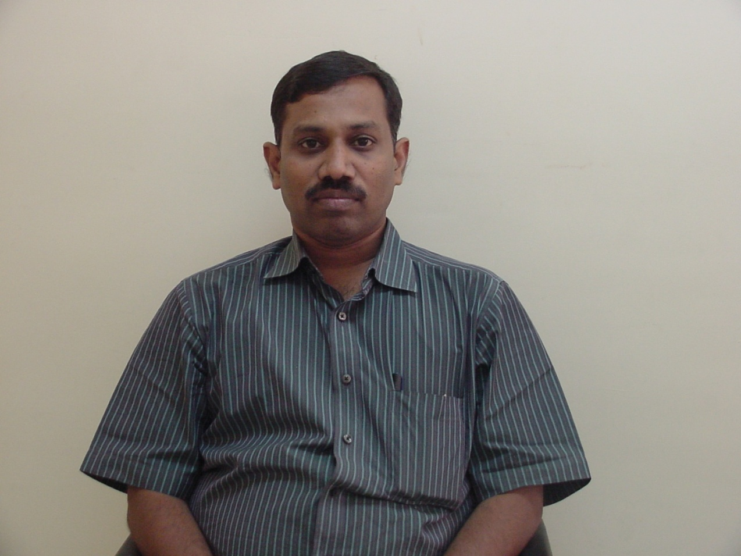

**Mr. S G Savio,** obtained his M.Sc (Materials Science) and M.Tech (Ceramic Technology) from Anna University, Chennai. He joined DRDO in 2002 and after a short teaching assignment at CME, Pune, he joined DMRL, Hyderabad during 2006. Currently, he is working as Scientist D in Armour Design and Development Division, DMRL, involved in evaluation of ballistic performance for ceramic armour materials. He has published several research papers in international journals and conferences. His research interests are in the areas of development and characterization of ceramic armour materials, ballistic testing and analysis and high strain rate studies on armour materials.



**Dr Vemuri Madhu**, obtained did his PhD (Applied Mechanics) from the Indian Institution of Technology (IIT) Delhi, New Delhi in 1993. Currently, he is working as Scientist G at the Defence Metallurgical Research Laboratory (DMRL), Hyderabad. He is working in the areas of development of armour materials and systems for various types of protective applications. He is a recipient of the DRDO *performance Excellence Award in 2008 (as a team member), Laboratory Scientist of the year Award in 2006 and National Technology Day Award in 2003*. He has more than 50 research papers and technical reports to his credit. His research interests are in the areas of ceramic and composite armour development, modelling and simulation of ballistic phenomena, high strain rate characterization and shock studies on armour materials and development of protective systems for military and civil applications.

C:\Documents and Settings\S G Savio\Desktop\scan0001.tif

**Dr A K Gogia** is working as Scientist H at Defence Metallurgical Research Laboratory (DMRL), Hyderabad. He is working in the areas of development of titanium alloys for aerospace applications and design and development of armour for various protective applications. He has several research papers and technical reports to his credit.