Performance Assessment of Preprocessing Filters for Infrared Search and Track Application
Hari Babu Srivastava¹, Vinod Kumar², H.K. Verma², and S.S. Sundaram¹
¹Instruments Research and Development Establishment, Dehradun-248 008
²Indian Institute of Technology Roorkee, Roorkee-247 667
hbs@irde.drdo.in

Abstract
In order to enhance detection probability and reduce false alarms, infrared imagery is pre-processed before subjecting it to detection algorithms in infrared search and track systems. Pre-processing algorithms are used to predict the complex background and then to subtract the predicted background from the original image. The difference image is passed to the detection algorithm to further distinguish between target and background and/ or noise more accurately. A number of pre-processing algorithms have been reported in literature, with their relative advantages and disadvantages. This paper brings out the computational complexities and simulation results of various algorithms for assessing their relative performance. Based on these parameters, statistical algorithms in general and max-min algorithm in particular are recommended to be used for infrared search and track systems.
Keywords: Contrast sensitivity, point target, long-range, pre-processing, Infrared Search and Track, Morphological Filters, Statistical Filters
- Introduction
The detection of small moving targets in clutter is an important subject in the area of signal/image processing. The algorithms for the detection of small and point targets are fundamental part of Infra-Red Search and Track (IRST) system and play vital role in the success of such systems. Typically, the spatial pre-processing step is performed on the input image to predict the background and consequently enhance the signal-to-clutter ratio (SCR). The detection algorithm may result in many false targets and this requires using the post processing algorithms to reduce the false alarms. Pre-processing algorithms are used to predict the complex background and then to subtract the predicted background from the original image. The difference image is passed to the detection algorithm to further distinguish between target and background and/or noise more accurately. The aim is to fit the background as closely as possible in the original image without diminishing the target signal. Many pre-processing algorithms have been reported in the literature. A review of these algorithms was presented by authors in [1]. It has experimentally been verified that the detection of dim point size targets in cluttered background is not possible without increasing the signal to clutter plus noise ratio (SCNR) by pre-processing of IR data. The output of pre-processing algorithm is passed to the detection algorithm which actually detects the targets and it may result in many false targets and this may require using the post processing algorithms to reduce false alarms and to generate candidate target list. The block diagram of the image processing algorithms for detection of point and/or small targets is given in Figure 1.
The brief introduction to these pre-processing filters is presented in section 2 for the sake of completeness. The simulation methodology is discussed in Section 3 and simulation results are presented in section 4. Lastly the paper is concluded in section 5.

Figure 1: Block Diagram of Point and/or Small Target Detection Algorithms
- Pre-processing Filters
The pre-processing algorithms can be broadly classified in morphological and statistical filters [1].
Morphological filters are based on successive use of erosion and dilation operations using a structuring element. Mathematical morphology provides an approach to the processing of images which is based on shape. The morphological operations tend to simplify image data, preserving their essential shape characteristics and eliminating irrelevances. Opening process (erosion of image by structuring element, followed by dilation of the result by the same structuring element) eliminates bridges (narrow edge like set of pixels) connecting two regions of the image. It rounds outward pointing corners in the image while leaving the inward pointing corners unaffected. The closing process (dilation of image by structuring element, followed by erosion of the result by the same structuring element) rounds the inward pointing corners in the image while leaving the outward corners unaffected. The problem with morphological filters is that the result is highly dependent on size and shape of structuring element. The adaptive selection of size and shape of structuring element is a challenging task. The computational load for some of the common morphological filters is tabulated in Table 1.
Let, f is a gray-scale image and g is the structuring element. C_{g} above refers the ‘closing’ operation performed on the image, f by a suitably chosen structuring element, g. Similarly, O_{g} above refers to the ‘opening’ operation performed on the image, f by the same chosen structuring element, g. C_O refers to the mean of the image pixels obtained after closing and opening operations. Repetitive usage of C_{g} followed by O_{g} (or vice versa) refers to the repetitive usage of closing and opening operators one after the other.

Table 1: Computational Complexity of Morphological Filters
Statistical filters make use of the fact that the statistical behavior of the target and the background are not identical to predict the background. Filters like mean, median, max-median, max-min, mean median, selective median, 2-D Gaussian etc. have been proposed in literature [2-7]. The methodology here is to replace the back ground pixel by mean/median etc. of the neighborhood. This assumes that one odd pixel occupied by the target (with higher intensity than the background) will not affect the statistics drastically.
S. No. | Pre-Processing Filter | Operations/Pixel* | Complexity
 | Morpho COg | 96 | O(n²)
 | Morpho COOC_{g} | 192 | O(n²)
 | Morpho COCOCO_{g} | 288 | O(n²)
 | Morpho ECOCDOCO_{g} | 336 | O(n²)
 | Selective-Morpho COOCg | 112 | O(n²)
*Operations/Pixels Calculation is based on window size of 5x5
The computational load of some of the common statistical pre-processing filters is tabulated in Table 2.
Table 2: Computational Complexity of Statistical Filters
S. No. | Pre-Processing Filter | Operations/Pixel* | Complexity
 | Median | 625 | O(n²)
 | Max-Median | 103 | O(n)
 | Max-Min | 19 | O(n)
 | Mean-Median | 105 | O(n)
 | Gaussian | 49† | O(n²)
 | Mean | 25 | O(n²)
 | Selective-Median | 225 | O(n²)
*Operations/Pixels Calculation is based on window size of 5x5
†Size of the Filter 5x5 and Sigma Value of 0.5
- Simulation Methodology
The object of this study is to find out a filter that is consistent and gives good performance, which can be made use of in the detection process. Towards this end, clouds were simulated using standard software program. Targets with known intensity and statistics were embedded in these video sequences.
The challenge is to decide a parameter for comparative analysis. The generally accepted parameter for this is the change in signal-to-noise ratio (SCNR). However, as brought out later in the paper, no clear cut direction could be found based on this parameter. Next we tried contrast sensitivity analysis. The ratio of the output contrast sensitivity to the input contrast sensitivity provided a good direction for selection of the preprocessing filter.
SCNR [8] is defined as given in eqn. (1).
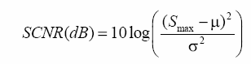 (1)
where, S_{max} is the signal peak value, μ is the mean, and σ is the standard deviation of the background.
The contrast sensitivity, also known as Weber’s fraction, is proposed to be the parameter for deciding the efficacy of pre-processing filters. Contrast sensitivity [9] is defined as given in eqn. (2).
$C_{s}=\frac{ΔI}{I}$ (2)
where, $ΔI$is the difference value between the object and background (mean value), $I$ is the mean background intensity.
To compare various pre-processing methods, a number of synthetic clouds are generated by means of Infra-Red Scene Simulator ([10], [11]). The Infra-Red Scene Simulator uses the Modified Gardener’s Fourier Series Method, Self-Similar Method, and Perlin’s Noise Method to generate the synthetic Infra-Red clouds. The IRSS typically does the object creation and its modeling, background scene creation and it’s modeling, and the integration of created IR object into simulated background scene and image rendering process. The snapshot of the IRSS with generated cloud is shown in the Figure 2.

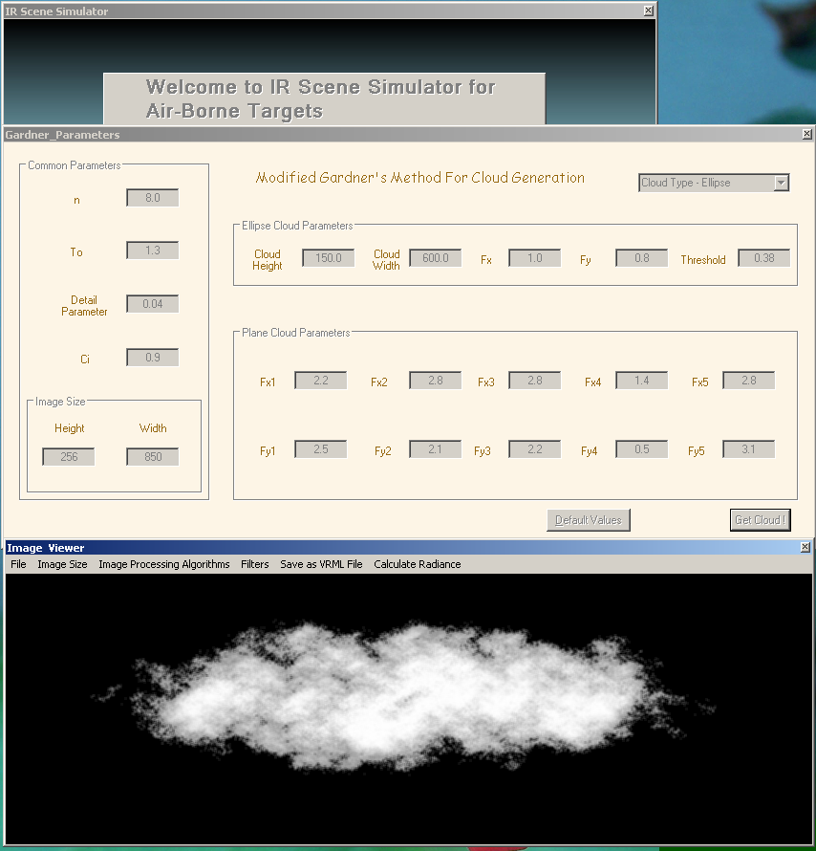
Figure 2: Infra-Red Scene Simulator (IRSS) and a synthetically generated cloud
The real infra-red video data containing the long-range small/point air targets is not available for study and analysis. Therefore the small/point targets were synthetically embedded in these clouds through a Target Embedding Routine in MATLAB [12] environment with known target and background profile as shown in Figure 3.
Finally, these images were subjected to various filtering processes. Appropriate pre-processing filters are selected for simulation process. The parameters for comparative study (SCNR, differential intensity and input-output contrast values) are automatically generated and logged in a file for analysis. The run time snapshot of the pre-processing simulation program is shown in Figure 4.
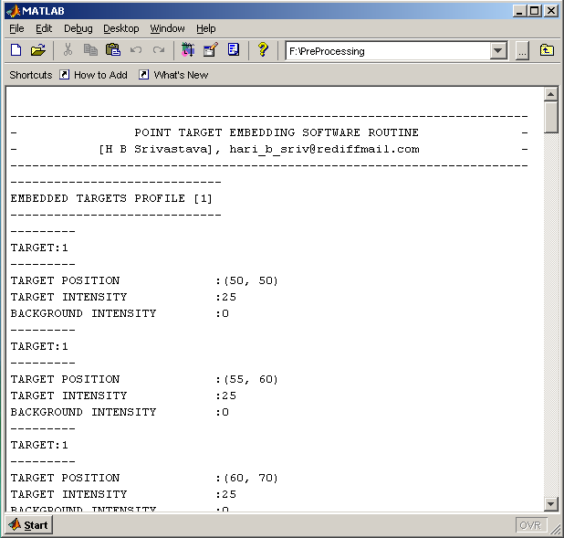 | 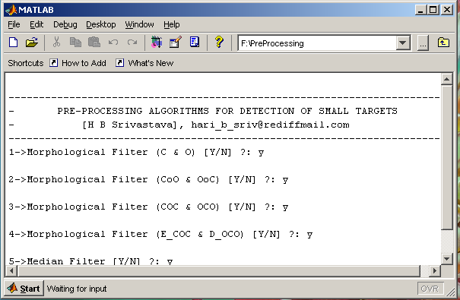
Figure 3: Infra-Red Scene Simulator Snap Shot | Figure 4: Run time snapshot of pre-processing simulation program
A total number of 50 types of back ground cloud sequences (each sequence with 25 image frames) were generated and targets with known target characteristics (target position, shape and gray-level difference between target and neighboring background) were embedded in each of the image frame.
- Simulation Results and Theoretical Discussion
The clouds generated as above, were embedded with a point target with input SCNRs of 5 dB, 10 dB and 20 dB (with respect to the surrounding window of 5x5 pixels. The pre-processing filters discussed in [1] have been simulated on infra-red image frames as above. SCNRs of the input and output image were calculated and the improvement in SCNR was found. The SCNR of the filtered output image was calculated in the same window of 5x5 pixels. Sample results are presented in Appendix ‘A’. The average performance of these filters over the full sample of clouds is presented in Figure 5.
Figure 5: Filter Performance on SCNR Basis

As seen in the table above, no clear cut pattern is emerging with respect to the performance of any of the filters. Hence, there is a need to find an alternate parameter for comparison of algorithms. Contrast sensitivity, as defined above, was chosen as the parameter for comparing various filters. Specifically, the ratio between the output contrast sensitivity and input contrast sensitivity was plotted.
The same target-background scenarios that were used for SCNR calculations were used for calculating contrast sensitivity. Encouraging results were seen. The five test cases were analyzed on each of 50 image sequences with gray level difference (GLD) of 2, 5, 10, 15 and 20 between target and background on 8-bit gray-scale images. The output contrasts sensitivities of filters for two sample cases of GLD of 2 and GLD of 20 are presented in Appendix. The results are similar for other test cases also. It is seen that max-min filter is almost always outscoring all other filters in terms of contrast sensitivity. It was also observed that there is a constant improvement in output contrast by various filters. Whenever, the input contrast is high, the output contrast saturates at 8-bit (255) value.
The max-min filter is defined as given in eqn.
$y(m,n)=\text{max}[z_{1},z_{2},z_{3},z_{4}]$ (3)
where, y (m, n) is the output of the (2N+1) ^{th} order max-min filter and z₁, z₂, z₃ and z₄ are minimum values of the middle row vector, middle column vector and the two diagonal vectors of the convolution kernel centered around the pixel of interest, respectively. The larger the value of N, the more is the spike suppression. This property is used to detect small targets. The maximum operation is chosen with criteria to preserve edges and discontinuities in the filtered signals. If other ranks are chosen rather than the maximum, it can be easily shown that the filter will tend to blur edges of the original signal. In many applications, all the z_{i’}s estimates may not be needed. The minimum operations on middle row vector, middle column vector and the two diagonal vectors initially predict the background as the minimum intensity value over the horizontal, vertical or diagonal direction. This operation preserves the low intensity targets and hence helps to enhance the SCNR in the absolute difference image.
The graphs showing the performance of the simulated filters for GLD of 2, 5, 10, 15 and 20 are shown in Figure 6, 7, 8, 9 and 10 respectively.
Figure 6: Filter Performance for input GLD 2
Figure 7: Filter Performance for input GLD 5

Figure 8: Filter Performance for input GLD 10

Figure 9: Filter Performance for input GLD 15

Figure 10: Filter Performance for input GLD 20

- Conclusions
Pre-processing filters are very useful to suppress the background and enhance the contrast sensitivity of the difference image frame for detection of small targets. From the simulation, it is seen that the statistical filters have superior performance in the present application. It is also found that max-min filter outperforms the other statistical filters. Moreover, the computational requirements are also O (n), making it an attractive choice for real-time application. Selective-median, improved hybrid morphological filter, median filter and max-median filter also perform satisfactorily if the input contrast of the target is good. However, their performance degrades for very low contrast targets.

References
- Hari Babu Srivastava, Vinod Kumar, H.K. Verma and S.S. Sundaram, “Image Pre-processing Algorithms for Detection of Small/Point Airborne Targets”, Defence Science Journal, Vol. 59, No. 2, March 2009, pp. 166-174
- R. Boyle and R. Thomas Computer Vision: A First Course, Blackwell Scientific Publications, pp 42 – 44, 1988.
- R. Gonzalez and R. Woods Digital Image Processing, Addison-Wesley Publishing Company, pp. 191, 1992.
- C. Helstrom, Probability and Stochastic Process for Engineers, Macmillan, New York, 1991.
- R. Boyle and R. Thomas Computer Vision: A First Course, Blackwell Scientific Publications, pp 32 – 34, 1988.
- Suyog D. Deshpande, M. H. Er, V. Ronda, and Phillip Chan, “Max-mean and max-median filters for detection of small-targets,” in Signal and Data Processing of Small Targets, SPIE, vol. 3809, pp. 74-83, 1999.
- Uday B. Desai and S. N. Merchant, “Development of signal processing/image processing techniques and IR scene simulator for infra-red search and track (IRST) systems- Phase II,” Final Completion Report to IRDE, Dehradun, pp. 23-24, October 2006.
- Diani, M.; Baldacci, A. & Corcini, G. Novel background removal algorithm for navy infrared search and track systems, Optical Engineering, 2001, 40(8),1729-734.
- William K. Pratt, “Digital Image Processing,” Third Edition, Wiley-Interscience Publication, ISBN 0-471-22132-5, pp. 30, 2001.

- Uday B. Desai and S. N. Merchant, “Development of Signal/ Image Processing Techniques and IR Scene Simulator for Infrared Search and Track (IRST) System- Phase II Final Completion Report,” SPANNN Lab, Department of Electrical Engineering, IIT-Bombay, Mumbai, October 2006.
- Uday B. Desai and S. N. Merchant, “Infrared Search and Tracking-Report-2,” SPANNN Lab, Department of Electrical Engineering, IIT-Bombay, Mumbai, June 2002.
- “Image Processing Toolbox: For Use with MATLAB-User’s Guide,” Version 5, October 2005.

Appendix ‘A’: SCNR Based Performance of Pre-Processing Filters
No. | Cloud Image
No. | Cloud Image |  |  | Performance of Pre-Processing Filters
No. | Cloud Image |  |  | Input SCNR: 5 dB |  | Input SCNR: 10 dB | Input SCNR: 20 dB
1.  Ratio of Output to Input SCNR |  |  | Output SCNR dB | SCNR improvement dB | Output SCNR dB | SCNR improvement dB | Output SCNR dB | SCNR improvement dB
1.  Ratio of Output to Input SCNR |  | CO_{g} | 5.3 | 0.3 | 9.82 | -0.18 | 14.4 | -5.6
1.  Ratio of Output to Input SCNR |  | COOC_{g} | 5.4 | 0.4 | 9.82 | -0.18 | 14.19 | -5.81
1.  Ratio of Output to Input SCNR |  | COCOCO_{g} | 5.4 | 0.4 | 9.82 | -0.18 | 14.19 | -5.81
1.  Ratio of Output to Input SCNR |  | ECOCDOCO_{g} | 3.13 | -1.87 | 12.82 | 2.82 | 12.01 | -7.99
1.  Ratio of Output to Input SCNR |  | Sel. COOC_{g} | 5.99 | 0.99 | 9.82 | -0.18 | 3.91 | -16.09
1.  Ratio of Output to Input SCNR |  | Median | 5.16 | 0.16 | 18.34 | 8.34 | 13.68 | -6.32
1.  Ratio of Output to Input SCNR |  | Max-Median | 8.4 | 3.4 | 18.46 | 8.46 | 14.07 | -5.93
1.  Ratio of Output to Input SCNR |  | Max-Min | 0 | -5 | 15.72 | 5.72 | 12.39 | -7.61
1.  Ratio of Output to Input SCNR |  | Mean-Median | 6.1 | 1.1 | 19.05 | 9.05 | 17.22 | -2.78
1.  Ratio of Output to Input SCNR |  | Gaussian | 3.76 | -1.24 | 16.99 | 6.99 | 15.88 | -4.12
1.  Ratio of Output to Input SCNR |  | Averaging | 5.69 | 0.69 | 17.22 | 7.22 | 17.07 | -2.93
1.  Ratio of Output to Input SCNR |  | Sel Median | 5.14 | 0.14 | 18.63 | 8.63 | 13.42 | -6.58

Ratio of Output to Input SCNR

2.
Ratio of Output to Input SCNR  2. |  | CO_{g} | 1.3 | -3.7 | 12.84 | 2.84 | 12.31 | -7.69
Ratio of Output to Input SCNR  2. |  | COOC_{g} | 0.98 | -4.02 | 12.57 | 2.57 | 11.25 | -8.75
Ratio of Output to Input SCNR  2. |  | COCOCO_{g} | 0.98 | -4.02 | 12.49 | 2.49 | 11.25 | -8.75
Ratio of Output to Input SCNR  2. |  | ECOCDOCO_{g} | 2.98 | -2.02 | 13.44 | 3.44 | 14.46 | -5.54
Ratio of Output to Input SCNR  2. |  | Sel. COOC_{g} | 0.68 | -4.32 | 13.52 | 3.52 | 11.38 | -8.62
Ratio of Output to Input SCNR  2. |  | Median | 1.79 | -3.21 | 16.12 | 6.12 | 10.1 | -9.9
Ratio of Output to Input SCNR  2. |  | Max-Median | 3.69 | -1.31 | 18.77 | 8.77 | 13.1 | -6.9
Ratio of Output to Input SCNR  2. |  | Max-Min | 1.83 | -3.17 | 14.57 | 4.57 | 9.89 | -10.11
Ratio of Output to Input SCNR  2. |  | Mean-Median | 2.74 | -2.26 | 16.05 | 6.05 | 12.03 | -7.97
Ratio of Output to Input SCNR  2. |  | Gaussian | 1.64 | -3.36 | 16.96 | 6.96 | 12.45 | -7.55
Ratio of Output to Input SCNR  2. |  | Averaging | 1.52 | -3.48 | 16.68 | 6.68 | 11.56 | -8.44
Ratio of Output to Input SCNR  2. |  | Sel Median | 2.71 | -2.29 | 14.93 | 4.93 | 10.23 | -9.77
3  Ratio of Output to Input SCNR | 
3  Ratio of Output to Input SCNR |  | CO_{g} | 0 | -5 | 9.88 | -0.12 | 9.5 | -10.5
3  Ratio of Output to Input SCNR |  | COOC_{g} | 0 | -5 | 9.88 | -0.12 | 9.5 | -10.5
3  Ratio of Output to Input SCNR |  | COCOCO_{g} | 0 | -5 | 9.88 | -0.12 | 9.5 | -10.5
3  Ratio of Output to Input SCNR |  | ECOCDOCO_{g} | 4.11 | -0.89 | 15.32 | 5.32 | 12.13 | -7.87
3  Ratio of Output to Input SCNR |  | Sel. COOC_{g} | 0 | -5 | 14.48 | 4.48 | 12.13 | -7.87
3  Ratio of Output to Input SCNR |  | Median | 3.07 | -1.93 | 16.02 | 6.02 | 11.63 | -8.37
3  Ratio of Output to Input SCNR |  | Max-Median | 1.48 | -3.52 | 0 | -10 | 0 | -20
3  Ratio of Output to Input SCNR |  | Max-Min | 2.88 | -2.12 | 14.41 | 4.41 | 10.5 | -9.5
3  Ratio of Output to Input SCNR |  | Mean-Median | 0 | -5 | 14.47 | 4.47 | 11.49 | -8.51
3  Ratio of Output to Input SCNR |  | Gaussian | 4.41 | -0.59 | 15.58 | 5.58 | 12.17 | -7.83
3  Ratio of Output to Input SCNR |  | Averaging | 5.51 | 0.51 | 16.32 | 6.32 | 12.67 | -7.33
3  Ratio of Output to Input SCNR |  | Sel Median | 6.3 | 1.3 | 16.08 | 6.08 | 12.86 | -7.14
4.  Ratio of Output to Input SCNR | 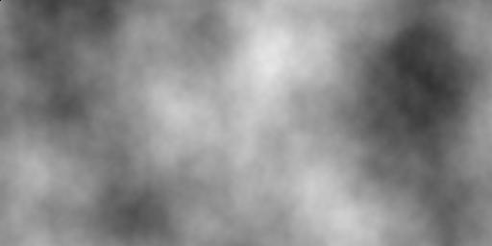
4.  Ratio of Output to Input SCNR |  | CO_{g} | -2.77 | -7.77 | 10.86 | 0.86 | 9.59 | -10.41
4.  Ratio of Output to Input SCNR |  | COOC_{g} | -3.58 | -8.58 | 10.54 | 0.54 | 9.54 | -10.46
4.  Ratio of Output to Input SCNR |  | COCOCO_{g} | -3.58 | -8.58 | 10.54 | 0.54 | 9.54 | -10.46
4.  Ratio of Output to Input SCNR |  | ECOCDOCO_{g} | -5.73 | -10.73 | 12.43 | 2.43 | 12.2 | -7.8
4.  Ratio of Output to Input SCNR |  | Sel. COOC_{g} | -4.67 | -9.67 | 10.76 | 0.76 | 9.96 | -10.04
4.  Ratio of Output to Input SCNR |  | Median | -3.9 | -8.9 | 15.44 | 5.44 | 11.6 | -8.4
4.  Ratio of Output to Input SCNR |  | Max-Median | -2.24 | -7.24 | 0 | -10 | 0 | -20
4.  Ratio of Output to Input SCNR |  | Max-Min | -1.23 | -6.23 | 15.38 | 5.38 | 14.99 | -5.01
4.  Ratio of Output to Input SCNR |  | Mean-Median | -1.45 | -6.45 | 16.34 | 6.34 | 13.39 | -6.61
4.  Ratio of Output to Input SCNR |  | Gaussian | -2.47 | -7.47 | 15.39 | 5.39 | 16.34 | -3.66
4.  Ratio of Output to Input SCNR |  | Averaging | -2.93 | -7.93 | 15.66 | 5.66 | 16.1 | -3.9
4.  Ratio of Output to Input SCNR |  | Sel Median | -3.24 | -8.24 | 14.93 | 4.93 | 15.41 | -4.59
5  Ratio of Output to Input SCNR
  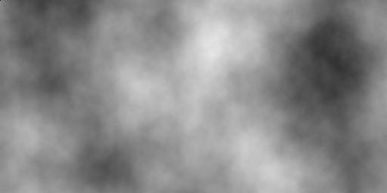
5  Ratio of Output to Input SCNR |  | CO_{g} | -1.97 | -6.97 | 10.63 | 0.63 | 8.77 | -11.23
5  Ratio of Output to Input SCNR |  | COOC_{g} | -2.14 | -7.14 | 11.64 | 1.64 | 9.1 | -10.9
5  Ratio of Output to Input SCNR |  | COCOCO_{g} | -2.14 | -7.14 | 11.64 | 1.64 | 9.1 | -10.9
5  Ratio of Output to Input SCNR |  | ECOCDOCO_{g} | -1.49 | -6.49 | 12.89 | 2.89 | 10.76 | -9.24
5  Ratio of Output to Input SCNR |  | Sel. COOC_{g} | -0.51 | -5.51 | 11.38 | 1.38 | 9.65 | -10.35
5  Ratio of Output to Input SCNR |  | Median | 0.94 | -4.06 | 16.84 | 6.84 | 11.96 | -8.04
5  Ratio of Output to Input SCNR |  | Max-Median | 0 | -5 | 0 | -10 | 0 | -20
5  Ratio of Output to Input SCNR |  | Max-Min | 4.72 | -0.28 | 16.33 | 6.33 | 4.24 | -15.76
5  Ratio of Output to Input SCNR |  | Mean-Median | 4.22 | -0.78 | 16.42 | 6.42 | 14.02 | -5.98
5  Ratio of Output to Input SCNR |  | Gaussian | 4.54 | -0.46 | 16.21 | 6.21 | 15.82 | -4.18
5  Ratio of Output to Input SCNR |  | Averaging | 3.42 | -1.58 | 16.69 | 6.69 | 15.96 | -4.04
5  Ratio of Output to Input SCNR |  | Sel Median | 2.4 | -2.6 | 16.5 | 6.5 | 13.64 | -6.36

 | Average SCNR improvement over all clouds as per Input SCNR
 | Filter | Input SCNR: 5dB | Input SCNR: 10dB | Input SCNR: 20dB
 | CO_{g} | -4.63 | 0.81 | -9.09
 | COOC_{g} | -4.87 | 0.89 | -9.28
 | COCOCO_{g} | -4.87 | 0.87 | -9.28
 | ECOCDOCO_{g} | -4.40 | 3.38 | -7.69
 | Sel. COOC_{g} | -4.70 | 1.99 | -10.59
 | Median | -3.59 | 6.55 | -8.21
 | Max-Median | -2.73 | -2.55 | -14.57
 | Max-Min | -3.36 | 5.28 | -9.60
 | Mean-Median | -2.68 | 6.47 | -6.37
 | Gaussian | -2.62 | 6.23 | -5.47
 | Averaging | -2.36 | 6.51 | -5.33
 | Sel Median | -2.34 | 6.21 | -6.89

Appendix ‘B’: Contrast Sensitivity Based Performance of Pre-Processing Filters
Case 1- Input GLD: 2
 |  |  |  |  |  |  |  | Output Contrast Sensitivity
 |  | Input CS
 |  |  | CO_{g} | COOC_{g} | COCOCO_{g} | ECOCDOCO_{g} | Median | Max-Med | Max-Min | Mean-Med | Gaussian | Averaging Filter | Sel Med | Sel COOC_{g}
Test | 1 | 1 | 2 | 2 | 2 | 142 | 161 | 0 | 255 | 92 | 158 | 255 | 201 | 3
Test | 2 | 12 | 40 | 7 | 7 | 27 | 47 | 240 | 165 | 132 | 128 | 87 | 105 | 9
Test | 3 | 11 | 43 | 42 | 42 | 16 | 31 | 0 | 218 | 87 | 35 | 43 | 55 | 34
Test | 4 | 58 | 241 | 244 | 244 | 45 | 75 | 255 | 255 | 255 | 146 | 196 | 255 | 255
Test | 5 | 3 | 6 | 6 | 6 | 12 | 2 | 0 | 12 | 0 | 40 | 67 | 0 | 6
Test | 6 | 2 | 3 | 3 | 3 | 16 | 81 | 0 | 255 | 5 | 39 | 79 | 70 | 3
Test | 7 | 2 | 3 | 3 | 3 | 16 | 81 | 0 | 255 | 5 | 39 | 79 | 70 | 3
Test | 8 | 15 | 26 | 9 | 9 | 44 | 69 | 0 | 167 | 38 | 26 | 37 | 81 | 7
Test | 9 | 8 | 2 | 2 | 2 | 37 | 55 | 0 | 57 | 61 | 60 | 52 | 59 | 3
Test | 10 | 68 | 2 | 2 | 2 | 126 | 189 | 80 | 239 | 211 | 142 | 188 | 255 | 2
Test | 11 | 9 | 6 | 5 | 5 | 8 | 15 | 100 | 41 | 53 | 15 | 15 | 67 | 9
Test | 12 | 42 | 17 | 17 | 17 | 38 | 87 | 0 | 114 | 91 | 21 | 21 | 58 | 12
Test | 13 | 107 | 18 | 17 | 17 | 17 | 167 | 200 | 202 | 151 | 24 | 23 | 149 | 18
Test | 14 | 165 | 71 | 41 | 41 | 173 | 182 | 117 | 188 | 255 | 170 | 175 | 202 | 43
Test | 15 | 1 | 4 | 4 | 4 | 23 | 38 | 108 | 164 | 95 | 44 | 44 | 90 | 6
Test | 16 | 5 | 4 | 4 | 4 | 50 | 95 | 0 | 153 | 69 | 52 | 61 | 62 | 5
Test | 17 | 71 | 57 | 56 | 56 | 48 | 159 | 200 | 149 | 85 | 108 | 110 | 76 | 59
Test | 18 | 2 | 2 | 2 | 2 | 26 | 101 | 0 | 185 | 28 | 90 | 115 | 196 | 3
Test | 19 | 10 | 3 | 2 | 2 | 28 | 83 | 83 | 45 | 47 | 63 | 114 | 119 | 4
Test | 20 | 10 | 7 | 8 | 8 | 59 | 148 | 251 | 53 | 93 | 62 | 84 | 215 | 9
Test | 21 | 2 | 252 | 255 | 255 | 138 | 255 | 0 | 255 | 246 | 255 | 255 | 255 | 191
Test | 22 | 2 | 7 | 5 | 5 | 8 | 4 | 0 | 68 | 2 | 4 | 4 | 4 | 9
Test | 23 | 2 | 134 | 107 | 107 | 255 | 255 | 0 | 255 | 255 | 255 | 255 | 255 | 107
Test | 24 | 2 | 28 | 43 | 43 | 255 | 255 | 0 | 211 | 255 | 255 | 255 | 255 | 43
Test | 25 | 2 | 18 | 43 | 43 | 255 | 255 | 0 | 255 | 255 | 255 | 255 | 255 | 43
Test | 26 | 2 | 35 | 33 | 33 | 22 | 23 | 0 | 54 | 12 | 24 | 31 | 97 | 17
Test | 27 | 2 | 11 | 9 | 9 | 10 | 12 | 0 | 50 | 0 | 10 | 12 | 30 | 12
Test | 28 | 2 | 132 | 88 | 88 | 66 | 96 | 0 | 255 | 122 | 119 | 178 | 255 | 173
Test | 29 | 2 | 117 | 132 | 132 | 204 | 226 | 0 | 255 | 225 | 234 | 255 | 255 | 132
Test | 30 | 2 | 170 | 136 | 136 | 153 | 218 | 0 | 255 | 255 | 249 | 255 | 255 | 137
Test | 31 | 1 | 3 | 3 | 3 | 101 | 181 | 0 | 222 | 246 | 255 | 255 | 255 | 3
Test | 32 | 3 | 0 | 0 | 0 | 255 | 255 | 0 | 255 | 255 | 255 | 255 | 255 | 0
Test | 33 | 1 | 4 | 4 | 4 | 255 | 255 | 0 | 255 | 255 | 255 | 255 | 255 | 4
Test | 34 | 1 | 4 | 4 | 4 | 255 | 255 | 0 | 255 | 255 | 255 | 255 | 255 | 4
Test | 35 | 2 | 2 | 1 | 1 | 1 | 1 | 0 | 27 | 0 | 1 | 1 | 14 | 6
Test | 36 | 1 | 86 | 86 | 86 | 199 | 255 | 255 | 255 | 255 | 255 | 255 | 255 | 101
Test | 37 | 1 | 9 | 10 | 10 | 12 | 55 | 0 | 255 | 15 | 13 | 28 | 33 | 10
Test | 38 | 2 | 5 | 5 | 5 | 6 | 2 | 0 | 255 | 5 | 2 | 1 | 3 | 5
Test | 39 | 2 | 5 | 5 | 5 | 255 | 255 | 0 | 255 | 255 | 255 | 255 | 255 | 5
Test | 40 | 1 | 19 | 19 | 19 | 255 | 255 | 0 | 255 | 255 | 255 | 255 | 255 | 19
Test | 41 | 1 | 5 | 5 | 5 | 255 | 255 | 0 | 255 | 255 | 255 | 255 | 255 | 5
Test | 42 | 1 | 5 | 5 | 5 | 255 | 255 | 0 | 255 | 255 | 255 | 255 | 255 | 5
Test | 43 | 1 | 19 | 63 | 63 | 255 | 255 | 0 | 255 | 255 | 255 | 255 | 255 | 63
Test | 44 | 1 | 5 | 5 | 5 | 255 | 255 | 0 | 255 | 255 | 255 | 255 | 255 | 5
Test | 45 | 1 | 6 | 48 | 48 | 255 | 255 | 0 | 255 | 255 | 255 | 255 | 255 | 48
Test | 46 | 1 | 6 | 6 | 6 | 255 | 255 | 0 | 255 | 255 | 255 | 255 | 255 | 48
Test | 47 | 1 | 6 | 6 | 6 | 255 | 255 | 0 | 255 | 255 | 255 | 255 | 255 | 48
Test | 48 | 1 | 9 | 9 | 9 | 255 | 255 | 0 | 255 | 255 | 255 | 255 | 255 | 9
Test | 49 | 1 | 0 | 0 | 0 | 0 | 0 | 0 | 10 | 0 | 0 | 0 | 5 | 0
Test | 50 | 2 | 4 | 4 | 4 | 0 | 1 | 0 | 245 | 0 | 1 | 0 | 3 | 4

Case 5- Input GLD: 20
 |  |  |  |  |  |  |  | Output Contrast Sensitivity
 |  | Input CS
 |  |  | CO_{g} | COOC_{g} | COCOCO_{g} | ECOCDOCO_{g} | Median | Max-Med | Max-Min | Mean-Med | Gaussian | Averaging Filter | Sel Med | Sel COOC_{g}
Test | 1 | 7 | 25 | 26 | 26 | 255 | 255 | 255 | 255 | 255 | 255 | 255 | 255 | 27
Test | 2 | 124 | 255 | 255 | 255 | 255 | 255 | 255 | 255 | 255 | 255 | 255 | 255 | 255
Test | 3 | 87 | 255 | 255 | 255 | 255 | 255 | 255 | 255 | 255 | 255 | 255 | 255 | 255
Test | 4 | 255 | 255 | 255 | 255 | 255 | 255 | 255 | 255 | 255 | 255 | 255 | 255 | 255
Test | 5 | 27 | 43 | 43 | 43 | 52 | 98 | 240 | 183 | 19 | 108 | 170 | 86 | 65
Test | 6 | 20 | 55 | 55 | 55 | 255 | 255 | 255 | 255 | 255 | 255 | 255 | 255 | 55
Test | 7 | 20 | 55 | 55 | 55 | 255 | 255 | 255 | 255 | 255 | 255 | 255 | 255 | 55
Test | 8 | 125 | 22 | 187 | 187 | 255 | 255 | 255 | 255 | 255 | 255 | 255 | 255 | 226
Test | 9 | 77 | 255 | 255 | 255 | 255 | 255 | 255 | 255 | 255 | 255 | 255 | 255 | 255
Test | 10 | 255 | 13 | 13 | 13 | 255 | 255 | 255 | 255 | 255 | 255 | 255 | 255 | 13
Test | 11 | 91 | 69 | 79 | 79 | 253 | 255 | 255 | 255 | 255 | 255 | 255 | 255 | 69
Test | 12 | 255 | 255 | 255 | 255 | 255 | 255 | 255 | 255 | 255 | 255 | 255 | 255 | 255
Test | 13 | 255 | 255 | 255 | 255 | 255 | 255 | 255 | 255 | 255 | 255 | 255 | 255 | 255
Test | 14 | 255 | 255 | 255 | 255 | 255 | 255 | 255 | 255 | 255 | 255 | 255 | 255 | 195
Test | 15 | 11 | 33 | 36 | 36 | 196 | 255 | 255 | 255 | 255 | 255 | 255 | 255 | 36
Test | 16 | 46 | 88 | 92 | 92 | 255 | 255 | 255 | 255 | 255 | 255 | 255 | 255 | 86
Test | 17 | 255 | 255 | 255 | 255 | 255 | 255 | 255 | 255 | 255 | 255 | 255 | 255 | 255
Test | 18 | 16 | 69 | 60 | 60 | 255 | 255 | 255 | 255 | 255 | 255 | 255 | 255 | 60
Test | 19 | 100 | 255 | 255 | 255 | 255 | 255 | 255 | 255 | 255 | 255 | 255 | 255 | 26
Test | 20 | 95 | 87 | 88 | 88 | 255 | 255 | 255 | 255 | 255 | 255 | 255 | 255 | 68
Test | 21 | 22 | 255 | 255 | 255 | 255 | 255 | 0 | 255 | 255 | 255 | 255 | 255 | 255
Test | 22 | 18 | 255 | 255 | 255 | 255 | 255 | 255 | 255 | 255 | 255 | 255 | 255 | 255
Test | 23 | 22 | 255 | 255 | 255 | 255 | 255 | 0 | 255 | 255 | 255 | 255 | 255 | 255
Test | 24 | 23 | 255 | 255 | 255 | 255 | 255 | 0 | 255 | 255 | 255 | 255 | 255 | 255
Test | 25 | 23 | 180 | 255 | 255 | 255 | 255 | 0 | 255 | 255 | 255 | 255 | 255 | 255
Test | 26 | 18 | 255 | 255 | 255 | 255 | 255 | 255 | 255 | 255 | 255 | 255 | 255 | 255
Test | 27 | 18 | 255 | 255 | 255 | 255 | 255 | 255 | 255 | 255 | 255 | 255 | 255 | 255
Test | 28 | 24 | 255 | 255 | 255 | 255 | 255 | 0 | 255 | 255 | 255 | 255 | 255 | 255
Test | 29 | 21 | 255 | 255 | 255 | 255 | 255 | 0 | 255 | 255 | 255 | 255 | 255 | 255
Test | 30 | 21 | 255 | 255 | 255 | 255 | 255 | 0 | 255 | 255 | 255 | 255 | 255 | 255
Test | 31 | 11 | 34 | 34 | 34 | 255 | 255 | 0 | 255 | 255 | 255 | 255 | 255 | 34
Test | 32 | 27 | 0 | 0 | 0 | 255 | 255 | 0 | 255 | 255 | 255 | 255 | 255 | 0
Test | 33 | 10 | 38 | 38 | 38 | 255 | 255 | 0 | 255 | 255 | 255 | 255 | 255 | 38
Test | 34 | 10 | 38 | 38 | 38 | 255 | 255 | 0 | 255 | 255 | 255 | 255 | 255 | 38
Test | 35 | 16 | 93 | 90 | 90 | 89 | 92 | 248 | 98 | 32 | 95 | 101 | 124 | 95
Test | 36 | 14 | 255 | 255 | 255 | 255 | 255 | 255 | 255 | 255 | 255 | 255 | 255 | 255
Test | 37 | 14 | 255 | 255 | 255 | 255 | 255 | 255 | 255 | 255 | 255 | 255 | 255 | 255
Test | 38 | 15 | 255 | 255 | 255 | 255 | 255 | 0 | 255 | 255 | 255 | 255 | 255 | 255
Test | 39 | 15 | 45 | 45 | 45 | 255 | 255 | 0 | 255 | 255 | 255 | 255 | 255 | 45
Test | 40 | 13 | 188 | 188 | 188 | 255 | 255 | 0 | 255 | 255 | 255 | 255 | 255 | 188
Test | 41 | 14 | 51 | 51 | 51 | 255 | 255 | 0 | 255 | 255 | 255 | 255 | 255 | 51
Test | 42 | 13 | 45 | 45 | 45 | 255 | 255 | 0 | 255 | 255 | 255 | 255 | 255 | 45
Test | 43 | 14 | 255 | 255 | 255 | 255 | 255 | 0 | 255 | 255 | 255 | 255 | 255 | 255
Test | 44 | 14 | 53 | 53 | 53 | 255 | 255 | 0 | 255 | 255 | 255 | 255 | 255 | 53
Test | 45 | 14 | 64 | 255 | 255 | 255 | 255 | 0 | 255 | 255 | 255 | 255 | 255 | 255
Test | 46 | 13 | 61 | 61 | 61 | 255 | 255 | 0 | 255 | 255 | 255 | 255 | 255 | 61
Test | 47 | 14 | 64 | 255 | 255 | 255 | 255 | 0 | 255 | 255 | 255 | 255 | 255 | 255
Test | 48 | 12 | 94 | 94 | 94 | 255 | 255 | 0 | 255 | 0 | 255 | 255 | 255 | 94
Test | 49 | 15 | 83 | 83 | 83 | 90 | 89 | 126 | 90 | 4 | 100 | 89 | 148 | 83
Test | 50 | 16 | 255 | 255 | 255 | 255 | 255 | 255 | 255 | 231 | 255 | 255 | 255 | 255

Contributors
Mr. Hari Babu Srivastava Scientist 'G' at IRDE, Dehra Dun and is currently heading the Fire Control System Design Center. He obtained his BE in Electrical Engg. from University of Roorkee in 1983. He completed his MTech in Electrical Engg. from Indian Institute of Technology, Kanpur in 1989. He is life member of Instrument Society of India & Optical Society of India and member of Computer Society of India and IEEE, USA. He has presented 20 research papers in various national/international conferences and published six research papers in refereed international/national journals.
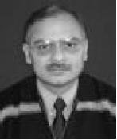
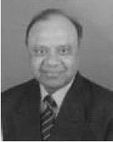
Prof. Vinod Kumar is Head of the Department of Electrical Engineering and Continuing Education Centre and the Coordinator of the Quality Improvement Centre at IIT Roorkee. He did his BSc. (Engg) from Punjab Engg. College, Chandigarh in 1973; M Tech. and Ph D in Electrical Engg. from University of Roorkee in 1975 and 1984, respectively. His research interests include ECG signal processing and analysis, digital signal processing and transducer instrumentation. He is the Life Fellow of the Institution of Engineers (I), Institution of Electronics & Telecommunication Engineers and Systems Society of India, Life Member of Indian Society for Continuing Engineering Education, Ultrasonic Society of India, Indian Society for Technical Education, Instrument Society of India, Biomedical Engineering Society of India, IEE UK and Senior Member of IEEE, USA.
Prof. H. K. Verma is at present the Deputy Director and Member of the Board of Governors of IIT, Roorkee. He has been the Head of the Department of Electrical Engineering, Dean of Research and Industry Liaison, Sponsored Research and Industrial Consultancy and Faculty Affairs at IIT, Roorkee. His research interests include measurement and instrumentation, digital protective relays, microprocessor and computer applications in instrumentation, power system protection, monitoring and control, medical instrumentation, telemedicine and medical informatics, telemetry and remote / supervisory control, automated test Equipment and Systems. He is a member of National Working Group on Philosophy and Application of Backup Protection for Transmission Lines, Reactors and Busbars and CIGRE National Study Committee on "Information System and Telecommunication for Power Systems" with Head Office at Central Board of Irrigation and Power, New Delhi.
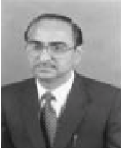

Mr. S. S. Sundaram is presently the Director of IRDE, Dehra Dun. He is engaged in the development of optical instrumentation, night vision instrumentation and laser instrumentation for the services in addition to realization of Fire Control Systems for tanks and ships. He has contributed considerably for the consortium of DRDO Labs, production partners in public and private sector in India and abroad and academia in fielding various sophisticated systems. He has vast experience in the field of communication electronic warfare and radar electronic warfare and has fielded integrated systems of high complexity, operating on wide area network, as leader of major programme/projects. As chief designer, he has led technology teams in the development of communication electronic counter measure systems including the design of fast settling frequency synthesizers, surveillance and monitor receivers and jammer exciters in DLRL, Hyderabad. He is a fellow of IETE, Optical Society of India and Instrument Society of India.
