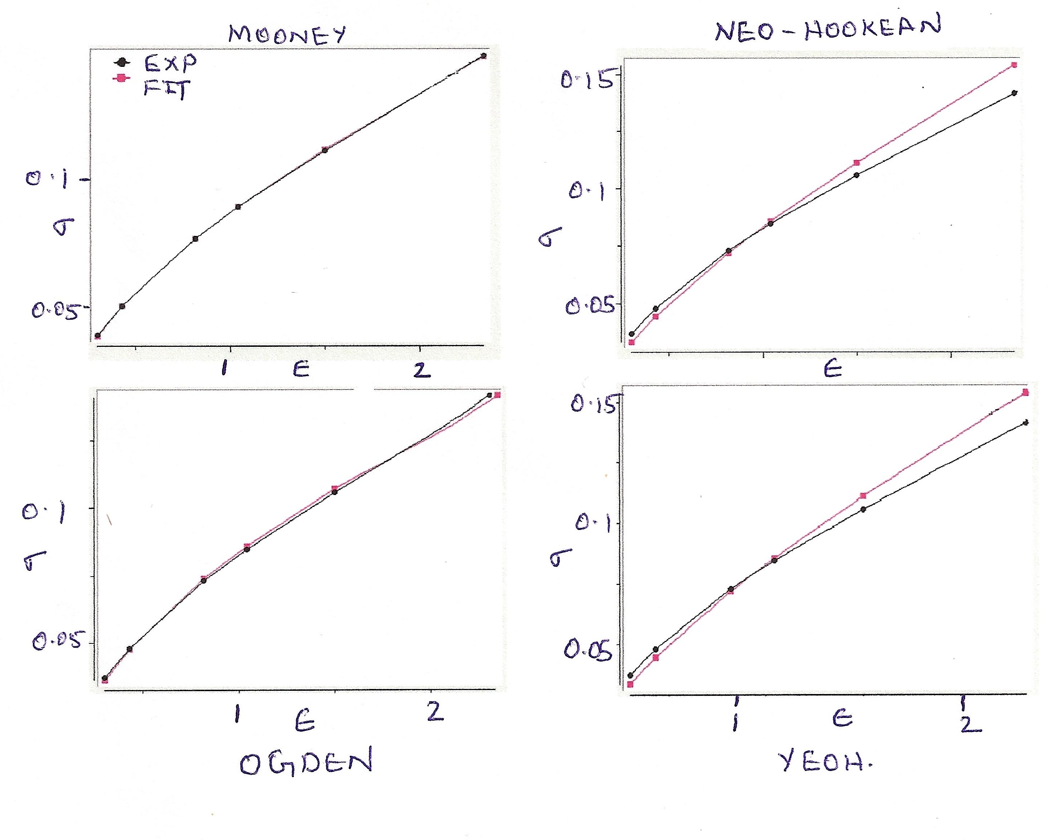

Figure-8 : Comparison of Material Models

Figure-9: Deformation Modes

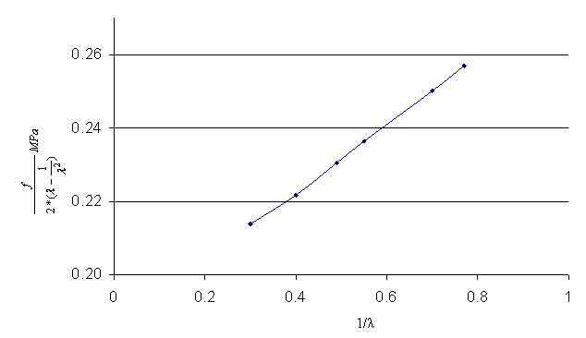

Figure-10: Mooney Rivilin Constants for Elastomer

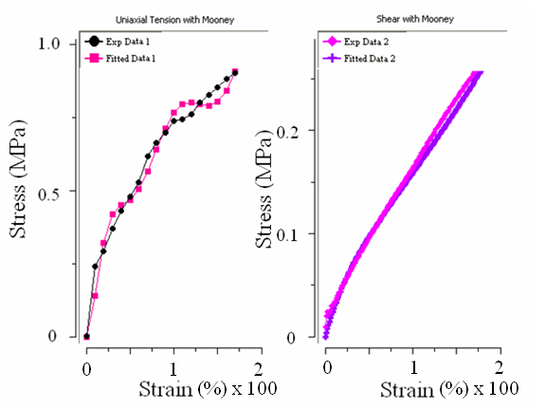
Figure-11: 2 Parameter Mooney Rivilin Model

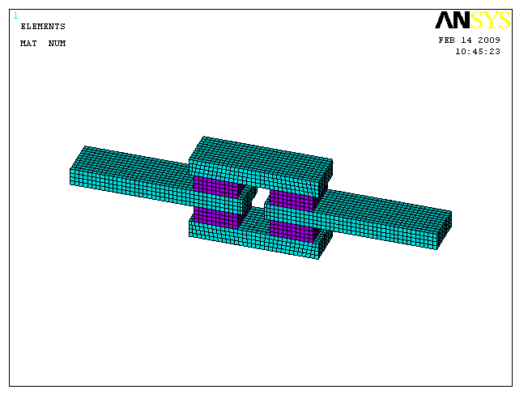
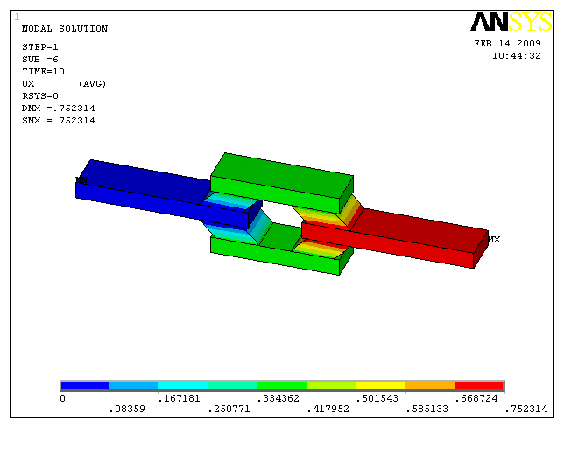

Figure-12: FE model of the QLSS specimen
Figure-13: Displacement plot in a QLSS specimen

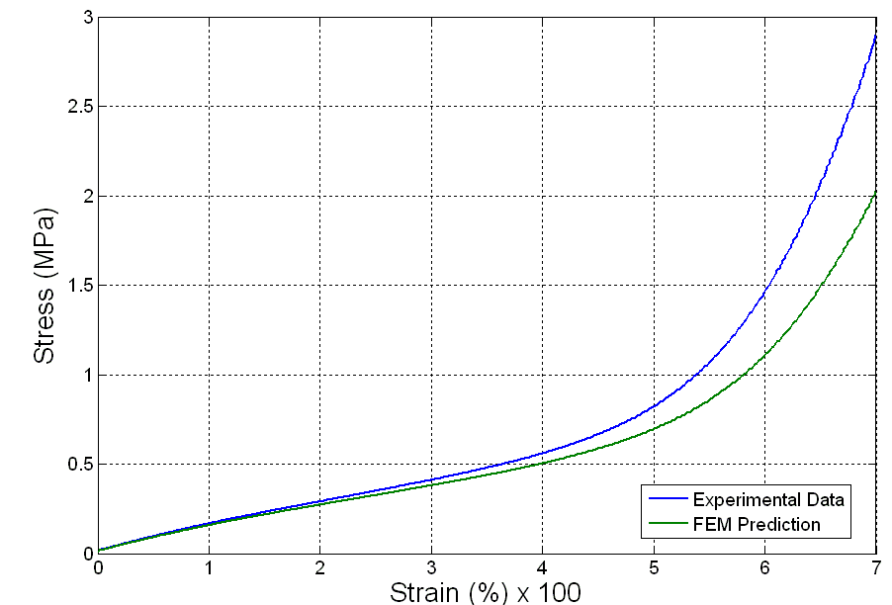

Figure-14: Comparison of FEM predictions and Experimental Results for a QLSS Specimen

