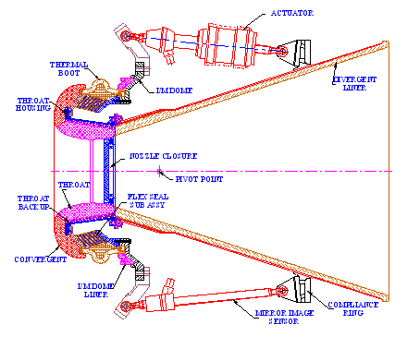
Figure – 1. Typical Flex Nozzle System

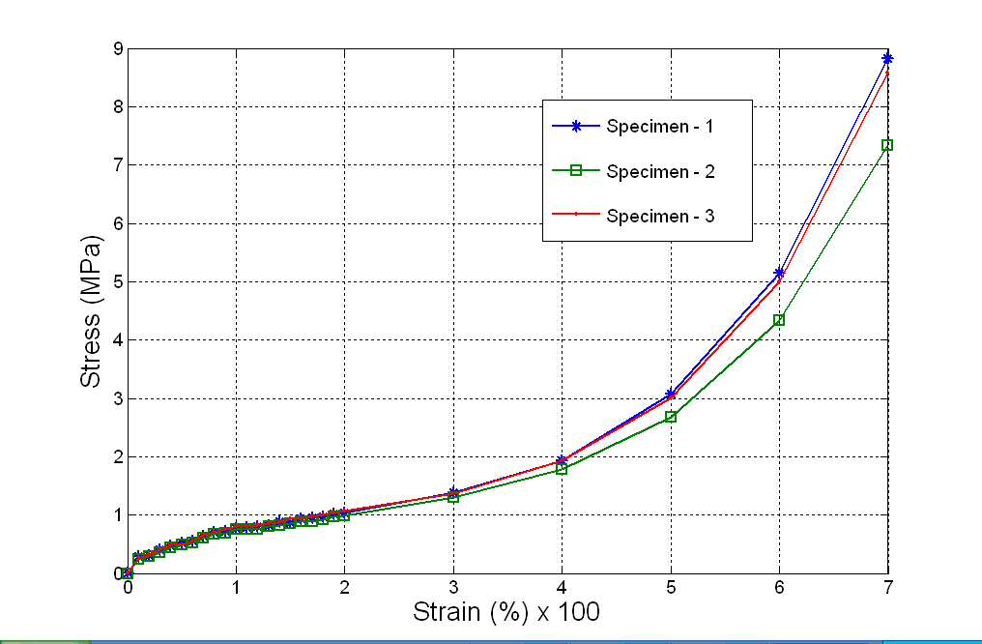
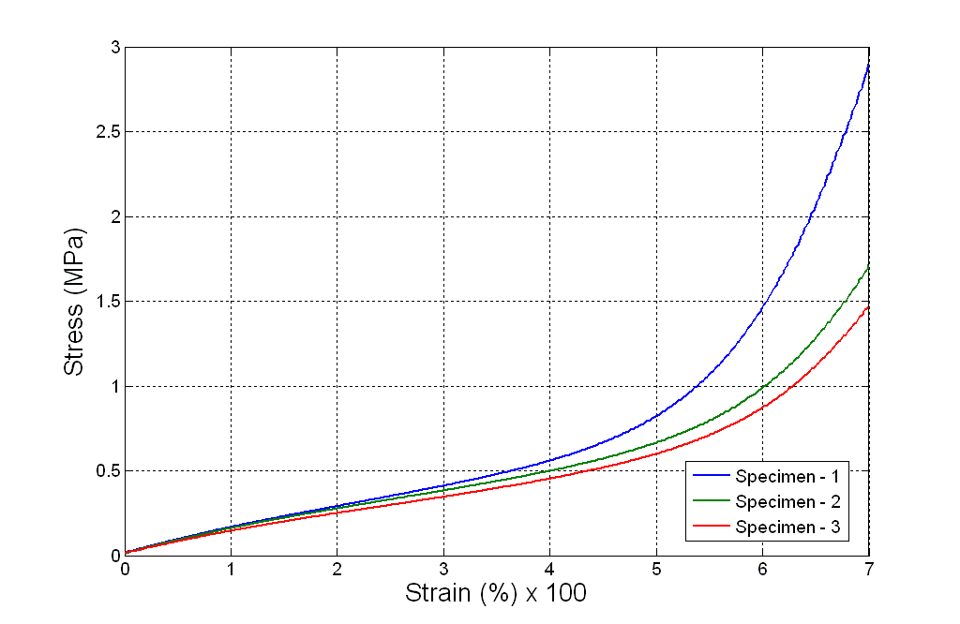

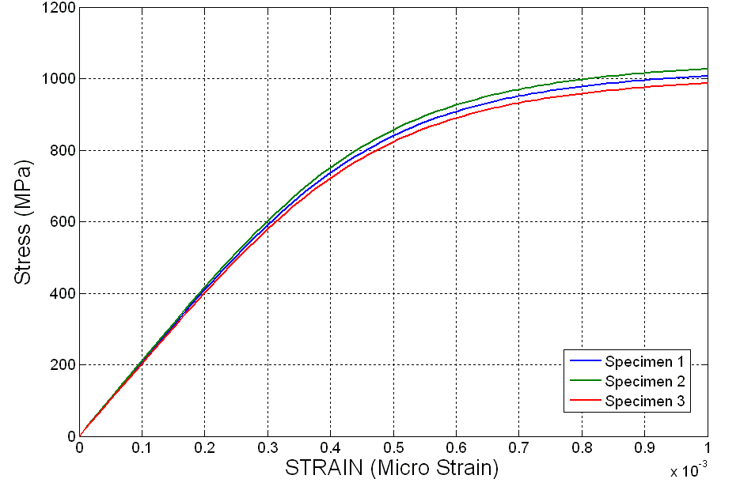
Figure-4: Stress Vs Strain for Tensile Test Specimen - Elastomer
Figure-5: Stress Vs Strain for QLSS Specimen - Elastomer

Figure-7: Stress vs Strain curve for tensile tests - Reinforcement

