Numerical investigation of hydrogen fuelled scramjet combustor with cavity flameholder
Malsur Dharavath, P. Manna & Debasis Chakraborty
Computational Combustion Dynamics Division, Directorate of Computational Dynamics
Defence Research & Development Laboratory,P.O. –Kanchanbagh, Hyderabad, INDIA
Tel: +91-40-24583323, Fax: +91-40-24340037 e-mail: debasis_cfd@drdl.drdo.in
ABSTRACT
Reacting flow field of a cavity based hydrogen fuelled Supersonic Combustion Ramjet (scramjet) combustor is explored numerically. 3-D NS equations are solved alongwith k-ε turbulence model and infinitely fast rate kinetics for combustion. Computed surface pressures match well with experimental values for different equivalence ratios. The cavity of the combustor behave as open cavity for both non-reacting and reacting flow even though the flow patterns inside the cavity are quite different for both the cases.
1. Introduction
Sustained flight at hypersonic speed in the atmosphere remains the largest unexplored region of the possible flight envelope. Development of air-breathing hypersonic technology has been the subject of renewed interest since 1980s because of tremendous military and commercial opportunities. The success of efficient design of such a transatmospheric hypersonic vehicle depends largely on the proper choice of the propulsion system which is capable of producing large thrust to overcome the drag experienced by the vehicle. These types of vehicles, according to current proposals, use supersonic combustion ramjet (scramjet) propulsion system. The research and development of scramjet engine technologies for various countries like USA, Russia, France, Japan, Germany, Australia and other countries for last four decades has been reviewed by Curran [1]. Two emerging applications, namely hydrogen and hydrocarbon-fuelled engines are mainly emphasized for the use in space and military purposes respectively.
A detailed understanding of the complex mixing and combustion process inside the combustor is required for the development of efficient scramjet engines. The flow field inside the scramjet combustor is fully three-dimensional with strong shock boundary layer interaction which causes flow separation. Fluid dynamics and chemistry interact very strongly inside the scramjet combustor. Detailed flow investigations are performed in various countries on different aspects of scramjet flow field including ignition, flame holding, fuel injection and intake combustor interaction for both hydrogen and kerosene fuel. Efforts were made to focus on different injection schemes like cavity, strut, pylon etc. for different geometrical configurations for fuel injection and flame-holding in scramjet combustor in. Various methods to enhance the mixing process in the scramjet engines are reported in Ref [2]. Some of the passive mixing devices like ramps, tabs, lobe mixers, vanes, backward facing step, port, cavity etc. use streamwise vorticity, swirl and acoustic excitation; while the active devices like vibrating splitter, pulsed jet, Helmholtz resonator and piezoelectric actuators use forced excitation to augment mixing. Cavity flame holders were found to facilitate self-ignition and flame stabilization due to substantial reduction of the critical equivalence ratio for stable combustion with the use of cavities. The physical mechanisms involved in cavity based flame holder on supersonic combustor are quiet complex and not properly understood. The existing definition of open and closed cavity characteristics is based on nonreacting flows and subject to revision for reacting flow situations. It is generally recognized that open cavities (L/h < 10) could be used for flame holding while the mixing enhancement could be achieved through the closed cavities. An overview of the research efforts using cavity as flame holder and flame stabilization with its effectiveness in scramjet flow field has been presented in details in Ref [3]. Yu et al [4] investigated experimentally eight different types of integrated wall injector cavity configurations to study the flame holding characteristics and combustor performance in scramjet combustor using hydrogen fuel. Both experimental and computational investigations [5-8] were carried out to study the flame characteristics and flame stabilization and combustion enhancement using cavity as a flame holder. Effects of cavity length, depth, aft ramp angle, back pressure etc on flow characteristics were studied in detail. Huang et al [7] studied numerically the effect of cavity length to depth ratio (L/h) and back pressure on the scramjet combustor flow field for nonreacting flow. Numerical investigation of combustion enhancement using cavity flame holder has been studied by Kim et al [8] to determine the effects of cavity length, depth, aft wall angle on combustion efficiency and total pressure loss.
Advanced flow models (including RANS, LES) and chemical kinetics involving multispecies and multi reaction paths were studied extensively in the literature to simulate Supersonic combustion with hydrogen fuel. Recently, Murty and Chakraborty [9] have demonstrated that standard engineering tools (simple chemical kinetic scheme and simple combustion model) can predict overall features of the mixing and reaction in a hydrogen fuelled scramjet combustor. In the present work, the experimental conditions of cavity based scramjet combustor with hydrogen fuel [4] are explored numerically. Three-dimensional Reynolds Averaged Navier–Stokes (RANS) equations along with standard k–ε turbulence model [10], species transport equations and the eddy-dissipation reaction models are solved to investigate the flow field numerically using a commercial CFD software [11]. The computed results are compared with the surface pressures reported in the literature [4]. Thermochemical parameters in the combustor are analyzed to understand the cavity characteristics in reacting flow.
2. Experimental set-up for which the computations are carried out
The schematic of cavity based scramjet combustor experiment [4] for which the computations are carried out is shown in Fig.1. Eight different types of integrated wall injector cavity configurations were designed and tested at various stagnation conditions with hydrogen fuel. High temperature vitiated air was produced by burning of hydrogen, oxygen and air in a heater, keeping the volume fraction equal to that of normal air. For all cases, the nominal Mach number at the entrance of the combustor entrance was 2.5, which was produced by the expansion of hot vitiated air through a two dimensional nozzle attached with the heater. Although the experimental condition of Yu et. al. considered eight different combustor configurations; present study considers two combustor geometries consisting of with and without cavities to investigate the detailed flow features inside the cavity. Detailed descriptions of the experiments are available in Ref.[4]. Combustor geometrical dimensions and inflow parameters are shown in Table 1. Combustor 1 has no cavity while the combustor 2 has a cavity of with L/h =3.0 with
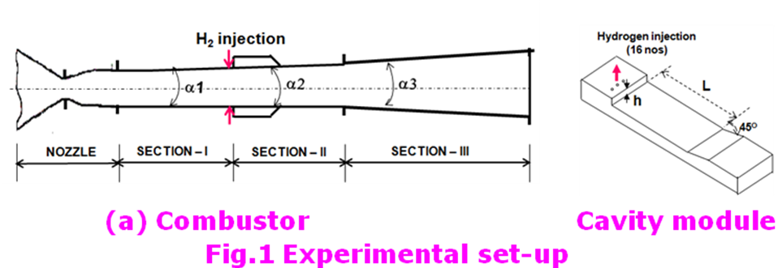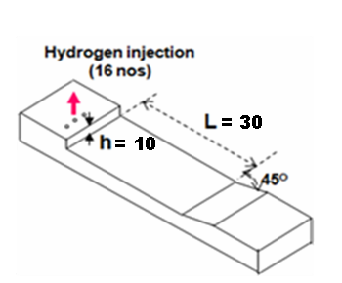
(a) Combustor (b) Cavity module
Fig. 1. Experimental set-up [4] for which the computations are carried out
ramp aft angle 45⁰. Stagnation pressure and temperature for both the combustors are 1.3 MPa and 1900 K respectively. The combustor is fitted with flush mounted interchangeable cavity modules on the top and bottom wall of the combustor. Sonic hydrogen gas was injected normally to the vitiated air stream via sixteen orifices (eight from top and eight from bottom wall) of 1.6 mm diameter located at an axial location of 140 mm from combustor inlet. In the present simulation, four different fuel equivalence ratios (0.46, 0.7, 0.93 and 1.14) are considered to understand the flow behavior in fuel lean as well as fuel rich conditions.
3. Computational methodology
Three dimensional Reynolds Averaged Navier Stokes (RANS) equations are solved using CFX-code [3], which is an integrated software system capable of solving diverse and complex multidimensional fluid flow problems. The code is fully implicit, finite volume method with finite element based discretization of geometry. The convective terms are discretized through 2nd order scheme and k - ε turbulence model with wall function is used. Hydrogen-air reaction is represented on a molar basis by 2H₂+O₂=2H₂O and the eddy dissipation combustion model is used. Log-normalized

Table 1 Geometrical dimension of the combustors and inflow parameters
Combustor details | Combustor 1 | Combustor 2
Length (mm) | 595 | 672
Width (mm) | 70 | 70
Section-I length (mm) & divergence (deg) | 140 & 1.0 | 140 &1.0
Section-II length (mm) & divergence (deg) | 155 & 1.0 | 155 & 5.0
Section-III length (mm) & divergence (deg) | 300 & 3.0 | 377 & 5.0
Cavity length (L, mm) & depth (h, mm) | ----- | 30 & 10
Cavity location from combustor inlet (mm) | ----- | 150
Location of fuel injection from combustor  inlet (mm) | 140 | 140
Test gas | Vitiated air
P_{o} (MPa) | 1.3
T_{o} (K) | 1900
Fuel | H₂
Fuel injection Mach no | 1.0
T_{o} of fuel (K) | 295
Nos. of H₂ injector and diameter (mm) | 16 & 1.6
Fuel equivalence ratio | 0.46, 0.7, 0.93, 1.14 | 0.7
maximum residue of -04 is considered as the convergence criteria. The details of the governing equations, thermodynamics and the discretization schemes are given in the following subsections. To find out the accuracy and the range of applications, the software has been validated for various reacting and non-reacting flows pertaining to the scramjet combustor including transverse sonic injection in supersonic flow [12], transverse H₂ injection in constant area duct [13], H₂ injection from struts [14, 15] and pylon injectors [16]. All these validation exercises have revealed that although, the computed pressures over predict the experimental values in the injection zone, the computational and experimental values of the flow parameters match fairly well in the divergent portion of the combustor where the major portion of thrust is produced.
Governing equations
The system of equations governs the turbulent flow of a compressible gas may be written as
Continuity equation:
$\frac{∂ρ}{∂t}+\frac{∂}{∂x_{k}}\left(ρ u_{k}\right)=0$ k = 1,2,3
Momentum equation :
$\frac{∂}{∂t}\left(ρ u_{i}\right)+\frac{∂}{∂x_{k}}\left(ρ u_{i} u_{k}\right)+\frac{∂P}{∂x_{i}}=\frac{∂(τ_{\text{ik}})}{∂x_{k}}$, i, k = 1,2,3
Energy equation :
$\frac{∂}{∂ t}\left(ρ H\right)+\frac{∂}{∂ x_{k}}\left(ρ u_{k}H\right)=−\frac{∂}{∂ x_{k}}\left(u_{j} τ_{\text{jk}}\right)+\frac{∂q_{k}}{∂ x_{k}}$, j, k = 1,2,3
Turbulent kinetic energy (K) equation :
$$\frac{∂}{∂t}\left(ρ K\right)+\frac{∂}{∂x_{k}}\left(ρ u_{k}K\right)= \frac{∂}{∂x_{k}}\left(\left(\frac{μ_{l}}{\text{Pr}}+\frac{μ_{t}}{σ_{K}}\right) \frac{∂K}{∂x_{k}}\right)+S_{K}$$
Rate of dissipation of turbulent kinetic energy (ε ) equation:
$$\frac{∂}{∂t}\left(ρ ε\right)+\frac{∂}{∂x_{k}}\left(ρ u_{k}ε\right)= \frac{∂}{∂x_{k}}\left(\left(\frac{μ_{l}}{\text{Pr}}+\frac{μ_{t}}{σ_{ε}}\right) \frac{∂ε}{∂x_{k}}\right)+S_{ε}$$
Species mass fraction (Z) :
$$\frac{∂}{∂t}\left(ρ Z\right)+\frac{∂}{∂x_{k}}\left(ρ u_{k}Z\right)= \frac{∂}{∂x_{k}}\left(\left(\frac{μ_{l}}{\text{Pr}}+\frac{μ_{t}}{σ_{c}}\right) \frac{∂Z}{∂x_{k}}\right)$$
where, ρ, u_{i}, p, H are the density, velocity components, pressure and total enthalpy respectively and μ = μ_{l} + μ_{t} is the total viscosity; μ_{l}, μ_{t} being the laminar and turbulent viscosity and Pr is the Prandtl number. The source terms S_{k} and S_{ε} of the K and ε equation are defined as
$S_{K}=τ_{\text{ik}}\frac{∂u_{i}}{∂x_{k}}−ρ ε$ and $S_{ε}= Cτ_{\text{ik}}\frac{∂u_{i}}{∂x_{k}}−C_{ε2}\frac{ρ ε^{2}}{K}$
where, turbulent shear stress is defined as
$$τ_{\text{ik}}=μ_{t}\left(\frac{∂u_{i}}{∂x_{k}}+\frac{∂u_{k}}{∂x_{i}}\right)$$
Laminar viscosity (μ_{l}) is calculated from Sutherland law as
$$μ_{l}=μ_{\text{ref}} {\left(\frac{T}{T_{\text{ref}}}\right)}^{3/2}\left(\frac{T_{\text{ref}}+S}{T+S}\right)$$
Where, T is the temperature and μ_{ref}, T_{ref} and S are known coefficient. The turbulent viscosity μ_{t} is calculated as
$$μ_{t}=c_{μ}\frac{ρ K^{2}}{ε}$$
The coefficients involved in the calculation of μ_{t} are taken as
c_{μ} =0.09, C_{ε1}=1.44, C_{ε2} = 1.92
σ_{K} =1.0, σ_{ε} =1.3, σ_{c} = 0.9
The heat flux q_{k} is calculated as $q_{k}= −λ \frac{∂T}{∂x_{k}}$, λ is the thermal conductivity.
Thermodynamics Model
A thermally perfect gas is assumed in the present study and, consequently, the specific heats for all species are function of temperature only. The specific heats are calculated using a fourth order polynomial at the internal of fluid temperature 300 – 5000 K. In each interval, the same form for the polynomials is used but different coefficients can be used.
$\frac{C_{p_{i}}}{R}=A_{i}+B_{i}T+C_{i}T^{2}+D_{i}T^{3}+E_{i}T^{4}$
Where, A_{i}, B_{i}, C_{i}, D_{i} and E_{i} are curvefit constants and T is the fluid static temperature. $C_{p_{i}}$ is linearly extrapolated when the fluid temperature T < 300 K or T > 5000 K. Then, the static enthalpy h, is calculated as $h=\sum_{i=1}^{n}{α_{i}h_{i}}(T)$ and the static enthalpy of each species$h_{i}(T)$, is
$h_{i}(T)={Δh}_{\text{fi}}^{o}+\int_{T^{0}}^{T}{C_{p_{i}}(T)\text{dT}}$
Where, ${Δh}_{\text{fi}}^{o}$ is the standard heat of formation of species I, defined as the heat evolved when one mole of substance is formed from its elements in their respective standard states at 298.15 K and 1.0 atmosphere. The fluid temperature is calculated based on the solution of the fluid enthalpy using a Newton’s iteration method for finding the roots of the polynomials. An equation of state of the following form for a multi-component is used to calculate fluid density$ρ=P/({\text{RT}}/{M_{w}})$, where the mixture molecular weight is obtained by the following equation, $M_{w}={\left(\sum_{i=1}^{n}{({α_{i}}/{M_{w}}}\right)}^{−1}$and $R$ is the universal gas constant.
The Gibbs free energy is required to determine the equilibrium constants for the combined eddy dissipation and finite rate chemistry models. It is obtained for a constant pressure process by
$\frac{g_{i}}{R}=A_{i}(T−\text{ln}T)−\frac{B_{i}}{2}T^{2}−\frac{C_{i}}{6}T^{3}−\frac{D_{i}}{\text{12}}T^{4}−\frac{E_{i}}{\text{20}}T^{5}+F_{i}−G_{i}T$
where $G_{i}$ is an additional curvefit constant.
  - Discretization of governing equations
The CFX-11 solver utilizes a finite volume approach, in which the conservation equations in differential form are integrated over a control volume described around a node, to obtain an integral equation. The pressure integral terms in the momentum integral equation and the spatial derivative terms in the integral equations are evaluated using finite element approach. An element is described with eight neighboring nodes. The advective term is evaluated using upwind differencing with physical advection correction. The set of discretized equations form a set of algebraic equations:$\overset{}{A} \overset{→}{x} = b$ where, $\overset{→}{x}$ is the solution vector. The solver uses an iterative procedure to update an approximated $x_{n}$ (solution of x at n^{th} time level) by solving for an approximate correction $x^{'}$ from the equation$A \overset{→}{x^{'}} = \overset{→}{R}$, where $\overset{→}{R} =\overset{→}{b} − A {\overset{→}{x}}_{n}$ is the residual at n^{th} time level. The equation $A \overset{→}{x^{'}} = \overset{→}{R}$ is solved approximately using an approach called Incomplete Lower Upper factorization method. An algebraic multigrid method is implemented to reduce low frequency errors in the solution of the algebraic equations. Maximum residual (=$ϕ_{j}^{n+1}−f\left(ϕ_{j}^{n+1}, ϕ_{j}^{n}\right)$ ) < 10⁻⁴ is taken as convergence criteria.
4. Results and discussion
4.1 Grid generation and boundary conditions
Taking the advantage of symmetry in the geometry, only one-fourth geometry of the combustor has been considered for the simulation. Multi-block structured grid with 1.1 million cells (450×45×55) are generated for 1/4th geometry. Typical grid structure for the combustor-2 along with the blown-up view near the cavity is shown in Fig.2.
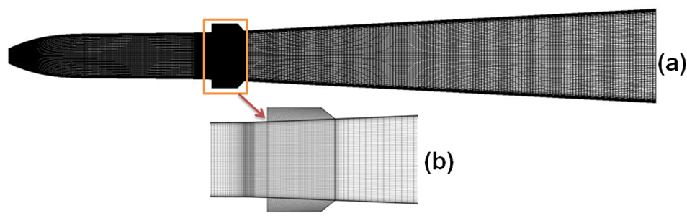
Fig. 2. Computational grid (a) Combustor-2 (b) Blown-up view near the cavity
The grids are much clustered near the inflow plane, solid walls and cavity region to capture the finer details of the flow. The origin of the computational domain has been taken at the middle of the combustor entry. In the simulation, X-axis is taken along the length of the combustor while Y and Z axes are taken along the height and width of the combustor respectively. The facility nozzle from the throat onwards is considered along with the combustor to get a realistic boundary layer profile at the inlet of the combustor. The sonic condition, no-slip and adiabatic wall and supersonic outflow conditions are prescribed in fuel inflow, wall and outflow boundaries respectively. The average Mach number at the combustor inlet has been found to about 2.5 which agree well with the experimental observation.

4.2 Combustor-1 flow characteristics
Mach number distributions for Nonreacting and reacting flow for equivalence ratio (φ) 0.46 in the symmetry plane for combustor-1 are shown in Fig.3.
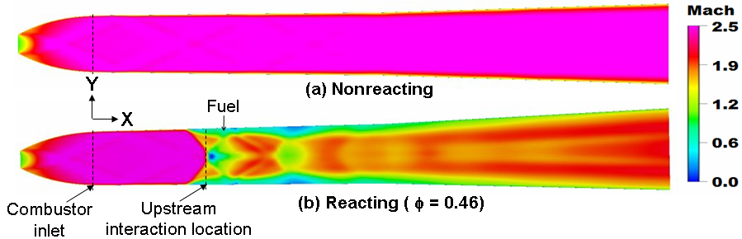
Fig. 3. Mach number distribution for Combustor-1
Predominant supersonic flow is observed in nonreacting flow throughout the combustor. Mach numbers are well above unity everywhere inside the combustor. However, for the reacting case, fuel injection and reaction caused the occurrence of complex shock reflections inside the combustor. The upstream interactions become more intense with increase in equivalence ratio. To quantify the effect, simulations were carried out for different equivalence ratio and the upstream interaction distance is plotted with fuel equivalence ratio in Fig. 4. Flow upstream interaction location is defined as the axial distance from the combustor inlet where predominant supersonic flow becomes subsonic in the core region of flow as shown in Fig.3. With the injection of more fuel i.e. increase of equivalence ratio, the upstream interaction increases and the interaction locations moves towards combustor inlet. This upstream interaction is also responsible for lower Mach number and higher static pressure ahead of the fuel injection (Fig.5). Average Mach number has been found to decrease initially and then increased in the divergent portion of the combustor in reacting flow (Fig.5(a)). The average Mach number along the length of the combustor has been found above unity even though subsonic pockets in the reaction zones have been observed for φ=0.46 (Fig.5(b)). However, for other equivalence ratios (φ =0.70, 0.93, 1.14), the average Mach number has been found to be subsonic in the reactive intense zones. The exit Mach number decreases with the increases of equivalence ratio. The exit Mach numbers are found to be 1.72, 1.51, 1.44 and 1.38 for at φ =0.46, 0.70, 0.93 and 1.14 respectively. Comparisons of top wall pressure between experimental and computation are shown in Fig.6. Computed top wall pressures match extremely well with the experimental results for nonreacting flow (φ=0.0). For reacting case, in the fuel injection zone, computation overpredicts the surface pressures because of the fast chemistry assumption in the simulation. But in the divergent section of the combustor, where most of the thrust is produced, the computed values agree well with the experimental values for all the equivalence ratios studied.
Fig. 4. Location of upstream interaction from combustor inlet
(a) Mach no (b) Static pressure
Fig. 5. Comparison of average Mach number and static pressure for various equivalence ratios
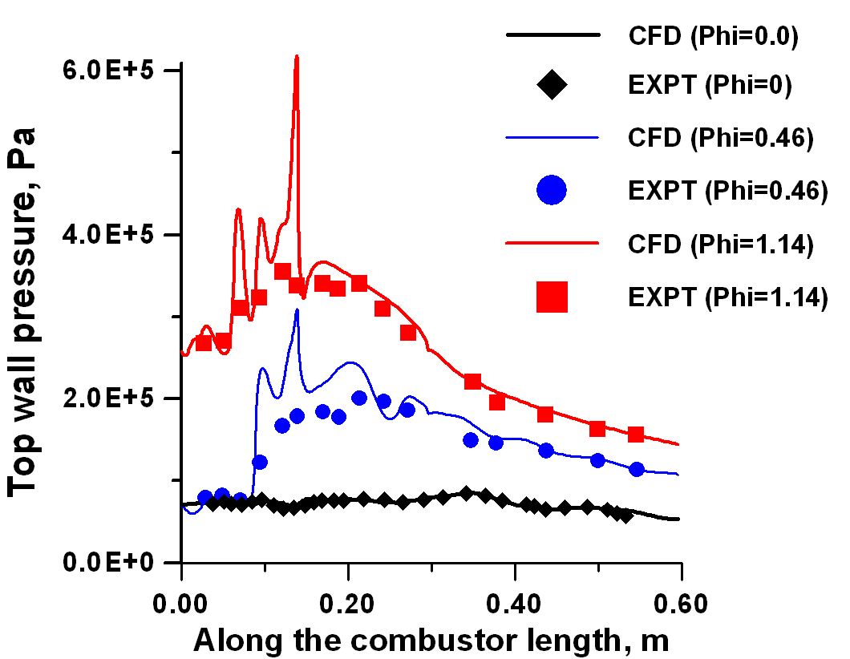
Fig. 6 Comparison of wall pressures between experiment and computation

4.3 Combustor-2 flow field and cavity characteristics
Mach number distributions in the symmetry plane for combustor-2 are shown in Fig.7 both for nonreacting and reacting flow (φ =0.7). The upstream interaction location has been found to be X=0.1182 m from combustor entry. Reacting flow average Mach number sharply decreases due to the reaction of fuel adjacent to the cavity regions (Fig.8). However, the average Mach number is above unity everywhere along the length of the combustor. The exit Mach numbers are found to be 2.82 and 1.90 for nonreacting and reacting flow respectively
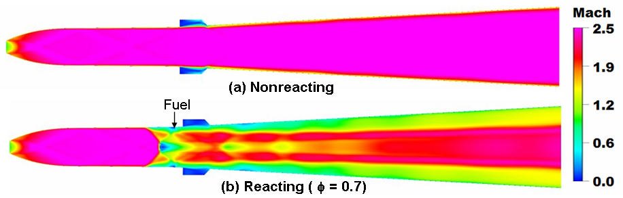
Fig. 7 Mach number distribution for Combustor-2
Fig. 8. Comparison of average Mach number between nonreacting and reacting flow
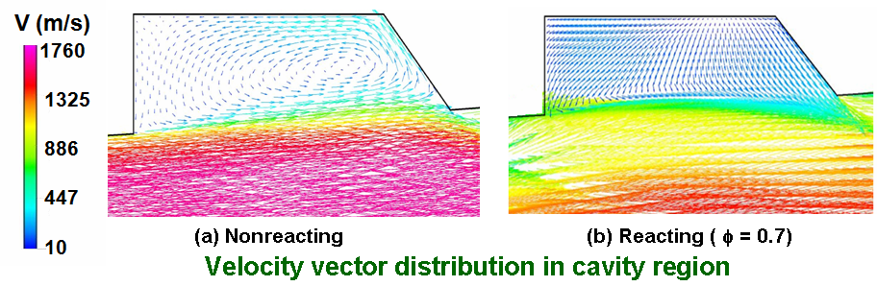
Fig. 9. Velocity vector plot in cavity region (combustor-2)
The flow field inside the cavity is studied in detail. Velocity vectors near the cavity region for reacting and nonreacting cases are shown in the Fig.9. Both the cases, the core flow is not seen to impinge inside the cavity. The velocity above the cavity is almost the same as free stream velocity about 1600 m/s in nonreacting flow, whereas, the same has been decreased to about 1200 m/s for reacting flow due to the fuel injection and the combustion of fuel. Recirculating flow pattern within the cavity is found to be quiet different between reacting and nonreacting flow. A well defined recirculating bubble is seen in the cavity for nonreacting flow; whereas, two weak recirculation bubble is seen in the cavity for reacting case. Although, the flow pattern inside the cavity region is markedly different between the reacting and nonreacting cases, the present cavity behaving like an open cavity for both the reacting and nonreacting cases. It is to be noted that the length to depth ratio (L/D) of the cavity is only 3.0 which is much below the limiting value of 10.
Fig. 10. Comparison of wall pressures between experiment and computation
Reacting flow top wall pressure comparisons between experimental and computation are shown in Fig.10. Wall pressure increases suddenly due to the injection of the fuel. Higher values of wall pressure have been observed adjacent to the cavity regions due to the reaction of the fuel. Computed top wall pressures match extremely well with the experimental results in the regions before the fuel injection and in the divergent combustor. The upstream interaction caused due to fuel injection is well captured in the simulation. However, in the fuel injection zone, comparatively higher pressures have been observed in CFD compared to the experimental measured values because of the fast chemistry assumption in the simulation as discussed earlier.
4.4 Comparison of results between combustor-1 and combustor-2 for φ= 0.7 – Effect of cavity
To find the effect of cavity on the flow field, the computed flow field without cavity (Combustor -1) and with cavity (Combustor -2) are compared for the same equivalence ratio 0.7. Fig. 11 depicts the comparisons of cross sectional distribution of Mach number at different axial stations [X =0.0 (combustor entry), 0.1, 0.16, 0.2, 0.3 and 0.5] for the two combustors for φ = 0.7. Computed mach numbers are found to
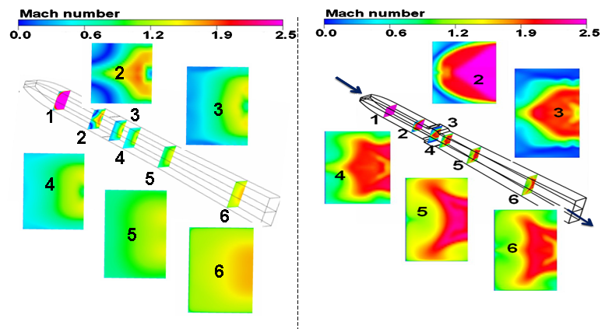
(a) Combustor-1 (b) Combustor-2
Fig. 11 Comparison of Mach number distribution at different axial planes (X=0, 0.1, 0.16, 0.2, 0.3 and 0.5 m)
be less in combustor-1 compared to combustor-2. This is due to more expansion in combustor -2 because of higher divergence (divergence angle is 5º and 3⁰ in combustor -2 compared to 1⁰ and 3⁰ combustor-1) In fact, the combustor-1 has the sections-1 and 2 to be almost flat (1⁰ divergent) upto L=0.295 m. Due to this, static pressure and static temperature rise more for combustor-1. The comparisons of average pressure and temperature for both the combustor are shown in Figs.12 and 13 respectively. Sudden rise of pressure for the combustors is found at X=0.14 m due to the fuel injection normal to the flow.
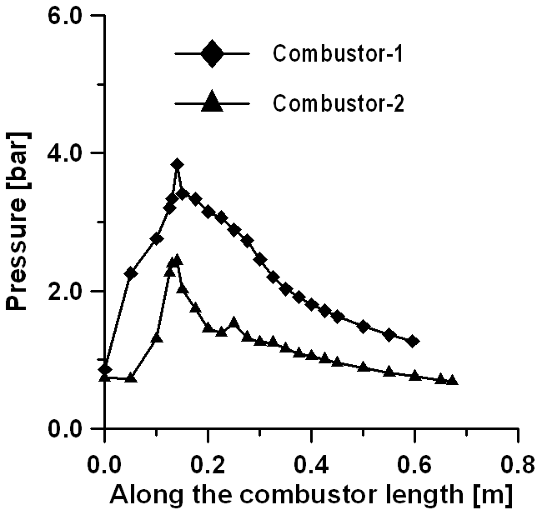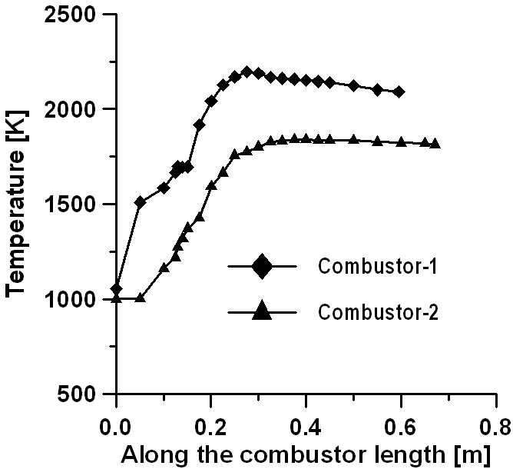
Fig.12. Average static pressure comparison Fig.13 . Average static temperature comparison
The combustion process inside the combustor is depicted through the water vapour mass fractions distribution at different axial positions for combustor-1 and combustor-2 in Figs.14(a) and 14(b) respectively. Almost no combustion is observed at X=0.1 m for combustor-1 but combustion has been visible at the same location for combustor-2 at the corners which may be due to the presence of cavity and upstream interaction of the flow. Combustion has been found in the whole cavity region (X=0.16 m) of combustor-2. However, as it proceeds downstream, more zones are covered under combustion in combustor-1 compared to combustor-2. This may be due to the higher upstream pressure and temperature and lesser expansion of the flow geometry.
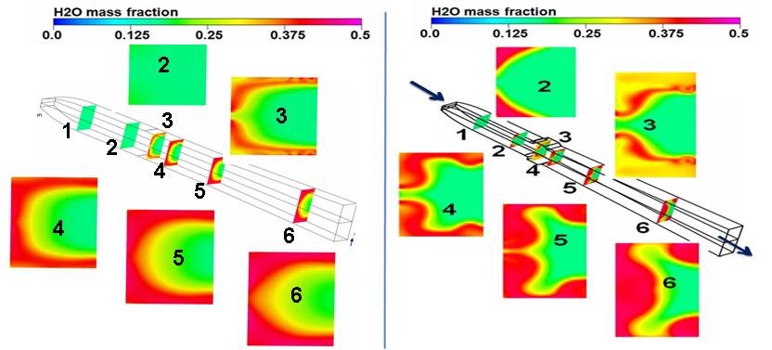
(a) Combustor-1 (b) Combustor-2
Fig. 14. Comparison of H₂O mass fraction at different axial planes (X=0, 0.1, 0.16, 0.2, 0.3 and 0.5 m)
The amount of fuel burnt has been calculated along the axial length and divided by the amount of total fuel injection to get the combustion efficiency. It has been found the amount of fuel is burnt more in combustor-1 than combustor-2 which gives combustion efficiency better in combustor-1 as shown in Fig.15. Due to this, average static pressure and temperature are found more in combustor-1 towards the downstream of the fuel injection (as shown in Figs.12 & 13).
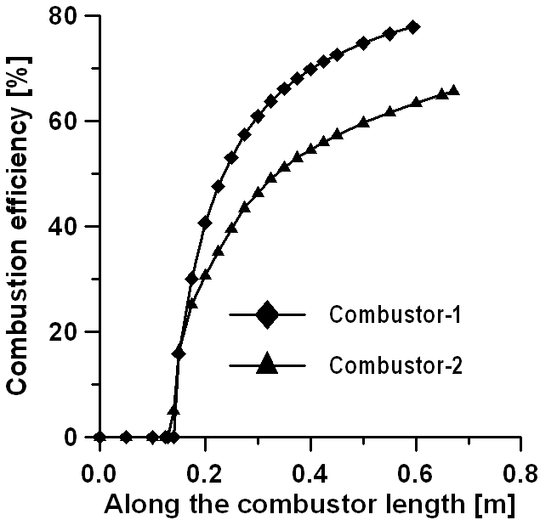
Fig. 15. Combustion efficiency comparison Fig. 16. Comparison of thrust along the length
Comparison of availability of thrust has been plotted in Fig.16. Thrust at any axial location is calculated by equating the momentum of that axial plane and then by subtracting the momentum at the combustor entry. Even though combustor-1 shows higher combustion efficiency, combustor-2 shows more thrust production which may be due to the higher flow expansion compared to combustor-1. The specific impulse is calculated by dividing the thrust by fuel flow rate and is found to be 979 s and 1233 s for combustor-1 and combustor-2 respectively.
In order to compare the performance of the same geometrical configuration, a new simulation has been carried out considering the combustor-2 configuration without cavity. The combustor outer envelope, inflow boundary conditions and the fuel injection remain the same except the deletion of the cavity from combutor-2 geometry. The results of the combustion efficiency and thrust availability are compared in Figs.17 and 18.
Fig. 17 Combustion efficiency comparison Fig. 18. Comparison of thrust along the length
The upstream interaction has been found more in without cavity case (X= 0.1178 m) compared to with cavity case (X=0.1182 m). Hence, combustion has been found to occur early in case of without cavity combustor as shown in Fig.17. However, more combustion has been found downstream of the cavity (with cavity case) which may be due to better mixing and reaction in presence of cavity. Because of this, higher combustion efficiency has been found at the exit of the combustor in with cavity case (65.6%) compared to without cavity case (62.3%). As a result, almost 14.63% more thrust has been achieved with cavity compared to without cavity case as shown in Fig.18. Small lab-level combustors like the present configuration, cavity can be used effectively for better nixing and combustion and thrust availability in accordance to the flameholding, but the cavity effectiveness need to be studied for the flight sized combustor before employing them in the design.
5. Conclusions
A cavity based hydrogen fuelled scramjet combustor is numerically explored for different equivalence ratios. Three dimensional Navier Stokes equations alongwith k-ε turbulence model and fast chemistry based combustion model are discretized using commercial CFD software. Simulations capture all the essential features of the mixing and reaction in the scramjet combustor. Computed surface pressures match well with experimental data for different equivalence ratios; although, the computation overpredicts the surface pressure in the fuel injection zone because of fast chemistry assumption. The comparison of cavity flow field between non reacting and reacting cases reveals that cavity is behaving as open type for both the cases even though the flow patterns in the cavity are markedly different. The cavity can be effectively used for mixing augmentation and combustion in small scale combustor.
REFERENCES
[1] E.T. Curran, Scramjet Engines: The first forty years, Journal of Propulsion and Power 17 (6) (2001) 1138-1148.
[2] John M. Seiner, S.M. Dash, D.C. Kenzakowski, Historical survey on enhanced mixing in scramjet engines, Journal of Propulsion and Power 17 (6) (2001) 1273-1286.
[3] Adela Ben-Yakar, Ronald K. Hanson, Cavity flame-holders for ignition and flame stabilization in scramjets: An overview, AIAA Journal of Propulsion and Power 17 (4) (2001) 869-877.
[4] G. Yu, J.G. Li, X.Y. Zhang, J.H. Chen, B. Han, C.J. Sung, Experimental investigation on flameholding mechanism and combustion performance in hydrogen-fuelled supersonic combustor, Combustion Science and Technology 174 (2002) 1-27.
[5] M-B Sun, H-Y Wu, Z-Q Fan, H-B Wang, X-S Bai, Z-G Wang, J-H Liang, W-D Liu, Flame stabilization in a supersonic combustor with hydrogen injection upstream of cavity flame holders: Experiments and simulations, Part G: Journal of Aerospace Engineering 225 (2001) 1351-1365.
[6] M.R. Gruber, R.A Baurle, T. Mathur, K.Y. Hsu, Fundamental studies of cavity-based flameholder concepts for supersonic combustors, Journal of Propulsion and Power 17 (1) (2001) 146-153.
[7] Wei Huang, Zhen-guo Wang, Li Yan, Wei-dong Liu, Numerical validation and parametric investigation on the cold flow field of a typical cavity-based scramjet combustor Acta Astrnautica 80 (1) (2012) 132-140.
[8] K.M. Kim, S.W. Baek, C.Y. Han, Numerical study on supersonic combustion with cavity-based fuel injection, International Journal of Heat and Mass Transfer 47 (2004) 271-286.
[9] M.S.R Chandra Murty, D. Chakraborty, Numerical simulation of angular injection of hydrogen fuel in scramjet combustor, Journal of Aerospace Engineering 226 (7) (2012) 861-872.
[10] B.E. Launder, D.B. Spalding, The numerical computation of turbulent flows, Computer Methods in Applied Mechanics and Engineering 3(2) (1974) 269– 289.
[11] ANSYS CFX, Release 11.0: Installation and Overview, July 2007.
[12] P. Manna, D. Chakraborty, Numerical investigation of transverse sonic injection in a nonreacting supersonic combustor, Proc. IMechE Part G: J. Aerospace Engineering 219 (2005) 205-215.
[13] P. Manna, and D. Chakraborty, Numerical simulation of transverse H₂ combustion in supersonic airstream in a constant area duct, Journal of The Institution of Engineers (India) 86 (November 2005) 47-53.
[14] Malsur Dharavath, P. Manna, D. Chakraborty, Thermochemical exploration of hydrogen combustion in generic scramjet combustor, Aerospace Science and Technology 24 (2013) 264-274.
[15] S. Saha, D. Chakraborty, Reacting flow computation of staged supersonic combustor with strut injection, AIAA Paper 2006-3895, 2006.
[16] A. Javed, D. Chakraborty, Numerical simulation of supersonic combustion of pylon injected hydrogen fuel in scramjet combustor, Journal of The Institution of Engineers (India) 87 (2006) 1-6.

