Figures with Caption

Fig. 1 Schematic of cascade planar fin model; FPC3_0.5N

Fig. 2 Schematic of cascade planar fin model; FPC3_0.5Y

Fig. 3 Schematic of cascade planar fin model; AFC4_0.5N

Fig. 4 Experimental setup for cascade fins
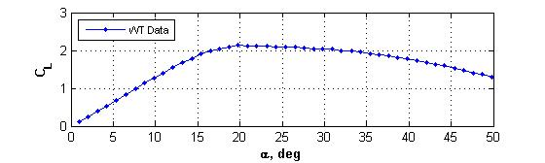
Fig. 5 Variation of C_{L} with α; FPC4_0.5N

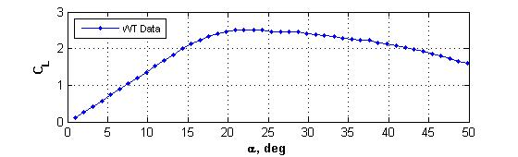
Fig. 6 Variation of C_{L} with α; FPC4_0.6N

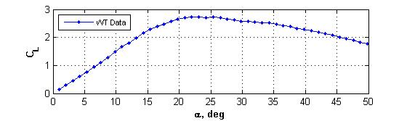
Fig. 7 Variation of C_{L} with α; FPC4_0.7N

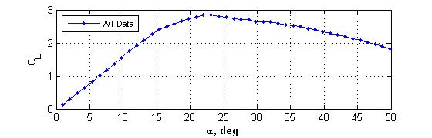
Fig. 8 Variation of C_{L} with α; FPC4_0.8N

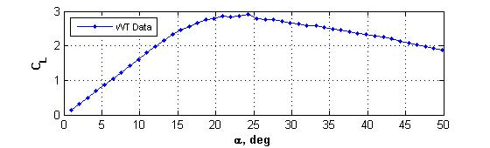
Fig. 9 Variation of C_{L} with α; FPC4_0.9N

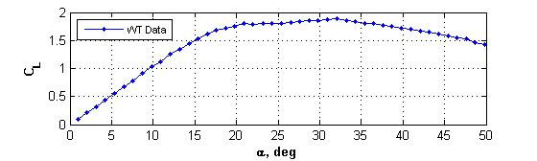
Fig. 10 Variation of C_{L} with α; FPC3_0.5N
Fig. 11 Variation of C_{L} with α; FPC4_0.5N

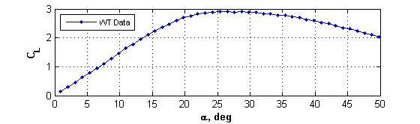
Fig. 12 Variation of C_{L} with α; FPC5_0.5N

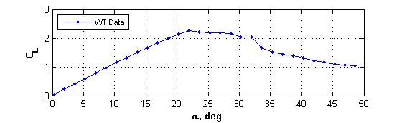
Fig. 13 Variation of C_{L} with α; AFC4_0.5N
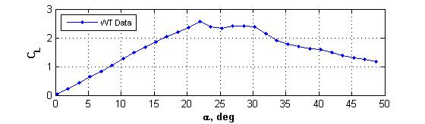
Fig. 14 Variation of C_{L} with α; AFC4_0.6N

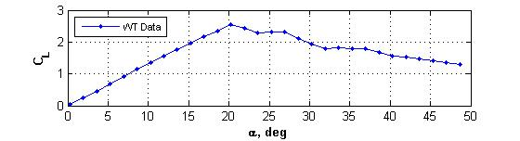
Fig. 15 Variation of C_{L} with α; AFC4_0.7N

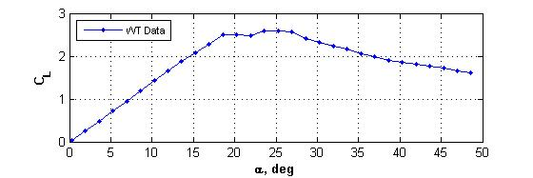
Fig. 16 Variation of C_{L} with α; AFC4_0.8N
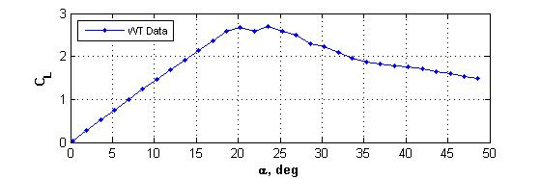
Fig. 17 Variation of C_{L} with α; AFC4_0.9N

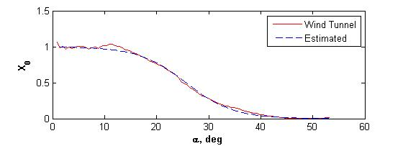
Fig. 18 Measured and estimated X₀; FPC4_0.5Y

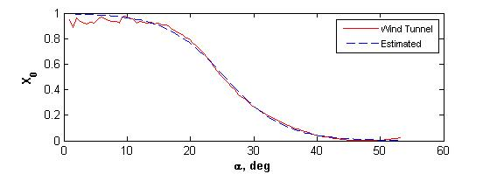
Fig. 19 Measured and estimated X₀; FPC4_0.6Y
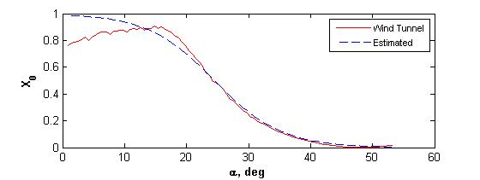
Fig. 20 Measured and estimated X₀; FPC4_0.7Y

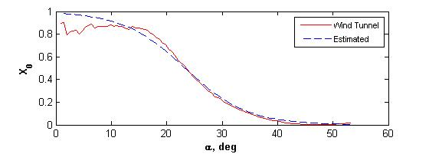
Fig. 21 Measured and estimated X₀; FPC4_0.8Y

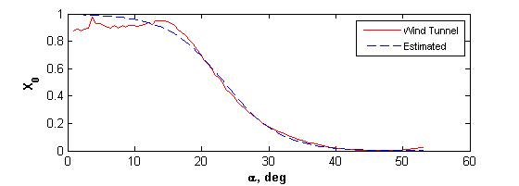
Fig. 22 Measured and estimated X₀; FPC4_0.9Y

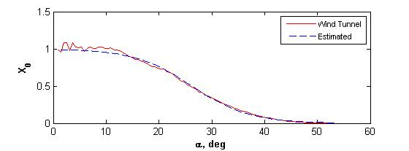
Fig. 23 Measured and estimated X₀; FPC3_0.5Y

Fig. 24 Measured and estimated X₀; FPC4_0.5Y

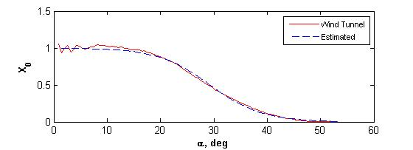
Fig. 25 Measured and estimated X₀; FPC5_0.5Y

