Testing of Paraffin-Based Hybrid Rocket Fuel Using Gaseous Oxygen Oxidizer

Yash Pal¹, J. Baskar², S. Murugesan³
Department of Aeronautical Engineering
Hindustan University, Chennai, India-603103
Email: yashsoni06@gmail.com

ABSTRACT

A series of paraffin-based hybrid rocket fuels have been studied experimentally in a laboratory-scale motor. To enhance the regression rate of paraffin solid fuel, three types of grain configurations were employed. Cylindrical, star and helical grain configuration of paraffin wax have been developed and tested with gaseous oxygen. The helical fuel grain presented the best performance among all test ports. About 40.2% and 20.6% regression rates increased by burning paraffin fuel with helical and star grain configuration respectively, as compared with cylindrical gain configuration at Gox=0.0191 g/mm²sec. The regression rates were significantly influenced by the oxygen injection pressure varied between 50psi and 90psi. Furthermore, the experimentally obtained exponents of oxidizer mass flux for all three grain configurations were found to be significantly different from those of the classical hybrid system. Finally, thrust-time traces for all three grain configurations were also studied. The result shows no significant increase or decrease in the amplitude of the thrust oscillations.

Keyword: Hybrid rocket; Regression rate; Injection pressure; helical grain; Star grain

NOMENCLATURE
= Regression Rate, mm/sec
G = Total mass flux, g/mm²sec
G_{o} = Gaseous oxidizer, g/mm²sec
m_{f} = Fuel mass flow rate, g/s

- INTRODUCTION

Hybrid rocket propulsion is attractive for its potential safety, non-polluting and low-cost characteristics as compared to solid rocket. In addition, the ability to change thrust over a wider range, engine shutdown and restart can be easily obtained by controlling oxidizer flow through the hybrid rocket motor. Other advantages offered by hybrids over liquid rockets include lower temperature sensitivity and throttling ability. Regression rate measurements in hybrid rocket engines are pre-requisite for the motor design. However, classical hybrid rockets have suffered from slow solid-fuel regression rates. Thus the most of researches are focused on the subject to enhance the regression rate of solid fuel without scarify the efficiency. Due to low regression rate of rubber based hybrid rocket solid fuel the attainable thrust level is very low as compared to other chemical rockets. Several investigations have been reported from researchers to enhance the regression rate of solid fuel. Some of methods are like use of energetic metallic additives in fuel, swirl oxidizer injection as well as the insert in the port of fuel grain to enhance the turbulence level prior to combustion. Hence, some of conventional hybrid motor has designed with multi-port grain configuration to achieve the required thrust levels. However, these Conventional methods have also undesirable characteristics.
Fast burning Paraffin based solid hybrid fuel was developed and tested at Stanford University¹. The results reported enhancement of regression rates 3-4 times larger than the conventional solid fuels. Since, the high regression rate attributed to the entrainment of liquid droplets of paraffin into the flame zone leads to a more dominant mass transfer mechanism.
Carmicino and Sorge² conducted a series of firing test to investigate the influence of the oxidizer injection on the solid fuel regression rate behavior. The regression rate of solid fuel was observed to increases several times in the region of the oxygen impingement on the grain’s surface. The ultrasound pulse-echo technique was used to measure local instantaneous regression rates. George, et al³ carried out systematic experimental investigations for regression rate enhancement for HTPB/GOX system. The effects of addition of AP or aluminium in the solid fuel, the variation of oxidiser fuel ratio, and the variation of characteristic dimensions of fuel grain had been reported. While the addition of AP and/or Al, and the reduction of grain port diameter enhances the regression rate. The experimentally obtained exponents of oxidizer mass flux and port diameter were found to be significantly different from those of the conventional turbulent diffusion-limited theory.
The experimental studies on combustion characteristics of cylindrical multi-port grain of a 96mm diameter hybrid rocket motor were conducted by Kim et al⁴. This work brought out the effect of the port number and the distance between ports on a regression rate of solid fuel. The results indicate regression rates becomes fast as the port number increases to a typical number up to 4 ports. Series of experiments was conducted to investigate the enhancement of regression rate with a helical grain configuration and embedded metal wires in solid fuel. Test results reported⁵ that the embedded metal wires method turned out to be ineffective whereas the 50% enhancement of regression rate was observed with helical grain configuration.
Changjin et al⁶ conducted a series of experimental investigation to optimize the conditions of oxidizer swirl flow and grain configuration for enhancement of regression rate of solid fuel. PMMA with gaseous oxygen was the solid fuel for investigation. The test results revealed that with helical grain configuration the regression rate enhanced up to 50 %. Also, numerical simulations shown that a helical grain induces swirl flow and increase the turbulence level along the helical grain. The ignition of the Paraffin/Polyethylene as solid fuels, regression rates and burning performance with gaseous oxygen was studied by Santos et al⁷. The main conclusion of their work was that the regression rate of paraffin-based fuel enhanced two to three folds compared to the ultra-high molecular weight polyethylene.
Palani and Amit⁸ have conducted a numerical simulation to investigate the enhancement of the regression rate of mixed hybrid rocket. AP as an oxidizer, mixed with HTPB solid fuel, ranging from 0% to 50% has been utilized for regression rate simulation. The increment in regression rate from 5.9 % to 183% has been reported by the authors. To extend the residence time of oxidizer in fuel grain port Wilkinson et al⁹ used a taper fuel-grain cavity in hybrid motor. Results of static test firing had shown an improvement in specific impulse of 10% with useful increment in regression rate. It observed that the increased regression rate has been not up to the level as compared to the work of other using gaseous oxygen.
This paper details the regression rate finding of solid fuel with different grain port geometry. The fuel and oxidizer selected for the experimental investigation are Paraffin-Wax and Gaseous oxygen respectively.

- Experimental Setup

  - Fuel grain specimen

In the present experimental investigation four types of paraffin fuel grain port configuration were considered. The first three circular, star and helical grain configurations were developed. The second circular fuel grain consisted of 85% paraffin and 15% Al by mass as additive as shown in Fig.1. All the fuel grains were prepared by pouring liquid paraffin wax into casing block with centred spindle of diameter 10mm. The paraffin has tendency to shrink in volume when transitioning from liquid to solid. Hence, the fuel grain after casting was allowed to cool and resolidify very slowly at room temperature to avoid this issue. The casted paraffin fuel grains were observed free from any bubbles or major cracks along length of grain. The pre and post firing test results were shown in Fig.2. The Al metal loaded paraffin fuel grain was tested (tearing by hand), significant strength and uniform distribution of aluminium particle was observed throughout the fuel grain.

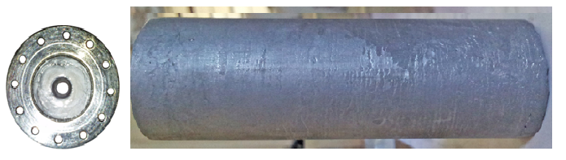
Fig.1 Finished Paraffin Fuel Grain with Al additive.

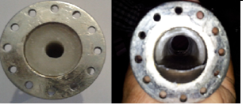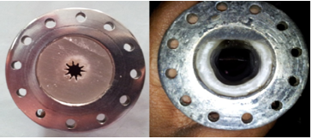
Fig.2 Pre and Post Test Result for Cylindrical and Star Paraffin Fuel Grains

  - Test Equipment

The hybrid rocket test facility consists of GOx, hybrid motor, ignition system and thrust measuring system. Gaseous oxidizer system was designed to supply and regulate the flow of oxygen from cylinder into the motor during test. A pressure regulator was used to control and maintain the desired constant mass flow rate of oxygen. Two NRV valves are included into the supply line to prevent the back flow into oxygen cylinder. High pressure oxygen Teflon line was used as a feed line from oxygen supply. The oxygen supply was guided into inlet of injector plate through a cup shaped oxidizer chamber of length 33mm and diameter 30mm. Injector plate of stainless steel with 47mm pitch circle diameter was used to ensure axial injection of oxidizer. Injector plate consists of 17 numbers of holes with diameter of 1mm. The length of hybrid rocket motor combustion chamber is 92mm with inner diameter 30mm. Schematic of test motor as shown in Fig.3. A straight cone convergent-divergent nozzle with throat diameter 6mm and nozzle area ratio 7.1 has been used.

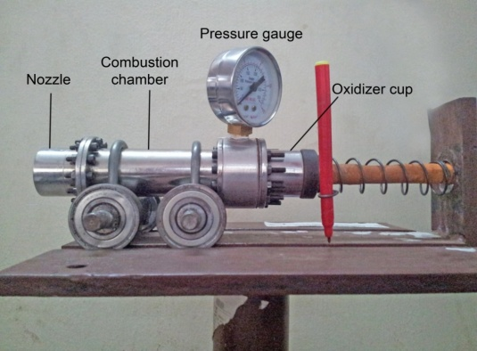
Fig.3 Schematic of Hybrid Test Motor

  - Thrust Measurement

The thrust was measured using calibrated spring mounted on head end of test motor as shown in Fig.3. The test motor was mounted on Bearing, which can accommodate linear and rotary motions simultaneously, used for the free motion of the hybrid rocket motor on the slots of test stand. During the test firing, the thrust force exerted by motor on spring is proportional to its deflection.
Thrust detector was calibrated using Hook’s law. Known loads between 1kg and 6kg were suspended from the spring testing machine and the deflection of spring was collected. The stiffness of the spring is 1Kg/mm. The calibration curve and calibration testing are shown in Fig.4 and Fig.5.
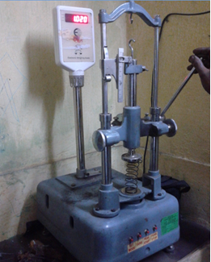
Fig.4 Calibration of the thrust sensors Fig.5 Calibration of thrust spring

  - Experimental Procedure

The fuel grains of required size were loaded in the combustion chamber at a distance of 2mm from head end. The combustion chamber wall surface was inhibited with inhibitor and cured grain was bonded to the inhibitor using epoxy. In order to conduct each test run and to maintain consistency during the test a set of general process was followed. The oxidizer injection pressure was regulated at the desired value with the help of a regulator. After the flow became steady in oxidizer chamber, the combustion was initiated by the pyrogen igniter. The igniter was placed in the port of the fuel grain towards the head end of the grain already loaded in the combustion chamber.

Fig.6 Test Firing of Hybrid Motor with Helical Fuel Grain

Oxygen gas was injected as soon as the igniter fired and the combustion was terminated after a lapse of pre-requisite duration by cutting off the oxidizer flow. The test measurements were the thrust and the chamber pressures. The other pre-and posttest measurements were the oxygen mass flow rate, final fuel grain weight. A test firing of hybrid motor with helical fuel grain was shown in Fig.6.

- Result and Discussion

The regression rate of hybrid fuel plays an important role for the satisfactory design and development of practical hybrid propulsion system. The combustion in hybrid rocket motor for paraffin based solid fuels is significantly different than that for classical rubber based fuels. The combustion process can be characterized as heat is transferred through convection and radiation from flame zone to the fuel. Due to entrainment of small droplets from liquid layer on fuel surface to combustion zone cause dominant mass transfer mechanism and cause the fuel to burn much faster. This new process of mass transfer is attributed to low melting point of paraffin. To enhance the regression rate of paraffin solid fuel, three types of grain configuration are employed in the present study.

  - Fuel regression rate

Static test firing are carried out with circular, star and helical fuel grain configurations. The oxidizer injection pressure varied between 50psi and 90psi. Regression rate is determined mainly by the grain weight burnt during the test. Oxygen mass flux is estimated based on the average port area. The experimental results have been presented in Table.1 for all the test firings. Fig.7 through Fig.9 shows the regression rate variation with Oxygen mass flux for circular, star and helical port configuration respectively. A curve fit to the regression rate data point results in an oxygen mass flux exponents of 0.58, 0.33 and 0.11 for cylindrical, star and helical port configuration respectively. It has been observed that this value is slightly smaller than the flux exponents commonly observed in classical hybrid rocket fuels. Since, the fuel regression rate is the exponential function of oxidizer mass flux. So, the higher oxygen mass flux in Fig.8 resulted in the higher fuel regression rate and much fuel from fuel surface was vaporized toward the diffused oxidizer in combustion zone.
Fig.7 Regression rate variation for cylindrical Fig.8 Regression rate variation for star
grain with Oxidizer mass flux grain with Oxidizer mass flux

As compare with all three ports configuration result shows lower regression rates for circular port because of the change of flow characteristics in each fuel port as indicated in Fig.10. The result shown the enhancement of turbulence by helical grain is one of the important design factors in controlling the regression rate along with the residence time of oxidizer stream.
Fig.9 Regression rate variation for helical Fig.10 Effect of different grain configuration
grain with Oxidizer mass flux on regression rate of fuel

  - Effect of Oxidizer Injection Pressure

Oxygen injection pressure was varied using the oxygen regulator ahead of injector. Fig.11 illustrates the increasing relationship between oxygen injection pressure and fuel mass flow rate. The enhanced fuel liberation rate associated with helical port among all three port configuration due to the increasing oxygen injection pressure. The tailored regression rate of helical port is attributed to generation of turbulence by the interaction of helical groove over the fuel surface with the axial flow. This turbulence effect could enhance the convective heat transfer and produce the excessive burning of solid fuel. Although the star port showed higher regression rate as compared to cylindrical port.
Fig.11 Effect of GOx Injection Pressure on Fig.12 Thrust-Time Traces for 50psi
Regression Rate

  - Thrust-Time Profile

The Thrust time traces of the entire three port configuration generally showed the characteristics of classical hybrid rockets. According to the values at Fig.12, the case with 15% Al additive in fuel produces about 1kg thrust and chamber pressure at 75psi, the other star and helical port are 0.5, 0.8kg thrust respectively. The star grain showed a neutral burning thrust-time profile whereas cylindrical and helical grain indicated progressive burning. For further comparison, test was also conducted at oxygen injection pressure of 70psi and 80psi. As it can be seen from Fig.13, the motor thrust for cylindrical grain at 70psi injection pressure tailored to 1kg whereas star and helical grain shown increment of 1.8kg and 2kg respectively. Thrust-time profile for 80psi injection pressure was also shown in Fig.14, thrust for star and helical grain configuration tailored to 2.5kg, 2.8kg respectively. However, the thrust- time profile remains unchanged as compared to 50psi and 70psi of oxygen injection pressure.
Fig.13 Thrust-Time Traces for 70psi Fig.14 Thrust-Time Traces for 80psi

The thrust for all three grain geometries are plotted in Fig.15 as a function of oxidizer mass flux. The standard deviation gives a measure of the amplitude of the oscillations during the motor operation. The higher the standard deviation, the larger the amplitude of the pressure oscillation. Table.2 shows the average thrust and standard deviation for several different oxygen mass flux.

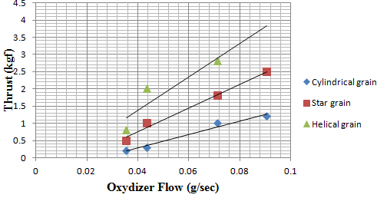
Fig.15 Effect of Oxygen flow on thrust for various grain geometries

Table.1 Summary of Lab-Scale Hybrid Test Firings

Grain Configuration | Oxygen Injection Pressure (psi) | Chamber Pressure (psi) | Burning Time (sec.) | Oxidizer Mass flux Go(g/mm² sec) | Regression Rate (mm/sec) | Oxidizer  Flow Rate (g/mm² sec.) | Thrust (kgf)
Cylindrical | 50 | 65 | 6.48 | 0.0191 | 2.76 | 1.50 | 0.2
Cylindrical | 60 | 73 | 10.64 | 0.0371 | 4.00 | 2.92 | 0.3
Cylindrical | 70 | 85 | 9.22 | 0.0364 | 4.36 | 2.86 | 1.0
Cylindrical | 80 | 100 | 5.11 | 0.0509 | 4.76 | 4.00 | 1.2
Cylindrical | 90 | 120 | 4.16 | 0.0713 | 6.08 | 5.60 | 1.9
Star | 50 | 62 | 6.48 | 0.0354 | 3.71 | 2.08 | 0.5
Star | 60 | 78 | 7.39 | 0.0435 | 4.20 | 2.56 | 1.0
Star | 70 | 82 | 9.22 | 0.0714 | 4.75 | 4.20 | 1.8
Star | 80 | 105 | 5.11 | 0.0905 | 5.21 | 5.32 | 2.5
Helical | 50 | 65 | 6.48 | 0.0445 | 4.62 | 2.77 | 0.8
Helical | 70 | 93 | 9.22 | 0.0548 | 4.72 | 3.41 | 2.0
Helical | 80 | 110 | 5.11 | 0.0879 | 4.96 | 5.47 | 2.8
15% Al Mixed With Paraffin Wax | 50 | 75 | 6.48 | 0.0231 | 3.65 | 1.82 | 1.0

Table.2 Average thrust and standard deviations for several Gox mass Flux

Oxygen Mass Flux (g/mm²sec) | Average Thrust (Kgf) | St. Dev.
0.0354 | 0.5 | 3.2
0.0435 | 1.1 | 7.4
0.0714 | 1.86 | 12.6
0.0905 | 1.85 | 12.4
0.0713 | 1.9 | 12.9

- Conclusions

A series of paraffin-based hybrid rocket fuels have been studied experimentally in a laboratory-scale motor. To enhance the regression rate of solid fuel, different grain configurations are studied. The main conclusions that can be drawn from this work are listed as follows:
- Hybrid propulsion system is easy to operate in static tests.
- Enhancement of regression rate can be achieved by employing a suitable grain configuration.
- Star and helical grain configuration enhanced the fuel regression rate in Paraffin/GOX hybrid motors as compared to cylindrical grain.
- Helical groove in fuel port signiﬁcantly generated turbulence in the flow which enhanced the fuel regression rate.
- The present experimental results indicate that the exponents of the mass flux for cylindrical, star and helical grains are 0.58, 0.33 and 0.11, which are significantly less than 0.8.
- Thrust-time traces have been studied for all three grain port configurations. The helical grain reported a highest thrust of 2.8kg among all three port configuration.
- Standard deviation in thrust is independent of oxygen mass flux. Therefore, the amplitude oscillations are not a factor of oxidizer mass flux. Since different fuel port shown to increase regression rate and thrust, and not increase the amplitude of thrust oscillations.

Acknowledgment
The author wishes to acknowledge the valuable input from Hindustan University, this input was useful towards the preparation of present paper.
References
- Karabeyoglu, M. A., B. J. Cantwell and D. Altman “Development and Testing of Paraffin-Based Hybrid Rocket Fuels” 37th AIAA/ASME/SAE/ASEE Joint propulsion Conference, Salt Lake City, Utah, July 8-11, 2001.
- Carmicino, C., and Sorge, A. R., “Role of Injection in Hybrid Rockets Regression Rate Behavior,” Journal of Propulsion and Power, Vol. 21, No. 4, 2005, pp: 606-612.
- George, P., Krishnan, S., Varkey, P.M., Ravindran, M. and Lalitha, R., “Fuel Regression Rate in Hydroxyl Terminated Polybutadiene/ Gaseous-Oxygen Hybrid Rocket Motors”, Journal of Propulsion and Power, Vol. 17, No. 1, 2001, pp: 35-42.
- Kim, S., Lee, J., Kim, G., Cho, J., Moon, H., Sung, H., Kim, J., and Park, S., “Combustion Characteristics of the Cylindrical Multi-port Grain for Hybrid Rocket Motor,” 45th AIAA/ASME/SAE/ASEE Joint Propulsion Conference & Exhibit, 2 - 5 August 2009, Denver, Colorado.
- Shin, K. H., Lee, C., and Yu. Y. H., “The Experiments for the Enhancement of Regression Rate of Hybrid Rocket Fuel,” Journal of Mechanical Science and Technology (KSME lnt. J.), Vol. 19, No. 10, 2005, pp: 1939-1949.
- Lee, C. J., Lee, J. W., Byun, B.W. and Lee, S. T., “Effect of Induced Swirl Flow on Regression Rate of Hybrid Rocket Fuel by Helical Grain Configuration,” European Conference for Aerospace Sciences (EUCASS), 4-7th July, 2005, Moscow.
- Santos, L. M. C., Almeida, L. A. R., Fraga, A. M., and Veras, C. A. G., “Experimental Investigation of a Paraffin Based Hybrid Rocket,” Journal of Engenharia Térmica (Thermal Engineering), Vol. 5, No. 01, 2006, pp: 08-12.
- Palani, C. K., and Amit, K., “ Mixed Hybrid concept for enhancement of regression rate of hybrid rocket motor,” Proceeding of the 37th National & 4th International conference on Fluid Mechanics and Fluid Power, 16-18 December, 2010, IIT Madras, Chennai, India.
- Wilkinson, R., Hart, K., Day, R., and Coxhill, I., “Proof-of-concept Testing of a sustained vortex-flow configuration for hybrid rocket motors,” 46thAIAA/ASME/SAE/ASEE Joint Propulsion conference & Exhibit 25-28 July 2010, Nashville, TN.


Mr. Yash Pal obtained his master degree in Aeronautical Engineering in 2011with a thesis on analysis of regression rate of PVC hybrid fuel in hybrid rocket combustion under the supervision of Dr. P.K. Dash. Presently, he is working as Assistant Professor in Department of Aeronautical Engineering at Hindustan University. His area of research includes Hybrid Rocket Combustion.

Mr. Baskar. J is an undergraduate student at Department of Aeronautical Engineering at Hindustan University. His area of interest is in the field of hybrid rocket propulsion.


Mr. S. Murugesan obtained his B.E degree from the University of Madras in 1970. He was working for ISRO from last 36years in the field of solid propulsion. Presently, he is working as Associate Professor at Department of Aeronautical Engineering at Hindustan University. His scientific activity is focused on solid rocket motor performance and high regression rate hybrid rocket fuels.

