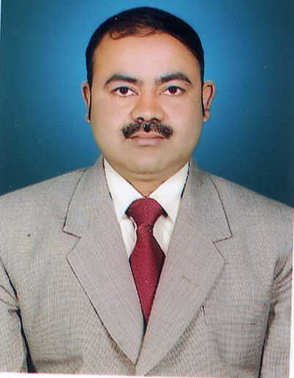
Dr Sanjay Mohan Gupta is a scientist-C at DIBER, Haldwani, obtained his PhD in Biochemistry in 2007 from Lucknow University. His major technical achievements are in field of plant molecular biology and genetic engineering. He has published 20 research papers in reputed peer reviewed journals and presented several scientific papers in national & International Conference/Symposia. He is a recipient of “Laboratory Scientist of the year -2010” award. He is the member of various professional Societies.

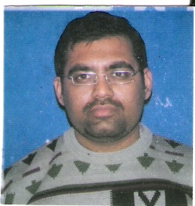
Dr Atul Grover is a scientist-C at DIBER, Haldwani. His major areas of technical expertise include Plant Genomics and Bioinformatics. He has published 16 peer reviewed articles in reputed journals and one book chapter. He has also presented several papers in national & International Conference/Symposia.

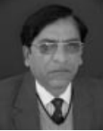
Dr Zakwan Ahmed obtained his PhD in Plant Breeding from G.B. Pant University of Agriculture and Technology in 1984. He is presently Director, DIBER, Haldwani as well as Programme Director of DRDO-Army Biodiesel Programme. He has made significant contribution in development and identification of varieties/hybrids of vegetable crops suitable for high altitude areas of Himalayan region. He is the fellow of various professional Societies.

