Reducing Attack Surface of a Web Application by OWASP Compliance

Sumit Goswami * #, Nabanita R Krishnan #, Mukesh#, Saurabh Swarnkar∞, Pallavi Mahajan ±
# Dte of Management Information System & Technologies (MIST), DRDO, New Delhi
∞ IAP Company Pvt Ltd, Gurgaon, India
± Dept of CSE, Beant College of Engg & Tech (BCET) Gurdaspur, Punjab
* Email: sumit_13@yahoo.com

Abstract
The attack surface of a system is the amount of application area that is exposed to the adversaries. The attack surface metric can be used to compare similar applications or to compare different applications having common functionality but variable security risk. Attack surface metric can be used to choose between two different applications having same functionalities. The attack surface of the application is calculated to estimate the security of the system. The overall vulnerability can be reduced by reducing the attack surface of the web application. The programmers use it to improve the quality of code, testers to estimate the extent to which testing has to be done and users can use this metric to compare different applications. In this paper, various parameters of attack surface for two versions of an in-house developed Project Management Web Application has been calculated prior and post OWASP compliance based on a security audit to determine and then compare the security of this Project Management Application.

Keywords: attack surface, DRDO Intranet, Project Management, OWASP, Security Audit, Security Compliance

1. Introduction
The security measurement of a system is a challenging task. The quantification of security in an application is becoming more and more difficult due to rapid advancement of the technologies and advancement in the hacker’s tools and strategies ^{[1]}. The major task that is faced by the applications’ users is to choose an application from a set of applications that provide same functionalities. Today the customers have great interest in considering the security of an application when the customer has to choose between the alternative applications. We have used a metric for the attack surface of web application that has been defined by Thomas Heumann in his paper “Quantifying the Attack Surface of a Web Application” ^{[2]}. This work calculates the relative security i.e. compares the security of two different applications rather than comparing the security of a single application in the absolute terms. Two attack surfaces, which are exposed to the same adversaries, if compared, the one having smaller attack surface is statistically expected to less vulnerable ^{[3]}.
Web applications use common concepts: browsers as client, HTTP as communication protocol between client and server, server-side and client-side runtime environments for executing code, XML for data representation. Due to the common concepts, most of the web applications have common security problems. Securing a web application is the task of application developers. So the developer has to reduce the attack surface of a web application ^{[4]}.
1.1. Threat, vulnerability and attacks
Threat is any kind of mishappening that could occur on the assets of an application/software. Vulnerability is the process that makes the threat to be indulged in an application. Attack causes exploitation of the vulnerability ^{[5]}. An application can be kept secured only if the threats that can occur in the application are known. To know about the threats, threat modeling should be done. Threat modeling helps to keep track of the vulnerabilities in an application by visualizing the application’s or system’s architecture or design. The vulnerable area helps in judging the areas or points from which user can attack accidentally or intentionally in an application area ^{[5]}. Most of the vulnerabilities are restricted to the particular environment. The common vulnerability that can occur in most of the applications is the buffer overflow. Measuring the attack surface helps to measure the security of a system and by reducing the attack surface the vulnerabilities in the application can be reduced and hence leading to decrease in threats.
1.2. Project management application
Management of various projects in an organization is done with the help of a project management application. Project management covers various phases of a project like initialization of the project, planning and designing of the project, execution of the project, monitoring, controlling and closing of the project. One of the main advantages of Project management application is that it helps in managing time and budget of a project. It helps in sharing resources and status between the developers and keeps track of various tasks of a project so that a common goal is obtained.
1.3. Data Repository of Projects
Data Repository of Projects is an in-house developed web application running on DRDO Intranet. It allows the user to update the project information on monthly basis. It is having 25 online forms for keeping the details about the projects like Project Details, Team, History, Schedule, Annual Milestones, Review Details, Manpower, Quality Assurance etc. User is authenticated with the help LDAP running on the Mail Server. It also provides the facilities for uploading of different type of document i.e .pdf, .doc, .xls, .txt, .mpp. A partial screenshot of the Splash Screen (with some information and login details hidden) of Data Repository of Projects ver 1 which is the entry page for the software alongwith login forms is shown in Figure 1

Figure 1 : Screenshot of the Splash Screen of Data Repository of Projects ver 1
Version 1 of Data Repository of Projects was developed using JSP and ORACLE 10g. It was running on Intranet using TOMCAT Application Server 4.1 on RedHat Linux 4.5. After deployment of application on the Intranet, Third Party Security Audit was done by authorized CERT-In (Indian Computer Emergency Response Team) security auditor.
The objectives of audit were to provide independent evaluation of Vulnerability and Security of the web application. The main purpose of the test is to determine any security vulnerabilities in the website as specified in the scope. The black box testing approach was used assuming the identity of an attacker or a user with malicious intent.
1.4. Audit Approach
The security auditors divided their tests into two parts namely automated checks and manual checks. The underlying web server IP was scanned first for potential vulnerabilities. Then website was scanned for web vulnerabilities manually and through web vulnerability scanners. Thereafter manual checks were done to exploit these vulnerabilities. Application functionality was tested for its:
• Adequacy
• GUI User friendliness
• Data Integrity
• Reporting
• Error handling
• Business Logics
The summary of the audit report was that the Application is not safe for business use as
- inputs and outputs are not properly designed, lack good GUI or adequately tested
- Data integrity does not exist and erroneous data is allowed
- Common and dangerous web vulnerabilities such as Cross Site Scripting and SQL injection exist in the application.
- The web application is infested with almost 80% of all type of vulnerabilities
- Pro-active, time bound controls using available best practices should be implemented to ensure business objectives of the application are delivered.
2. Attack surface and system resources
The term attack surface refers to the amount of code, functionality and interfaces of a system exposed to attackers. The surface that is exposed to the attackers can only be exploited by the adversaries. Attack surface can be calculated in terms of system resources. The system resources are generally the data items, channels and operating environment. These are considered general system resources since the attacks can occur when data is sent from the system’s operating environment to the system and when the system sends the data to the operating environment. The attacker can send the data items through channels. ^{[6]} The following is the usage of attack surface metrics:
- The programmers use the attack surface metric to improve the quality of code.
- Testers use this metric to estimate the extent to which testing has to be done.
- Users use this metric to compare different applications and
- Organizations use this metric to make proper investment on the better application. ^{[1]}

2.1. Web application and their attack surfaces
Web application is accessed in a network. Web application uses a web browser as a client. It uses a client-server architecture where the client enters the information and server stores and retrieves information. Example of network over which the web application can be run is the internet or an intranet ^{[7]}.Web application development is the execution of software on a platform independent browser ^{[8]} and in developing a web application certain risks are involved like security, software bugs ^{[9]}.
The user enters the http request with the help of the browser. The web server can now does the following two tasks:
- If there is a simple web page, then the web server will immediately respond to the request.
- Otherwise the web server forwards request to the server for further processing, server will process the request and gives the output to the web server. The web server will now respond to the web browser. ^{[10]}
The main purpose of the attack surface metric is to estimate the area of web application that is exposed to the adversaries. Generally the users and attackers can access the web application through the HTTP interface(s) of the web server(s). Simply the HTTP interface can be defined as one of the attack surface of the web application. However, there are other risks also, like cookies etc.
2.2. Working model of a Web Application
Data Repository of Projects (PDR) follows the Model View Controller (MVC) architecture. The goal of this architecture is to separate the application data and the business data from the presentation data to the user. Here the classes contain Business logics class, Beans class, concrete classes and other logic classes where Business Logics is called models. When web application runs on the browser then http request is sent to the particular server where web application is hosted. TCP/IP is responsible for locating and connecting to the server where the application is hosted. The Architecture of the Project Management Web Application is represented in Figure 2.

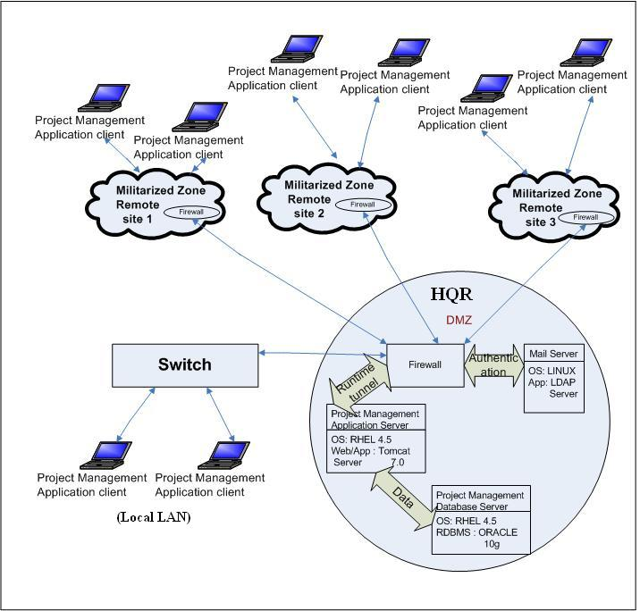
Figure 2 : Architecture of a Project Management Web Application

The web server software, which in case of PDR application is Apache Tomcat 7.01 continuously runs on the server machine. In the webserver, Catalina (container) looks for the new http request, reads the request and forward it to the particular servlet/jsp (controller). The controller communicates with the database server and generates a view in form of html. The html view is then forwarded back to the container and container sends a http response to the user. A working MVC model of Data Repository of Projects version 2 in the execution environment is shown in Figure 3
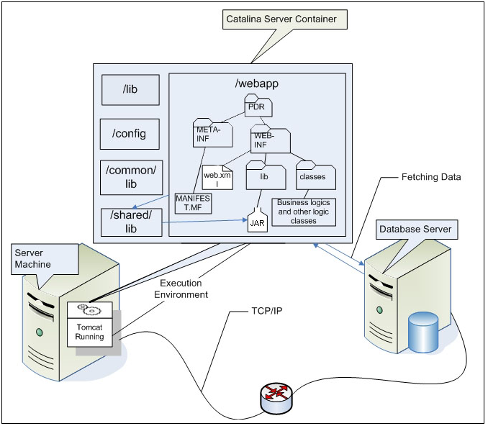
Figure 3 : Working model of web application

2.3. Symptom code
Symptom code can be defined as the insecure coding practices that may lead to the addition of vulnerabilities in an application and thus increases the attack surface of the application e.g. from dynamic SQL symptom, SQL injection vulnerability can be induced. Similarly dangerous functions, cookie access methods and writing inline request objects can cause buffer overflow, broken access control and cross-site scripting respectively. The symptom does not always lead to the vulnerabilities in an application.^{[11]}
2.4. Securing web application
When an application is reviewed, analysed and audited, a variety of problems can be unearthed that effect the application. On arranging these problems in some order, it will be easy to tackle them. This order of problems can be reffered as vulnerability catagories ^{[5]}. Some of the vulnerability catagories are given below:
- Session management means to keep track of the user’s activity across the session of user’s interaction with the system. It is used to know about the applications that are opened by the users and the documents that are opened by various applications. ^{[12]}
- Exception management is defined as handling the exceptions that can occur in the application. It can be done either by application server or language compiler ^{[13]}.
- Input validation means filtering and rejecting the invalid input before further processing.
- Enforcing confidentiality and integrity by an application is called cryptography ^{[4]}.

Apart from these vulnerabilty catagories, there are authentication, authorisation etc. The Security is maintained in the web based application by taking into account the following techniques:
- Reduce the attack surface of the application or remove the unused protocols, functionalities etc.
- Use least privilige: The security of a system can be increased by running processes having least privileges or access right and hence the capability of the attacker to attack the application can be reduced. ^{[14]}
- The developer should not trust the input of the user as the user is considered primary weapon of the attack. ^{[5]}
2.5. Attack Surface Metric
Attack surface is generally measured in terms of the resources of an application that are exposed to the adversaries. More the resources are exposed to the user or attacker, more will be the attack surface of an application and hence more will be the insecurity. Attacks from the earlier years have shown that certain resources are more used by the users or attackers to damage an application. Thus all the resources are not considered to have equal effect on the security of an application. Different set of resources are created that exploit the application, according to their effect on that application.
The entry points and exit points of an application are also considered to be the part of attack surface. The entry point is the point through which data can be entered in the system and the exit point is the point through which data can be retrieved from the application. The entry points and exit points of the application are the points that are used to prevent and detect the attack from the system and these points are considered to be the entry and exit points of the attacker also. ^{[15]} The application’s channels are also considered the basis for the attacks since the attacker can connect to the application through application’s channels. There are also another basis for attacks on an application i.e. the attackers can use the persistent data for the attack on an application. This persistent data can be referred as untrusted data items. ^{[16]} The attack surface of the application can be reduced by:
- Reducing the amount of running code
- Reducing application access by users/attackers at entry points
- Reducing privilege to limit damage potential. ^{[17]}
2.6. Attack surface and potential attacks
Comparing two applications A and B, if the attack surface measurement of A is larger than B, then more will be the number of potential attacks on the application A than the application B. Damage potential is the tendency of the attacker to exploit the application. Damage potential and effort goes in tandom. If the attacker gains high privileges, then the more will be the tendency/potential of the attacker to attack on the application and hence exploiting the system. Thus the contribution of a resource (in exploiting an application) can be estimated in terms of the damage potential-effort ratio^{[8]}.
3. Handling of Vulnerability as per OWASP 2007 Guidelines
Web application security is an important feature in web applications. Without security features websites are insecure and unreliable. Presence of vulnerabilities like direct object reference, broken link, broken authentication and session management, insecure error handling etc. are some common vulnerabilities. To secure a web application developer needs some guidelines or set of rules according to which they can construct the web application because it is very difficult to learn and keep every rule in mind while developing. Generally web application frameworks are vulnerable, so developers should pay attention to these vulnerabilities while developing an application.
Open Web Application Security Project (OWASP) is to help developers, designers and organizations get an insight to most common web application security vulnerabilities.
In order to improve the software based on the audit report, the entire web application for Data Repository of Projects was redesigned as per OWASP-2007 guidelines. A partial screenshot of the Splash Screen (with some information and login details hidden) of Data Repository of Projects ver 2 which is the entry page for the software alongwith login forms is shown in Figure 4
The guideline describes and guides on the prevention of the basic vulnerabilities like:
- Cross Site Scripting (XSS)
- Injection Flaws
- Malicious File Execution
- Insecure Direct Object Reference
- Cross Site Request Forgery (CSRF)
- Information Leakage and Improper Error Handling
- Broken Authentication and Session Management
- Insecure Cryptographic Storage, Insecure Communications
- Failure to Restrict URL Access

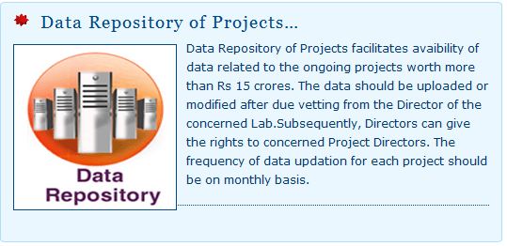
Figure 4 : Screenshot of the Splash Screen of Data Repository of Projects version 2
At the designing stage developer should prevent common Vulnerabilities. The solution implemented by us to prevent these vulnerabilities is as mentioned:
- Cross Site Scripting (XSS): Standard input validation mechanism has been used to validate all input data for length, type, Syntax by designing functions at common JavaScript file with regular expression. Invalid input like external script, blacklisted keywords etc. are rejected by using tag lib directors (TLD). Struts can be used for designing any web application that has inbuilt above mentioned preventions.
- SQL Injection Flaws: Connection and query execution has been established using class instead of directly from JSP webpage. So direct reference to execute database query on server has been disabled. Query will be executed on the basis of credential assigned to user after input validation.
- Insecure Direct Object Reference: The application has been developed using object oriented MVC model approach with Tag Lib Directors (TLD) so it eliminates Insecure Direct Object References. No webpage can be access directly from the browser as it checks for session validation.
- Cross Site Request Forgery (CSRF): Prevention for XSS vulnerabilities have been implemented that automatically minimized CSRF vulnerability to some extent. All GET parameters have been replaced with hidden text boxes and disable external scripting execution .Verification of session before saving into the database for handling CSRF vulnerability also incorporated.
- Information Leakage and Improper Error Handling: Proper error/exceptions handling has been implemented. All error messages are customized so that error should not display internet content of server or web application.
- Broken Authentication and Session Management: Session expired after idle time of 30 minutes or once the logout option is clicked in the application.
- Failure to Restrict URL Access: No webpage can be accessed directly from the browser as it checks for session Integrity and user credential before showing the web contents.
4. Quantification of the attack surface
Attack surface vector AS represents the attack surface. According to the Eucledian norm, the attack surface indicator ASI is given by ASI = |AS|. Boolean values are the raw measurements that represent presence or absence of a feature. 0 represents false and 1 represents true. Functions are used to map raw measurements to components of AS ^{[2]}.
The attack surface AS of a web application is defined as
AS = [ddist;dyn;(security);(input);(active);cookie;role;rights] ^{[2]}
i.e the components of attack surface vector are: degree of distribution ddist,page creation method dyn,security mechanisms (security),input vectors (input),active content (active),cookies cookie,user roles role and acess rights rights. Round brackets indicate groups of components.
Maximum value of attack surface vector is given by:
AS_{max} = [34;1;(1;10;10;10;10;10;10;10);(1;1;1;4;1;8);(5;7;8;6;10);40;10;10]
4.1 Components
The various components of the attack surface metric have been shown as parameter family in Table 1. These are the components that affect the security of a web application and hence are used to calculate the attack surface metric of the web application. These components have been taken from OWASP. The range of these components has been defined in the Table 1. The value of a component is set according to the presence or absence of the component in the web application. The various components are described as:
Degree of distribution (ddist) determines the spanning of the application over multiple domains. More the value of ddist, more the chances of attacks.
- Sub domains (sdom_{wa}), domains (dom_{wa}) and foreign domains (dom_{ext}) are required to calculate the value of ddist, which is given by: ddist=1/2.sdom+dom+2.dom_{ext}-1.
- Page creation method (dyn) distinguishes whether the pages are dynamically created on server side or not. The value of dyn is 1 if it uses server-side technologies, otherwise 0.
- Security mechanism (security), if present reduces the value of attack surface. Transport Layer Security and input validation are considered here. Security mechanism comprises three groups:
- crypt € {0,1} which shows the presence of TLS;
- cryptomix € {0,10} which shows the mixing of the contents accessed over the TLS with the contents accessed over HTTP;
- validate € {0,10}, the value 10 indicates that input validation is not present or has been broken^{[2]};
- buffer errors € {0,10},the value is 10, if the developer wants to put the data in the buffer above its threshold amount, otherwise 0;
- cross-site request forgery (CSRF) € {0,10}, the value is 10 if there is a CSS attack, otherwise 0;
- cross-site scripting (XSS) € {0,10}, the value is 10 when XSS is present, otherwise 0;
- sql injection € {0,10},the value is 10, when a security vulnerability is exploit in database layer of an application;
- direct object reference € {0,10},the value is 10 if the internal implementation object is exposed to the user, otherwise 0. ^{[9]}
- Input vectors (input) increase the complexity of an application.
- The presence of URL parameters (urlparam), HTML forms (forms), hidden form fields (hidden) and HTTP authentication mechanisms auth is indicated by 1,
- file uploads is indicated by files € {0,8} and search € {0,2,4} indicates the presence of search function. If no site search is present then the value is 0, if locally implemented mechanism is present then the value is 2 and if internet search engine is used then the value is 8.
- Active content (active) has the following set:
- js € {0,5} for JavaScript,
- js_{ext} € {0,7} if javascript is loaded from a different site,
- sss € {0,8} if server-side scripting is used,
- Ajax € {0,6} if AJAX is used,
- java € {0,8} if java applets are used,
- RIA own € {0,10} if flash is used.
- Cookies (cookie) are a compound parameter. These include:
- c € {0,10} represents presence of cookies and
- c_{ext} € {0,10} represents the number of foreign cookies. From these we can calculate the value of cookie which is given by: cookie= c+3.c_{ext.}
- Access control is also a compound parameter: role and rights.
- role € {0,5,10} and represents the user status: unauthenticated(0), authenticated(5) or root(10);
- right € {0,5,10}: none(0), limited(5) or root (10) ^{[2]}.

Keeping in view all these parameters, all the values of our web applications i.e. Project Management Application Version 1 and Project Management Application Version 2 has been quantified which has been shown into Table 1.

Table 1 Attack Surface parameters of Project Management Application
Parameter family | Short name | Parameters | Range | Version 1  Value | Version 2  Value
Degree of distribution | ddist | Subdomains (sdom_{wa} )  Domains (dom_{wa})  Foreign domains (dom_{ext}) | [0,10]  [0,10]  [0,10] | 0  1  0 | 0  1  0
Dynamic creation | dyn | Dynamic creation | {0,1} | 1 | 1
Security features | security | TLS (crypt)  Partial TLS (crypto-mix)  Validate (validate)  Buffer Error  Cross Site Request Forgery (CSRF)  Cross Site Scripting  SQL Injection  Direct Object Reference | {0,1}  {0,10}  {0,10}  {0,10}  {0,10}  {0,10}  {0,10}  {0,10} | 1  1  1  10  10  10  10  10 | 0  0  0  0  0  0  0  0
Input vectors | input | URL parameters (urlparam)  Forms (forms)  Hidden fields (hidden)  Authentication methods (auth)  Search (search)  File upload (files) | {0,1}  {0,1}  {0,1}  {0,1}  {0,2,4}  {0,8} | 1  1  1  1  0  8 | 1  1  1  1  0  8
Active content | active | Client-side scripting own (js)  Client-side scripting foreign (js_{ext})  Server side scripting (sss)  Ajax (ajax)  Java (java)  RIA own (flash) | {0,5}  {0,7}  {0,8}  {0,6}  {0,8}  {0,10} | 5  0  8  0  0  0 | 5  0  8  0  0  0
Cookies | cookies | Own cookies (c_{wa})  Foreign cookies (c_{ext}) | [0,10]  [0,10] | 0  0 | 0  0
Access control | role rights | Role  Privileges | {0,5,10}  {0,5,10} | 5  0 | 5  5

The values assigned above shows the maximum risk that can occur in the two Project Management applications. Here the maximum possibility of risk or insecurity has been taken that can occur in the web applications without considering the precautions or safety measures taken in the web application.
The minimum and maximum attack surface vector are given by^{[2]} :

Attack surface vector ASI
Min [0;0;(0;0;0);(0;0;0;0;0;0;0);(0;0;0;0;0;0);0;0;0] 0
Max [34;1;(1;10;10;10;10;10;10;10);(1;1;1;4;1;8);(5;7;8;6;10);40;10;10] 63.37

The parameters of the web application Project Management Application Version 1 is:
[0;1;(1;1;1;10;10;10;10;10;10);(1;1;1;1;0;8);(5;0;8;0;0;0);0;5;5]
And its ASI (attack surface indicator) is given by:
√1²+0²+1²+10²+10²+10²+10²+10²)+(1²+1²+1²+1²+0²+8²)+(5²+0²+8²+0²+0²+0²)+0²+5²+5²
= 26.192
So the insecurity in the web application is 41.33%.

The parameters of the web application Project Management Application Version 2 is:
[0;1;(0;0;0;0;0;0;0;0;0;0;0);(1;1;1;1;0;8);(5;0;8;0;0;0);0;5;5]
And its ASI (attack surface indicator) is given by:
√0²+1²+(0²+0²+0²+0²+0²+0²+0²+0²)+(1²+1²+1²+1²+0²+8²)+(5²+0²+8²+0²+0²+0²)+0²+5²+5²
= 14.42
So the insecurity in the web application is 22.76%.

4.2 Result and Analysis
The values of various parameters of the web applications (Project Management Application version 1 and Version 2) have been used. These values define the maximum risks that can occur in the web applications. From these values of parameters, the attack surface vector of two different versions of Project Management Application can be calculated with the help of eucledian norm, which further tells about the security of the web application.
From the attack surface metric calculated in this paper, th security of different web applications, whether build on same technology or different technology can be compared. The attack surface of two different applications is a good and quick way to compare the applications. The attack surface of two applications differ due to number of parameters. It can be seen that the larger attack surface of the web application- Project Management Application Version 1 is due to non availability of security features.
The value of the attack surface metric of Project Management Application has reduced down from 41.33% calculated for Version 1 to a value of 22.76% in Version 2 due to incorporation of the security features like the presence of privileges and absence of buffer errors, cross-site request forgery, cross-site scripting, direct object reference and SQL injection in version 2.
Here it can be observed that the value of attack surface metric of a web application can be reduced but can not become 0% because the server-side technologies cannot be supressed completely as the httpresponse is generated in the form of HTML by the server. So there is possiblity of XSS attack. As a web based application can not run in isolation without inputs and outputs from or to users, agents and other applications or network connectivity, it is prone to attacks through these exposed surfaces. An application generally has some degree of cohesion and coupling exposing the gaps. Besided, ease of use calls for reduction in security and enhanced security reduces the ease of use. As the application has to be finally used by a person or a software, accessibilty has to be provided to the application, leading to an optimisation between accesibility and security. Even a ‘black body’ application is exposed to attacks from the data that it receives. However, the value of attack surface vector of Project Management Application Version 2 can possibly be reduced further by:
- Avoiding the use of URL parameters.
- Minimising the use of hidden fields, forms etc.
- Minimising the use of server-side technologies.
- Using more secure framework technologies like struts as structs have powerful validator engine to validate input data without writing the additional code for validation. Moreover it is also having mapping facility for webpage so that original webpage name as well as webpage component like textbox, combobox, radio buttons etc will be hiddern frorm outside .
- Considering further components in the calculation that are going to be used in the improved web application.
- Refining the parameters like access control and authorisation since these are very complex and few parameters can not represent them.

5. Conclusion
The attack surface metric of web application is calculated to measure vulnerabilities under grey-box testing conditions, which is important for testers to have idea about the extent of testing that is to be done and for the developers to apply more security. More the attack surface of the application, more is the effort the tester has to be put on testing and if the attack surface of the application is less, then the tester has to put less effort on testing. Similarly, the developer has to improve its quality of code, if the attack surface of the application is more. To improve the security of the system or an application, attack surface metric plays an important role.
References
[1] Vincent C. S. Lee, Linyi Shao. Estimating Potential IT Security Losses: An Alternative Quantitative Approach, IEEE Security and Privacy, v.4 n.6, p.44-52, October 2011.
[2] Thomas Heumann, Sven Türpe, Jörg Keller. Quantifying the Attack Surface of a Web Application. In Proceedings of Sicherheit'2010, volume 170 of LNI, pp.305-316, July 2011.
[3] M. Howard, J. Pincus, and J. M.Wing, Measuring Relative Attack Surfaces, in Proc. of Workshop on Advanced Developments in Software and Systems Security, Taipei, August 2011.
[4] Web application development,en.wikipedia.org/wiki/web-application-development,July 2011.
[5] Web application security fundamentals,http://msdn.microsoft.com/en-us/library/ff648636.aspx, September 2011.
[6] Attack surface analysis and reduction, http://www.ntru.com/products/computer-based-training/courses/attack-surface-analysis-and-reduction.html, July 2011.
[7] Web application,http://en.wikipedia.org/wiki/web-app, July 2011.
[8] Web application development, www.icreonglobal.com/web-application-development.shtml, July 2011.
[9] P. Manadhata and J. Wing. An attack surface metric, in First Workshop on Security Metrics, Vancouver, BC, August 2011.
[10] About internet application and web application server,http://livedocs.adobe.com/coldfusion8/htmldocs/help.html?content=introducing-cf-2.html, September 2011.
[11] Attacking web applications at the source,http://networksecurity.org.ua/0596007949/networkst-chp-6-sect-1.html, July 2011.
[12] Session management,http://en.wikipedia.org/wiki/session_management, September 2011.
[13] Exception management,http://en.wikipedia.org/wiki/exception_management, September 2011.
[14] Principle of least privilige,http://en.wikipedia.org/wiki/principle _of_least_privilige, September 2011.
[15] Manadhata, P. K., Karabulut, Y., and Wing, J. M. Report: Measuring the Attack Surfaces of Enterprise Software. In ESSoS ’09: Proceedings of the 1st International Symposium on Engineering Secure Software and Systems (Berlin, Heidelberg, 2009), Springer-Verlag, pp. 91–100, September 2011.
[16] Pratyusa Manadhata , Jeannette Wing , Mark Flynn , Miles McQueen, Measuring the attack surfaces of two FTP daemons, Proceedings of the 2nd ACM workshop on Quality of protection,2006, Virginia, USA , October 2011.
[17] Mitigate Security risks by minimizing the code you expose to untrusted users,msdn.microsoft.com/en-us/magazine/cc163882.aspx, August 2011.

Contributors:


Sumit Goswami holds an M Tech Degree in Computer Science and Engineering from IIT Kharagpur, a Post Graduate Diploma in Journalism and Mass Communication, a Bachelors Degree in Library and Information Science and a BTech in Computer Science and Engineering. He has been working as a Scientist with DRDO since 2000. His areas of interest include network centric operations, mobile ad hoc and sensor networks, web-hosting security, text mining and machine learning. He has published 53 papers/chapters in various journals, books, data competitions and conferences. He is a reviewer for many international journals published. He was invited to chair a few conference/workshop sessions and has been serving in the program committees of some international conferences.

Ms. Nabanita Radhakrishnan is Director, Management Information System and Technologies (MIST) at DRDO Hqrs. A Graduate in Electronics & Communication Engineering from Guindy Engineering College,s Chennai with a Post Graduation in Electrical Engineering (Control, Guidance & Instrumentation) from IIT Madras, she joined DRDO, at the Combat Vehicles Research & Development Estt. (CVRDE) in 1984 where she worked initially for the Testing & Evaluation of Main Battle Tank sub-systems. In 1992, she was posted to the LCA program as part of the project team at CVRDE for the design & development of the Aircraft Mounted Accessory Gearbox (AMAGB) for LCA. In June 2004, she was deputed to G-Fast (Group for Forecasting of Systems and Technologies- a DRDO Think Tank) at DRDO Hqrs for providing techno-management analysis of DRDO projects and programs. She was appointed as Director, of the newly created Dte of MIST in Dec 2009. She is a Member of Aeronautical Society of India and Instrument Society of India.


Shri Mukesh holds MCA from IGNOU, Delhi and MSc (Computer Science) from MDU Rohtak. He has been working with DRDO as Senior Technical Assistant and he has more than 15 years of experience in software development, website designing and hosting, Linux, Windows, MySQL, JAVA, JSP, ORACLE, Crystal Report, Visual Basic, and PHP.


Saurabh Swarnkar holds Bachelor of Engineering in Computer Science and Engineering from Institute of Information Technology and Management ( IITM ) Gwalior( M.P.), a Post Graduate Diploma in Advance Computing from (Center for Development in Advance Computing - Advance Computing Training School) CDAC-ACTS Bangalore. He is working as a Programmer in IAP Company Ltd, Gurgaon. He has more than two years of experience in developing web application in JAVA, Web designing and hosting in Linux/Windows, MySQL, and Oracle.


Pallavi Mahajan is pursuing B Tech in Computer Science and Engineering from Beant College of Engineering and Technology (BCET) Gurdaspur, Punjab. She is presently doing 6 months internship from DRDO, New Delhi.

