**Testing and Evaluation of High Energy Portable Laser Source (HEPLS) used as a Target Designator**

Tutul Gogoi @, Rajni Kumar #, Joshua Anand Gladwin $ and Vivek Goyal *

Laser Science and Technology Centre, DRDO, Metcalfe House, Delhi-110054

**Abstract:** Precision Guided Munitions are often driven with the help of a special kind of laser beam, pointing onto the target of interest which can be a ground based stationary target or a moving one. The laser source which is popularly known as target designator is a key element in this and plays a vital role in performing any laser guided bombings. In this paper a testing methodology and evaluation technique is described for such a portable high energy laser source. The parameters of the designator are checked in laboratory environment as well as verified in field conditions. The measured and tested parameters are laser source energy, laser wavelength accuracy, pulse width and pulse repetition frequency. The designator is tested along with a laser seeker in field condition by designating a target located at a distance of 5 km from the designation and seeker site.

**Keywords:** Circular Error Probability (CEP), Laser Guided Bomb (LGB), High Energy Portable Laser Source (HEPLS), Full Width Half Maximum (FWHM), Pulse Repetition Frequency (PRF), Inertial Navigation System (INS), Global Positioning System (GPS)

1. **Introduction**

With the simultaneous advent of both the laser technologies and data processing capabilities the complete concept of the weapon delivery system got improved. It's not only the technique but also the shape and size of a bomb also got changed drastically. Laser beam guidance enabled the bombs just become more and more precise in heating a target or with improved CEP which thereby reducing the amount of ammunitions required for a specific damage of any target. Advanced data processing technology enabled the bomb to be much smarter than earlier dumb kind of versions [1], [2].

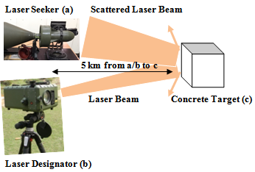A semi active guidance system of a laser guided bomb (LGB) consist of mainly a laser sensor and processing unit, canards for the mechanical guidance and a wing section towards the tail of the bomb. The laser sensor and processing unit is popularly known as Laser Seeker. The front end is the Optical receiver to gather laser scattered radiations from the illuminated target and the required photo detector assembly with data conditioning modules. Next portion of the bomb is the controlling guidance canards which are attached to the warhead part of the bomb. The job of these canards is to provide steering commands of the LGB. The tail portion consists of the wings to provide lift to the LGB. Once the LGB is released from the launch vehicle it goes through mainly three phases - Ballistic phase, Transition phase and finally Terminal phase. Ballistic phase is a very critical phase since the way the LGB is being released from the aircraft determines to some extent the maneuverability in the last terminal phase also. So, the velocity vector in this initial phase is an important parameter. In the transition phase the acquisition of the laser illuminated target is started. Once any laser radiation is detected by the seeker it goes into the terminal actions. In the final terminal phase the laser radiation coming from the target reflections starts centering the seeker and the canards are commanded to align the LGB towards the target. Now a days INS and GPS systems integrated with these bombs making them almost smart enough to cater the countermeasures techniques as well [3], [4], [5].

**Fig. 1 Laser Target Designator and Seeker Operation**

This paper is mainly confined to the testing and measurement of different parameters of the laser target designator in laboratory and field conditions.

1. **Laboratory Testing and Evaluation of the Laser Target Designators called as -**

**High Energy Portable Laser Source (HEPLS) –**

The Laser beam source used in battlefield for LGB delivery is basically a Q-switched Solid State high energy pulsed laser packaged with portability. This kind of laser source is popularly known as Laser Target Designators used to illuminate an aim point target. The laser designator is fired at a particular frequency called PRF (Pulse Repetition Rate) and at a suitable energy level depending on the target distance and weather conditions. The important parameters that are being programmed in the laser primarily are - Laser Energy, PRF, and ON Time etc. The PRF is an important parameter because this is basically the code being programmed in the Seeker data base to identify the laser radiation scattered back from a designated target. This PRF Code determines whether the laser is a friendly laser or a hostile one. If the PRF set in the LGB Seeker matches with that of the Designator laser radiation the acquisition of the target is started.

The major specifications [3] of the laser being used are as follows –

**Laser Wavelength - 1064 nm ± 1 nm**

**Laser Pulse Width - 20 ± 5 nsec**

**Pulse Repetition Frequency - 5 to 20 Hz**

**PRF Accuracy - ± 5 µsec**

**Maximum Energy Level - 100 mJ**

**Beam Divergence - 0.3 mrad**

1. **Laser Source Wavelength and Accuracy Measurement**

The wavelength and its accuracy of the laser is being tested using a spectrometer of and the result with accuracy got as 1064 ± 0.3 nm.

**Spectrometer Make: Avantes**

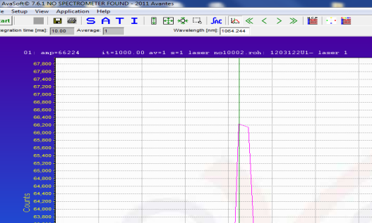

**Fig. 2 Laser Wavelength Measured by Spectrometer**

The green line in the plot of figure 2 shows the peak wavelength of the laser pulse which at 1064.224 nm. Multiple readings are observed and the peak wavelength is obtained within 1064 **± 1 nm.**

1. **Laser Pulse Width Measurement**

The Laser Pulse width is measured with a Photodiode Module and Oscilloscope. The designator is fired onto a metallic plate as shown below and the scattered laser beam is sensed by a photodetector module. The photodetector output is connected to a standard oscilloscope to measure the laser pulse width of the designator. The details of the equipments used are given below –

**Photodetector : Make: Alphalas, Model No. : UPD-300-UD**

**Oscilloscope : Make: Tektronix, Model No.: MSO4104B**

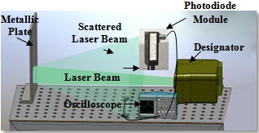

**Fig. 3 Setup for Measuring Laser Pulse Width**

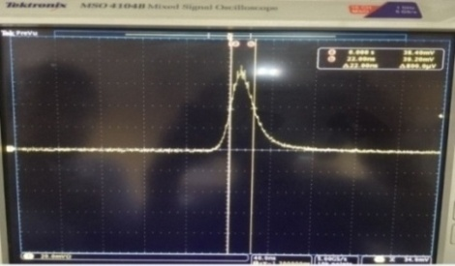

**Fig. 4 Photodiode Output Pulse**

The Pulse Width of the photodiode output is measured at FWHM and found to be in the range of **22/23 nanoseconds** as shown in the oscilloscope screenshot above.

1. **Output Energy Measurement:**

The details of the equipments used for the measurement of the output energy of the designator is as follows –

**Energy Meter : Make: OPHIR, Model No. : VEGA 7Z01560**

**Energy Sensor : Make: OPHIR, Model No. :**

**PE50SHV2**

The set up for laser output energy measurement is as shown in the schematics below –

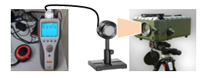

**Fig. 5 Setup for Laser Output Energy Measurement**

The maximum available energy per pulse is measured to be around 100 mJ and also tested with an LGB Seeker of make Elbit Systems for a target at a distance of 5 km apart as shown in figure 1 earlier.

1. **Laser Pulse Repetition Frequency (PRF) Measurement**

Designator is fired at different PRF and measured with the help of a PRF Decoder developed by LASTEC and verified the Pulse Repetition Time (PRI) using a standard Frequency Counter with the following specifications. The PRF accuracy obtained of this Laser source is around **± 5 µsec.**

**Frequency Counter: Agilent 53220A 350 MHz Universal Frequency Counter/Timer**

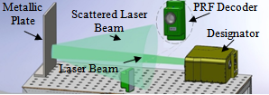

**Fig. 6 Setup for PRF Code Measurement of Laser**

1. **Laser Beam Divergence Measurement**

The laser beam divergence is measured using a Beam Profiler of Ophir-Spiricon make set up and the measurement is carried out at the laser manufacturer site which is M/s Bharat Electronics Ltd., Pune. The beam profiler camera is placed on the focal point of the mirror which is alligned with the laser beam. Divergence measured for 80% of beam energy is found to be around 0.25 mrad which is less than 0.3 mrad as per the specifications mentioned. So, idealy for a 0.25 mrad divergence the spot size at 5 km distance should be around 1.25 meters. Practically the spot size noted at a distance os 5 km is around 1.5 to 2 meters wide with scintillation due to atmospheric disturbances.

1. **Testing with actual laser seeker in field**

The laser designator has been tested with a standard laser seeker in field condition as depicted in figure-1 in the introduction above. The testing was carried out with the following arrangments –

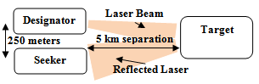

**Fig. 7 Setup for Field Testing of Designator with Seeker**

**Equipments and set up used are -**

**Laser Seeker : M/s Elbit Systems**

**Designator : M/s Bharat Electronics Ltd.**

**Target : Concrete Structure**

The testing was carried out in different environmental visibility conditions and the seeker was able to lock onto the laser backscattered signals from the concrete structure being designated from 5 km away. The laser spot size onto the target is taken around 2 meters. The laser power level in the seeker end calculated as follows –

**Estimation of received power level at seeker end:**

**Parameters –**

**Ed - Laser energy of designator (mJ)**

**Pd - Peak power of a designator pulse (MW)**

**Pt - Peak power of a pulse on target (MW)**

**Ps - Peak power of a pulse on seeker end (W)**

**Rd - Distance of target from designator (km)**

**Rs - Distance of seeker from target (km)**

**D - Seeker receiver aperture diameter (mm)**

**A - Seeker receiver cross section (m2)**

**µ - Atmospheric attenuation per km**

**V - Environmental visibility (km)**

**Λ - Laser wavelength (nm)**

**θ - Angle of target position w.r.t. designator (deg)**

**β - Angle of target position w.r.t. seeker (deg)**

**Condition 1:**

Environmental visibility is around **10 km** and the atmospheric attenuation for 1064 nm wavelength laser is calculated as below –

Attenuation Coefficient, $μ = \frac{\text{3.912}}{\text{V}}{\left(\frac{\text{1064}}{\text{550}}\right)}^{-1.3}$----- (i)

[7]

So, for V = 10 km, µ = 0.166per km

Peak power per pulse at target $P_{t}=P_{d}e^{-\text{μ}R_{t}}$---- (ii)

[8]

If the designator is fired at its maximum available energy level of 100 mJ energy then

Peak power per pulse is Pd = 5 MW

For a range of 5 km, the peak power per pulse at target would be - Pt = 2 MW ------------------------ (iii)

The laser pulse then gets reflected and scattered from the target structure throughout a hemispherical area towards the seeker side. It’s considered a hemispherical area because the seeker and designator are almost collocated or a very small distance apart in comparison to the target distance which is 5 km. Also the target is a concrete structure and the laser falls onto a wall of it.

The power level received by the seeker receiver is calculated as follows –

Seeker receiver aperture diameter D = 25.4 mm

So, cross sectional area

m2 ----- (iv)

Power received by seeker aperture is given by –

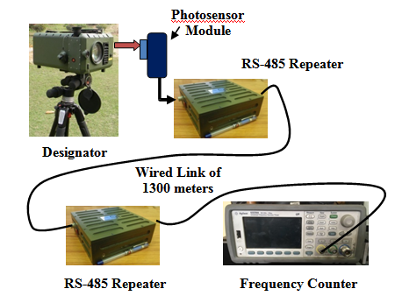 ${\text{P}}_{\text{s}}\text{= }\frac{\text{A }{\text{P}}_{\text{t}} \text{cos}{\text{θ r }{\text{e}}^{\text{-μ}{\text{R}}_{\text{s}}}}}{\text{2π}{{\text{R}}_{\text{s}}}^{\text{2}}}$----------------------- (v)

[8], [9]

For, θ = 10 deg and target reflectivity r = 25 % [8] the power received by the seeker is calculated as –

Ps = 64 nW Approx. ---------------- (vi)

The seeker is able to lock onto the target with this power level scattered from the target. This is verified by seeing the status of the seeker whether it’s in the acquisition mode or in track mode. The seeker is observed to stay in the track mode. Also to verify that the locking is happening to the actual target, the seeker is fixed to an angular motorized pan and tilt arrangement. Once the line of sight (LoS) of the target w.r.t. the seeker is established the locking of the seeker with the actual target is being verified in real time.

**Fig. 8 Field Setup for measuring Laser PRF**

**Condition 2:**

Environmental visibility is low and around **2 to 3 km** –

In such a foggy situation the atmospheric attenuation for 1064 nm is given by –

Attenuation Coefficient, µ = 0.921per km

[From equ. i]

So, for a range of 5 km, the power level at target would be - Pt = 50 KW (Peak power per pulse) ---------- (vii)

[From equ. ii]

The power received by the seeker aperture would be –

Ps = 36 pW Approx. ---------------- (viii)

[From equ. v]

In this situation where the visibility is very low and less than 2 km it is difficult for the seeker to lock onto the target. The seeker in a dense foggy situation is not able to sustain in track mode.

1. **Remote Laser Data Analysis in Field Conditions**

Important parameters viz. laser Pulse Repetition Frequency (PRF) is also often needed to be monitored in real time if any changes happen in real time while laser is fired. These parameters are transmitted through a long distance wired link to a safer location which may be a few kilometres away from the target aim point of the LGB under testing. A kind of signal repeater is designed and developed based on RS-485 protocol which can cater for a data link of more than kilometres of distance.

This RS-485 repeater device is designed for field applications which are powered by a rechargeable battery bank and a low battery indicator module inside. The internal RS-485 transceiver module can take differential inputs and amplifies to a level suitable of transmission again up to more than a kilometre distance. The input to this repeater is basically the differential pulses obtained through a laser pulse detector detecting laser triggered at a particular pulse repetition frequency. The pulses are transmitted through this repeater module and measured the PRF using a pulse counter which can display the PRF value in real time. The PRF of the laser being measured is verified in terms of pulse repetition time (PRI) using a standard frequency counter as discussed in the earlier section. Such two RS-485 Repeaters can provide a range of more than 02 km in field testing conditions.

1. **Safety Measures:**

The Laser source is a class-3 lasers, so utmost precautions is taken while operating within the lab as well as in field conditions. In laboratory it is operated in a closed room and all users wear protective goggles with Optical Density at least of OD 7 for 1064 nm wavelength. Reflected laser strength is as below –

Considering visibility V = 10 km, Atmospheric attenuation – µ = 0.166per km ------------------ (ix)

Testing within lab is carried out for around 5 meters separation from the designator and a reflecting plate. For a condition as follows –

Goggles efficiency – Optical Density OD = 7

Goggles cross section A diameter d = 50 mm

Reflector Plate reflectivity r = 50 % [8]

Distance between designator and reflector R = 5 m

Power received through goggles is given by –

$${\text{P}}_{\text{s}}\text{= }\frac{\text{AxODx}{\text{P}}_{\text{t}}\text{x}\text{cos}{\text{θx rx}{\text{e}}^{\text{-μR}}}}{\text{2π}R^{2}}$$

[From equ. v]

It comes around 2.8 - 3 µW peak power per pulse behind the goggles and so, it’s within the human eye’s permissible limit as per as safety is concerned. More over although goggles are used one should not look into the laser transmitter directly.

1. **Conclusion:**

LASTEC has been engaged in developing Laser Warning Sensor (LWS) and laser countermeasure techniques for quite a few years. For testing the LWS and countermeasure systems the laser source plays an important role. So, the LWS reliability and the efficacies of the countermeasure systems directly or indirectly depend upon the laser source used. The laser source parameters are tested and measured within laboratory with the procedures discussed here. For field conditions laser data is transmitted through the RS-485 Repeater module designed and developed for field applications. The portable laser designator parameters tested successfully and verified as per the product specifications as mentioned in the beginning.

Periodic check of all these laser parameters is necessary and carried out to keep the laser designator in healthy condition.

1. **Reference:**
2. Joint Laser Designation Procedures (JLASER) of Dept. of Army USA, 28 May 1999, www.dtic.mil/get-tr-oc/pdf?AD=ADA434233
3. "Precision-Guided Munitions: Laser-Guided Munitions" by Dr. Anil Kumar Maini and Nakul Maini, Electronics For You, May 16 2015, https://electronicsforu.com/technology-trends/precision-guided-munitions-laser-guided-munitions-part-2-4.
4. Review Paper - "PRECISE GUIDED AIRCRAFT BOMBS" By Jan KUSAK 02/2007, aimt.unob.cz/articles/07_02/07_02%20(5).pdf
5. "The Emergence of Smart Bombs" By John T. Correll, AIR FORCE Magazine/March 2010, http://www.airforcemag.com/MagazineArchive/Pages/2010/March%202010/0310bombs.aspx.
6. "Modern Laser Guided Bombs" By Dr. Carlo Kopp, Defence Today -41, http://www.ausairpower.net/weps.html.
7. “The Guidance Accuracy of a Projectile using A Wind Stabilized Seeker” by J. P. Fourie and Y. Yavin, Laboratory for Decision and Control, Dept. of Electrical and Electronics Engineering, University of Pretoria, Pretoria 0002, South Africa
8. “Propagation of optical and infrared waves in the atmosphere” by Al Naboulsi et al., France Telecom, 6, Avenue des usines, BP382-90007 BELFORT Cedex, France.
9. “Tactical Laser Systems Performance Analysis In Various Weather Conditions” by Capt. R. Sabatini, Italian Air Force Research and Flight Test Division (DASRS), Pomezia 00040 (Rome), Italy.
10. “OPTOELECTRONICS SYSTEM DESIGN FOR DEFENCE APPLICATION” by R. Srinivasan and et al, ICOP-2009, International Conference on Optics and Photonics, Chandigarh, India, 31st Oct – 1st Nov 2009.
11. www.bel-india.com
12. www.elbitsystems.com

@ - Tutul Gogoi, Scientist-D, LASTEC, DRDO, Ministry of Defence, Metcalfe House, Delhi-110054.

E-mail: [tutulgogoi@lastec.drdo.in](mailto:tutulgogoi@lastec.drdo.in)

Phone: 9968292945

# - Rajni Kumar, Technical Officer, LASTEC, DRDO, Ministry of Defence, Metcalfe House, Delhi-110054.

$ - Joshua Anand Gladwin, Technical Officer, LASTEC, DRDO, Ministry of Defence, Metcalfe House, Delhi-110054.

* - Vivek Goyal, Technical Officer, LASTEC, DRDO, Ministry of Defence, Metcalfe House, Delhi-110054.