Figure Captions
Fig.1 Concrete targets
Fig.2 TNT Charge

Fig.3 TNT charge in a concrete target
Fig.4 Postmortem observation on the targets with the depth of burial h = 400mm
Fig.5 Relationship between R_{c}/D and L/D

Fig.1 Concrete targets

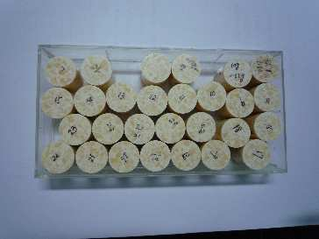 |  | 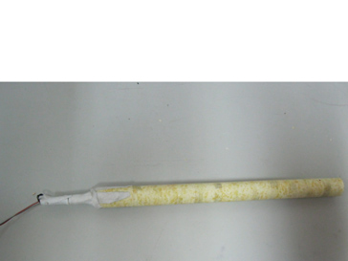  Detonator  TNT
Fig.2 TNT Charge

Fig.3 TNT charge in a concrete target

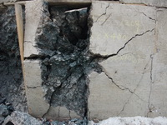 | 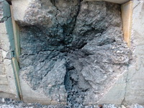 | 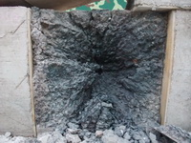
(a) M = 120g | (b) M = 130g | (c) M = 150g
Fig.4 Postmortem observation on the targets with the depth of burial h = 400mm

Fig.5 Relationship between R_{c}/D and L/D

