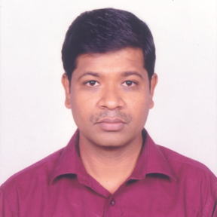
Mr Suresh D. Meshram received BE (Mechanical) from NIT, Surat, in 2000 and MTech (Prod. & Ind. System Engg.) from IIT Roorkee in 2002. He is working as scientist ‘E’ at Defence Metallurgical Research Laboratory (DMRL), Hyderabad since 2003 in Metal Joining Group. Area of Research mainly includes joining of advance similar and dissimilar materials through process like electron beam welding, friction welding and friction stir welding and characterisation of welded joints.
Experimentation and data generation is carried out by him in the present study.

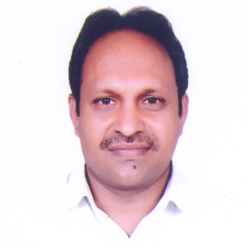
Dr. G. Madhusudhan Reddy, Scientist ‘H’ obtained Ph.D in Metallurgical Engineering from Indian Institute of Technology, Madras in 1999. He is heading the metal joining group of DMRL, Hyderabad. He has more than 300 scientific publications to his credit. Dr. Reddy is a Fellow of the ASME (USA), IWS (India) and Institution of Engineers (India). He is member of several professional societies. He has won several awards for his scientific contributions to name a few; Government of India recognized his contributions to the metallurgical sciences by the award “Metallurgist of the Year”. He is also a recepent of DRDO scientist of the year award.
Data analysis and correlation of weld defects with different input and output parameters
are carried out by him

