**Design, Development of Compact Conformal Microstrip Antenna at S-band frequencies**

V Srinivasa Rao1,DR Jahagirdar1, and Girish Kumar2

1Research Centre Imarat, DRDO, Hyderabad-500069, India,

Email: varanasi0205@gmail.com, dr_jahagirdar@hotmail.com

2Indian Institute of Technology, Bombay, Powai, Mumbai-400076, India

Email: gkumar@ee.iitb.ac.in

***Abstract:***

***A compact microstrip Antenna at S-Band frequencies is described in this work. This paper presents the theoretical and experimental investigations on conformal quarter circular microstrip antenna using shorting wall.*** ***The performance of antenna characteristics is obtained using FEM based HFSS software and the computed results are verified by measurement. Here, microstrip antenna is loaded with shorting wall to achieve frequency deduction which in turn leads to a smaller patch. Introducing shorting wall at the edge of the patch size reduction of about 75% has been achieved. The radiation characteristics of antenna mounted on vehicle body is carried out at S-Band frequency. Results show that antennas have moderate gain and wider coverage in roll plane as well as elevation planes and may be used as small, compact antennas for onboard telemetry applications.***

***Keywords: Shorting wall loaded microstrip antenna, Compact antenna, Shorted plate, Radome, Conformal***

**I INTRODUCTION**

In many communication applications, there is a great demand for small size, low profile and light weight antennas. Modern wireless, vehicular communications systems and missiles require conformal antennas [1-2]. The most notable problem of the patch antenna is that its size tends to be large at the low microwave frequencies. Hence, wireless applications require antenna size that is compliant with the space restrictions of the portable devices. There are a few methods presented in literature to reduce the size of the patch antennas and most of the designs are achieved by using a shorting post, high dielectric constant substrate, and by loading a chip resistor. [3-6].

Dielectric cover i.e., radome is used over the radiating element to protect from environmental constraints like vibration, temperature, pressure and leaks [7-8]. The radome is transparent to microwave radiation at the operating frequency, and there will be no change in antenna characteristics. However, practically, because of radome material loss, dielectric constant and thickness, there will be a change in antenna characteristics

The radiation characteristics of the antenna mounted on metallic square body(side = 200mm) is explained as the pattern and coverage alters by the shape of the mounting body. Conformal antenna characteristics for different applications were explained [9-12]. The relevant simulation and experimental results are presented.

In this paper, we report the theoretical and experimental investigations carried out on shorting wall loaded microstrip antenna (MSA) to achieve frequency deduction which in turn leads to miniaturization of the patch***.***

**II. MINIATURIZING MICROSTRIP PATCH ANTENNA DESIGN**

There are a few techniques presented in literature to reduce the size of the patch antenna [13-17]. The theory behind this is that the electric field has maximum value at edges and goes to zero at the centre. It is also observed that the resonant frequency of the antenna heavily depends upon the dielectric constant of the substrate, thickness of the substrate, radome material, location and radius of the shorting-pin or wall. The size of Circular Microstrip antenna (CMSA) is reduced by shorting along its zero potential lines from the centre to ground plane, and by using one half of the patch, a compact semicircle MSA (SCMSA) is designed. The area is further reduced one fourth of a circle by shorting along zero field lines of SCMSA, resulting in shorted 90° Sectorial CMSA (QCMSA) is shown in Fig. 1. The substrate used for antenna is RT 5870 with relative permittivity, 2.33 and loss tangent, tan δ = 0.0012.

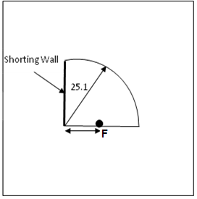

(a)

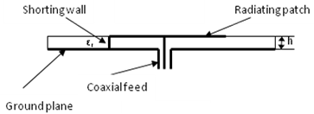

(b)

Fig. 1. Shorting wall loaded microstrip antenna(a) Top view (b) Side view

The resonant frequency of this kind of antenna and approximately the same resonance frequency as that of a Circular Microstrip Antenna (CMSA). It is observed that CMSA with D=50.25mm, F=7mm has a resonance frequency of 2.25 GHz, and its BW is 34 MHz and HPBW is 980 x 820 in E and H-Planes respectively.

Its size is further reduced by using 90° Sectorial MSA (QCMSA) with D= 50.2mm, and Feed point = 3 mm.

The proposed antenna performance has been studied by placing a Radome on a Shorted QCMSA .The shorted Quarter CMSA is designed on Rogers RT5870 substrate of 3.2mm thick with D= 47.9mm. The PTFE material is used as dielectric cover having height of 8mm. The schematic diagram of proposed antenna is shown in Fig. 2. The Radome is used to protect the antenna from environmental constraints. A few shorting pins of diameter 0.8mm are placed in the place of a shorting wall. The feed point is placed at 3mm from the centre of the patch.

Fig.2. Schematic diagram of QCMSA with Radome

**III. SIMULATED RESULTS**

The antenna performance has been studied by placing the Radome over 90° sectorial MSA with finite ground plane having metallic cavity using HFSS software. Fig.3 shows the simulated model and radiation patterns in E and H- planes at f=2.25GHz of proposed antenna.

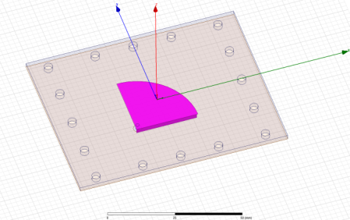

**(a)**

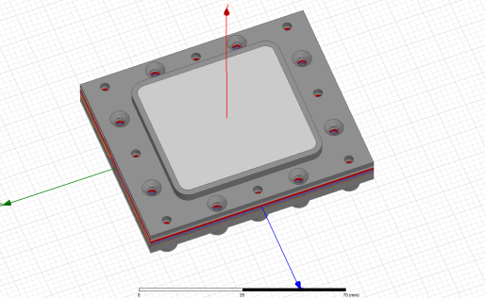

(b)



(c)

Fig.3 (a) Antenna model QCMSA (b) Antenna with radome and cavity (c) Return loss plot

**IV ANTENNA MOUNTED ON SQUARE BODY**

The airborne antenna is required to be low profile, light weight, compact and rugged enough to minimize and withstand the aerodynamic drag during the flight. Microstrip antennas(MSA) are preferred for onboard applications in a wide range of wireless applications. One of the major advantages of microstrip patch antenna is that it can be flush mounted to a curved host surface such as an aircraft, missile and satellite to avoid aerodynamic drag. The omni-directional coverage is required for onboard application to get proper line of site communication between onboard vehicle to ground station. The number of antenna elements required to get omni-directional coverage when they are mounted on body depends on the type of antenna, size, structure and frequency of operation.

The radiation behavior of ground and airborne antennas in terms of placement of antenna, coverage and polarization is important for effective data communication through microwave link. In most of airborne applications, the monopole antennas and their variants are preferred to achieve omni-directional radiation when they are mounted on the aircraft or missile at the cost of protrusion from the surface of the body. The array can be made up of various types of antennas like slotted blade antennas, microstrip wrap around antennas and patch antennas around the circumference of the body to obtain omni-directional coverage.

The radiation characteristics of compact shorted antenna with radome of PTFE material placed on square body have been studied using commercially available HFSS software [18]. Based on the individual antenna performance on body, the number of elements can be decided to get omni-directional coverage.

So, the analysis of single antenna mounted on body is essentially required.

The simulation results of compact antenna mounted on section is shown in Fig. 4

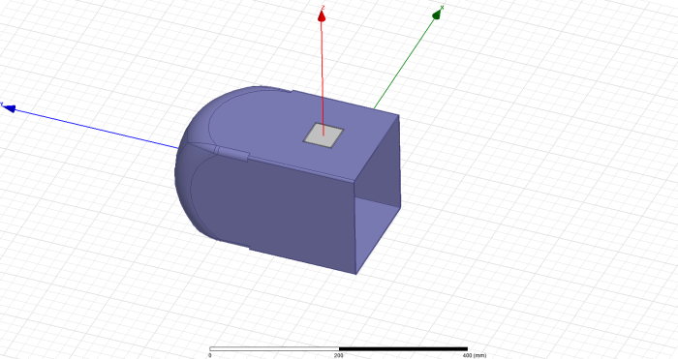

(a)



(b)



(c)

Fig.4 (a) Antenna model mounted on square body

(b) Return loss plot (c) 2D Patterns at 2.250GHz

It is observed that the antenna resonates at 2.250 GHz. From the simulated results, it is observed that the designed antenna provides a beam width of 1150 in elevation plane and 900 in roll planes respectively. The gain at 2.25GHz is 5.85dBi is obtained.

The simulated results for all antennas are summarized in Table-1.

The antenna is designed, fabricated and tested. The fabricated antenna is shown in Fig.5. The antenna assembly consists of microstrip antenna with radome along with metallic cavity.

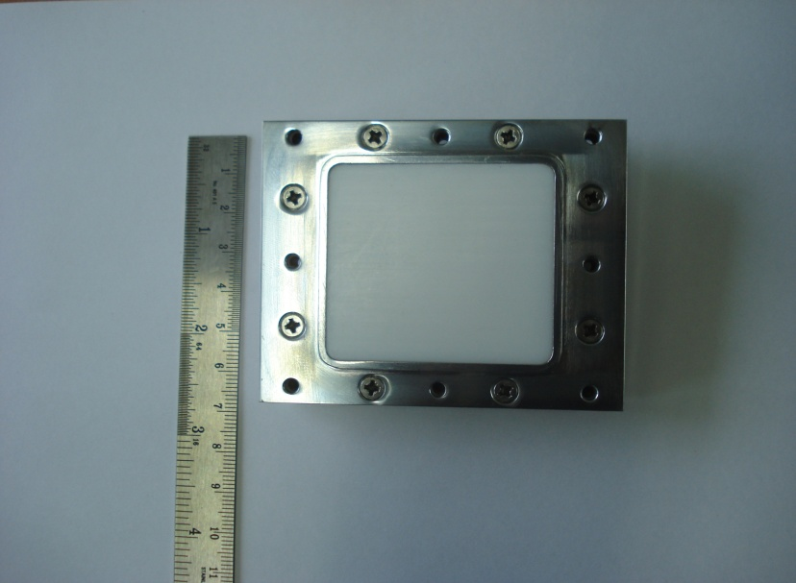

Fig. 5 Fabricated compact Antenna with radome

The antenna is characterized by measuring the resonant frequency, return loss, rain and beam width. The proposed antenna array was evaluated for its performance. The return loss of the antenna was measured using a Vector Network Analyzer. Fig.6 shows the simulated and measured return loss of antenna. The simulated impedance bandwidth for S11≤ -10dB is from 2241MHz to 2264MHz (23MHz) whereas the measured bandwidth is from 2234 to2263MHz(29MHz) 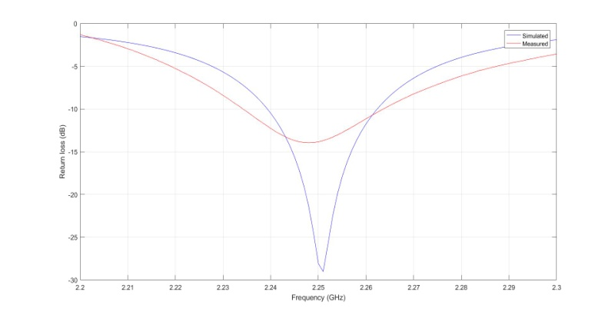

Fig.6.Simulated and measured return loss plot of compact antenna with radome

Experiments have been conducted to confirm theoretical predictions. The radiation pattern has been carried out in Compact Antenna Range facility with proper separation between transmitting and receiving ends meeting the far field condition.

The radiation patterns of proposed antenna mounted on the square body are shown in Fig.7.The HPBW of a single antenna is 920 in roll plane and 1110 in its orthogonal plane (Elevation) are achieved. The fabricated antenna has a gain of 3.3 dBi (min.) over the entire band

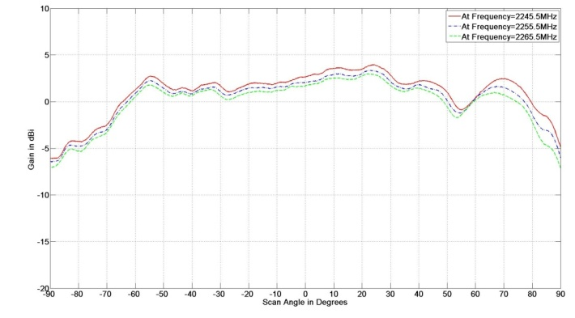

(a)

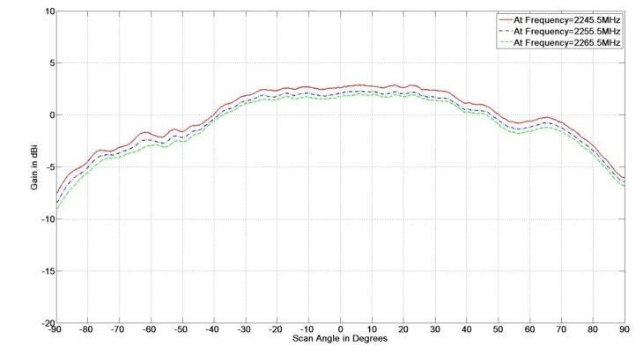

(b)

Fig.7. Measured Shorted QCMSA with Radome and cavity mounted on body (a) Elevation Plane (c) Roll plane at S-Band Freq.

Table -1. Performance comparison:

|  |  |  |  |
| --- | --- | --- | --- |
| **Type** | **Beam width (Deg.)** | | **Gain (dBi)** |
| **E-Plane** | **H-Plane** |
| **CMSA** | 980 | 820 | 5.8 |
| **QCMSA** | 850 | 810 | 4.5 |
| **QCMSA with Radome& Cavity** | 1300 | 1000 | 4.51 |
| **Antenna mounted on body** | 1150 | 900 | 5.85 |

**V. RESULTS & DISCUSSIONS**

The simulated and measured 10dB bandwidths of compact conformal antenna are 23 MHz and 29 MHz respectively. The obtained HPBWs of antenna mounted on section in both elevation and roll planes 1150 X 900 in simulation and 1110 X920 in measurement are achieved. The measured gain is around 3.3dBi at 2.25 GHz.

**VI.CONCLUSION**

A compact shorting wall loaded on a microstrip antenna was successfully designed and fabricated at required S Band frequency.The microstrip antenna is loaded with shorting pin to achieve frequency deduction which in turn leads to miniature of the patch i.e. patch size is decreased by around 75%. The simulated model has been fabricated and measured. The measured gain of 3.3dBi is obtained. The 3dB beamwith of the prototype is 1110 in Elevation plane and 920 in Roll plane. There is good agreement between the simulated and the measurement results It is well suited for telemetry applications operating in the S band to maintain uninterrupted link.

**ACKNOWLEDGEMNETS**

The authors would like to acknowledge the encouragement of Technology director, DOFI and Director, RCI Hyderabad for granting permission to publish this work.

**REFERENCES**

1. R. Garg, P. Bhartia, I. Bahl and A. Ittipiboon, "Microstrip design handbook, " Artech house: Boston, Mass, USA , 2001
2. I J Bhal and P Bhartia, Microstrip antennas, Artech house, 1980.
3. Girish Kumar and K.P.Ray, Broadband microstrip antennas, Artech House, Boston, Mass, USA, 2003
4. R. Porath, "Theory of miniaturized shorting- post microstrip antennas, "IEEE Transactions, Antennas and propogation, Vol. 48, No.1, pp 41-47, 2000
5. M Sanad, " Effect of the shorting posts on short circuits microstrip antennas , " Proceedings, IEEE antennas and propagation society International symposium, pp 794-797, 1994
6. R.Water house, " Small microstrip patch antenna", Electronic letters31, 604-605, April 13, 1995
7. I. J. Bahl And Stanislaw S. Stuchly, “*Analysis of a Microstrip Covered with a Lossy Dielectric*”, IEEE Transactions On MicrowaveTheory And Techniques, Vol. MTT-28, No. 2, February 1980, pp.104-109
8. I.J. Bahl, P. Bhartia and S.S. Stuchly, “*Microstrip Antennas Covered with A Dielectric layer*”,AP.16-2, pp.589-592
9. Abdul Mueed and Jiadong Xu, Ghularn Mehdi *Cavity Backed Embedded Antenna on Cylindrical Surface for Conformal Applications*, 2011IEEE, pp.351-356
10. Zhijun Zhang, Xu Gao, Wenhua Chen, Zhenghe Feng and Magdy F. Iskander, "*Study of Conformal Switchable Antenna System on Cylindrical Surface for Isotropic Coverage*", Ieee Transactions On Antennas And Propagation, Vol. 59, No. 3, March 2011, pp.776-783
11. Prateek Chopra, Megha Bhandari, Dr. K.S Beenamole, Sanjeev Saxena *Design of an X-Band Conformal Antenna UsingMicrostrip Patches*, 2015 2nd International Conference on Signal Processing and Integrated Networks (SPIN), 2015 IEEE, pp.83-87
12. Vidhi Sachdeva, Prakash kumar Mishra, Drishti Sharma, Samir Dev Gupta, “*Design of antenna conformal to cylindrical surface for aircrafts*”, 2015 Fifth International Communication systems and Network Technologies, 2015 IEEE, pp.33-36
13. Pradeep kumar, G. Singh, " Microstrip antennas loaded with shorting posts," published online June2009 in Scires, Engineering, 2009, 1, 1-54
14. Amit A.Deshmukh, K.P.Ray, “Analysis of Short- Plated Compact and Broadband Microstrip Antenna”,IEEE Antennas and Propagation Magazine, Vol.55, No.6, Dcemeber2013, pp.100-113
15. Amit A.Deshmukh, Kshitij Lele, Ami A.Desai, K.P.Ray, “Compact Edge shorted Microstrip Reflectarray Antennas”,2015 ieee International Conference on Research in Computationa Intelligence and Communication Networks(ICRCICN), pp.13-16
16. M.Tarikul Islam, M.Samsuzzaman, M.Z.Mahmud, M.T.Islam, “A compact slotted patch antenna for ultrawideband application”, 19th International conference on Computer and Information Technology (ICCIT), 2016
17. Jiangfeng Wu, Kamal Sarabandi, “Compact Omnidirectional Circularly Polarized Antenna”. IEEE Transactions on Antennas and Propagation, Vol 65, Issue 4, 2017, pp: 1550-1557
18. Ansoft High frequency Structure Simulator HFSS