Relay based Coupling Scheme of High
Speed Communication data, High voltage DC
And High Power Pulsed AC for Coaxial Cable

ABSTRACT

Coaxial cable telemetry is most commonly used in the field of underwater applications like data logging in oil rigs, underwater wireless modem, underwater acoustic measurements, borehole measurements, deep sea telemetry for sediment analysis, airborne sonars, imaging sonars etc. In all the above applications coaxial multicore cables are used. This paper describes the design and development of relay based coupling scheme which helps to replace the multi core cable with a single core coaxial cable for telemetry application. To achieve longer distance data communication over wired medium, single core cable is suitable. Multi core cables are generally heavy and due to the size, may not met space constraints in complex systems. They are not economical too. The relay based coupling scheme is used to mix or separate the high speed bidirectional communication data, high voltage DC and high power pulsed AC. The simulation of the coupling scheme was done using PSPICE. A prototype of the coupling scheme was also made for analysis.

Keywords: Passive filters, coupling schemes, coaxial cable, power line communication, remote systems, telemetry

- Introduction
Coupling circuits are used for power line communications (PLC’s) for impedance transformation which is realized using passive components [1]. Passive coupling circuitry is also used to replace the transformer coupling for PLC’s to reduce the cost of PLC modems [2]. Passive filters have the ability to pass or block band of frequencies. For Remotely operated vehicle (ROV) applications, cable signal separation filters were developed to separate the DC and information signal [3]. Filtering schemes for AC coupled systems have also been discussed. High voltage low valued capacitor is used in series with a coupling transformer [9] between the power line and the transmitter or receiver, were used in power line communication to couple the data signal to the transmission line. This will block any signal of a frequency lower than the cut off frequency and allow passing any signal having a frequency higher than the cut off frequency. A novel coupling/decoupling scheme for PLC in dc differential power buses employed on-board space vehicles has been proposed by Flavia Grassi etal [10]. In SABER [11] model of PLCC system, coupling of data from a transmitter side and recovery of data at the receiver side over a power line is discussed.

Underwater applications like ROV [3], underwater acoustic measurements [4], data logging in oil rigs, borehole measurements [5], deep sea telemetry for sediment analysis [6], airborne sonars [7], imaging sonar [8] etc. require remote unit and on-board platform unit which is connected using coaxial cable. All the above mentioned applications use multi core coaxial cables. The remote unit requires high voltage DC supply, high power pulsed AC transmission and bi-directional high speed communication data. Separate cables for each signal are not cost effective and have a multiplicity of engineering challenges in implementation. The coupling schemes discussed in the above mention paper is for signal data and voltages. So a proper coupling scheme for all three signals is necessary to effectively operate the remote unit through single core coaxial cable.

Relay scheme and passive filter based scheme are the two coupling schemes commonly used [12]. For data telemetry the coupling scheme is to be used at both the remote unit and on-board unit, which are connected through single core coaxial cable. The bi-directional high speed communication data, high voltage DC and high power pulsed AC are transmitted from one end of the cable. At the other end, the signals are separated out using coupling filters. Transmission of high power AC realized using a single relay scheme has already been discussed in [12]. For coupling and retrieving these signals proper filters is used thereby enabling inter-operation of all the above signals through the same single core coaxial cable.

The major challenges in the mixing schemes are the coexistence of low voltage communication signal along with the high voltage DC supply and high power pulsed AC. As the coupler is operated along with high power pulsed AC, protection and isolation are essential for high power pulsed AC and high speed bidirectional communication data.

The single relay based coupling scheme has poor isolation while high power pulsed AC transmission occurs. This can be overcome by using dual relay based coupling scheme. This paper covers the design, simulation, development and analysis of a dual relay based coupling scheme. One relay is kept for the centre core and the other one is for ground (shield). This helps to provide full isolation of the high power AC signal from the high speed bidirectional data. The dual relay based coupling scheme has been tested with 4.3 KV peak to peak pulsed AC signal.

The paper covers a brief introduction about the relay based coupling scheme in section II. Design of dual relay based coupling scheme is discussed in section III. Simulation using PSPICE is discussed in section IV. Results and discussion about the dual relay based coupling schemes are explained in section V.

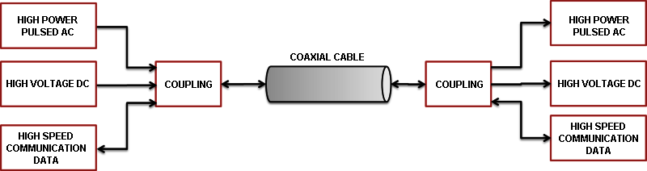
Fig: 1. Block diagram of Single Core Coaxial cable coupling
- COUPLING SCHEMES
For the applications mentioned in the introduction, bidirectional telemetry is required to communicate between remote side and on-board side along with high power pulsed AC transmission and high voltage DC. To operate this over a single core coaxial cable, a properly designed coupling scheme is essential. These signals are operated at different band of frequencies. Fig. 1 shows the basic block diagram of a coupling scheme for a single core coaxial cable [12]. For high power pulsed AC transmission, it is required to provide proper protection and isolation, vacuum relay based coupling was chosen. The ground lifting issue due to lack of isolation may cause damage of electronics in the data path.

In the proposed design a two relay scheme is discussed, which will provide full isolation in both high voltage AC and high speed data. When high power pulsed AC transmission occurs, the relay connected to the high voltage AC signal and the one connected to the ground path is switched.
- DESIGN OF DUAL RELAY BASED COUPLING SCHEME
For providing isolation of the data communication signal from the transmission signal, vacuum relay based coupling scheme is used. The Vacuum relay consists of three terminals, namely Normally Open (NO), Normally Close (NC) and Common (COM).

Dual relay configuration provides a ground isolation when the high power pulsed AC signal transmission happens. Fig. 2 shows the block diagram of the coupling scheme with a dual relay based switching.

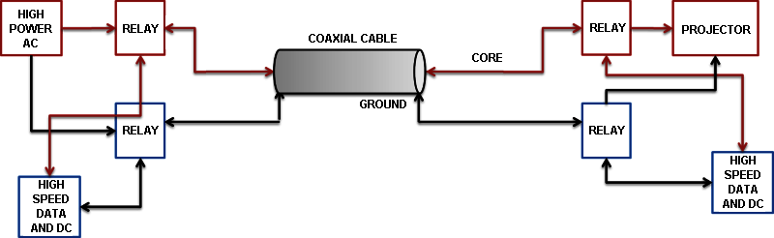
Fig: 2. Block diagram of dual relay based Single Core Coaxial cable coupling
The vacuum relay is controlled by high voltage DC which is sent from on-board unit. At remote unit, the high voltage DC has been separated out using DC coupling circuit. At the same time the high power AC signal has to be blocked. This area is challenging and coupling scheme for high voltage pulsed AC and high voltage DC has to be thoroughly studied. Once DC is available, the vacuum relay will switch from high power AC signal transmission mode to high speed data mode.

When relay is connected to the high speed bidirectional data communication signal, the high voltage DC generates the relay control to maintain continuous high speed bidirectional communication data. Once high power pulsed AC transmission starts, then the high voltage DC is not available at the remote side. This leads to the switching of relay at remote side for high power pulsed AC transmission. Once transmission is over the high voltage DC is available at remote unit, which leads to switching of the relay for bi-directional high speed communication.

The high speed bidirectional communication data and high voltage DC is sent through the cable from the on-board unit and at the remote side of the cable, the high speed bidirectional communication data and high voltage DC has to be separated using passive filters. The design of the passive filters is critical as the high speed data is attenuated at the high voltage DC path.

The high speed bidirectional communication data and high voltage DC (250 V) is a well separated band. So the design of the coupling scheme for high speed bidirectional communication data of on-board and remote units is simple compared to that of the high voltage AC transmission path.

For designing a coupling scheme it is necessary to consider the attenuation characteristics of filters [2].

$A=10 Log{[1+(\frac{ω}{ω_{c}})]}^{2n}$ (1)

Equation (1) is the attenuation for a low pass filter where
A represents the attenuation in decibels, ω is the frequency at which the attenuation is desired, ωc is the cut-off frequency of the filter, and n is the number of elements in the filter circuit. However, if designing high-pass or band-pass filter the equation is simply transformed by inverting the ratio ω/ωc for a high-pass filter. For the transmission path the coupling filter should drastically attenuate the high voltage AC signal in the high voltage DC path. Various filter designs are discussed by Mloyiswa et al [2].

Coupling filter response is selected based on the operating band of frequency of the signals that used. In this paper the signal used are well separated band of frequencies. For high voltage DC coupling, low pass filter response are suitable. High voltage pulsed AC coupler uses high pass filter response. High speed bidirectional communication signal operates at a band of frequencies (1 MHz to 10 MHz). So band passes or high pass filter responses are suitable. The high voltage DC coupler uses inductors and capacitor elements. The combination of L3, L4, L5, C2 and C3 has a low pass filter response. The theoretical value of the attenuation of high voltage pulsed AC signal of 5 kHz frequency at the high voltage DC coupling filter is -148 dB.

The high voltage pulsed AC coupling filter requires a high voltage rating capacitor. It is realized using a capacitor C4 and the diode D1. C4 blocks the DC component and D1 is to bypass the negative cycle of the high voltage AC signal. The theoretical value of attenuation of high voltage DC at the high voltage AC coupling filter is -148 dB.

Similarly for the high speed bidirectional data path, coupling filter needs a capacitor to block high voltage DC in the high speed bidirectional communication path. Attenuation of high speed communication signal (10 MHz) in the high voltage DC path is -490 dB.

The Transfer function of the high voltage DC coupling circuit is shown in Equation (2).

$H(s)=\frac{s^{2}L5c3+1}{s^{4}C2{C3}^{2}L4+s^{4}C2{C3}^{2}L5+s^{2}C2C3+s^{2}C3L5+s^{2}C3L4+ s^{2}{C3}^{2}+1}$ (2)

It is clear from the transfer function that the coupler has two zeros and four poles. The transfer function of DC coupler circuit used at the on-board side is shown in Equation (3). Here there are only two poles.

$H(s)=\frac{1}{{(s}^{2}L6C12)+1}$ (3)

For the high speed data coupler, transfer function is computed and is shown in Equation (4). From the equation it is clear that there are two zeros and two poles

$H(s)=\frac{s^{2}C10L}{s^{2}LC10+s^{2}L7C10+1}$ (4)

- SIMULATION STUDY USING PSPICE
For the design of coupling scheme, two vacuum relay are used for isolation of high power signal transmission. Simulation study has been carried out for transmission path and for data path using PSPICE.

Fig. 3 shows the PSPICE model of coupling scheme of high power transmission path. As the DC is coupled from the single core cable at the remote unit, it is essential to study the effect of high voltage pulsed AC signal in the DC path at the remote side.

A coaxial cable model with Resistance, Capacitance, Inductance and Conductance are arranged in a manner to simulate the coaxial cable. The values [R(6 ), L(0.1 uH), C(120 pF) and G(10 M)] of a 300 m single core coaxial cable are used to simulate single core coaxial cable.

At remote side the high voltage DC has been taken from the cable and not from the relay. So the operation of coupler and its circuit has been simulated along with the coupler of high voltage DC path. When the transmission happens at on-board side the relay is controlled by a transmission enable signal, which switches the relay for high power pulsed AC.

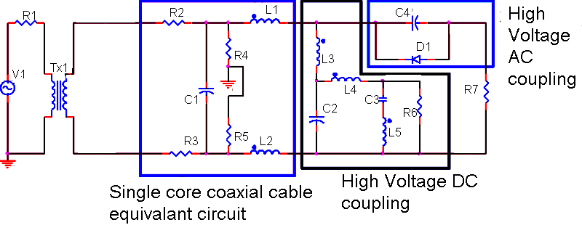
Fig: 3. PSPICE model of high transmission path.

Fig. 4 plots the frequency response of the couplers in the high power pulsed AC path, ie. for high power AC and high voltage DC. Fig. 4a is the high pass response of the high power AC coupler and Fig. 4b is the low pass response of high voltage DC coupler at remote side. From the figure it is clear that there is no high power AC in the DC path as the coupler -3 dB point is 8.6 Hz. For high power AC coupler the -3 dB point is at 8.6 Hz.

. 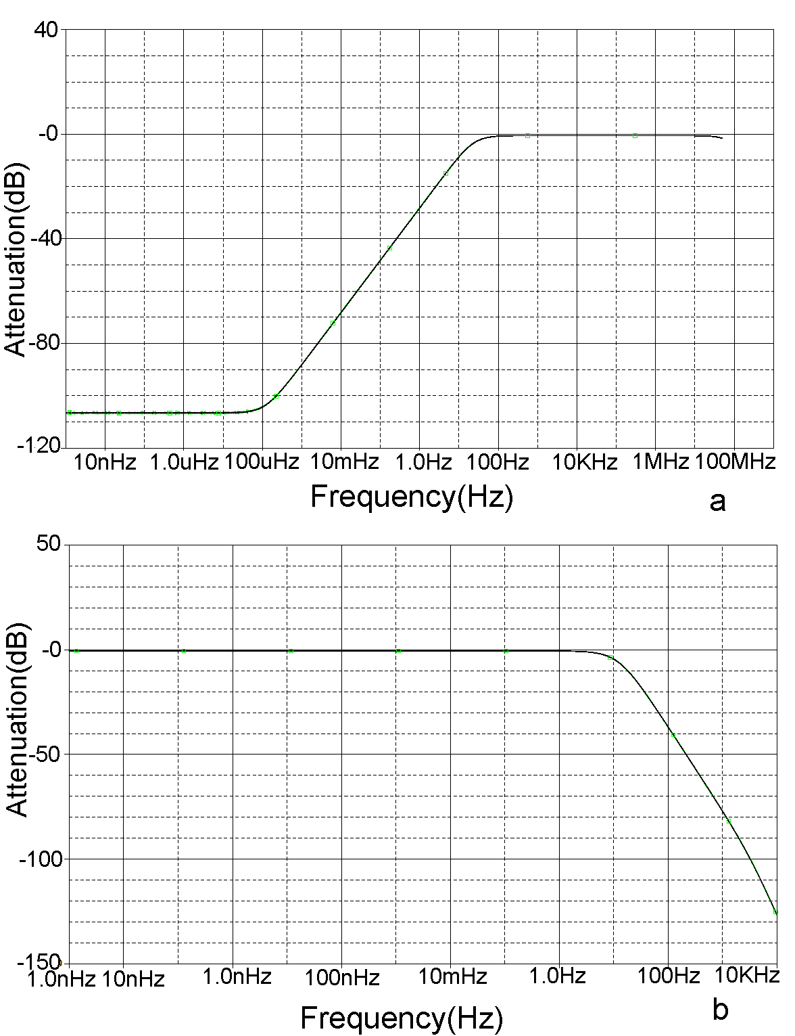
Fig: 4. Frequency Response of the filters in the high power pulsed AC path.(a) is the response of high power pulsed AC coupling circuit, (b) is the response of high voltage DC coupling circuit

Fig. 5 shows the PSPICE model of coupling scheme of high speed bidirectional data along with high voltage DC. The high voltage DC path is common for both high voltage pulsed AC and high speed bidirectional data. When transmission enable issued by on-board unit, stops the flow of high voltage DC supply to remote unit. The high voltage DC supply will be receives at remote unit once transmission is disable at on-board unit. So the high voltage DC is used to control the vacuum relay for transmission and reception.

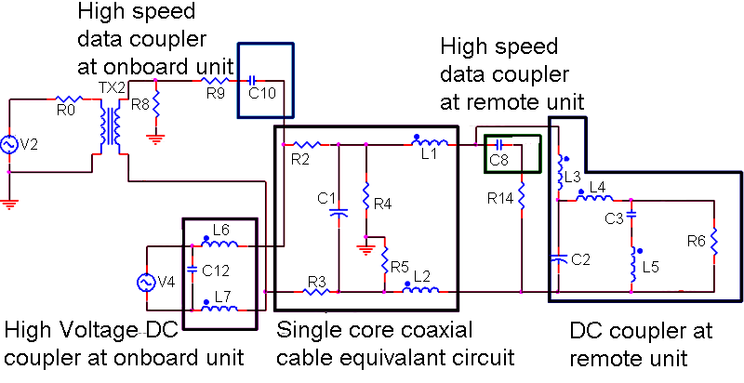
Fig: 5. PSPICE simulation coupler circuit for high speed data and high voltage DC path

Fig. 6a shows the effect of high speed data at the high voltage DC coupler and Fig. 6b is the band pass response of the high speed data coupler at on-board side. The -3dB point of the band pass filter with lower cut off is 4.6 Hz and upper cut off is 41 MHz. Similarly the -3dB point of the high voltage DC coupler at on-board side with respect to the high speed data input is 9.6 Hz.

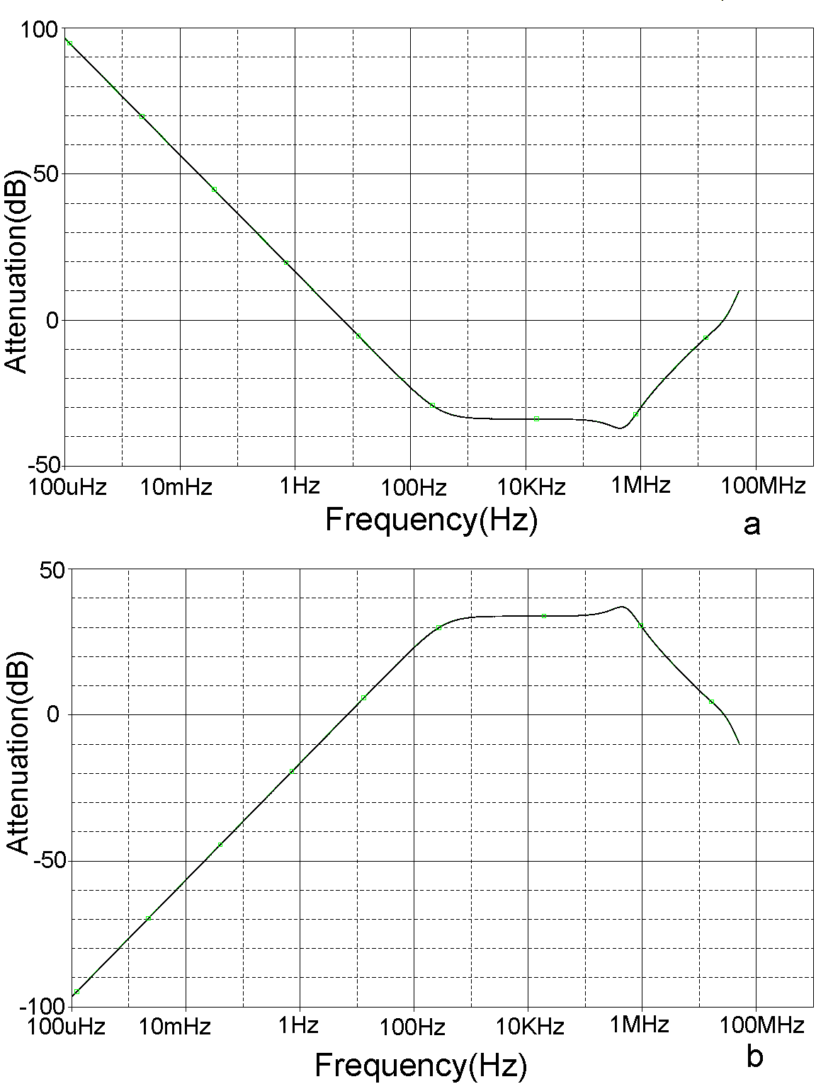
Fig: 6. Filter response at on-board side. (a) Effect of high voltage DC coupler circuit, (b) Effect of high speed data coupler circuit

The frequency response of the high speed data coupler used in the high speed data path at remote side is shown in Fig. 7. The -3 dB point of the high speed data coupler is 62.85 kHz.

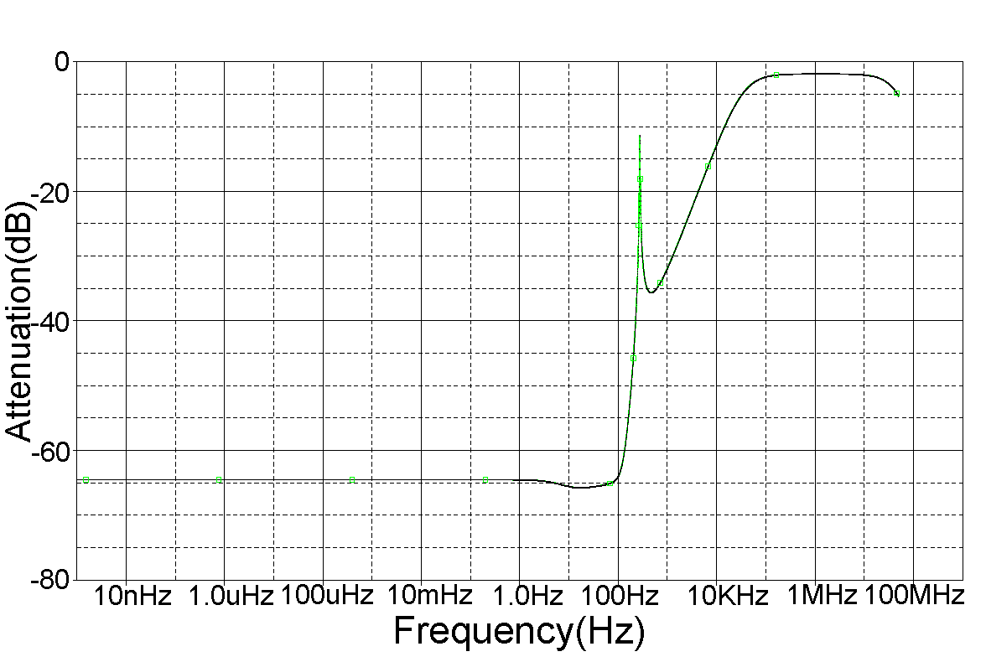
Fig: 7. Frequency response of high speed data coupler with respect to high speed data input at remote side

The designs of the couplers are optimized based on the operating band of frequency. The values of R, L and C are decided based on cut off frequency of coupling section. The attenuation of the frequency components is the only parameter to be check while optimise the coupler design.
- MEASUREMENT AND ANALYSIS OF DUAL RELAY BASED COUPLING SCHEME
A prototype PCB has been fabricated and assembled for on-board and remote unit. Measurements were carried out for the transmission of high power AC signal, reception of high speed bidirectional communication data and high voltage DC separately. By impulse method, the filter response of the each filter were plotted and carried out the analysis to verify the effect of filter in high power AC coupling, high voltage DC and high speed bidirectional data coupling paths.

- Transmission path

The coupling circuits were tested with an input of 20 Vpp
half sinusoid given from a signal generator. Fig. 8 shows the filter response of high voltage AC coupling filter. The high power pulsed AC coupling circuit has a low pass filter profile with an attenuation of -25 dB at 10 KHz.

High power pulsed AC signals were transmitted through the coupling filters. Measurements were carried out for two frequencies 3 kHz and 7 kHz respectively with 4.3 KV peak to peak voltage. Fig. 9a and 10a are the captured outputs of the high voltage AC signal at the remote unit and Fig. 9b and 10b are the components of high voltage AC signal in the DC coupling path.

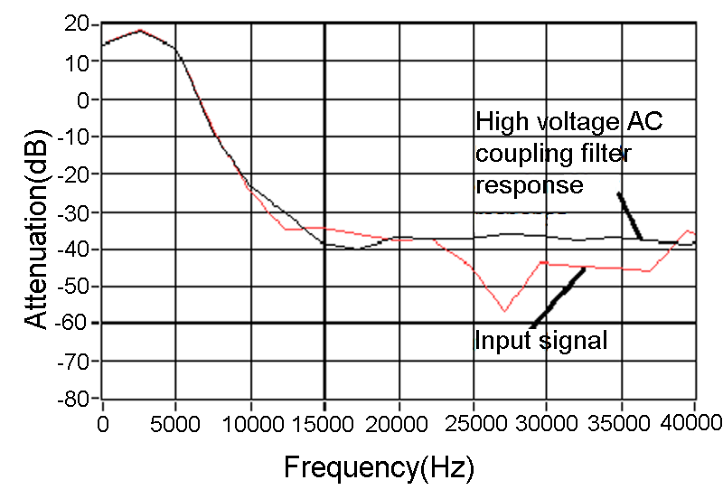
Fig: 8. High voltage AC coupling Filter Response

From the analysis, it is observed that the 3 KHz signal has a peak of 61.88 dB and that of the 7 KHZ signal is 62.50 dB. The component of 3 kHz and 7 KHz in DC path has a voltage level of 9.375 dB and 25.63 dB respectively. This can be suppressed by using sufficient protection in the high voltage DC power supply side.
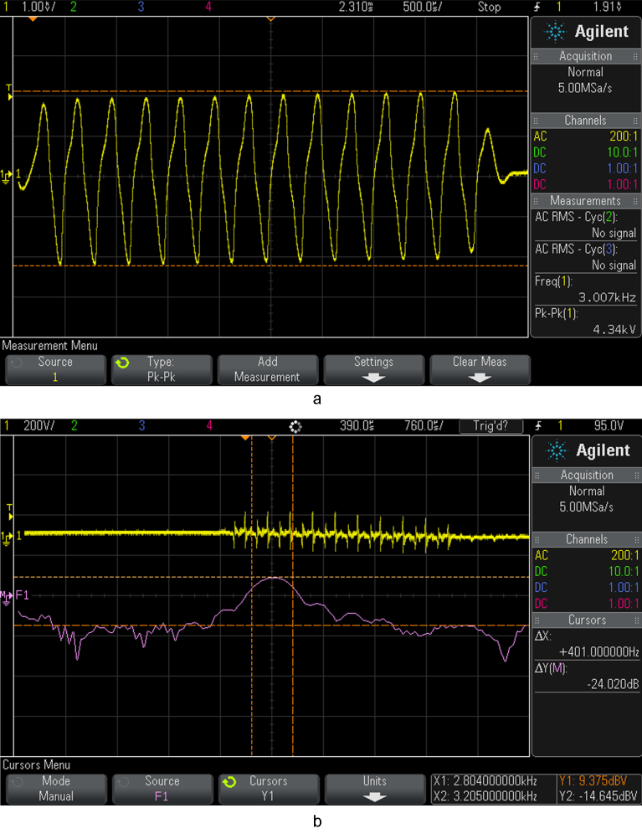
Fig: 9. High power AC signal at the remote unit. (a) 3 kHz transmitted signal, (b) Component of 3 kHz signal at the output of high voltage DC coupler
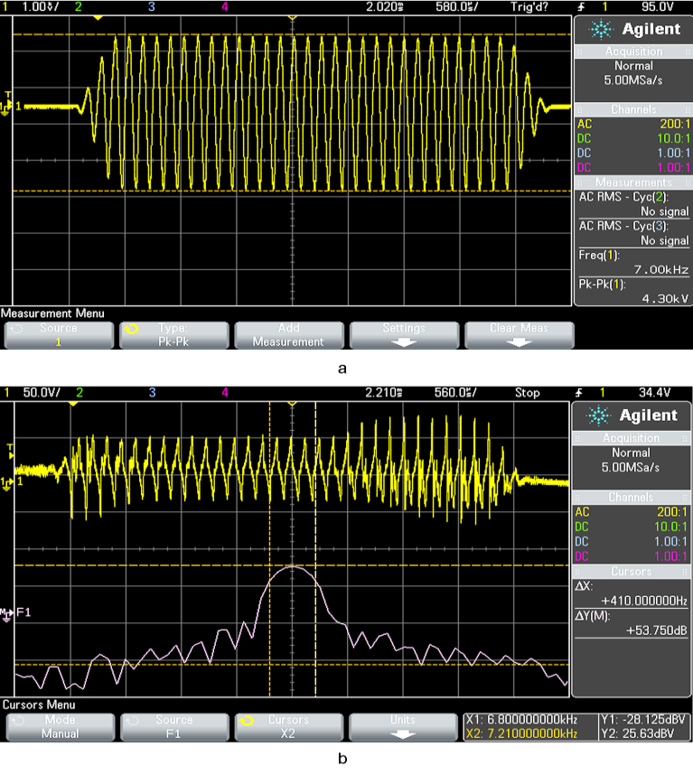
Fig: 10. High power AC signal at the remote unit. (a) 7 kHz transmitted signal, (b) Component of 7 kHz signal at the output of high voltage DC coupler

- Data path

Once the vacuum relay switches to the data path, it will completely isolate the high power AC signal. This time the single core coaxial cable carries the high voltage DC and high speed data. This high speed communication data and high voltage DC is coupled through filters.

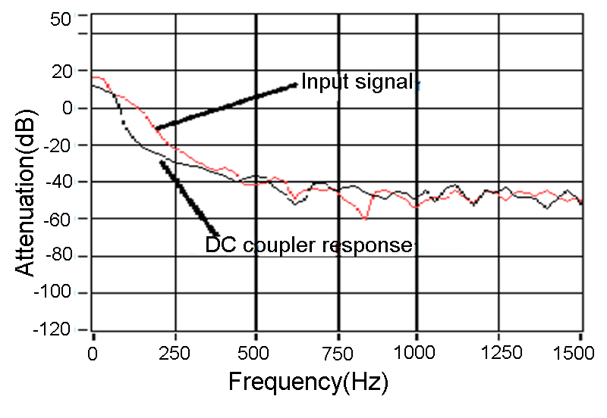
Fig: 11. High voltage DC coupling Filter Response

Fig. 11 is the low pass filter response, for the high voltage DC coupler, with a cut off frequency of 85 Hz at -3 dB point. Fig. 12 is the filter response of a high speed data coupler which is a high pass filter response with cut off frequency of 500 kHz at -3 dB.

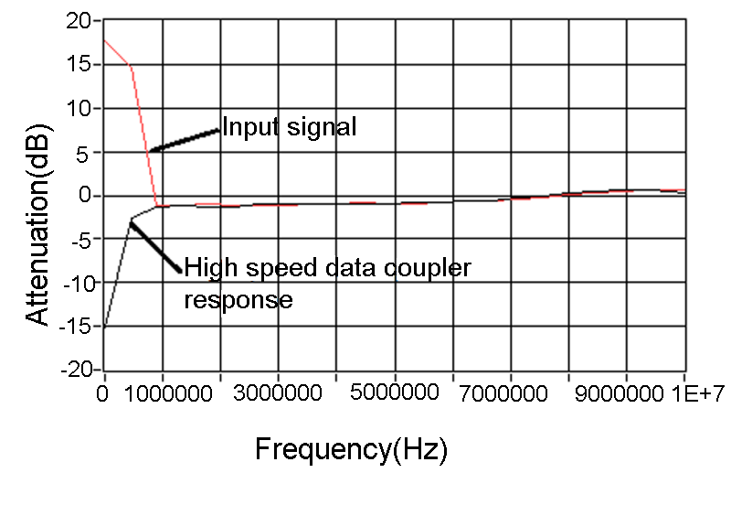
Fig: 12. High speed data coupling Filter Response
- CONCLUSIONS
This paper introduces a dual relay coupling scheme, which will fully isolate the high power AC. The signals transmitted through the single core coaxial cable are well separated band of frequencies. The dual relay coupling scheme provides good isolation compared to that of the single relay coupling scheme. When high power pulsed AC transmission occurs, both the centre core and shield of the cable is switched to high voltage pulsed AC path. To realize this dual relay coupling scheme, simulation studies were carried out using PSPICE. Measurements were done to verify the filter response. A high power pulsed AC signal of 4.3 KV peak to peak is transmitted and measurements were taken to study the effect of high power pulsed AC. Unlike the single relay mechanism, this scheme provides ground isolation. So this can be used in applications where high power signal handling is required along with high speed data communication and high voltage DC supply. Applications include imaging sonar and airborne sonar telemetry.

Acknowledgment
The heading of the Acknowledgment section and the References section must not be numbered.
References

[1] Sibanda, M.P.; van Rensburg, P. A. J. and Ferreira, H. C. “A compact economical PLC band-pass coupler with impedance matching”, International Symposium on Power Line Communications and Its Applications (ISPLC), pp. 339-344, June 2013.

[2] Sibanda, M. P. ; van Rensburg, P. A. J. and Ferreira, H. C. “Passive, transformer less coupling circuitry for narrow-band power-line communications”, International Symposium on Power Line Communications and Its Applications (ISPLC), pp. 125-130, March 2009.

[3] Shefter, A. P. “ROV and remote data gathering control, communications, and power supply over a single inexpensive coaxial cable using a low power multiplex system”, InOCEANS’93 Engineering in Harmony with Ocean, vol.3, pp. III/236-III/241, Oct 1993.

[4] Morash, P.; Wortley, C. and Trider, R. “A high speed digital data system for underwater acoustic measurements”, IEEE Conference on Engineering in the Ocean Environment, pp. 377-380, Sep 1971.

[5] Dogan, V. ; Miodrag, B. ; Vukoje, N. ; Mancic, G. and Zivanov, M. “A novel solution for realisation of data transfer in borehole measurement systems”, Proceedings of the 35th International Convention MIPRO, pp. 118-122, May 2012.

[6] Barry, W. and Haas, R. “Deep sea telemetry system for sediment analysis”, IEEE Conference on Engineering in the Ocean Environment,
pp. 188-191, Sep 1971.

[7] Hardiman, J. E.; Rosario, T. N. ; Quellette, T and Hegg, F., “High repetition rate side looking SONAR”, OCEANS ’02, vol. 4, pp. 2268-2272, Oct 2002.

[8] Belcher, E.; Hanot, W. and Burch, J. “Dual-Frequency Identification Sonar (DIDSON)”, International Symposium on Underwater Technology, pp. 187-192, April 2002.

[9] Md, Imamul Arefeen.; Md, Abdus Samad; Md, Asadujjaman Nur. “The power line home automation type communication system for voice communication and data transmission using an existing power line”, The 9th International Forum on Strategic Technology (IFOST), October 21-23, 2014 (IEEE), Cox’s Bazar, Bangladesh.

[10] Flavia Grassi; Sergio A. Pignari ; and Johannes Wolf;. “Design and spice simulation of coupling circuits for powerline communications on-board spacecraft”, 2012 ESA Workshop on Aerospace EMC, Venice, 2012, pp. 1-6.

[11] R. N. Gore; E. A. Andarawis and D. M. Davenport,. .“Design methodology for powerline coupling circuit: a system-level and Monte Carlo simulation based approach”, International Symposium on Power Line Communications and Its Applications, 2005. SP - 270 EP - 274 AU,(IEEE)

[12] Manoj, G.; Jacob, E. and Kundukulam, S. O. “Design, Simulation and Comparison of Mixing Schemes for DC, AC and Bidirectional Data through Coaxial Cable”, Procedia Computer Science, pp. 578-584, Dec 2016.

