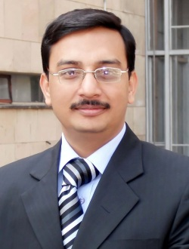
Mr. Manmohan Dass Goel graduated from Yashwantrao Chavhan College of Engineering, Nagpur, India in 2000 and completed his post-graduation from Indian Institute of Technology (IIT) Bombay, India in 2003. He is a doctoral research scholar in the Department of Civil Engineering, Indian Institute of Technology (IIT) Delhi, India. He has been working at Advanced Materials and Processes Research Institute (AMPRI), Council of Scientific and Industrial Research (CSIR), Bhopal since 2006. His research interests blast resistant design of structures, numerical and finite element modeling of materials and structures under high strain rate loading and application of aluminum foam in blast mitigation and crashworthiness.

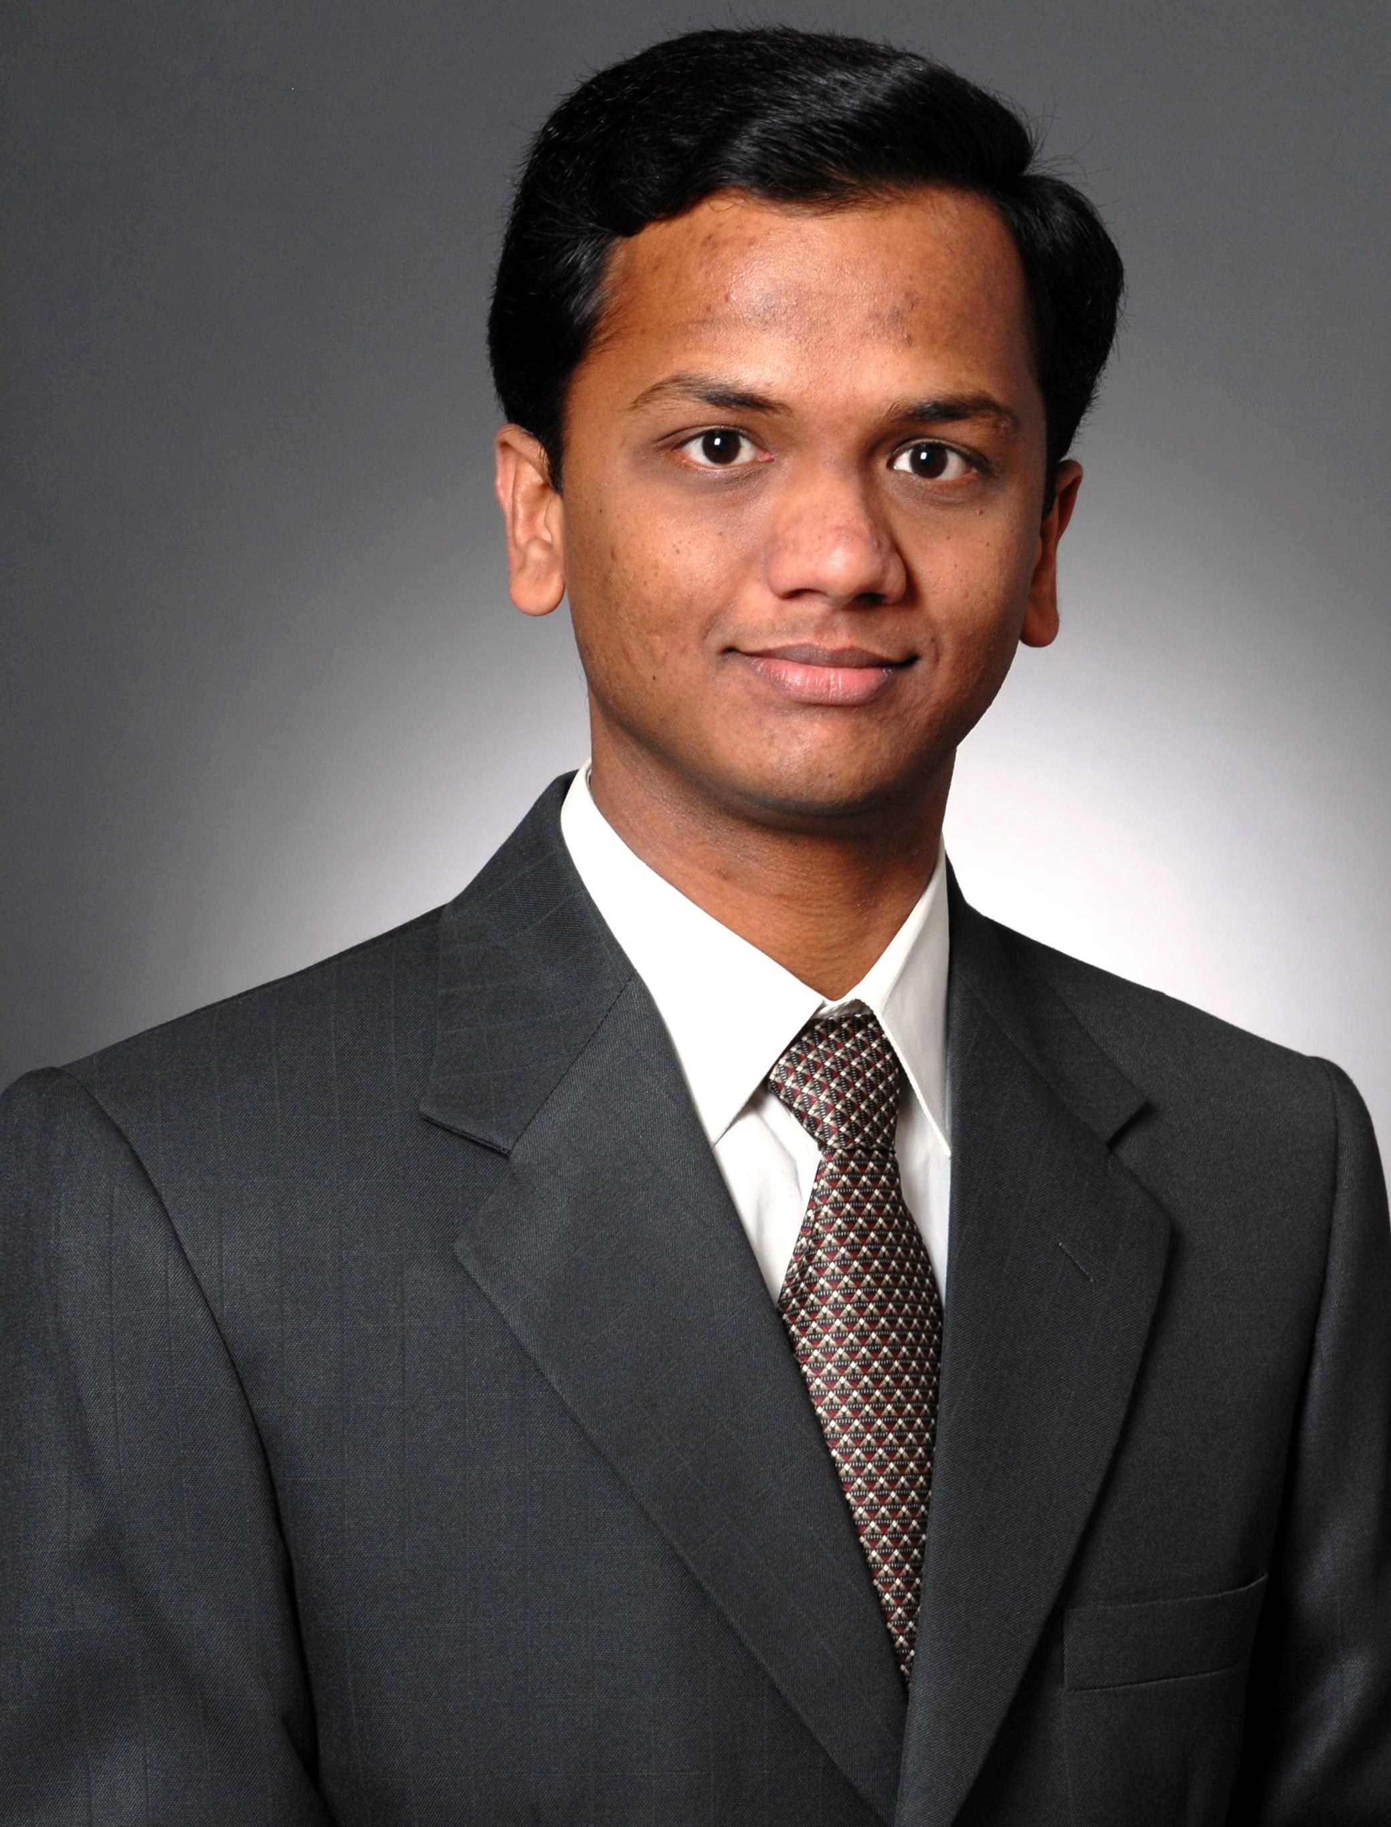
Dr. Vasant A. Matsagar obtained his Doctoral degree from Indian Institute of Technology (IIT) Bombay, India. He is Assistant Professor in Department of Civil Engineering, Indian Institute of Technology (IIT) Delhi, India. His research interests include structural engineering, earthquake and wind engineering, offshore structures, fiber reinforced polymer composites, finite element analysis, blast and fire engineering.

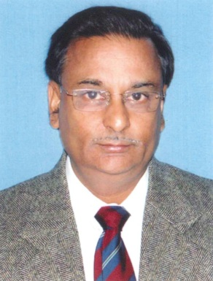
Dr. Anil K. Gupta obtained his Bachelor’s Degree in Mechanical Engineering in 1973 from National Institute of Technology (NIT) Warangal, (A.P.). He did his Ph.D. (Mech. Engg.) in 1987 from Delhi College of Engineering, University of Delhi. Presently, he is the Director at Advanced Materials and Processes Research Institute (AMPRI), Bhopal. His research interest includes lightweight materials, magnesium alloys and metal forming.


Dr. Steffen Marburg is Professor in Department of Aerospace Engineering, University of German Armed Forces, Munich, Germany. His research interests include development and application of numerical methods (FEM, BEM) for analysis and reduction of vibrations and noise, analysis of models with uncertainty, arising for example due to manufacturing tolerances or by biological growth.

