Submitted to Defence Science Journal
(Revised Manusript)

Concurrent Development and Certification of
SOFTCOMAG 49AA Alloy for Aeronautical Applications

Ashok Kumar*, Y. Balaji*, H.V. Kiran**, P. Sarkar**, Vijay K. Varma***,
N. Eswara Prasad*,† and K. Tamilmani***

*Regional Center for Military Airworthiness (Materials), CEMILAC, PO Kanchanbagh, Hyderabad – 500 058, India
** Mishra Dhatu Nigam Limited (Midhani), PO Kanchanbagh, Hyderabad – 500 058, India
***Centre for Military Airworthiness and Certification (CEMILAC), DRDO, Marathahalli Colony, Bangalore – 560 037, India
(†Corresponding author: Email – nep@cemilac.drdo.in)

ABSTRACT

Softcomag 49AA alloy consisting of 49 wt.% Fe, 49 wt.% Co and 2 wt.% V is a soft magnetic alloy with a combination of very high saturation magnetization and high magnetostriction and used for several aeronautical applications such as generators (stators and rotors), fixed iron moving armature units etc. Though this alloy is brittle in nature, it can be formed into hot rolled bars and cold rolled sheets by adopting suitable thermo mechanical treatments. In order to indigenize and subsequent type certification for aeronautical applications, the alloy was produced using 100 % virgin raw materials in a vacuum induction melting (VIM) furnace which not only ensures substantial reduction of inclusions, but also the production of homogeneous alloy as a result of induction stirring. The chemical composition was examined and hot working parameters of the alloy were so optimized that they would result in the best combination of magnetic, physical and mechanical properties for the end use, which forms the central theme behind the developmental activity that was simultaneously covered by a comprehensive certification process. The material thus produced is subjected to stringent quality control checks in accordance with stipulated airworthiness norms. The paper discusses in detail the indigenization efforts and airworthiness certification of the alloy Softcomag 49AA and its comparison with equivalent grades, namely PERMENDUR 49 and VACOFLUX 50.

Keywords: Softcomag 49AA alloy, Melting, Processing, Characterisation, Testing,Type Certification.

- INTRODUCTION

Softcomag magnetic alloy 49AA, designated here as SOFTCOMAG 49AA, having 49 wt.% Co, 49 wt.% Fe and 2 wt.% V, is an aeronautical grade alloy having high saturation flux density of 2.35 Tesla, high Curie Point (950⁰C) and high magnetostriction (+70x10⁻⁶) and has been chosen for use in fighter aircraft¹⁻⁵. A systems engineering design approach is utilized to translate the requirements of the user / customer. This calls for production technology to be fully evolved and standardized, ie., the materials must be produced according to a fixed process specification and have been registered in accordance with an aerospace material specification. These standards contain material and process specification requirements consistent with conditions representative of the processing and manufacturing environment.

Many a commercial equivalents of Softcomag 49AA have been developed and produced. Notable among them include PERMANDUR 49^{2,4}, VACOFLUX 50³ and CARPENTER⁵. The major constituents of most soft magnetic alloys are one or more of the common ferromagnetic element, namely Fe, Ni and Co. Most useful combination of these elements employ typically the substitutional solid solutioners. They contribute in terms of controlling the lattice crystalline structure to promote high permeability, low coercive force and low hysteresis loss.

The contents of a typical type certification standard for the production of Softcomag 49AA, that include the scope of the standards, reference to applicable documents, technical requirements, provisions for quality assured production and delivery. To ensure consistency in product quality, the test population must include ten batches of material from at least 3 to 5 production heats, casts, or melts for each product form. Since the production of aero grade Softcomag 49AA needs the fulfillment of certian physical, mechanical, magnetic and chemical property requirements of the alloy, the operational environment of the candidate alloy must be considered. Typically, these material property data exceed the scope of Military Specifications. Therefore, test data sufficient to statistically substantiate the alloy’s behavior in its operational environment must be developed. Material factors to consider are static-strength requirements, corrosion and embrittlement, environmental stability, magnetic properties, besides producibility, availability, costs, fabrication characteristics, inspectability, compatibility with other materials, thermal and electrical characteristics. Furthermore, NDE techniques must be shown to be capable of detecting representative defects and the effect of defects on materials properties must be understood and characterized. Also the limitations of the NDE techniques being applied must be understood, along with the probability of detecting processing and manufacturing defects.

The present paper describes the above technological development effort for the production of aero grade Softcomag 49AA alloy with airworthiness certification, which is mandatory for the production of components for fighter aircraft.

- PRODUCTION TECHNOLOGY

Due to high criticality of application, integrity verification in each melt and consistent verification of 3 to 5 melts has been adopted for the certified production of Softcomag 49AA. A systematic process flow chart employed for the production of Softcomag 49AA is shown in Figure 1. In order to maintain the desired quality, rigorous quality assurance steps were adopted from raw material stage to finished product, at each successive stage of production as given at Table 1.

Extensive property evaluation has been conducted on these melts to adjudge the material capability. Optimization of chemical composition, forging, rolling and heat treatment parameters has been done to obtain the best combination of properties for end use⁶. These are briefly described in the following sections.

  - Melting

Vacuum Induction Melting (VIM) using a 2.2 ton capacity furnace, was used for primary melting and 100% virgin raw materials were used from approved aeronautical sources. The vacuum induction melting thus used was found to result in a Softcomag 49AA alloy that has low inclusion content and a homogeneous chemistry, principally due to induction stirring. It also reduced porosity levels and has resulted in uniform distribution of unavoidable impurities, enabling the production of ingots which are grossly improved in quality with considerable ease during forging.
Vacuum Induction Melting (550mm Dia)
Conditioning
(550mm Dia)
Forging (80-10mm Dia)
Ultrasonic Inspection
Ultrasonic Inspection

Forging & Machining
Machining, Hot rolling& Pickling,
Cold Rolling
Type testing/Evaluation

Rolling (80mm Dia)
Virgin Raw Materials
(Approved Aeronautical Sources)
Finished product for dispatch

Fig 1. Process flow chart for manufacture of Softcomag 49AA

Table 1. Process steps for the quality assured production of Softcomag 49AA.

Process Steps | Quality Assurance
- Raw Material & Material Control  - Process Control  - Primary Melting  (Vacuum Induction Melting)  - Forging  (c ) Rolling  (d ) Heat treatment  - Testing & Evaluation | - Approval of sources  - Comparison with aeronautical specifications  - Raw materials inspection certificate (RMIC )  - Test certificate by suppliers  Crucible condition, ultimate vacuum level, leak rate, melt chemistry, ingot surface & soundness etc.  Furnace atmosphere, heating cycle, calibration of furnaces, finish temperature, dimensional check, ultrasonic testing, macro examination, surface quality check, etc.  Temperature control, visual inspection and removal of defects  Furnace atmosphere, heating cycle, calibration of thermocouples & furnaces etc.  Dimensional check of test specimens, calibration of all equipment  & heat treatment furnaces.  - Load cell calibration.  - Metallurgical, physical, chemical & Magnetic property evaluation.  - Verification of test results & consistency in melt etc.

  - Forging and Rolling

The ingots cast were forged using a reduction rate of 5-10 mm/min (which corresponds to a nominal strain rate of 1.6-3.2x10⁻⁴ s⁻¹), employing a start temperature of 1100 ºC and the forging operation was continued till the forge stock has reached a temperature of 850 ⁰C. Bogie hearth furnace was used for soaking and a 1500 ton press was used for forging. Ingots were thus reduced to various mill sizes by forging and they were further rolled by giving 10-12% reduction to final section sizes that were specified by the user. To ensure a defect free structure and to avoid rejection at subsequent stages, ultrasonic testing was carried out at different stages of forging and rolling processes.

  - Heat Treatment

Suitable heat treating temperature for production of Softcomag 49AA alloy with specific properties is chosen so that best soft magnetic characteristics with optimized mechanical properties are obtained⁷⁻⁹. For this, a highest possible temperature, which results in highest soft magnetic properties, is selected and employed. The wrought products of the alloy produced by forging and rolling were then heat treated under the optimized conditions of 850⁰±10⁰C/ 3hrs in H₂ atmosphere followed by cooling to 300 ⁰C using a controlled cooling rate of 60-180⁰ C/hr, and then furnace cooled to room temperature.
- CHARACTERISATION

Chemical analysis of the elements like manganese, silicon, chromium, nickel, cobalt, phosphorus and vanadium was carried out using optical emission spectrometer as per ASTM E 354¹⁰. Carbon and Sulphur were analyzed using Leco Carbon & Sulphur analyzer as per ASTM standard E-1019¹¹. Gases, particularly hydrogen, oxygen and nitrogen, were analyzed using Leco Gas Analyzer. Macrostructural evaluation was carried out in accordance with ASTM standard A-604¹². Microstructural characteristics and grain size were determined in both annealed condition and in the final product forms as per ASTM standard E-112¹³. Non metallic inclusions were rated in accordance with method D of ASTM standard E-45¹⁴. Coefficient of thermal expansion was measured in accordance with ASTM standard E-228¹⁵, using a dual push rod dilatometer. Magnetic properties of these materials were evaluated using DC in accordance with ASTM standard A-596¹⁶ using ring shaped specimens. Mechanical properties, viz., Vicker’s Hardness (as per ASTM standard E-92¹⁷), tensile properties at ambient temperature (as per ASTM standard E-8¹⁸) and elevated temperature tensile properties (as per ASTM standard E-21¹⁹) were evaluated and reported. Both ambient and elevated temperature tensile tests were done on specimens with gage length that is 4 times the gage diameter, in accordance with the ASTM standards E-8 and E-21. Young’s modulus was determined in accordance with ASTM standard E-111²⁰. Finally, the ultrasonic inspection was carried out in accordance with AMS 2630A using 2 mm flat bottom hole (FBH) as reference standard²¹. Sizes and tolerances were checked in accordance with AMS 2241²².

- RESULTS

  - Chemical Composition

The data in Table 2 provide the specified and average chemical composition obtained over five melts of the Softcomag 49AA alloy, evaluated in the fully annealed condition of the forged and rolled product of 80 mm diameter bars. These results show that the alloy’s chemical composition is well within the permissible limits, specified by the AMS 2248 ²³. The hydrogen, nitrogen and oxygen gases were also analyzed and their levels were found to be 0.5, 10 and 53 ppm, respectively. Alloy produced by International manufacturers (Telcon, Permendur, and Vacuumschmelze) used for comparsion with indieginised Softcomag 49AA alloy are having similar chemical composition.

Table 2. Chemical composition of SOFTCOMAG 49AA forged and rolled bars of 80 mm diameter in the annealed condition
Element  (Weight %) | Specified Value | Obtained Value
Carbon (C) | 0.025 Max | 0.0086
Manganese (Mn) | 0.15 Max | 0.04
Silicon (Si) | 0.15 Max | 0.02
Phosphorus (P) | 0.015 Max | <0.005
Sulphur (S) | 0.010 Max | <0.005
Chromium (Cr) | 0.15 Max | 0.10
Nickel (Ni) | 0.25 Max | 0.05
Cobalt (Co) | 47.50-49.50 | 49.5
Vanadium (V) | 1.75-2.10 | 2.10
Iron (Fe) | Balance | Balance
  - Microstructure
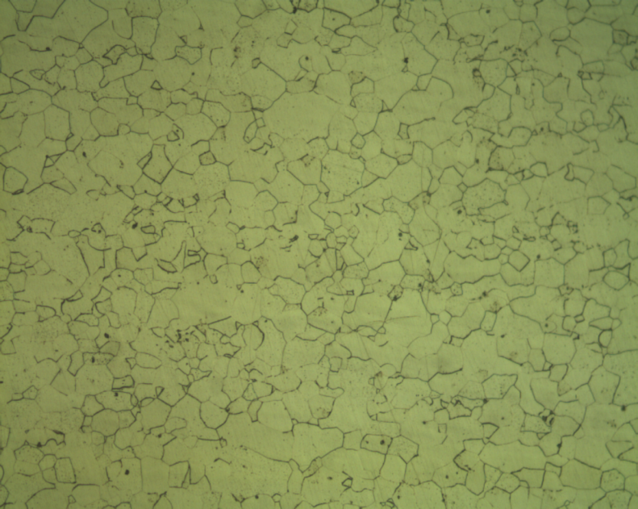
Macrostructural evaluation was conducted on specimens, obtained from top, middle & bottom of the ingots. Such an examination has revealed that the ingot was free from shrinkage, cracks, pipe, porosity, blow holes etc.. The optical micrograph, shown in Fig. 2, clearly indicates ferrite morphology with grain size of ASTM number 4 to 6. This is slightly higher than the size of the grains of the imported Softcomag 49AA alloy, obtained and evaluated for comparison purpose. The imported alloy showed a grain size that in the range of ASTM number 5 to 6. The imported and indigenously produced alloys have marginal difference in their grain size. This has resulted in similar properties in the two alloys. The non metallic inclusions in both imported and indigenously developed products were found to be within the specified limits.
100μm
Figure 2 Microstructure showing ferrite morphology in annealed condition.

  - Physical Properties

Density of the Softcomag 49AA alloy produced in the present development was found to be in the narrow range of 8.11 - 8.12 g/cc, which is slightly lower than the typical value of 8.15 g/cc. Coefficient of thermal expansion (α) was measured in the temperature range RT-500⁰ C using a dual pushrod Dilatometer. The α values thus determined are given in Table 3. Specific heat too was measured and it ranged from 0.401 to 0.434 K Cal/ kg ⁰C against the typical value of 0.1 K Cal/kg ⁰C specified. Thermal conductivity values obtained were in the range 40 to 50 W/m-k, against the typical value of 30 W/m-k.

Table 3. Coefficient of thermal expansion (α) of the SOFTCOMAG 49AA alloy

Temperature  range | Co-efficient Thermal  Expansion (α), 10 ⁻⁶ / ⁰C
 | Obtained | Typical
20-100⁰C | 8.57 | 9.2
20-200⁰ C | 9.52 | 9.5
20-300⁰ C | 9.9 | 9.8
20-400⁰ C | 10.36 | 10.1
20-500⁰ C | 10.58 | 10.4

  - Magnetic Properties

Magnetic properties of the product have been evaluated and obtained properties (average of material from 5 different heats) are compared with specified properties (Table 4). The variation of flux density (B) and permeability (µ) with magnetic field strength (H) in the present Softcomag 49AA alloy is shown in Figure 3. The guaranteed flux density of 20000 Gauss was achieved below the specified 10 Oe Max. The remenance measured from a flux density of 21400 Gauss was 12600 Gauss. Magnetic properties of this alloy are found to be comparable (see data in Table 5) with equivalent alloys having the similar chemistry of other reputed international manufacturers. While most of the alloying elements lower the magnetic properties, Cobalt improves magnetic saturation induction⁵.

Table 4. Magnetic properties of Softcomag 49AA alloy in the annealed condition of the forged and rolled bars.

Properties | Obtained value | Specified value
Saturation induction at 12.5 Oe (T) | 2.135 | >1.95
Residual Induction (T) | 1.26 | 1.0 minimum
Coercive filed strength (Oe) | 0.46 | 2.00 maximum
Maximum magnetic permeability (µ) | 11400 | 7000 typical

Table 5. Comparison of the magnetic properties of the indigenised Softcomag 49AA alloy with similar alloys manufactured by other international agencies.

Properties | Specified | Softcomag 49AA alloy | Telcon Permendur 49 | Vaccumschmelze Vacoflux 50
Flux Density, Tesla at 10 Oe | 1.95 min. | 2.135 | 1.96 | 2.0
Coercive Force, Oe | 2.0 max. | 0.46 | 1.2 | 1.4
Maximum Permeability | 7000 min. | 11400 | 7000 | 8000
Curie Temperature, ⁰C | 925 | 940 | 940 | 950

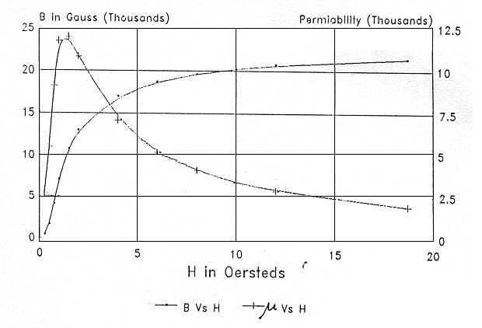

Fig. 3: DC magnetization curve, obtained from Softcomag 49AA alloy.

  - Mechanical Properties

Hardness: Hardness in annealed condition ranged from 183 to 189 HV against specified 250 HV maximum and the same in as-forged and machined condition is in the range of 253 - 268 HV against 270 HV maximum specified.

Young’s modulus: Young’s modulus in annealed condition is between 229 and 248 GPa against 200 GPa minimum specified and the same in as-forged and machined condition is found to be from 188 to 247 GPa against 200 GPa minimum specified.

Tensile properties: Average values from tensile properties obtained from specimens of 5 different heats, tested at room temperature, 200⁰ C and -70⁰ C in forged and annealed conditions are given in Fig. 4. The data in Fig. 4 also show the specified values at RT for comparison. The RT tensile test data in Fig. 4 show that the Softcomag 49AA alloy exhibited tensile properties that are far superior to the specified values. The strength values are lower and elongation is higher than the specified value of the annealed alloy. Further, the alloy in the as-forged and machined condition too exhibited higher strength and elongation values as compared to the specified property levels. The strengths in this condition are more than 30% higher and the elongation is more than 150% higher.

The mechanical properties (hardness, modulus and tensile) of the presently developed Softcomag 49AA alloy, are much higher than the specified values. The physical and functional (magnetic properties, in this case) too are comparable or even superior to the specified values or those obtained from the same alloy of reputed international sources.
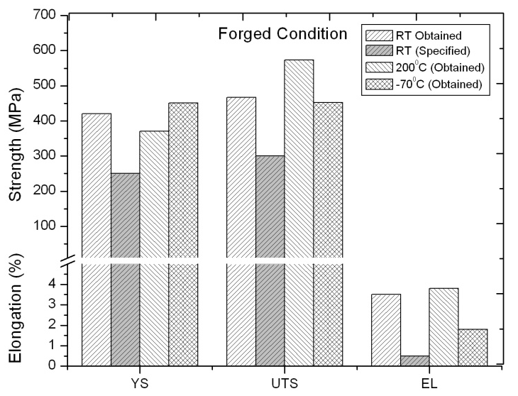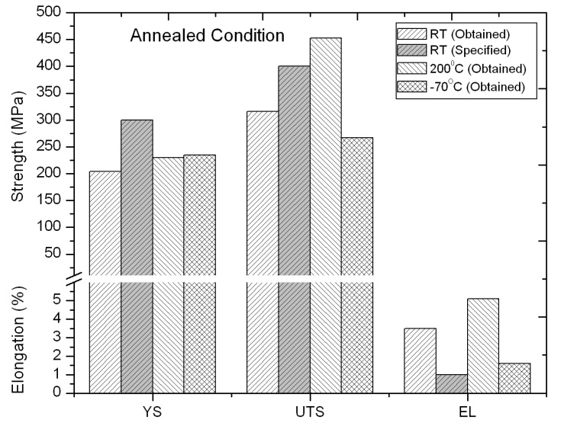

Figure 4. Tensile properties of Softcomag 49AA alloy as a function of test temperature for (a) Forged and (b) Annealed conditions.
- DISCUSSION

The Softcomag 49AA alloy is normally an intrinsically brittle material and virtually near impossible to process. Any additives to improve workability of the alloy would affect the magnetic properties. Since the alloy is required in the form of 30-80 mm diameter bar and 0.2 mm thick strips, working of this alloy is inevitable. This challenge has been overcome by the optimization of the chemistry and processing parameters briefly described below:

- Primarily, optimization of alloy chemistry is vital to achieve the required high level of magnetic properties. This has been achieved in the present technological development by balancing the cobalt and iron contents within the specified ranges, by employing the Cobalt levels that are close to the maximum value in the specified range and restricting the iron to the minimum of the specified range.
- Secondarily, workability has been imparted to the alloy by controlled addition of 2% Vanadium and 0.15% rare earth mixture during melting. Vanadium and the rare earth mixture help in retarding long range ordering thus avoiding brittle structure; thus, improving the processing capability⁵. Hence, this is the only modification that can be done to achieve the short range ordering resulting in ductile structure. After suitable thermo mechanical treatments, 90% cold reduction could be given to the alloy in this condition without intermediate annealing. Intermediate annealing is to be avoided since it is found to result in an ordered structure, which will reintroduce the brittleness.

However, neither the cold rolled strip nor the components manufactured from the strip possess the required magnetic properties. To impart the same, suitable heat treatment with a constrained cooling rate has been designed and employed. Low annealing temperatures resulted in a structure which is magnetically not soft enough to give the desired properties. On the other hand, higher temperatures result in lower than desired mechanical properties. Heat treating for the best magnetic properties should ensure that the temperature does not exceed 900⁰C. These conflicting requirements were balanced and a suitable heat treatment was arrived at. Such an optimized heat treatment condition is found to be: soaking at 850⁰ C followed by controlled cooling at a rate of 60-100⁰C / hr to obtain the desired coarse grain structure. The atmosphere used was non-oxidizing and non-carburizing, which should be either hydrogen or vacuum. This again was found to result in excellent magnetic properties. Such data comparison reveals that the present alloy development programme is successful and the Softcomag 49AA alloy thus produced can be used in Indian aeronautical and aerospace application with confidence.

- CONCLUSIONS

1. The present programme of development with airworthiness qualification of Softcomag 49AA alloy has been satisfactorily completed and material supplied for end use was found to be highly satisfactory during performance.

2. The alloy has been successfully developed, commercially produced and type certified for Indian strategic satellite, missile and aeronautical applications. The production costs too were found to compare favorably with international prices, being lower by eight to ten percent.

3. Indigenization and supply of this strategic alloy has helped self reliance in several Indian aeronautical and aerospace programmes.

4. Consistency among melts and integrity within each melt have been the principal achievements of the present technological development and the Softcomag 49AA alloy, thus produced, was found to possess properties that are comparable or even superior to those specified values or those obtained from imported alloy from reputed international agencies.

ACKNOWLEDGEMENTS

The authors wish to put on record their deep sense of gratitude to Shri M Narayana Rao, Chairman and Managing Director, Mishra Dhatu Nigam, Hyderabad and Shri G Gouda, Group Director (Propulsion), CEMILAC for their keen interest in this work. Financial support from DRDO and Ministry of Defence (Production) is gratefully acknowledged.

REFERENCES

- ASTM International Standard Specification for Wrought iron-cobalt high magnetic saturation alloys UNS R 30005 and R 92650, ASTM A 801/A 801M-1999.
- Technical Data Sheet 4b, Telecon Metals Limited on Permendur 49.
- Technical Data Sheet of Soft Magnetic Materials, Vacoflux 50.
- High temperature metals 800-500-2141-permendur 2 V Hiperco 50 A, Technical information (Pp 1 to 4).
- D.W. Dietrich, AMS Handbook, Vol.1 (ASM International, PA, USA) Pp. 761-781
- Development type test schedule for Softcomag 49AA for forged and hot rolled bars, No. RCMA (M)/90, 2002.
- Emile Josso Fe-Co-V alloys: A critical study of the phase diagrams in relation to Magnetic properties, IEEE Transactions on Magnetics, Vol.Mag-10, No.2, Pp 161-165, June, 1974.
- Lesile L. Harner, A simplified method of selecting soft magnetic alloys, May 1999.
- Richard M. Bozorth, Ferromagnetism, D. Van Nostand Company, Inc., New York, USA.
- ASTM International Standard test methods for chemical analysis of High-Temperature, Electrical, Magnetic and other similar Iron, Nickel and Cobalt alloys- ASTM E 354-1993.
- ASTM International: Standard test methods for determination of Carbon, Sulphur, Nitrogen and oxygen in steel and in Iron, Nickel and Cobalt alloys, ASTM E 1019-2003.
- ASTM International Standard Test Method for Macroetch Testing of Consumable Electrode Remelted Steel Bars and Billets, ASTM A 604-2007.
13. ASTM International Standard test methods for determining average grain size of metals, ASTM E 112-1996.
14. ASTM International Standard test methods for determining the inclusion content of steel, ASTM E 45-1997.
15. ASTM International Standard test method for linear thermal expansion of solid materials with a push-rod dilatometer, ASTM E 228-1995.
16. ASTM International Standard Test Method for Direct-Current Magnetic Properties of Materials Using the Ballistic Method and Ring Specimens, ASTM A 596-1995.
17. ASTM International Standard Test Method for Vickers Hardness of Metallic Materials, ASTM E 92-1997.
18. ASTM International Standard Test Method For Tension Testing Of Metallic Materials, ASTM E 8-2004.
19. ASTM International Standard Test Methods for Elevated Temperature Tension Tests of Metallic Materials, ASTM E29-2008
20. ASTM International Standard Test Method for Young's Modulus, Tangent Modulus, and Chord Modulus, ASTM E111-1997
21. Aeronautical Material Specification for Inspection, Ultrasonic Product Over 0.5 Inch (12.7 mm) Thick, AMS 2630.
22. Aeronautical Material Specification for Tolerances Corrosion and Heat Resistant Steel, Iron Alloy, Titanium, and Titanium Alloy Bars and Wire, AMS 2241.
23. Aeronautical Material Specification for Chemical check analysis limits, corrosion resistant and heat resistant steels and alloys, Maraging and other highly alloyed steels, and Iron alloys, AMS 2248.

Sri Ashok Kumar is a senior scientist in Regional Centre for Military Airworthiness (Materials), CEMILAC, Hyderabad. He graduated from Punjab University in 1974 and obtained M.Tech degree in metallurgical engineering from IIT, Kanpur. Since then he has been engaged in the development and airworthiness certification of alloy steels in addition to various other materials.

Sri Yarlagadda Balaji has specilised the Certification of Steels and Steel Components for Indian Defence. He have over 18 years experience in Steel Development and Production and has been instrumental in the issuance of type approvals for the production of various grades of Steels and Superalloys for DRDO Systems and Technologies. He is a recipient of Appreciation Certificate from SA to RM, DRDO for his contributions on the Development of Components for Jet Fuel Starter for LCA.

Dr. H V Kiran, is a post graduate in Physics with specialization in electronics and Ph D from IIT, Bombay. He has been working in the Quality Control Department of M/S Mishra Dhatu Nigam Ltd (MIDHANI), Hyderabad since 1983. His areas of specialization include magnetic & Physical testing and Non destructive evaluation. Currently he is heading the Marketing Division of MIDHANI. He is a life member of MSI & ISNT and a member of Indian Institute of Metals.

Sri P. Sarkar did his B.Tech from B.E. college, Shivpur, Calcutta University and M.Tech from IIT, Kanpur. He joined in MIDHANI in the year 1979. Presently, he is working as Additional General Manager (Management Services) and looking after Production Planning and Control, Technology and R&D, Projects, Industrial Engineering and Management Information Services. He is recipient of ‘Metallurgist of the Year 2008’, Instituted by Ministry of Steel and Mines. He has worked in the area of Soft Magnetic Alloys, Super Alloys and Steels.

Dr. Vijay Kumar Varma, Senior Scientist and Group Director (TC&S) in Centre for Military Airworthiness and Certification (CEMILAC), Bangalore and specializes in establishing Process Technologies for the Development of advanced alloys/materials, which include Nickel base Superalloys, Ti-alloys, Aluminum alloys and Metal Matrix Composites (MMCs). He holds the merit of receiving DRDO Agni Award for Excellence in Self Reliance (2005) and DRDO Technology Award (2003).

Dr. N Eswara Prasad, specializes in Mechanical Behavior of Engineering Materials as well as Development, Certification and Production of several Structural Materials for Indian Defence. He has published nearly 120 peer-reviewed papers and conference proceedings in reputed national and international journals. He has also authored several comprehensive classified technical reports, including some first DRDO documents on Nano Technology and Aluminum Alloys. He has bagged several national recognitions, including the prestigious NMD Award – the Metallurgist of the Year 2010. He is presently the Regional Director of RCMA (Materials) of CEMILAC at Hyderabad. He is a Fellow of Institution of Engineers (FIE) and Indian Institute of Metals (FIIM).

Dr K Tamilmani, Distinguished Scientist, is the Chief Executive of Centre for Military Airworthiness and Certification (CEMILAC), DRDO, Ministry of Defence. He did his graduation in Aeronautical engineering at MIT, Chennai, Post-Graduation in BITS, Ranchi, MA (Defence Studies) at Madras University, MBA (HRD) at IGNOU and has been conferred with the Doctoral Degree in “Defence and Strategic Studies”. He is a fellow of Aeronautical Society of India. He has received the DRDO Out-standing contribution award in 1992 and in 1995 and Prof. VM Ghatge award by Aeronautical Society of India in 1995 for his significant contributions to the indigenous Air Borne Early Warning (AEW) System. He is a strong believer in indigenization and has encouraged the indigenization of many airborne systems/stores.

