Viscous Shock Layer Method to Predict Communication Blackout

Rhea George and R.K. Gupta
Advanced Systems Laboratory, Kanchanbagh, Hyderabad- 500058
E-mail: rheageorge@gmail.com and rkg_204@yahoo.co.in

ABSTRACT
Communication blackout generally occurs during the reentry at high velocities through the atmosphere. Air ahead of the reentry vehicle dissociates and then ionizes, leading to the production of electrons. These electrons may reflect or attenuate the communication signals. Electron densities with plasma frequency exceeding the communication frequency lead to blackout. Electron density is a function of the body shape, velocity and altitude. The viscous shock layer method is used to predict the electron density and thereby the plasma frequency for various configurations. This method is successfully implemented for analytic and non-analytic geometry configurations available in literature. The electron densities computed for the RAM-C configuration agree well with the flight results. The onset of blackout during the reentry phase is also predicted reasonably well by this method. The method performs well at high altitudes, where non-equilibrium conditions prevail.

Keywords: Communication blackout, hypersonic, reentry, plasma, viscous shock layer, plasma frequency, Communication frequency

Nomenclature

Symbol | Description
C_{i} | Concentration of species i, ρ_{i}/ρ
C_{p} | Specific heat at constant pressure
e | Electronic charge
ƒ_{p} | Plasma frequency
FVSL | Fully viscous shock layer
 | Backward reaction rate constant
 | Forward reaction rate constant
m | Mass of electron
M₁, M₂, M₃ | Catalytic third bodies
nj | Number of species plus catalytic third bodies
nr | Number of chemical reactions
N_{e} | Electron density
P | Pressure, p*/(ρ*u∞^{*2})
r | Body radius, r*/R_{n}*
Re | Reynolds number
R_{n}* | Body nose radius
s | Coordinate measured along body surface, s*/R_{n}*
T | Temperature, T*/T_{ref}*
T_{ref}* | Reference temperature, u∞^{*2}/C_{p∞}*
TVSL | Thin Viscous Shock Layer
u | Velocity component tangent to body surface, u*/u∞*
u∞* | Freestream velocity
v | Velocity component normal to body surface, v*/u∞*
X_{i} | Chemical species and catalytic third bodies
y | Coordinate measured normal to the body, y*/R_{n}*
z | Coordinate measured along body axis, z*/R_{n}*
Greek Symbols
α_{ri} | Forward stoichiometric coefficients
β_{ri} | Backward stoichiometric coefficients
ε | Reynolds number parameter
Η | Transformed normal coordinate (= y/y_{sh})
Κ | Surface curvature, κ*/R_{n}*
Μ | Coefficient of viscosity, μ*/μ_{ref}*
μ_{ref}* | Coefficient of viscosity evaluated at T_{ref}*
ξ | Transformed coordinate along body surface (= s)
ρ | Density, ρ*/ρ∞*
Φ | Angle between body tangent and axis
Superscripts/Subscripts
* | Indicator for dimensional quantities
eq | Equilibrium value
i | Species i
sh | Value behind the shock
w | Wall value
∞ | Freestream value

1 INTRODUCTION
Communication blackout generally occurs during reentry at high velocities through the atmosphere. The ionized gas forms a layer of plasma over the reentry vehicle. The frequency of oscillation of the electrons about their mean position is called plasma frequency. If the plasma frequency exceeds the communication frequency, it attenuates the communication signal, leading to communication blackout.
The plasma frequency, ƒ_{p} in Hz is obtained from Eqn. . (1), where N_{e} is the electron density per cc, e is the electronic charge, ε the permittivity of vacuum and m is the mass of electron.
$f_{p}=\frac{1}{2π}\sqrt{\frac{N_{e}\text{.}e^{2}}{ε\text{.}m}}≈\text{9000}\sqrt{N_{e}}$ (1)
Viscous shock layer (VSL) approach is one of the methods to estimate the electron density in the shock layer. Communication is restored at lower altitudes due to reduction in vehicle velocity and increase in collision frequency of electrons with neutral particles in high density air.
At atmospheric pressure, dissociation of oxygen and nitrogen molecules start at 2000 K and 4000 K respectively. Molecular oxygen is completely dissociated at 4000 K. Molecular nitrogen is totally dissociated at 9000 K. Above this temperature, the gas becomes a partially ionized plasma consisting of O, O⁺, N, N⁺ and electrons¹. In the temperature range of 4000 to 6000 K, small amounts of NO are formed, some of which ionize to form NO⁺ and electrons. The electron density due to NO ionization may be sufficient to cause communication blackout. The mechanism by which free electrons in the plasma affect the electromagnetic wave signals has been explained in literature².
Viscous shock layer approach can be used to compute viscous, hypersonic flows over blunt bodies. The entire flow-field from the body to the shock is treated in a combined manner. One of the pioneers in the development of viscous shock layer method was Davis³. The VSL equations hold across the entire shock layer and are hence more powerful than the boundary layer equations¹. These equations are parabolic and hence a downstream marching solution can be obtained using finite difference method. The perfect gas viscous shock layer method of Davis was extended for chemically reacting non-equilibrium flow⁴ and for nonanalytic blunt bodies with multi-component, ionizing air or dissociated oxygen⁵.
The VSL code described in this report was developed⁶ to predict hypersonic, low Reynolds number flows over nonanalytic blunt bodies. The first non-equilibrium gas chemistry model is for dissociating oxygen and the second is for ionizing, multicomponent air. The aim of this study is to implement the VSL code, named Viscous Shock Layer - Advanced Systems Laboratory (VSLASL) for different nonanalytic blunt bodies like the 20° blunted cone, radio attenuation measurements-C (RAMC) and space capsule recovery experiment (SRE) configurations in order to predict the electron density.

2 GOVERNING EQUATIONS
The governing equations include the continuity equation, s-momentum equation, y-momentum, energy equation, species conservation equation in addition to the equation of state. Since these equations are given in literature^{3, 4} they are not presented here. The y-momentum equation is solved in the first iteration assuming thin viscous shock layer (TVSL) and subsequent iterations use either TVSL or fully viscous shock layer (FVSL). The VSL equations are second order accurate in the Reynolds number parameter.
The independent and dependent variables are normalised by their local shock values to transform the shock-layer equations. Solutions of continuity and y-momentum equations are obtained by integration with the trapezoidal rule. The transformed equations for the remaining governing equations are expressed in the standard form of a parabolic partial differential equation. Finite difference method³ is used for solving the governing equations.

3 THERMODYNAMIC AND TRANSPORT PROPERTIES
Species enthalpy and specific heat are computed by second order Lagrangian interpolation from the tables included in the program. The viscosity of each individual species is calculated by curve fit relations in the program. The mixture viscosity and thermal conductivity are evaluated using semi-empirical relations.

4 BOUNDARY CONDITIONS
At the body, no slip boundary conditions are specified. The species concentrations in the freestream are specified as C_{O} =0, C_{N} = 0, C_{O2} = 0.23456, C_{NO} = 0, C_{NO}⁺ = 0, C_{N2} = 0.76544.
A fully catalytic wall leads to recombination of all atoms at the wall. The recombination reactions release heat and increase the heating of the surface. If the surface is noncatalytic, the recombination does not take place and heating of the surface is relatively low⁷.

5 CHEMICAL REACTION MODEL
The chemical reactions are assumed to proceed at a finite rate. The chemical reaction equations are written in the general stoichiometric form as in Eqn. (2), where r = 1,2,...nr (nr = number of reactions) and nj is equal to sum of the number of species and catalytic third bodies. X_{i} represents the chemical species and catalytic third bodies, and α_{ri} and β_{ri} are the stoichiometric coefficients for reactants and products. The reaction rate constants, and are the forward and backward reaction rate constants.
$\sum{\underset{i=1}{\overset{\text{nj}}{}}}α_{\text{ri}}X_{i}\underset{k_{\text{br}}}{\overset{k_{\text{fr}}}{↔}}\underset{i=1}{\overset{\text{nj}}{\sum{}}}β_{\text{ri}}X_{i}$ (2)
The reactions used for dissociating oxygen are given by Eqns. (3) and (4):
O₂ + O₂ ↔ O + O + O₂ (3)
O₂ + O ↔ O + O + O (4)
For multi-component air, the reactions and chemical reaction rates are taken from literature⁸. The seven reactions for the seven species (O₂, N₂, NO, O, N, NO⁺ and e⁻) are given in Eqn. (5) through Eqn. (11) where M₁, M₂ and M₃ are the catalysts.
O₂ + M₁ ↔ O + O +M₁ (5)
N₂ + M₂ ↔ N + N + M₂ (6)
N₂ + N ↔ N + N + N (7)
NO + M₃ ↔ N + O + M₃ (8)
NO + O ↔ O₂ + N (9)
N₂ + O ↔ NO + N (10)
N + O ↔ NO⁺ + e⁻ (11)

6. DESCRIPTION OF PROGRAM
The VSL program is written in Fortran. This program is applicable to nonanalytic blunt bodies in addition to analytic bodies like the paraboloid and hyperboloid. The first global iteration is for TVSL only. Subsequent global iterations may be for TVSL or FVSL. The altitude and body nose radius, freestream density, body wall temperature, freestream temperature and freestream velocity are specified. At each streamwise ‘s’ location, the shock-layer equations are solved in the order of species, energy, s-momentum, continuity and y-momentum. For spherically blunted cones, the pressure distribution being highly non-Newtonian, an initial shock shape is input to the program.

7. LIMITATIONS
The limitation of VSL method are as follows.
- The VSL method being a space-marching scheme cannot be applied to separated flows.
- For solving flow past a spherically blunted cone, the discontinuity in surface curvature at the sphere-cone tangent point creates difficulties in solving the equations in a stable manner.
- For conditions approaching equilibrium, there is increased difficulty in obtaining a converged solution at the stagnation point.

8. RESULTS
The present VSL code is run for both analytic and nonanalytic bodies. The implementation of this code is checked by running it for the sample cases⁶. On successful implementation of these sample cases, the code is examined for spherically blunted cones such as 20° blunted cone, RAMC 9° blunted cone and SRE configurations.

8.1 Sample Cases
8.1.1 Hyperboloid
The first analytic geometry considered is the 31° hyperboloid sample case⁶ at an altitude of 74.6 km with a freestream velocity of 7.6 km/s. The temperature profile in the stagnation region, with the maximum temperature at the shock, is shown in Fig. 1. The results obtained match perfectly with literature⁶.

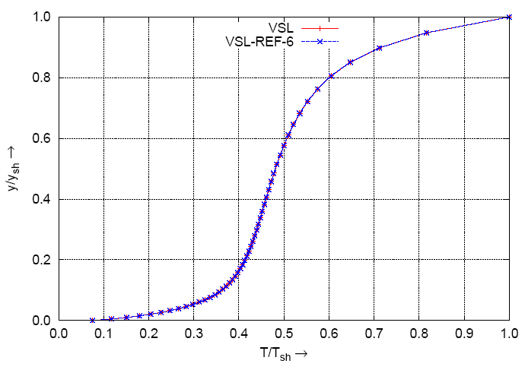

Figure 1. Temperature profile over hyperboloid in stagnation region.
8.1.2 140B Orbiter
The second sample geometry considered is the 140B Orbiter, for which the geometry is specified in a tabular form. The electron density at the stagnation point of this body matches extremely well with literature⁶ as shown in Fig. 2. It is observed from this figure that the peak electron density occurs within the shock layer. Since the sample cases are implemented successfully, the VSL code is extended to spherically blunted cones.
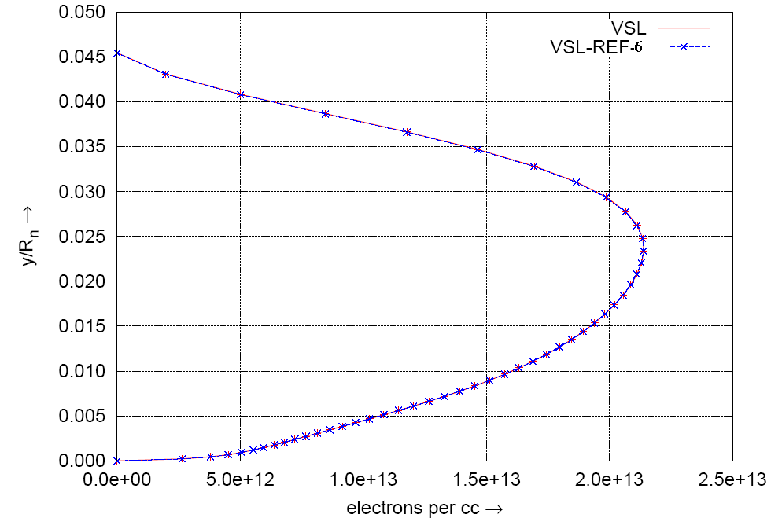

Figure 2. Electron density over 140B Orbiter at stagnation point.
8.2 Spherically Blunted Cone Geometries
8.2.1 20° Blunted Cone
The blunted cone geometry considered⁹ is a cone of 20° half angle with a nose radius of 38.1 mm. The non-dimensional pressure on the body wall in the nose region is compared with literature⁹ and plotted in Fig. 3. The pressure drop due to expansion of the flow over the spherical portion and almost constant pressure over the conical portion is clearly observed from the above figure. The non-dimensional temperature at the stagnation point extending from the body to the shock is shown in Fig. 4. The mass fraction of the various species in the stagnation region is compared in Fig. 5. It is observed that the mass fraction profiles match reasonably well with literature⁹. The small variations in the mass fraction profiles might be due to differences in the thermodynamic properties. The degree of non-equilibrium in the flowfield is evident from the mass fraction profiles.

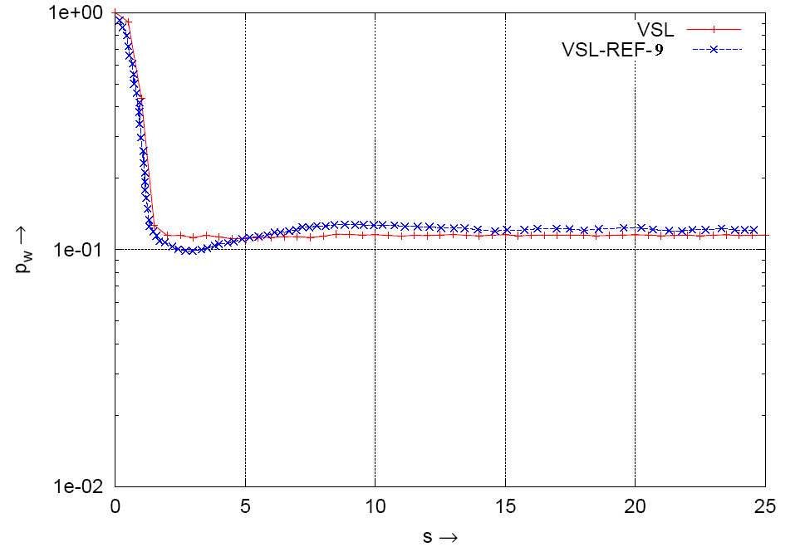

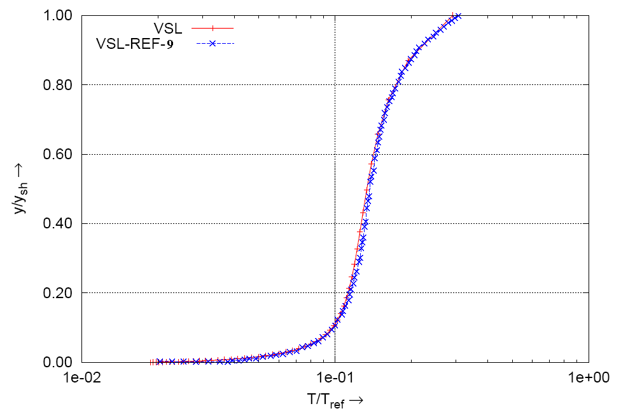
Figure 3. Body pressure comparison over 20° sphere-cone in the nose region.

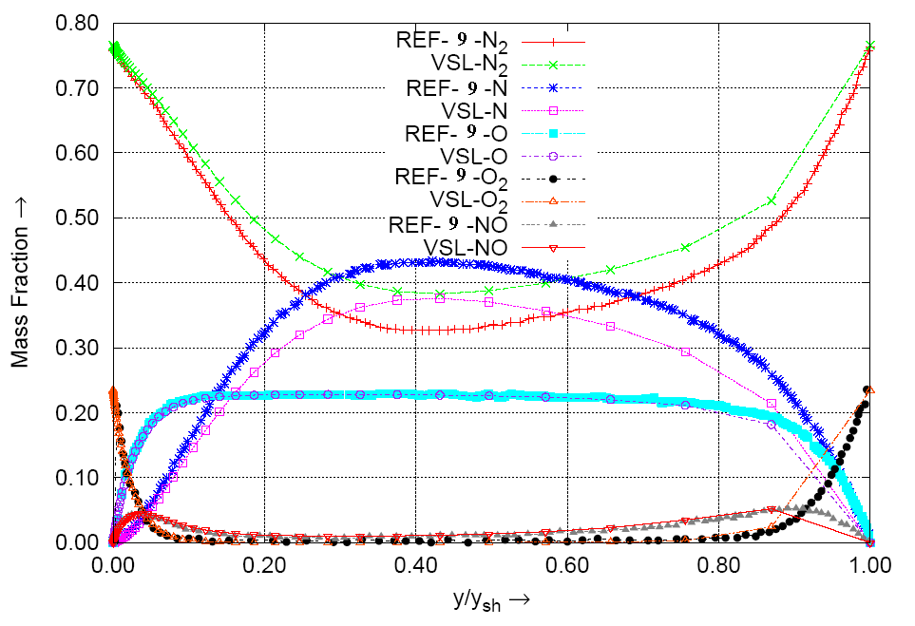
Figure 4. Temperature profile comparison in the stagnation region of 20° sphere-cone.

Figure 5. Mass fraction comparison over 20° sphere-cone (stagnation region, s=0).

8.2.2 RAMC - 9° Blunted Cone
The radio attenuation measurements (RAM) project consisted of spherically blunted cones used to study the plasma characteristics during reentry¹⁰. The RAM series-C consists of flight experiments in a higher velocity regime (about 7.6 km/s)¹¹. The RAMC configuration consists of a 9° cone with a bluntness radius of 152.4 mm.
The change in curvature at the sphere-cone junction of the RAMC geometry causes problems in obtaining the shock shape properly. Hence the shock shape computed from a code based on Inviscid Shock Layer¹² is given as an input to the Viscous Shock Layer code. This helps in better resolution of the shock shape. The runs are carried out assuming no shock slip as in literature⁵. The electron density at the antenna location for altitudes varying from 61 to 76 km computed from the present code are compared with literature^{5, 13}. As shown in Figure 6, the order of the electron density at the antenna location obtained from this code matches fairly well with literature. It is observed from the above figure that with decrease in altitude the electron density increases.
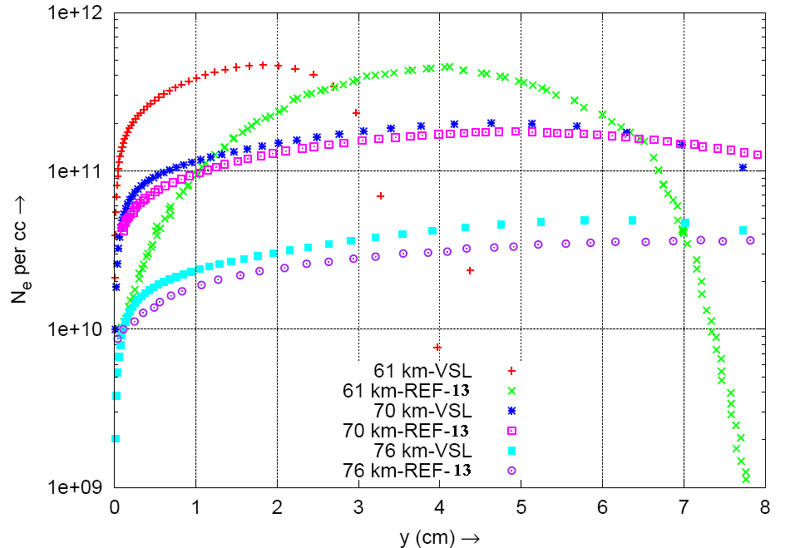

Figure 6. Electron density profiles at various altitudes for RAMC.

The shock layer thickness at an altitude of 70 km compares reasonably well with literature⁵ as shown in Fig. 7. The temperature profile at the antenna location obtained from the present code also compares well with literature⁵ for the same altitude as shown in Fig. 8. It is observed from the above plot that the maximum temperature occurs within the shock layer. The temperature distribution behind the shock at 70 km altitude also matches well with literature as presented in Fig. 9. As expected, the temperature behind the shock decreases along the surface as the shock strength reduces downstream of the stagnation point.

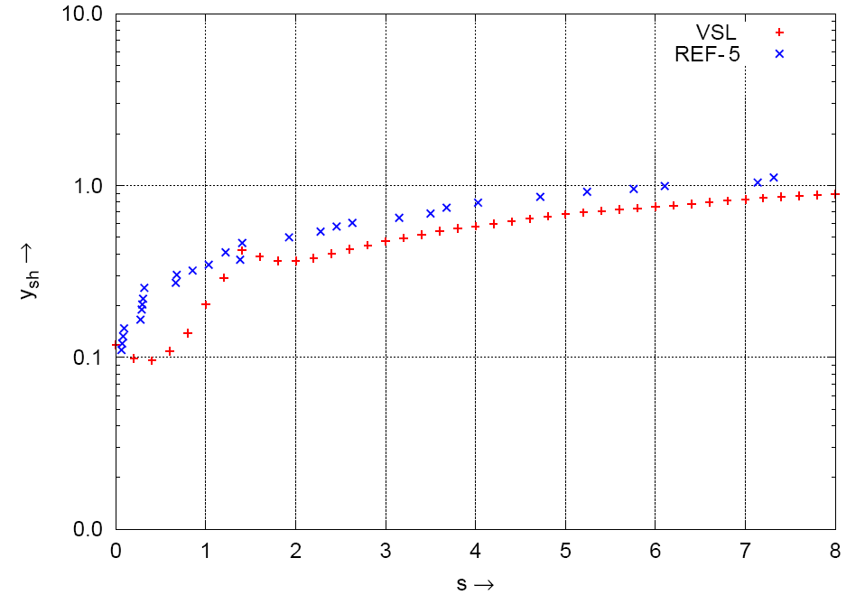

Figure 7. Shock layer thickness distribution at 70 km for RAMC.

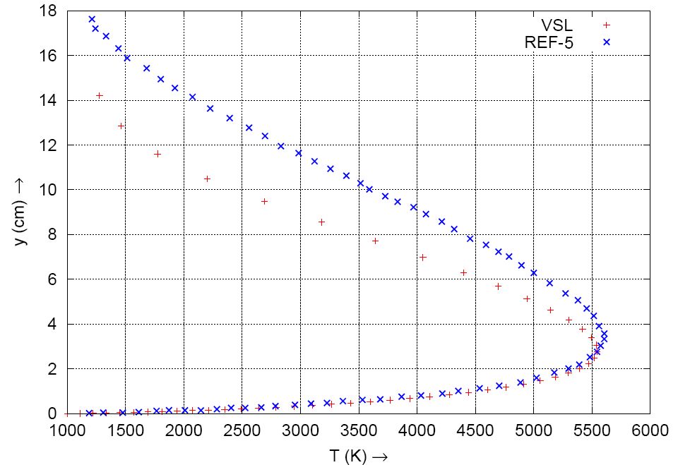

Figure 8. Temperature profile at antenna location for RAMC at an altitude of 70 km.

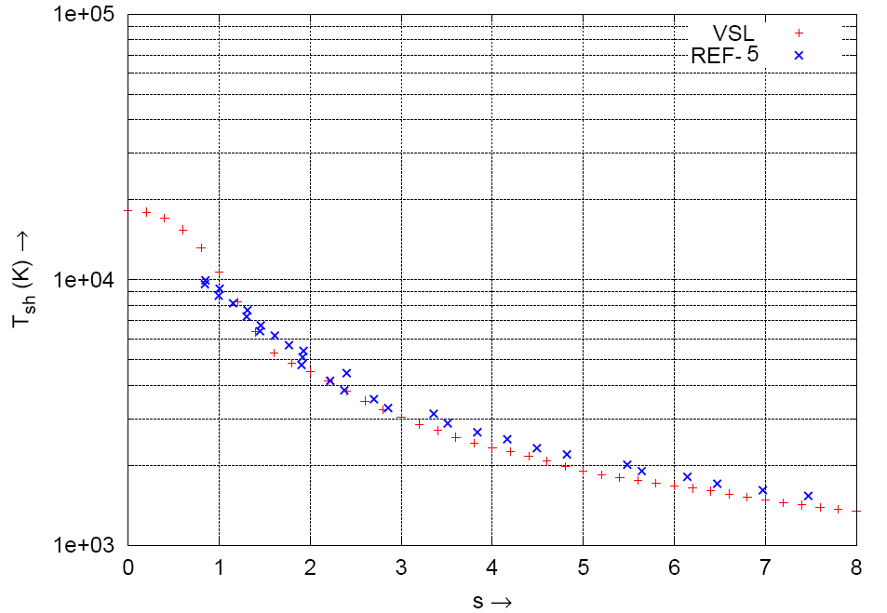

Figure 9. Shock temperature distribution for RAMC at an altitude of 70 km.

8.2.3 SRE Configuration
The SRE configuration consists of a blunted double cone. The bluntness radius is 508.8 mm while the cone angles are 20° and 25°. Since the antenna is located on the 20° cone, only this part is considered as the SRE geometry in the present VSLASL code. The walls are assumed to be catalytic and at a temperature of 1000 K as in the VSL results reported in literature¹⁴. Shock slip boundary condition is applied to enable comparison with literature. The electron densities at the stagnation and antenna location at an altitude of 80 km are plotted in Fig. 10. The viscous shock layer code is able to predict the electron density levels quite well as compared with literature¹⁴. The maximum electron density along the axial direction for 80 km and 85 km are shown in Fig.11. A fairly good match is obtained in predicting the maximum electron density level. The kinks in the plot could be due to the change in curvature near the sphere-cone junction. The plasma frequency, obtained from the electron density, at altitudes varying from 70 to 85 km at the stagnation and antenna locations are plotted in Fig. 12. The communication signal frequency is 2.25 GHz. The present code predicts the onset of blackout to be at about 82 km which matches very well with flight, where the onset of blackout was at 81 km¹⁴.

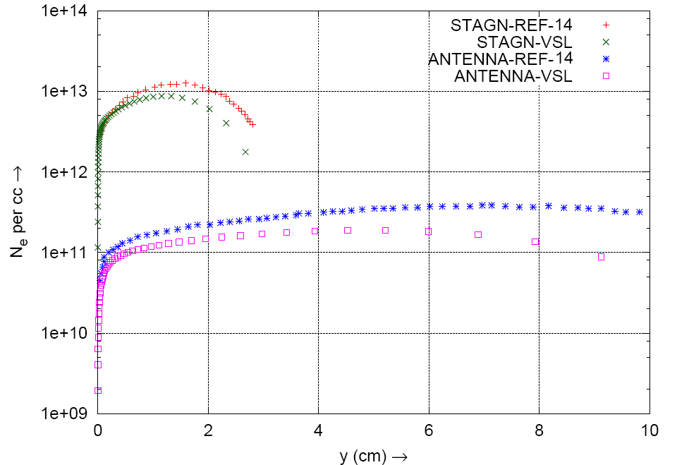

Figure 10. Electron density over SRE at an altitude of 80 km.
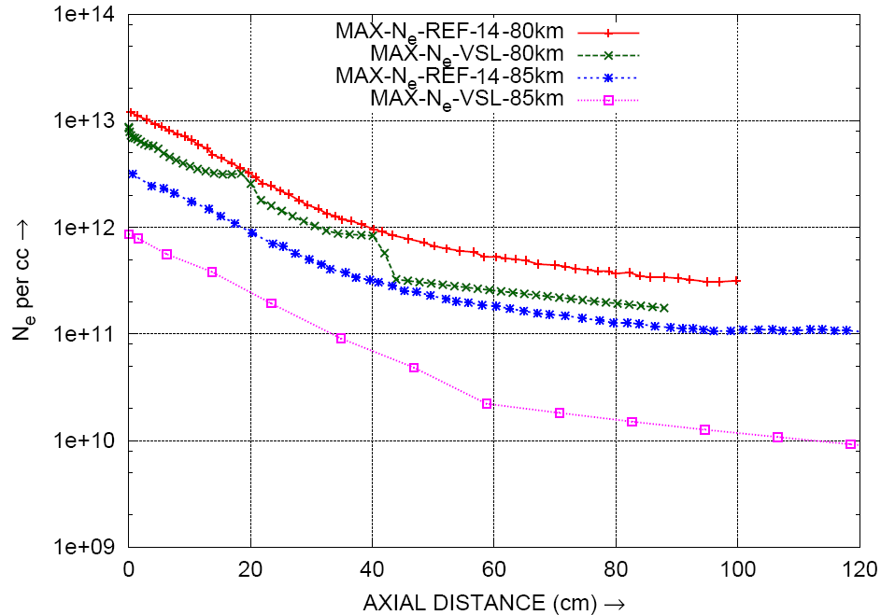

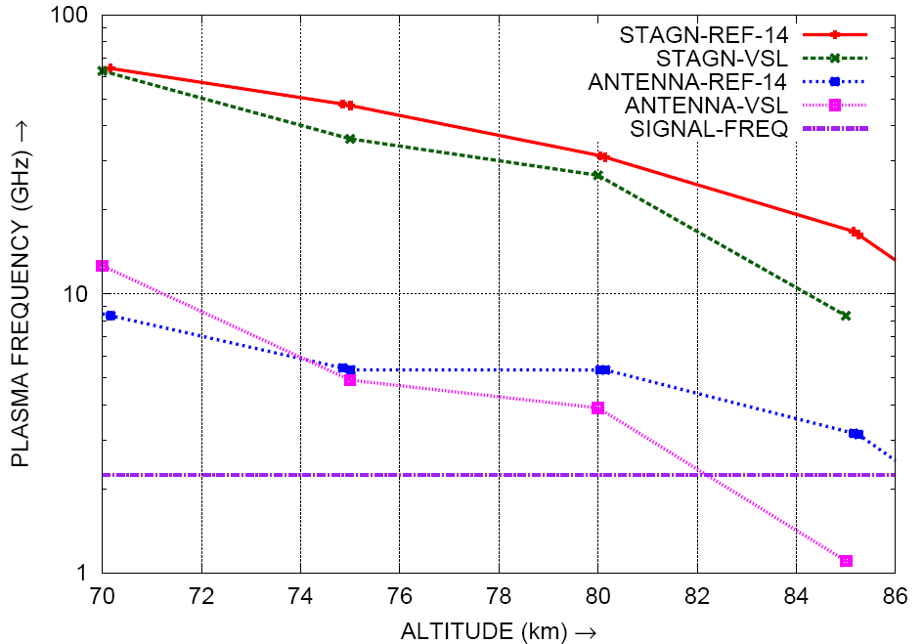
Figure 11. Maximum electron density along the axis for 80 and 85 km altitudes.

Figure 12. Plasma frequencies at various altitudes for SRE.

9 CONCLUSIONS
The present VSLASL is implemented for both analytic and nonanalytic body geometries. The results from the present code for spherically blunted cones like the 20° cone, RAMC and SRE configurations compare favourably with available literature. Various parameters such as the temperature, pressure, species mass fraction, electron density and plasma frequency are found to match well with literature. A good comparison is obtained between the electron densities for the RAMC configuration predicted by the present code and the measured flight electron densities. Hence the present code can be utilised to compute the electron densities for similar spherically blunted cones. Since this code is meant for non-equilibrium flows, it functions well at higher altitudes. But convergence problems arise at lower altitudes, which aid in achieving the equilibrium state. Consequently this code can be used to compute the electron density over bodies during reentry and predict the altitude corresponding to onset of communication blackout.

ACKNOWLEDGEMENTS
The authors thank Shri Avinash Chander, Director, Advanced Systems Laboratory, Hyderabad for granting permission to publish this work. The efforts of Shri Rahul Chopde formerly working at Advanced Systems Laboratory is also gratefully acknowledged.

References
- Anderson, J.D. Hypersonic and high temperature gas dynamics. McGraw-Hill series. 1989. (page no.)
- Rybak, J.P. & Churchill, R.J. Progress in reentry communications. IEEE Trans. Aero. Electronic Syst., 1971, AES-7(5), 879-94.
- Davis, R.T. Numerical solution of the hypersonic viscous shock layer equations. AIAA Journal, 1970, 8(5), 843-51.
- Moss, J.N. Reacting viscous shock layer solutions with multicomponent diffusion and mass injection. NASA TR 411, 1974. (page no.)
- Miner, E.W. & Lewis, C.H. Hypersonic ionizing air viscous shock-layer flows over nonanalytic blunt bodies. NASA CR 2550, 1975. (page no.)
- Miner, E.W. & Lewis, C.H. Computer user’s guide for a chemically reacting viscous shock-layer program. NASA CR 2551, 1975. (page no.)
- Bertin, J.J. Hypersonic aerothermodynamics. AIAA Education Series, 1994. (page no.)
- Blottner, F.G.; Johnson, M. & Ellis, M. Chemically reacting viscous flow program for multi-component gas mixtures. Sandia Laboratories. Report SC-RR-70-754, 1971. (page no.)
- Cheatwood, F.M. & DeJarnette, F.R. An approximate viscous shock layer technique for calculating non-equilibrium hypersonic flows about blunt-nosed bodies. AIAA 92-0498, 1992. (page no.)
- Weaver, W.L. & Bowen, J.T. Entry trajectory, entry environment and analysis of spacecraft motion for the RAMC-III experiment. NASA TMX 2562, 1972. (page no.)
- Widhopf, G.; Kaplan, B. & Jannone, J. Numerical flow field prediction for RAMC. NASA CR 66109, 1966. (page no.)
- Zoby, E. V. & Graves, R.A., Jr. A computer program for calculating the perfect gas inviscid flowfield about blunt axisymmetric bodies at an angle of attack of 0°. NASA TMX 2843, 1973. (page no.)
- Swift, C.T.; Beck, F.B.; Thomson, J. and Castellow, S.L. Jr., RAM C-III S-Band diagnostic experiment. NASA SP 252, 1970. (page no.)
- Asokarajan. N.; Ashok, V. & Mehta, R.C. Electron concentration study for SRE re-entry flight. VSSC/ARD/TM/SRE/054/2007, 2007. (page no.)

