Figures and Tables
Host Computer
Onboard command reception system in flight vehicle
Real-Time Controller
Command Transmission System (CTS)
Ground Reception System (GRS)
RF Link
Transmitting Antenna
Receiving Antenna
Remote Control Unit
Serial Link

Ethernet
Link

Fig.1. GRS incorporated in CTS

Flex-RIO System

LabVIEW Real-Time
FPGA

LabVIEW FPGA
LabVIEW RT VI
LabVIEWFPGA VI
Network
Commun.
FPGA
Interface
WindowsPC

LabVIEW for Windows
Windows VI
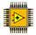

Fig.2. Communication architecture of NI Flex-RIO

- (b)
Translation
Filtering
Analog to Digital Converter
Digital Mixer
Digital Local Oscillator
Low pass Filter
Tuning Freq
Decimation
Digital Baseband Sample
Start
Generate a 15MHz signal using DDS

Read the sample from I/O Module

Multiply both the signal in Multiplexer

Pass the result in a low pass FIR Filter

FM demodulated baseband signal

Pass the signal component less than 5 MHz

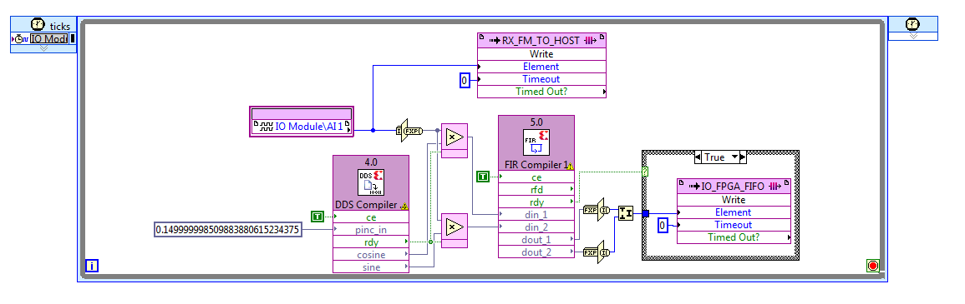
(c)

Fig.3. Digital down Conversion of FM Modulated Signal (a) general overview of digital down conversion, (b) Flowchart of digital down conversion of FM modulated signal, (c) LabVIEW implementation of digital down conversion

- (b)
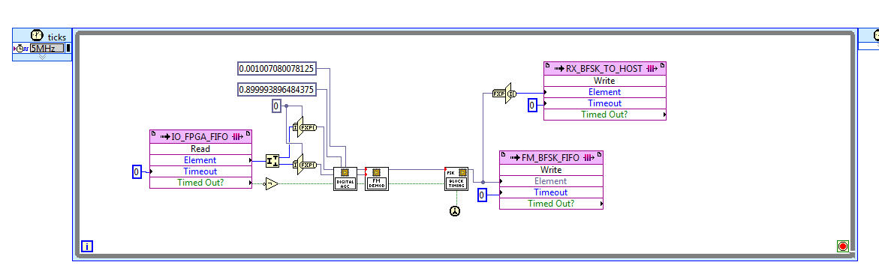
Start
Read the FM modulated signal
from FIFO

Splitting of complex signal into I & Q phase

Calculate using Arc/Tan method

BFSK modulated signal

Differentiate

(c)
$$φ\left(t\right)$$
Differentiator
$$∆ φ\left(t\right)$$

$$\tan^{-1}\left[\frac{S_{Q}\left(t\right)}{S_{I}\left(t\right)}\right]$$
$$S_{I}\left(t\right)$$
$$S_{Q}\left(t\right)$$

Fig.4. FM demodulation; (a) LabVIEW implementation of FM demodulation, (b) Flowchart of Arc/Tan FM demodulation, (c) Digital ARCTAN Differentiated Demodulator method

- (b)
Yes
Start
Collect three consecutive bits from BINARY_DATA FIFO
Match these three bits with start bits
Collect data bits from BINARY_DATA FIFO

Collect Stop bit

Collect data bits from BINARY_DATA FIFO

Match the received data bits with all commands individually

No
No
Yes
Match Found

Display the matched command

Display the RESET status

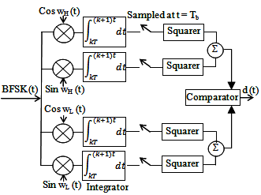

(c)
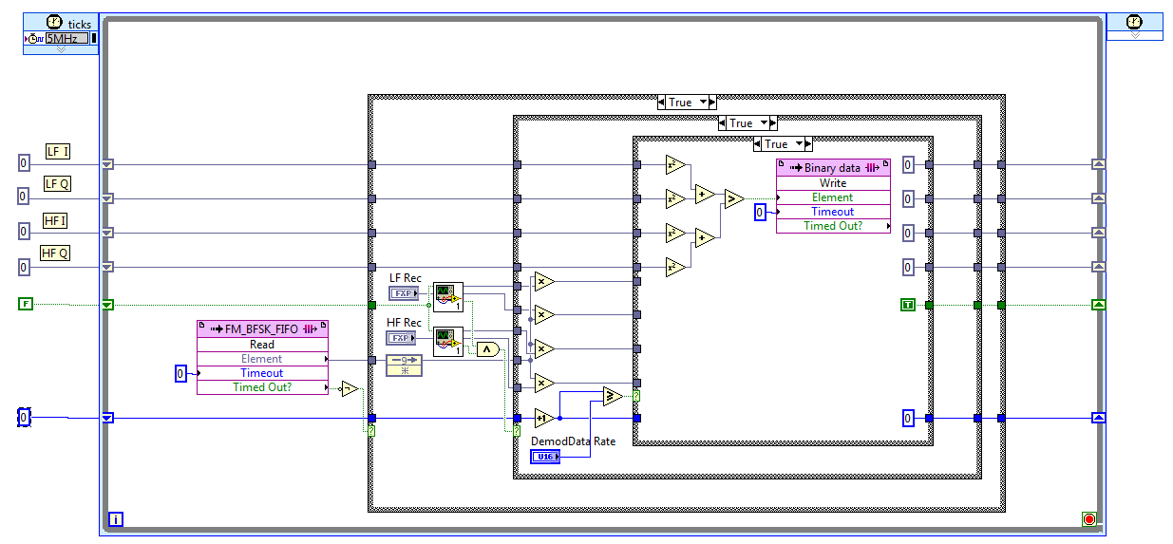

Fig.5. BFSK demodulation; (a) Block diagram of BFSK demodulation, (b) Flowchart of BFSK demodulation, (c)LabVIEW implementation of BFSK demodulation

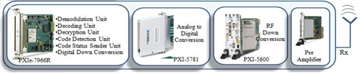

Fig.6. Hardware configuration block diagram of SDR based GRS system

- (b)
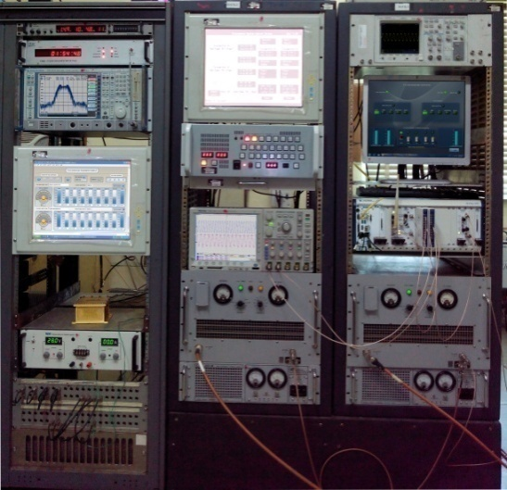
Receiving Antenna
Preamplifier
RF down converter
FPGA
Real-time controller
Host Computer
Flex-RIO system (RTC, FPGA, PXIe cards)
Onboard receiver
Power Amplifier 1
Onboard parameter display
Power Amplifier 2
Spectrum Analyzer

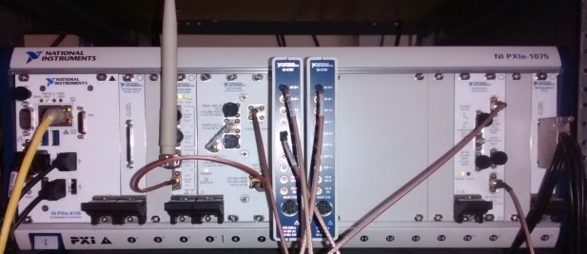

Fig.7. Laboratory setup (a) Broad setup, (b) Flex-RIO system

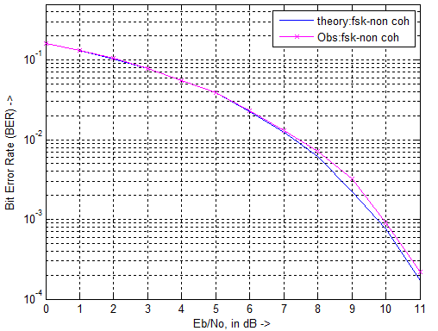

Fig.8. Plot between BER and Eb/N0 (theoretical vs. observed)
(a) (b)
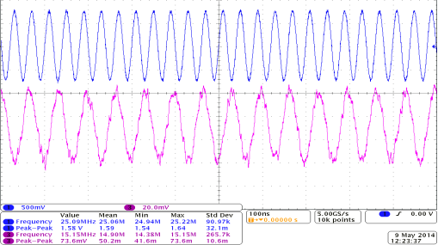
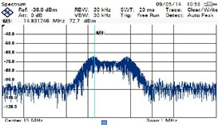

Fig.9. IF spectrum observed in spectrum analyzer at (a) 15 MHz at receiver side, (b) received IF frequency observed in oscilloscope
- (b)
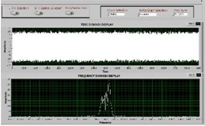
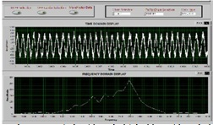

Fig.10. GUI showing various intermediate processed waveforms of GRS (a) BFSK data in reception line, (b) FM data in reception line

TABLE I
SDR BASED GRS PARAMETERS SETTING
Parameters | Operation Range | Unit
Baseband Data rate | 2-8 | Kbps
BFSK Mark Frequency | 0-50 | kHz
BFSK Space Frequency | 0-50 | kHz
FM Deviation | 100-200 | kHz
IF Center Frequency | 15-35 | MHz
RF Down Conversion Center Frequency | 25-2750 | MHz

