Structure
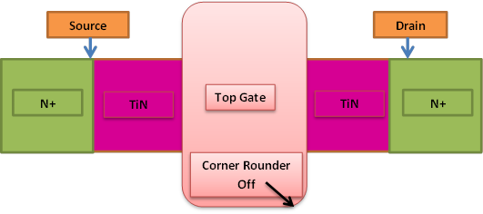

Table.1: Comparison of different cases
Parameters | I_{on} (mA/µm) | I_{off}  (A/µm) | I_{on}/I_{off}
CASE A | 1.5 | 4.3e-08 | 10⁵
CASE B | 0.08 | 5.36e-09 | 10⁴
CASE C | 2.92 | 3.66e-11 | 10⁸

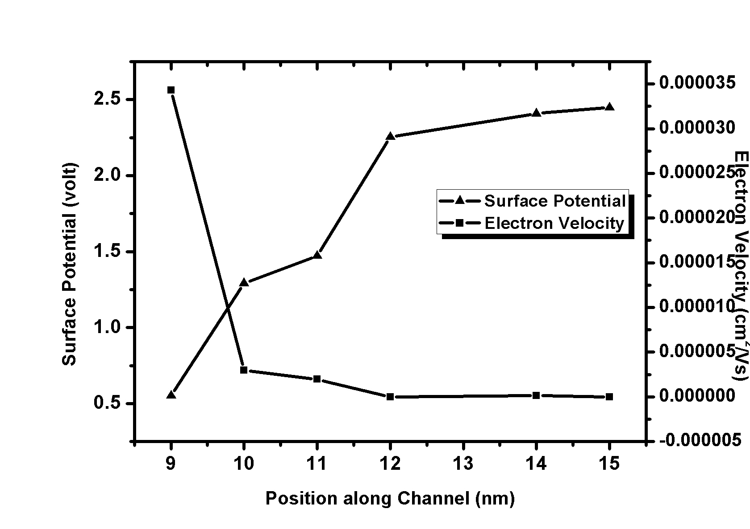
Surface potential and electron velocity vs position along channel

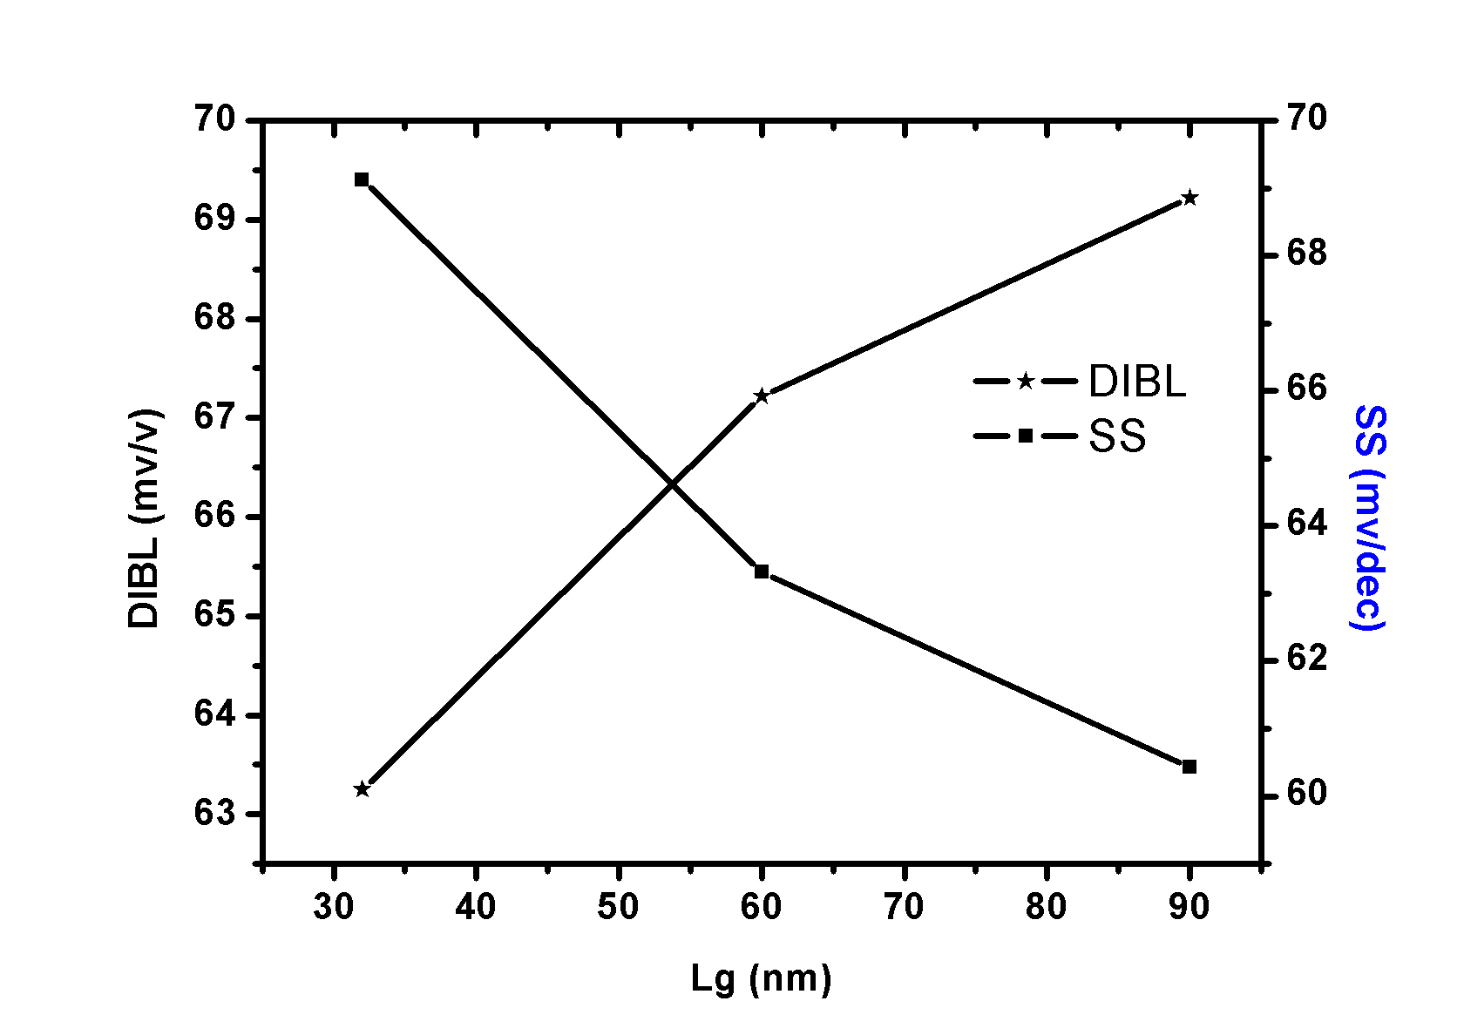
Gate Length Vs DIBL and Subthreshold slope

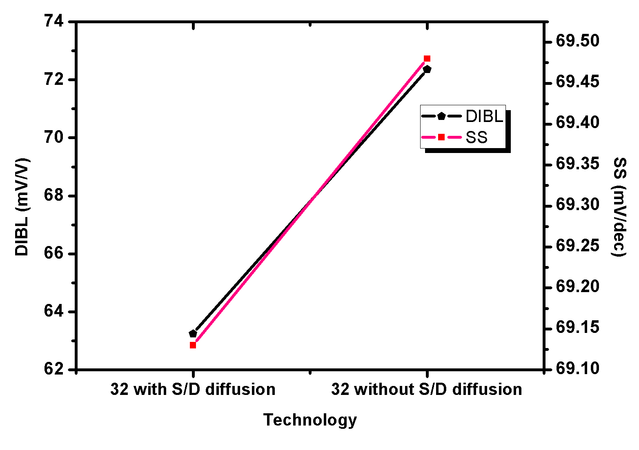
Comparison of DIBL and SS w.r.t. metal diffusion in Source/ Drain

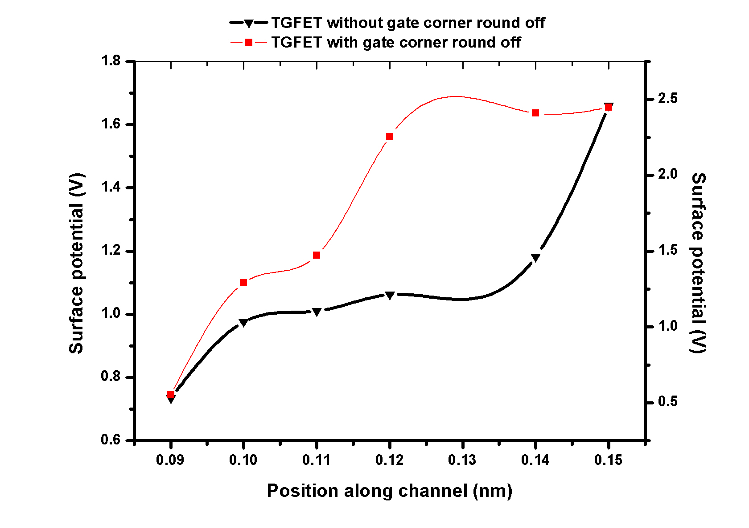
Position along channel vs Surface Potential

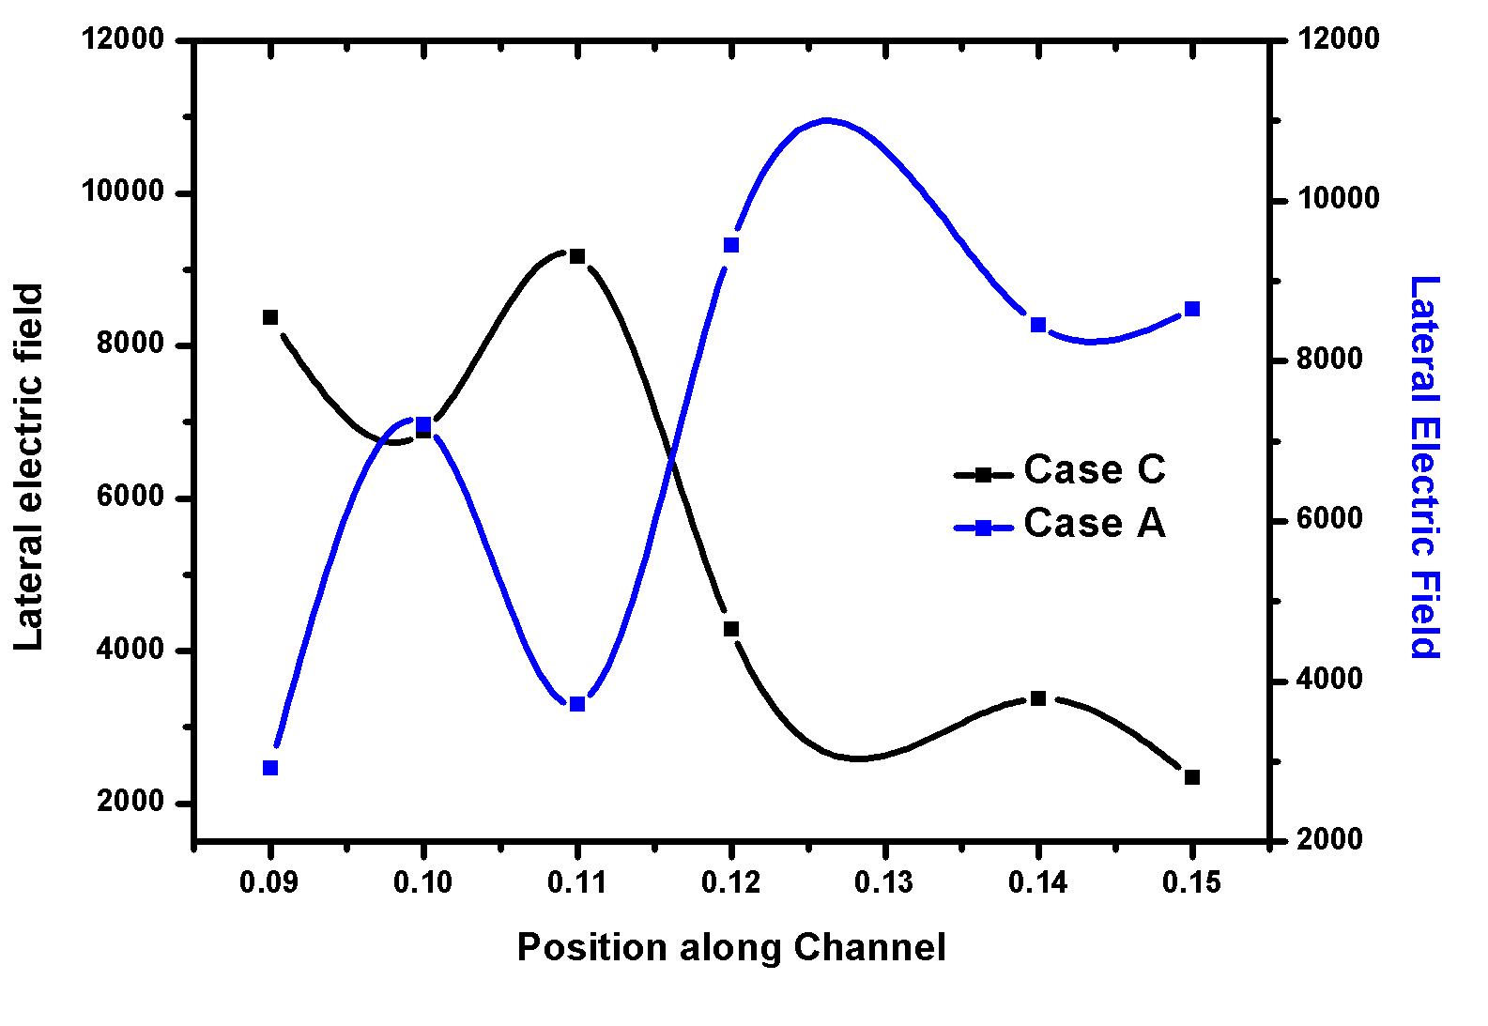
Position along channel vs lateral electric field

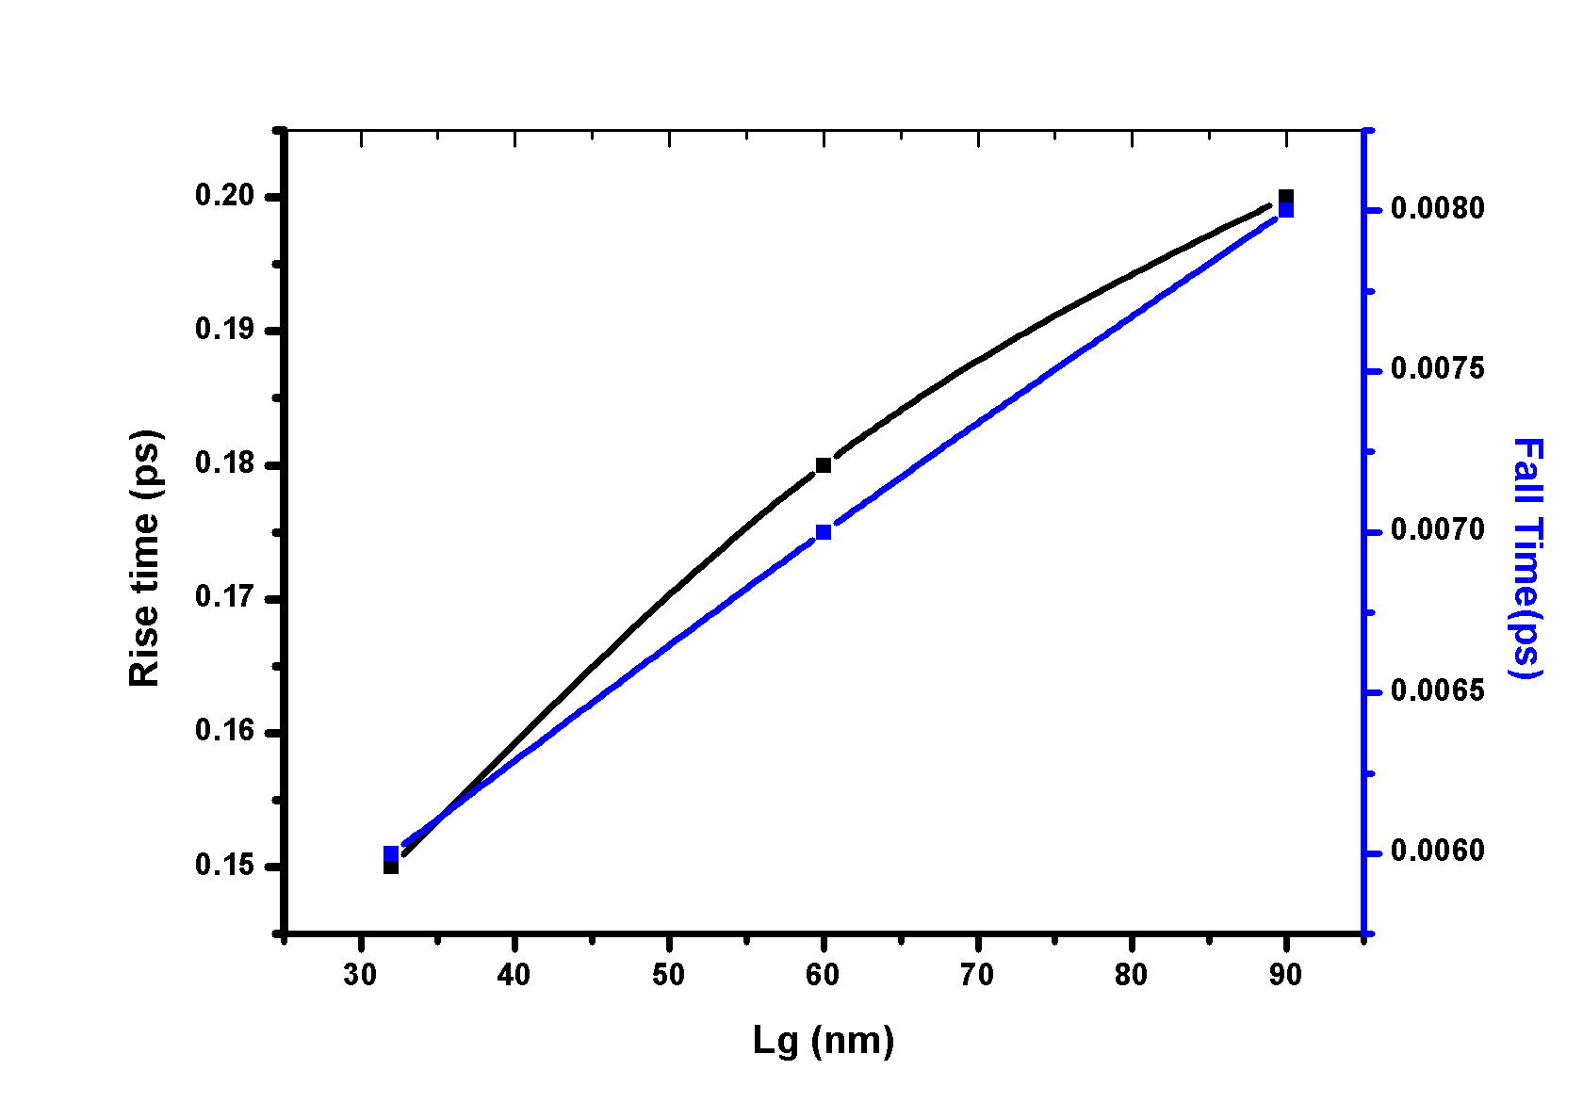
Position along channel vs rise and fall time

