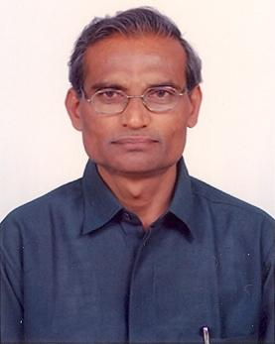
Dr S Sudarshan Rao (Bsc. MA, MLISc, PhD in LIS), Professor (Retd.) and Head, Dept of Library and Information Science, and Chairman, BoS in LIS, Osmania University, Hyderabad (TS). Presently he is the UGC Emeritus Fellow (2015-17), and formerly ICSSR Senior Fellow(2013-2015). He has guided 7 Ph.D and 14 M.Phil Degrees in Library & Information Science and published 78 articles in Journals and Conference / Seminar Volumes. Edited 16 monographs. Recipient of: 1. Parvathaneni Gangadhara Rao Memorial Award, 2009. 2. IATLIS–Motiwale Library & Information Science Best Teacher Award, 2010, and 3. Govt. of Andhra Pradesh ‘Meritorious Teacher Award, 2012’. Presently, he is the Vice-President of Indian Library Association (ILA), Delhi, 2013- .

