This is to certify that the reported work entitled, “...Faculty publications in journals and their citation count in Humanities and Social science departments of IIT Kharagpur- A study.” submitted for publication in DESIDOC Journal of Library and Information Technology (DJLIT) is an original work and has not been submitted/published elsewhere. I/We further certify that proper citations to the previous reported work have been given and no data/tables/figures have been quoted verbatim from other publications without giving due acknowledgement and without the permission of the original author(s). The consent of all the authors of this paper has been obtained for submitting the paper to the Journal.

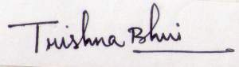 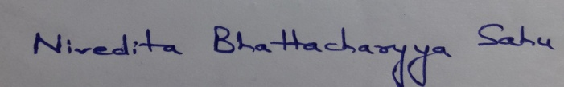
Trishna Bhui Dr. Nivedita Bhattacharyya Sahu

[Signature and names of all the authors]

