This is to certify that the reported work entitled, ……………………………………………………………………………… submitted for publication in DJLIT is an original work and has not been submitted/published elsewhere. I/We further certify that proper citations to the previous reported work have been given and no data/tables/figures have been quoted verbatim from other publications without giving due acknowledgement and without the permission of the original author(s).
Contributor Signature: 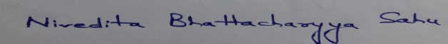
Date: 30-08-2018
Contributor Full Name : Dr. Nivedita Bhattacharyya Sahu
AFFLIATION (Company, Univ.): Vidyasagar University, Midnapore, West Bengal
MAILING ADDRESS: 1C, Sky View Apartment, Bidhannagar, Dak Bungalow Road, Midnapore, Pin- 721101
PHONE: 09051837676
E-MAIL ADDRESS: nives.b22@gmail.com

