CERTIFICATE OF ORIGINALITY

This is to certify that the reported work entitled, ……………………………………………………………………………… submitted for publication in DJLIT is an original work and has not been submitted/published elsewhere. I/We further certify that proper citations to the previous reported work have been given and no data/tables/figures have been quoted verbatim from other publications without giving due acknowledgement and without the permission of the original author(s).
Please note that each contributor must complete an individually signed agreement
Contributor Signature: 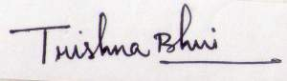
Date: 30-08-2018
Contributor Full Name: Trishna Bhui
AFFLIATION (Company, Univ.): Vidyasagar University
MAILING ADDRESS: Dept. of Lib. & Info.Sc., Vidyasagar University, Midnapore
PHONE: 7076117896
E-MAIL ADDRESS: trishnalibrary@gmail.com

