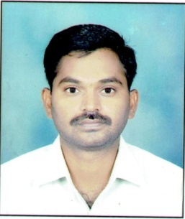
Mr. Vishal D. Bapte has been working as Assistant Librarian in Sant Gadge Baba Amravati University, Amravati, and Maharashtra since 2012. He is the Head of Acquisition Section, Periodical Section and Circulation Section of the University Library. Previously, he worked as a Librarian in Shankarlal Khandelwal College, Akola (MS). His special areas of interest are collection development, library automation and Information Literacy and Bibliometrics.
-----------------------------------------------------------------------------------------------------------------------

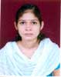
Ku. Jyoti S. Gedam has been working as a Library Assistant in the University Library of Sant Gadge Baba Amravati University, Amravati since 2008. She renders her service in the Periodical Section of the University Library.

