CERTIFICATE OF ORIGINALITY
This is to certify that the reported work entitled, ‘A Scientometric Profile of Sant Gadge Baba Amravati University, Amravati During 1996-2017’ submitted for publication in DJLIT is an original work and has not been submitted/published elsewhere. I/We further certify that proper citations to the previous reported work have been given and no data/tables/figures have been quoted verbatim from other publications without giving due acknowledgement and without the permission of the original author(s).
Please note that each contributor must complete an individually signed agreement
Contributor’s Signature:
- Vishal Dattatray Bapte¹ - 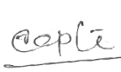
- Jyoti Sukhram Gedam² - 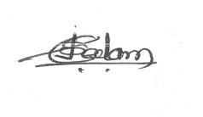

Date:

Vishal Dattatray Bapte¹  Knowledge Resource Centre  Sant Gadge Baba Amravati University,  Amravati-444602  Maharashtra  vishal_bapte@rediffmail.com, baptevishal@gmail.com | Jyoti S. Gedam²  Knowledge Resource Centre  Sant Gadge Baba Amravati University,  Amravati-444602  jsgedam@rediffmail.com

