CERTIFICATE OF ORIGINALITY
This is to certify that the reported work entitled, Evaluation of “Precision and Relative Recall” of five University Web OPACs submitted for publication in DJLIT is an original work and has not been submitted/published elsewhere. I/We further certify that proper citations to the previous reported work have been given and no data/tables/figures have been quoted verbatim from other publications without giving due acknowledgement and without the permission of the original author(s).
Please note that each contributor must complete an individually signed agreement
*Contributor Signature: 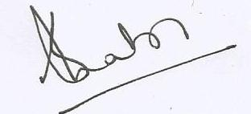
*Date:30.01.2017

*Contributor Full Name : SOMAIRA NABI
*AFFLIATION (Company, Univ.): University Of Kashmir, Srinagar.
*MAILING ADDRESS: Allama Iqbal Library , University of Kashmir, Hazratbal Srinagar J &K- 190006
*WORK PHONE: 0194-2272097 , Ext.2257 : Fax (O): 0194-2415448
Mobile no: 09469073251
*RESIDENCE PHONE: 0194-2493348
Residence ADDRESS 837-A, Sector 2F, Bemina Housing Colony,
Srinagar-190018
*E-MAIL ADDRESS: sumairanabi@yahoo.co.in ;
nabisomaira@kashmiruniversity.ac.in .

