CERTIFICATE OF ORIGINALITY

This is to certify that the reported work entitled, “Tradition and Transition: The Journey of an iSchool Deep in the Heart of Texas,” submitted for publication in DJLIT is an original work and has not been submitted/published elsewhere. I/We further certify that proper citations to the previous reported work have been given and no data/tables/figures have been quoted verbatim from other publications without giving due acknowledgement and without the permission of the original author(s).
Please note that each contributor must complete an individually signed agreement
*Contributor Signature: 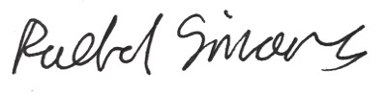
*Date: 24 September 2016
*Contributor Full Name: Rachel N. Simons
*AFFLIATION (Company, Univ.): School of Information, The University of Texas at Austin
*MAILING ADDRESS: 11700 Metric Blvd Apt 1517, Austin, Texas 78758 USA
*WORK PHONE: 1-512-822-0323
*RESIDENCE PHONE: 1-512-822-0323
*E-MAIL ADDRESS: rnsimons@utexas.edu

