CERTIFICATE OF ORIGINALITY
This is to certify that the reported work entitled “INVESTIGATING KNOWLEDGE MANAGEMENT STRATEGIES IN CENTRAL UNIVERSITY LIBRARIES IN INDIA” submitted for publication in DJLIT is an original work and has not been submitted/published elsewhere. I/We further certify that proper citations to the previous reported work have been given and no data/tables/figures have been quoted verbatim from other publications without giving due acknowledgement and without the permission of the original author(s).
Please note that each contributor must complete an individually signed agreement
*Contributor Signature: 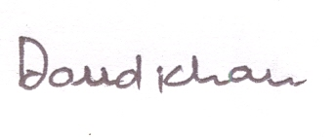
*Date: 24.08.2016
*Contributor Full Name: Daud Khan
*AFFLIATION (Company, Univ.): Department of Library & Information Science, Aligarh Muslim University
Aligarh, UP- 202002

*MAILING ADDRESS: Department of Library & Information Science, Aligarh Muslim University
Aligarh, UP- 202002
*WORK PHONE: +918881027286
*RESIDENCE PHONE: +918881027286
*E-MAIL ADDRESS: daudk297@gmail.com

